User Guide
Version 2016.2
© 2016 Exago Inc. All rights reserved.
Exago Reporting is a registered trademark of Exago, Inc. Windows is a registered trademark of Microsoft Corporation in the United States and other countries. All other company and product names mentioned may be trademarks of the respective companies with which they are associated.
Exago Inc. makes a sincere effort to ensure the accuracy of the material. The content of this manual is furnished for informational use only, is subject to change without notice, and should not be construed as a commitment by Exago Inc. Exago Inc. assumes no responsibility or liability for any errors or inaccuracies that may appear in this document.
Except as permitted by licensing agreement, no part of this publication may be reproduced, stored in a retrieval system, or transmitted, in any form or by any means, without the prior written permission of Exago Inc.
Exago Inc. strives to provide our customers with high-quality printed and online documentation. If you have any comments or suggestions on how we can improve our documentation for your use, please contact us at: webmaster@exagoinc.com.
Exago, Inc.
Two Enterprise Drive
Shelton, CT 06484 USA
Phone | 203.225.0876
Fax | 203.926.9505
Email | exagoinc.com
Support & Development
Phone | 845.481.5221
Fax | 845.255.0209
Email | support@exagoinc.com
Web | exagosupport.com
Blog | exagoinc.com/blog.html

Table of Contents
Table of Contents 3
About 6
Supported Browsers 6
Navigation 6
Main Menu 7
Tabs 7
Creating New Reports 8
Types of Reports 8
Express Report Wizard 10
Name Tab 10
Categories Tab 11
Sorts Tab 12
Filters Tab 13
Layout Tab 14
Options Tab 19
New Standard Report Wizard 23
Name Tab 23
Categories Tab 24
Sorts Tab 25
Filters Tab 26
Layout Tab 27
New CrossTab Wizard 32
Name Tab 32
Categories Tab 33
Filters Tab 34
Layout Tab 35
Searching Reports 43
Folder Management 44
Editing Reports 45
Report Designer 46
Design Grid 46
Data Menu 46
Toolbar 47
Design Grid 48
Sections 48
Columns and Rows 50
Cells 53
Using Page Breaks 53
Collapsible Rows 54
Data Menu 57
Adding Data Fields to a Report 57
Toolbar 58
Saving Reports 58
Undo/Redo 58
Font & Alignment Options 58
Formatting Cells 59
AutoSum 64
Images 64
Formulas 64
Suppress Duplicates 64
Chart Wizard 66
Maps 85
Linked Reports 91
Gauges 94
CrossTabs 97
Renaming Reports 102
Changing Description 102
Changing Data Categories 103
Changing Sorts 104
Changing Filters 106
General Options 108
Report Viewer Options 110
Advanced Options 113
Document Template 114
Duplicating Reports 116
Deleting Reports 117
Scheduling Reports 118
Schedule Report Wizard 118
Recurrence Tab 119
Parameters Tab 120
Filters Tab 120
Batch Tab 121
Recipients Tab 123
Email Report 123
Manage Scheduled Reports 124
Executing Reports 126
Interacting with Reports 126
Changing Styling 127
Resizing Columns 127
Applying Interactive Filters 127
Conditional Filters 128
Changing Sorts 128
Hiding Columns 129
Saving & Clearing Changes 129
Exporting to Other Formats 130
Creating and Editing Dashboards 131
Dashboard Designer 131
Dashboard Items 134
Toolbar 142
Chained Reports 148
Chained Report Wizard 148
Name Tab 148
Reports Tab 149
Options Tab 151
Formulas 153
Functions 153
Parameters 153
Data Fields 153
Referencing a Cell 153
Using Formulas 154
Formula Editor 154
Manual Formulas 154
Full Description of Parameters 156
Quick List of Functions 157
Full Description of Functions 159
Aggregate Functions 160
Logical Functions 162
Date Functions 164
Financial Functions 168
Database & Data Type Functions 175
Arithmetic & Geometric Functions 177
String Functions 184
Formatting Functions 186
Other Functions 187
Other 189
User Preferences 189
Startup Reports 189
Context Sensitive Help 189

About

This application is a powerful yet easy-to-use reporting tool. It runs in your web browser and does not require any downloads.

Supported Browsers
Supported browsers include:
- Firefox 3+
- Internet Explorer 9+ / Edge
- Google Chrome
- Safari

Navigation
This application consists of two sections. On the left is the Main Menu and on the right are Tabs. The Main Menu displays the available reports, folders, and buttons. Tabs can contain the New Report Wizard, report outputs, design windows, or help pages.
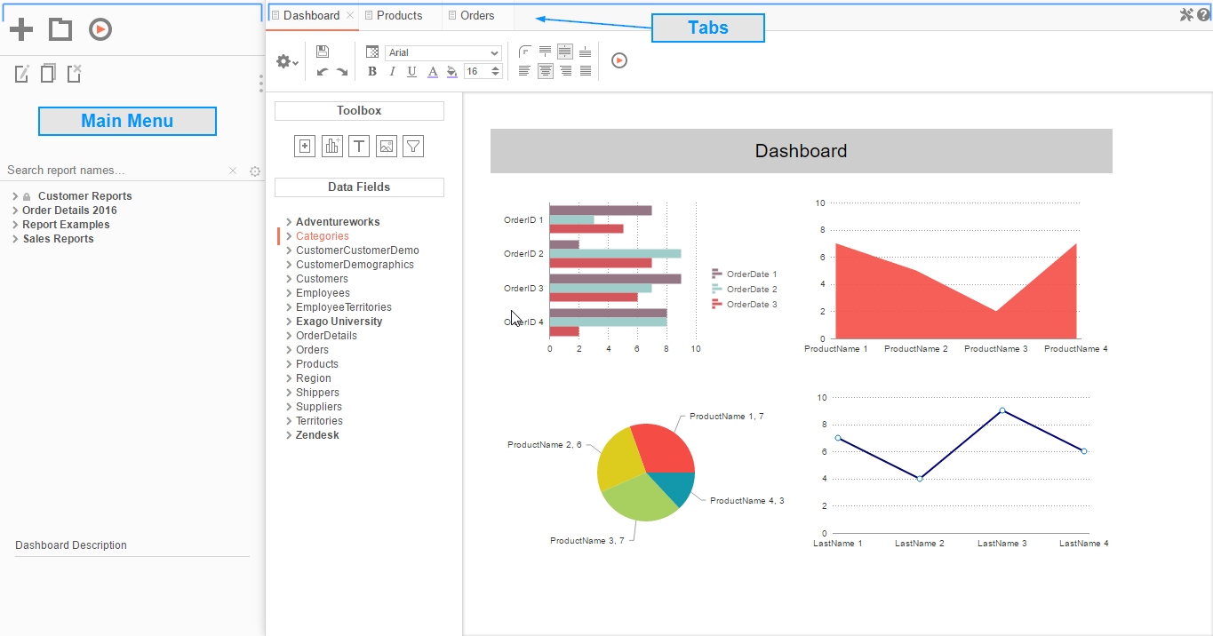

Main Menu
Through the Main Menu you can:

- Create new reports
- Search for reports
- Read report descriptions
- Run reports
- Export reports to other types (Excel, PDF, RTF and CSV)
- Duplicate reports to save time setting up reports that are similar
- Edit reports
- Delete reports
- Schedule reports to be emailed or archived
- Manage folders and report storage
Press the splitter icon to hide the Main Menu. This is located in the top left corner of the application's interface between the Main Menu and the Tabs.

Tabs
The right section is made up of tabs containing the New Report Wizard, reports outputs, design windows, or help pages. Tabs can be closed by pressing the () to the right of the tab name.
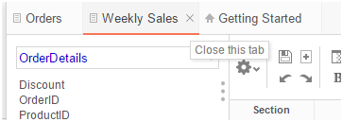

Tabs can be rearranged by clicking and dragging them left or right.
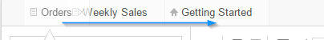

Creating New Reports

To create a new report, press the New Report Button. This will launch the New Report Wizard in a new tab.
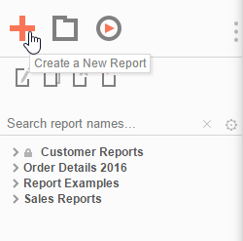

Types of Reports
This application has five types of reports.
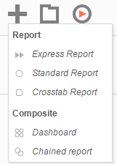
- Express Reports – This simplified report designer enables you to quickly build reports with basic layouts and calculations. For more information, see Express Reports.
- Standard Reports – This type of report uses an intuitive grid to lay out data and labels. Standard reports can provide more complex sections in which to group data and make specialized calculations. For more information, see Report Designer.
- CrossTab Reports – CrossTab reports utilize the Standard Report Designer to create reports that may expand both horizontally and vertically based on data. For more information, see CrossTabs.
- Dashboards – This is a canvas for combining and laying out reports, data visualizations, images, text and web pages. For more information, see Dashboards.
- Chained Reports – This type of report compiles multiple reports into a single document. For more information, see Chained Reports.

Express Report Wizard
The Express Report Wizard is an interactive tool which allows you to quickly create and edit Express Reports.
To navigate the wizard, either select the desired tab, or use the and buttons.
To save an Express Report, press the save button.
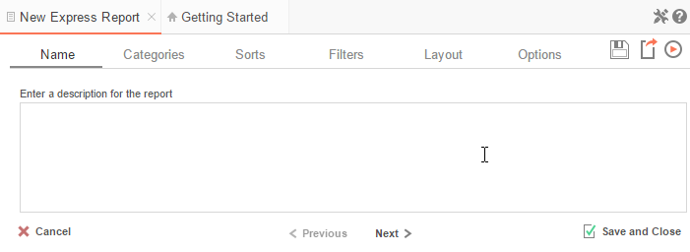
The Express Report Wizard has six sub tabs. The Name, Categories and Layout tabs must be completed while the other tabs are optional.

Name Tab
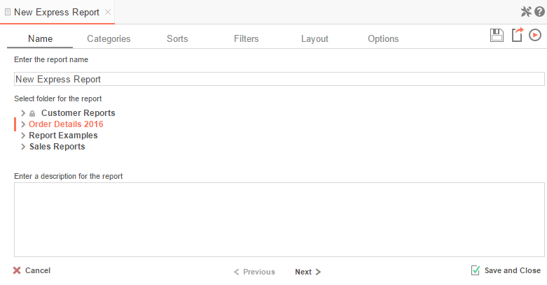

In the Name tab, enter a report name and select the Folder to save the report.
The report name can be up to 255 characters long. Avoid special characters such as ? : / \ * “ < >.
A report's description appears at the bottom of the Main Menu when it is selected. You may also search by a report's description text.
You cannot create a report inside a folder that is read-only ().

Categories Tab
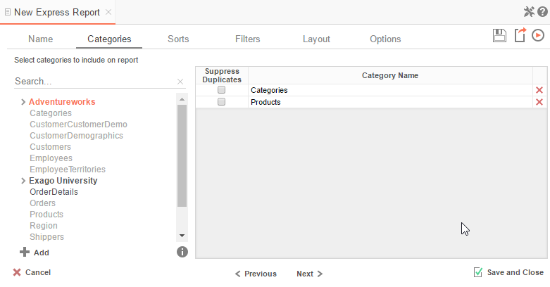

In the Categories Tab, select the Data Categories that you would like to have access to on the report. It is important to understand two terms: Data Category and Data Field.
Data Category – A Data Category is a data object that has several attributes. E.g. Orders is a category; each order has an ID, a date, a customer, etc.
Data Field – A Data Field is a single attribute within a category. E.g. Orders.OrderID is numeric value that identifies a specific order.
- To add a Data Category, either drag and drop it to the selection pane, or select the Category and press the button, or double-click the Category.
- To search for a Data Category or folder, enter the terms into the search bar ().
- To see the Data Fields in a Data Category, select the Category and press the info button ().
- Check the 'Suppress Duplicates' box to suppress any repeated records from that Category.
- To remove a Data Category, press the delete button ().

Sorts Tab
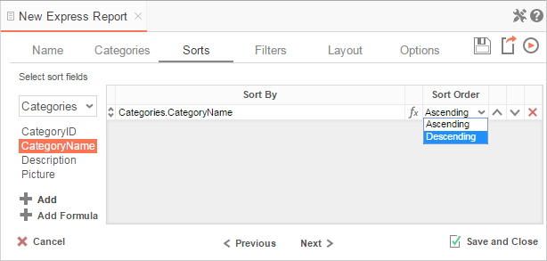

In the Sorts Tab, specify which Data Fields will be used to determine the order of data on the report.
- To sort by a Data Field, either drag and drop it to the selection pane, or select the Data Field and press the button, or double-click the Data Field.
- To sort by a Formula, press the button. To edit an existing formula, press the Formula Editor () button. See Sorting by Formula for more information.
- You can order each sort in Ascending (A-Z, 0-9) or Descending (Z-A, 9-0) order.
- Use the up () and down () arrows to indicate the sort priority.
- To remove a sort, press the delete button ().

Filters Tab
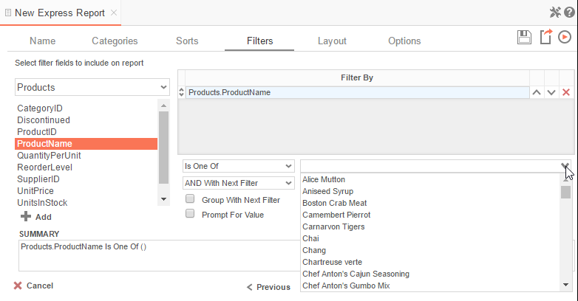

In the Filters Tab, create statements that will be used to filter the data when you run the report.
There is no limit to the number of filters that can be defined. Filters can be numeric (up to eight decimals) or alphanumeric.
- To filter by a Data Field, either drag and drop it to the selection pane, or select the Data Field and press the button, or double-click the Data Field.
- Use the up () and down () arrows to indicate the filter priority.
- To remove a filter, press the delete button ().
- Set the operator (Equal To, Less Than, One Of, etc.) by selecting it from the operator drop-down.
- Set the filter value either by entering it manually or by selecting a value from the drop-down. If the Data Field is a date, the calendar and function buttons can be used to select a value.
- Check 'Prompt for Value' to allow the filter to be modified at the time the report is run.
- Select 'AND With Next Filter' to require that the selected filter and the one below it both evaluate to true. Choose 'OR With Next Filter' to require that either be true.
- Check 'Group With Next Filter' to specify the precedence of the filters. Filters can be nested indefinitely by using the following keyboard shortcuts while a filter is selected:
  - Ctrl + [ adds an open-parenthesis before the selected filter.
  - Ctrl + ] adds a close-parenthesis after the selected filter.
  - Ctrl + Shift + [ removes an open-parenthesis from before the selected filter.
  - Ctrl + Shift + ] removes a close-parenthesis from after the selected filter.

Layout Tab
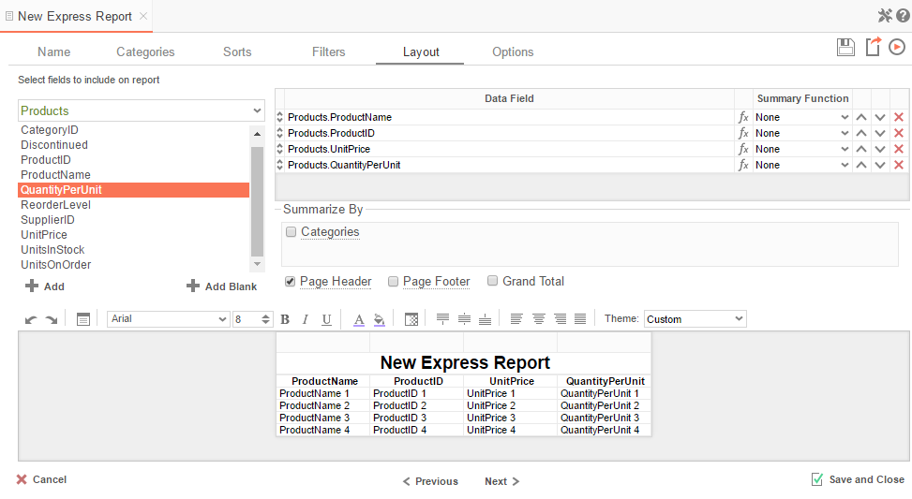

In the Layout Tab, select which Data Fields will appear on the report. For each Data Field chosen, the report will automatically create a column header and the Data Field. You can add subtotals, grand totals, and page header/footers.

Display Data
- To place a Data Field on the report, either drag and drop it to the selection pane, or select the Data Field and press the button, or double-click the Data Field.
- To add blank columns that can be edited manually, press the button. You can enter text into a blank column.
- Use the up () and down () arrows to indicate the order the Data Fields should appear on the report. The Data Field at the top will appear as the leftmost column of the report.
- The Summary Function column is used to make subtotals and grand totals. See Subtotals and Grand Totals for more information.
- To remove a Data Field, press the delete button ().
For each Data Field in the Sorts tab, a checkbox will appear in the 'Summarize By' box. Using the 'Summarize By' box you can display subtotals, grand totals, or headers for the values of a Data Field.

Subtotals and Grand Totals
- To display subtotals, check the box of the Category you want to subtotal. Then, for each Data Field you want totaled, select a Summary Function (see below).
- To display grand totals, check the Grand Total box. Then, for each Data Field you want totaled, select a Summary Function (see below).
Summary Functions:

  - Sum: Totals the all of the data in the Data Field.
  - Count: Returns the number of rows in the Data Field.
  - Average: Takes the mean of the data in the Data Field.
  - Minimum: Displays the lowest value in the Data Field.
  - Maximum: Displays the highest value in the Data Field.
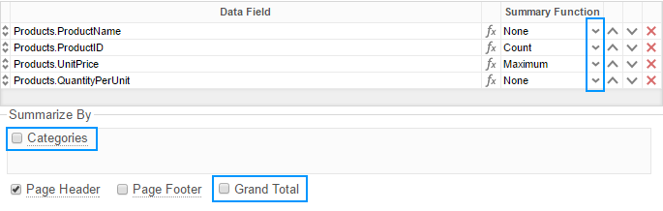

Data Headers
To display a header for each value of a Data Field, click on the associated Data Category in the Summarize By box. Click the Data Category name next to the checkbox, and the Header Menu will appear.
- To include a blank row before each unique value of the selected Data Field, check the box 'Add space before each unique item'.
- To include a Header, check the box 'Include Header at the beginning'. In order to select the text that will appear as the header value, use the Header Text dropdown to select a Data Field or use the Formula Editor Button () to create a formula.
- Use the 'Summarize by each unique' dropdown to specify if the header should repeat based on a specific Data Field or if it should repeat for all of the keys of a Category.
- Check the box 'Include Total at the end' to have a subtotal created for this Category.
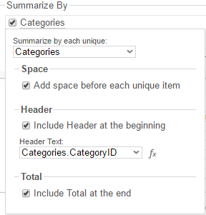

Page Header
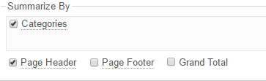
To display information on the top of each page, check the 'Page Header' box. Press 'Page Header' and the Page Header Menu will appear:
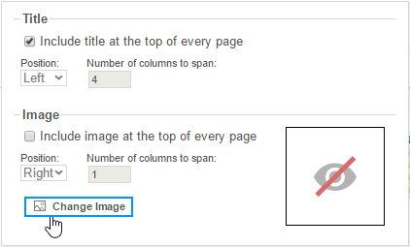
- Check the box 'Include Title at the top of every page' to display the name of the report on each page. If an image is also included, use the position dropdown to set where the title should appear and the number of columns it should span.
- Use the 'Change Image' button to upload an image to display at the top of each page. If a title is also included, use the position dropdown to set where the image should appear and the number of columns it should span.

Footers
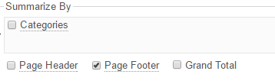
To display information on the bottom of each page, check the 'Page Footer' box. Press 'Page Footer' and the Page Footer Menu will appear:
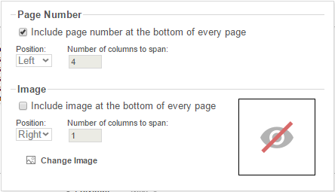
- Check the box 'Include page number at the bottom of every page' to display the page number on each page. If an image is also included, use the position dropdown to set where the page number should appear and the number of columns it should span.
- Use the 'Change Image' button to upload an image to display at the bottom of each page. If the page number is also included, use the position dropdown to set where the image should appear and the number of columns it should span.

Preview
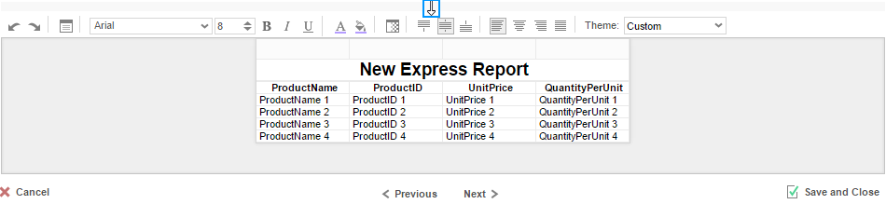
At the bottom of the Layout Tab, a preview will display how the report will appear based on the fields that have been added. You can increase/decrease the size of the preview or hide it altogether by dragging the top of the Express Report Designer box.

Styling Express Reports
The toolbar above the preview can be used to style the Express Report. To utilize this toolbar, select the cell(s) in the preview you want to modify, then use one of the following options:
Undo/Redo – can undo or redo the last change made. You can also use Ctrl+Z /Ctrl+Y, respectively.

Layout Options – see Layout Options for more information.

Font – see Font for more information.

Foreground & Background Color – see Color for more information.

Number/Date Format/Border Color – see Formatting Cells for more information.

Alignment – see Alignment for more information.

Theme – Quickly style the report using one of the pre-defined themes.

Layout Options
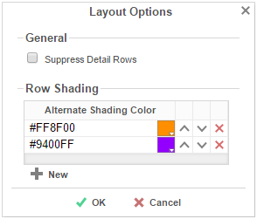
In Layout Options you can hide the detail information and set row shading.
- Check 'Suppress Detail Rows' to only display Subtotals, Grand Totals, Data Headers & Page Headers/Footers.
- To add row shading press the button and select a color from the color dropdown or enter a hex value.
Row Shading is only applied to the detail rows that contain Data Fields.

Options Tab
The Options Tab allows you to control various report settings.

General Options
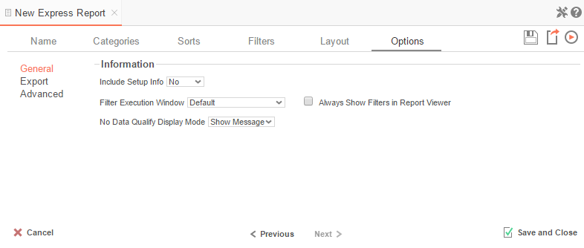
- From the 'Include Setup' menu, select Top or Bottom to display the data categories, sorts, and filters at either the beginning or end of the report.
- Select which type of Filter menu to display when executing a report that has prompt-for-value filters.
  - Default – Display the default type of filter execution window.
  - Standard – Display the standard filter execution window.
  - Simple with Operator – Display a simplified filter execution window that only allows the operator and value to be changed.
  - Simple without Operator – Display a simplified filter window that only allows the filter value to be changed.
- Check 'Always Show Filters in Report Viewer' to show the filter menu and allow changes to be made each time the report is run.

Export Options
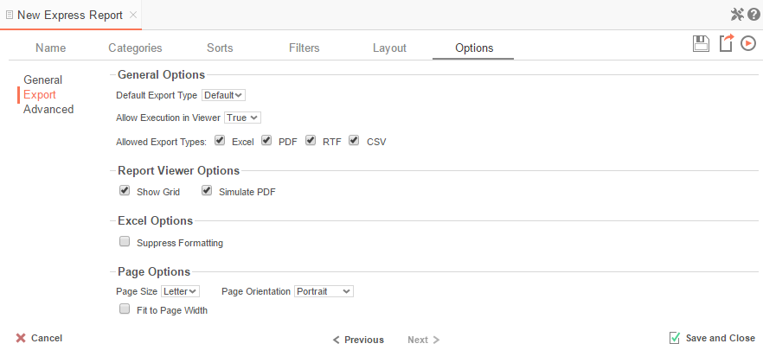
General Export Options
- Use the Default Export Type drop-down to specify the default format for the report.
- Output types may be disabled by unchecking the respective 'Allowed Export Types' box.
Report Viewer Options
- Uncheck 'Show Grid' to disable grid lines.
- Uncheck 'Simulate PDF' to prevent the report from appearing as though it were on a page.
Excel Options
- Check 'Suppress Formatting' to prevent the report formatting from exporting to Excel.
Page Options
- Specify the size of the report in the 'Page Size' drop-down. Default is Letter.
- Set the orientation for the report in the 'Orientation' menu. Default is Portrait.
- Check 'Fit to Page Width' to scale all columns to fit the width of the page.

Advanced Options
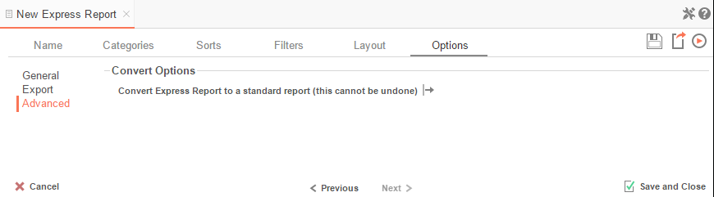
In the Advanced Options an Express Report can be converted to a Standard Report.
IMPORTANT. This CANNOT be undone.
- Press the 'Convert simple report to a standard report' button to convert an Express Report to a Standard Report.

New Standard Report Wizard
The New Standard Report Wizard is an interactive tool which will walk through the process of creating a new standard report. All of the selections made in the New Standard Report Wizard can be modified in the Report Designer after the report has been created.
To navigate the wizard, either select the desired tab, or use the and buttons.
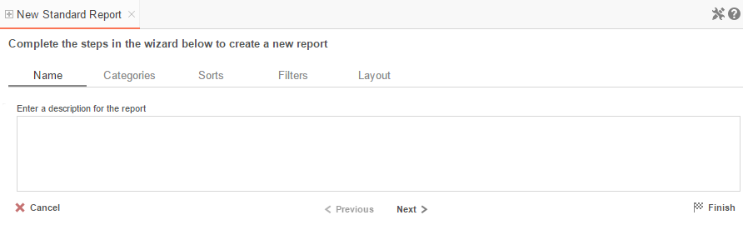
The New Report Wizard has five sub tabs. The Name and Categories tabs must be completed while the other tabs are optional.

Name Tab
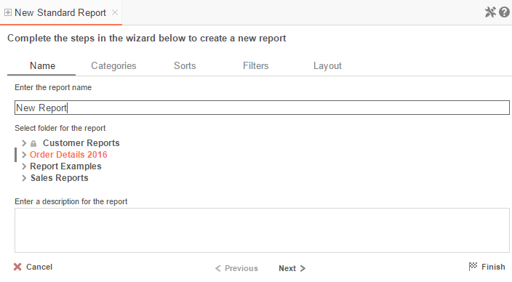
In the Name tab, enter a report name and select the Folder to save the report.
The report name can be up to 255 characters long. Avoid special characters such as ? : / \ * “ < >.
A report's description appears at the bottom of the Main Menu when it is selected. You may also search by a report's description text.
You cannot create a report inside a folder that is read-only ().

Categories Tab
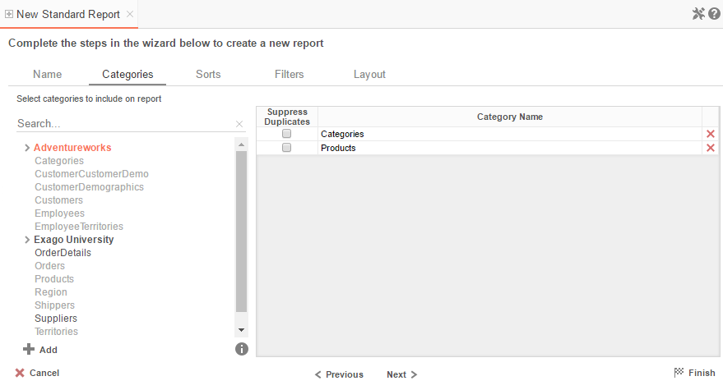
In the Categories Tab, select the Data Categories that you would like to have access to on the report. It is important to understand two terms: Data Category and Data Field.
Data Category – A Data Category is a data object that has several attributes. E.g. Orders is a category; each order has an ID, a date, a customer, etc.
Data Field – A Data Field is a single attribute within a category. E.g. Orders.OrderID is numeric value that identifies a specific order.
- To add a Data Category, either drag and drop it to the selection pane, or select the Category and press the button, or double-click the Category.
- To search for a Data Category or folder, enter the terms into the search bar ().
- To see the Data Fields in a Data Category, select the Category and press the info button ().
- Check the 'Suppress Duplicates' box to suppress any repeated records from that Category.
- To remove a Data Category, press the delete button ().

Sorts Tab
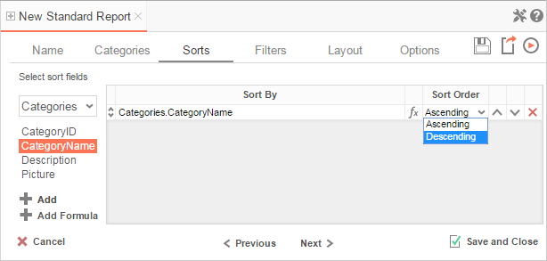
In the Sorts Tab, specify which Data Fields will be used to determine the order of data on the report.
- To sort by a Data Field, either drag and drop it to the selection pane, or select the Data Field and press the button, or double-click the Data Field.
- To sort by a Formula, press the button. To edit an existing formula, press the Formula Editor () button. See Sorting by Formula for more information.
- You can order each sort in Ascending (A-Z, 0-9) or Descending (Z-A, 9-0) order.
- Use the up () and down () arrows to indicate the sort priority.
- To remove a sort, press the delete button ().

Filters Tab
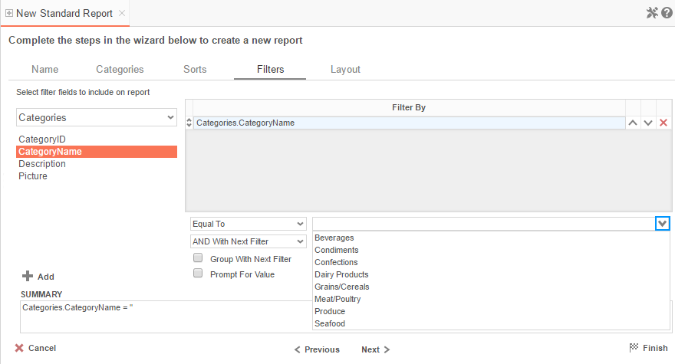
In the Filters Tab, create statements that will be used to filter the data when you run the report.
There is no limit to the number of filters that can be defined. Filters can be numeric (up to eight decimals) or alphanumeric.
- To filter by a Data Field, either drag and drop it to the selection pane, or select the Data Field and press the button, or double-click the Data Field.
- Use the up () and down () arrows to indicate the filter priority.
- To remove a filter, press the delete button ().
- Set the operator (Equal To, Less Than, One Of, etc.) by selecting it from the operator drop-down.
- Set the filter value either by entering it manually or by selecting a value from the drop-down. If the Data Field is a date, the calendar and function buttons can be used to select a value.
- Check 'Prompt for Value' to allow the filter to be modified at the time the report is run.
- Select 'AND With Next Filter' to require that the selected filter and the one below it both evaluate to true. Choose 'OR With Next Filter' to require that either be true.
- Check 'Group With Next Filter' to specify the precedence of the filters. Filters can be nested indefinitely by using the following keyboard shortcuts while a filter is selected:
  - Ctrl + [ adds an open-parenthesis before the selected filter.
  - Ctrl + ] adds a close-parenthesis after the selected filter.
  - Ctrl + Shift + [ removes an open-parenthesis from before the selected filter.
  - Ctrl + Shift + ] removes a close-parenthesis from after the selected filter.

Layout Tab
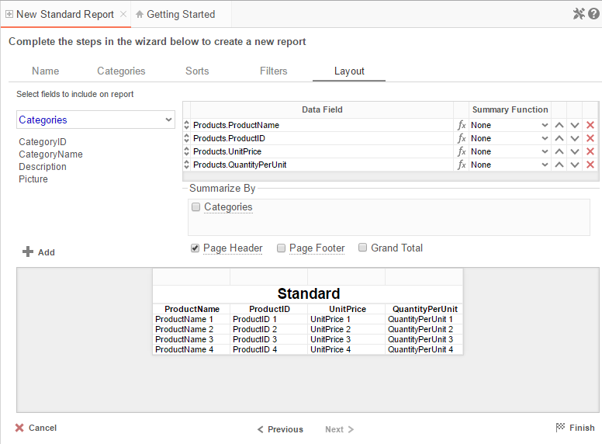
In the Layout Tab, select the Data Fields that will appear on the report. For each Data Field chosen, the report will automatically create a column header and place the Data Field in the detail section. Additionally, subtotals, grand totals, and a page header/footer can be created.

Display Data
- To place a Data Field on the report, either drag and drop it to the 'Data Field' column, use the button, or double-click the field.
- Use the up () and down () arrows to indicate the order the Data Fields should appear on the report. The Data Field at the top will appear on the report as the left-most column.
- The Summary Function column is used to make subtotals and grand totals. See Subtotals and Grand Totals for more information.
- To remove a Data Field, press the delete button ().
For each Data Field added in the Sorts tab, a checkbox will appear in the 'Summarize By' box. Using the 'Summarize By' box you can display subtotals, grand totals, or headers for the values of a Data Field.

Subtotals and Grand Totals
- To display subtotals, check the box of the category you want subtotals for in the Summarize By box. Then, for each Data Field you want totaled, select a Summary Function.
- To display grand totals, check the Grand Total box. Then for each Data Field you want totaled, select a Summary Function.
Summary Functions | - Sum: Totals the all of the data in the Data Field.  - Count: Returns the number of rows in the Data Field.  - Average: Takes the mean of the data in the Data Field.  - Minimum: Displays the lowest value in the Data Field.  - Maximum: Displays the highest value in the Data Field.

Data Headers
Each Data Category in the Sorts tab will appear in the 'Summarize By' box. To display a header for each value of a Data Field, click on the Data Category name and a Header Menu will appear.
- To include a Header, check the box 'Include Header at the beginning'. In order to select the text that will appear as the header value, use the Header dropdown to select a Data Field or use the Formula Editor Button () to create a formula.
- Use the 'Summarize by each unique' dropdown to specify if the header should repeat based on a specific field or fields within a Category.
- Check the box 'Include Total at the end' to have a subtotal created for this Category.

Page Header
To display information on the top of each page, check the 'Page Header' box. Click on 'Page Header' and the Page Header Menu will appear.
- Check the box 'Include Title at the top of every page' to display the name of the report on each page. If an image is also included, use the position dropdown to set where the title should appear and the number of columns it should span.
- Use the 'Change Image' button to upload an image to display at the top of each page. If a title is also included, use the position dropdown to set where the image should appear and the number of columns it should span.

Footers
To display information on the bottom of each page, check the 'Page Footer' box. Click on 'Page Footer' and the Page Footer Menu will appear.
- Check the box 'Include page number at the bottom of every page' to display the page number on each page. If an image is also included, use the position dropdown to set where the page number should appear and the number of columns it should span.
- Use the 'Change Image' button to upload an image to display at the bottom of each page. If the page number is also included, use the position dropdown to set where the image should appear and the number of columns it should span.

Preview
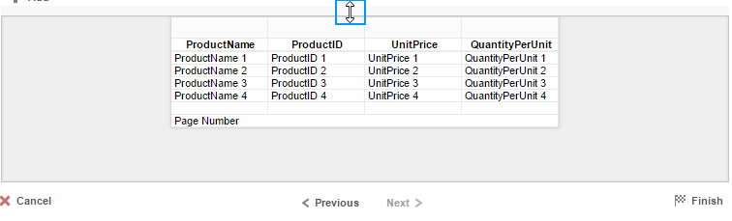
At the bottom of the Layout Tab, a preview will display how the report will appear based on the fields that have been added. You can increase/decrease the size of the preview or hide it altogether by dragging the top of the preview box.

New CrossTab Wizard
The New Crosstab Wizard is an interactive tool which will walk through the process of creating a new CrossTab report. All of the settings in the New CrossTab Wizard can be modified in the Report Designer after the report has been created.
To navigate the wizard, either select the desired tab, or use the and buttons.
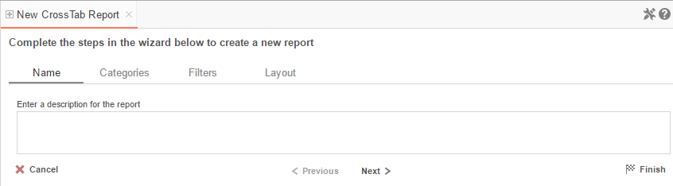
The New Report Wizard has four sub tabs. The Name, Categories, and Layout tabs must be completed while the other tabs are optional.

Name Tab
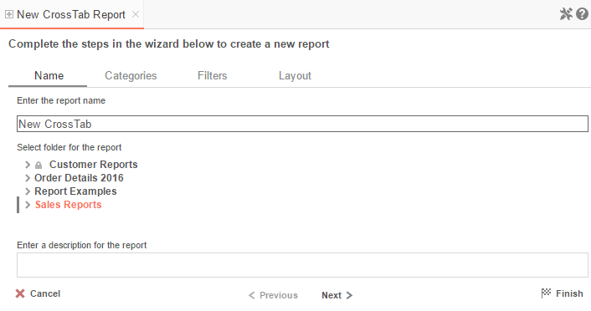

In the Name tab, enter a report name and select the Folder to save the report.
The report name can be up to 255 characters long. Avoid special characters such as ? : / \ * “ < >.
A report's description appears at the bottom of the Main Menu when it is selected. You may also search by a report's description text.
You cannot create a report inside a folder that is read-only ().

Categories Tab
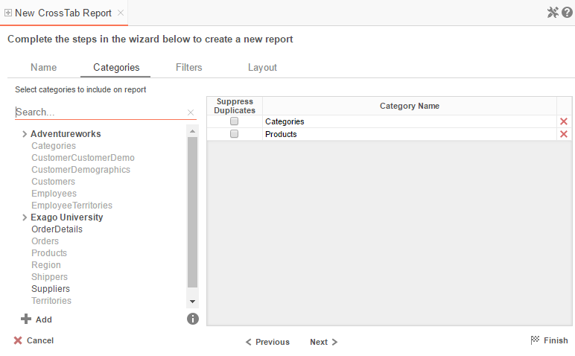
In the Categories Tab, select the Data Categories that you would like to have access to on the report. It is important to understand two terms: Data Category and Data Field.
Data Category – A Data Category is a data object that has several attributes. E.g. Orders is a category; each order has an ID, a date, a customer, etc.
Data Field – A Data Field is a single attribute within a category. E.g. Orders.OrderID is numeric value that identifies a specific order.
- To add a Data Category, either drag and drop it to the selection pane, or select the Category and press the button, or double-click the Category.
- To search for a Data Category or folder, enter the terms into the search bar ().
- To see the Data Fields in a Data Category, select the Category and press the info button ().
- Check the 'Suppress Duplicates' box to suppress any repeated records from that Category.
- To remove a Data Category, press the delete button ().

Filters Tab
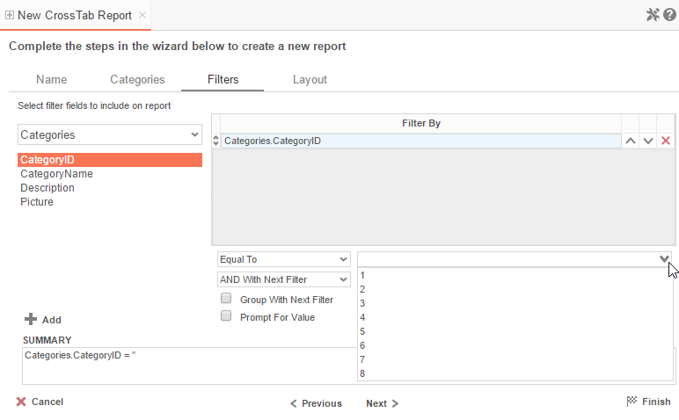
In the Filters Tab, create statements to filter the data at runtime.
There is no limit to the number of filters that can be defined. Filters can be numeric (up to eight decimals) or alphanumeric.
- To filter by a Data Field, either drag and drop it to the 'Filter By' column, use the button or double-click the field.
- Use the up () and down () arrows to indicate the filter priority.
- To remove a filter, press the delete button ().
- Set the operator (Equal To, Less Than, One Of, etc.) by selecting it from the operator drop-down.
- Set the filter value by either entering it manually or selecting a value from the drop-down. If the Data Field is a date, the calendar and function buttons can be used to select a value.
- Check 'Prompt for Value' to allow the filter to be modified at the time the report is executed.
- Select 'AND With Next Filter' to require that the selected filter and the one below it both evaluate to true. Choose 'OR With Next Filter' to require that either be true.
- Check 'Group With Next Filter' to specify the precedence of the filters. Filters can be nested indefinitely by using the following keyboard shortcuts while a filter is selected:
  - Ctrl + [ adds an open-parenthesis before the selected filter.
  - Ctrl + ] adds a close-parenthesis after the selected filter.
  - Ctrl + Shift + [ removes an open-parenthesis from before the selected filter.
  - Ctrl + Shift + ] removes a close-parenthesis from after the selected filter.

Layout Tab
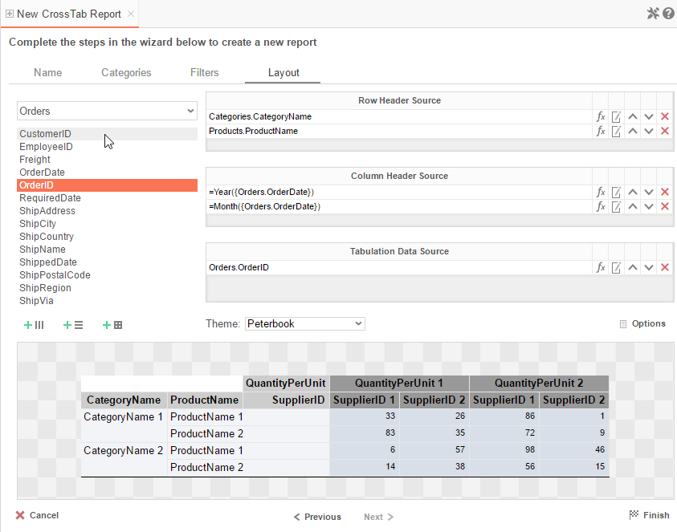

In the Layout Tab, design the CrossTab by moving Data Fields into the Row Header, Column Header, and Tabulation Data panels.

Row Headers
Row Headers expand a CrossTab vertically. A CrossTab has a row for each unique value of a Row Header.
E.g. If you were using sales data, you might select Row Headers Category.CategoryName and Products.ProductName to provide rows for each product grouped by category.
- To add a Row Header, either drag and drop the Data Field to the 'Row Header Source' panel or select the Data Field and press the button.
- Use the Formula Editor Button () to insert a formula into the Row Header.
- Use the Edit Header button () to open the header options menu.
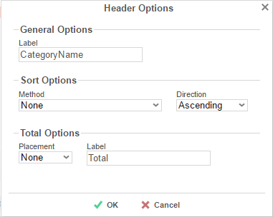
In the Header Options Menu, you can:
  - Set a Label for the Row Header. This label will appear at the top of the CrossTab.
  - Select a sorting Method and Direction:

    - None – Does not sort the Row Headers.
    - Header Value (Text) – Sorts the Row Header by its values as though they are text.
    - Header Value (Number) – Sorts the Row Header by its values as though they are numbers.
    - Tabular Totals – Sorts the Row Header by the totals of the Tabulation Data.
If there is more than one Row Header, the Header Options Menu for the top-most Row Header will have Options for subtotals of Tabulation Data.
  - Select where to display subtotals by using the Placement dropdown:

    - None – Does not display subtotals.
    - Top – Displays subtotals above the Tabulation Data for each Row Header value.
    - Bottom – Displays subtotals below the Tabulation Data for each Row Header value.
  - Set a Label for the subtotals.
- Use the up () and down () arrows to rearrange the order of the Row Headers.
- To remove a Row Header, press the delete button ().

Column Headers
Column Headers expand a CrossTab horizontally. A CrossTab has a column for each unique value of a Column Header.
E.g. If you were using sales data, you may have the Column Headers 'Year({Order.OrderDate})' and 'Month({Orders.OrderDate})' to provide columns for each month grouped by year.
- To add a Column Header, either drag and drop the Data Field to the 'Column Header Source' panel or select the Data Field and press the button.
- Use the Formula Editor Button () to insert a formula into the Column Header.
- Use the Edit Header button () to open the Header Options menu.
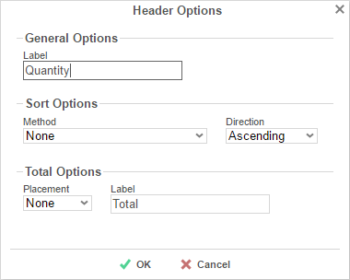
In the Header Options Menu, you can:
  - Set a Label for the Column Header to appear at the top of the CrossTab.
  - Select a Sorting Method and Direction:

    - None – Does not sort the Column Headers.
    - Header Value (Text) – Sorts the Column Header by its values as though they were text.
    - Header Value (Number) – Sorts the Column Header by its values as though they were numbers.
    - Tabular Totals – Sorts the Column Header by the totals of the Tabulation Data.
If there is more than one Column Header, the Header Options Menu for the topmost Column Header will have Options for subtotals of Tabulation Data.
  - Select where to display subtotals by using the Placement dropdown.

    - None – Does not display subtotals.
    - Left – Displays subtotals to the left of the Tabulation Data for each Column Header value.
    - Right – Displays subtotals to the right of the Tabulation Data for each Column Header value.
  - Set a Label for the subtotals.
- Use the up () and down () arrows to rearrange the order of the Column Headers.
- To remove a Column Header, press the delete button ().

Tabulation Data
Tabulation Data provides information when data exists for both the Column Header and Row Header values.
E.g. If you have a Row Header on Products and a Column Header on the Month, then Tabulation Data of Orders.OrderID may use the Count function to display how many orders contained each product each month.
- To add a Tabulation Data Source, either drag and drop the Data Field to the 'Tabulation Data' panel or select the Data Field and press the button.
- Use the Formula Editor Button () to insert a formula into the Tabulation Data.
- Use the Edit Tabulation button () to open the Tabulation Options menu.
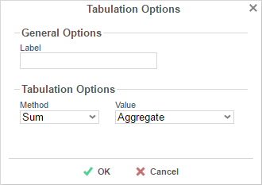
In the Tabulation Options Menu, you can:
  - Set a Label for the Tabulation Row to appear at the beginning of each row.
  - Use the Method dropdown to select the summary function to be applied to the Tabulation Data.
Summary Functions | - Sum: Totals the all of the data in the Tabulation Data.  - Count: Returns the number of rows in the Tabulation Data.  - Average: Takes the mean of the data in the Tabulation Data.  - Minimum: Displays the lowest value in the Tabulation Data.  - Maximum: Displays the highest value in the Tabulation Data.  - None: Displays the value in the Tabulation Data without doing any calculations.

  - Use the Value dropdown to select how the Tabulation Data should be displayed:
    - Aggregate: Display the result of the selected Method.
    - Percent of Row: Display the result of the selected Method as a percentage of the row total.
    - Percent of Colum: Display the result of the selected Method as a percentage of the column total.

- Use the up () and down () arrows to rearrange the order of the Tabulation Data.
- To remove a Tabulation Data Source, press the delete button ().

CrossTab Themes
The Theme dropdown can be used to quickly style the CrossTab using a predefined theme. Further styling can be done in the Report Designer.

CrossTab Options
Settings that affect the entire CrossTab are controlled in the CrossTab menu.
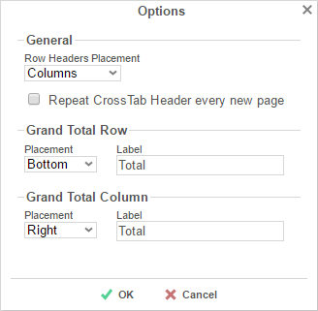
Using this menu, you can adjust the following settings:
General
- Use the Row Headers Placement dropdown to determine how the Row Headers are displayed.
  - Columns – Display the Row Headers in columns from left to right in the order they appear in the Row Header Source panel.
  - Hierarchical – Display Row Headers in a hierarchical structure using indentation to display their order.
- Check 'Repeat CrossTab Header every new page' to repeat Row Header labels and Column Headers on each new page.
Grand Total Row
- To get a total for each column, select 'Top' or 'Bottom' from the Placement dropdown and provide a label in the Label text box.
Grand Total Column
- To get a total for each row, select 'Top' or 'Bottom' from the Placement dropdown and provide a label in the Label text box.

Preview
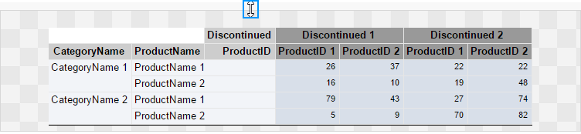

At the bottom of the Layout Tab, a preview will display how the Crosstab will appear based on the fields that have been added. You can increase/decrease the size of the preview or hide it altogether by dragging the top of the preview box.

Searching Reports

To search for a specific report, enter your search terms in the search box in the Main Menu. All reports that contain one or more of the search terms in their names will appear.
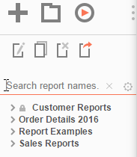
To cancel your search and return to a complete list of reports, press the Clear button ().
To expand your search to include report descriptions, press the Settings button () and check the 'Include Description (slower) ' box.
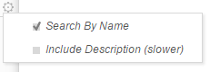

Folder Management

If you do not see a Manage Folders button in the Main Menu, then you do not have folder management privileges and should contact your administrator.
In the Main Menu, press the Manage Folders button. A drop-down menu will appear:
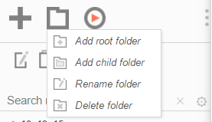

Add root folder: Add a new folder at the base of the directory.
Add child folder: Add a new folder within the selected folder.
Rename folder: Rename the selected folder.
Delete folder: Delete the selected folder. The folder must be empty.
A folder marked read-only () cannot be modified.

Editing Reports
To edit an existing report:
On the Main Menu, select the report you want to edit and press the Edit button () or double-click the report.
- For Standard and CrossTab reports, the Report Designer will open in a new tab.
- For Express Reports, the Express Report Wizard will open in a new tab.
- For Chained Reports, the Chained Report Wizard will open in a new tab.
- For Dashboards, the Dashboard Designer will open in a new tab.
You cannot edit reports marked read-only (). You can duplicate a read-only report into an unlocked folder and edit the duplicate.

Report Designer
The Report Designer can be used to add data, charts, formulas, sorts, filters and many other features to a report.
The Report Designer has three parts: the Design Grid, the Data Menu and the Toolbar.
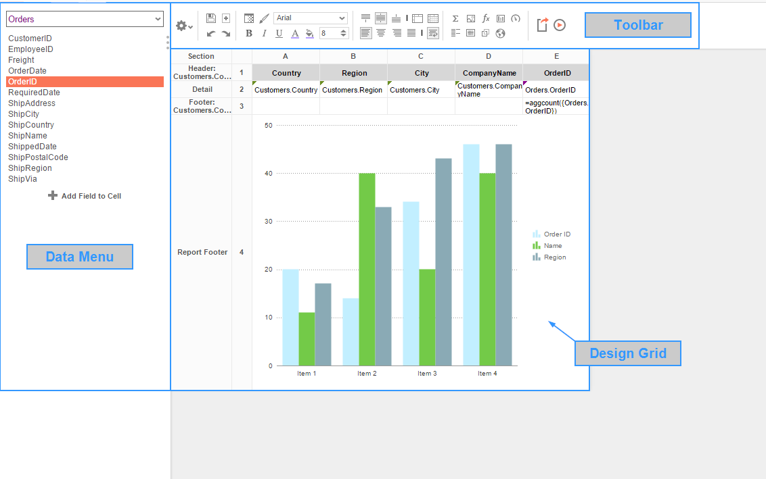

Design Grid
In the design grid, you can:
- Add and delete rows, columns, and sections.
- Enter Data Fields, text, and formulas.
- Drag and drop data and text into different sections, rows, or columns.

Data Menu
Using the data menu, you can:
- Drag and drop Data Fields onto cells in the report.
Press the splitter icon ( ) to hide the data menu.

Toolbar
Using the toolbar, you can:
- Rename the report.
- Add, modify, or remove sorts and filters.
- Format cells' font, font size, alignment, color, and borders.
- Use the Formula Editor to create complex functions.
- Insert charts, gauges, and images.
- Link reports, allowing users to drilldown for more detail.
- Save the report.
- Run the report in the Report Viewer.
- Export the report to Excel, CVS, RTF, or PDF.
- Add or remove Data Categories from the report.
- Add Action Events.

Design Grid
In the design grid, you can:
- Add and delete rows, columns, and sections.
- Enter data fields, text, and formulas.
- Drag and drop fields into different sections, rows, or columns.

Sections
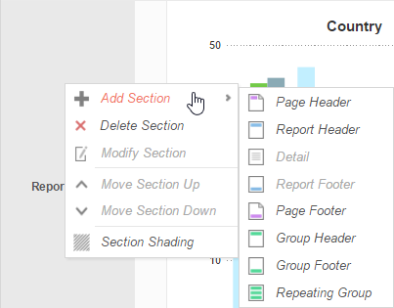
Sections dictate how the data appears in a report. There are five types of sections: page, report, details, group, and repeating group.
Page Header & Page Footer – The rows in the Page Header section appear at the top of every page of a report. Typically, the Page Header section is used to designate column headers for a report. The rows in the Page Footer section appear at the bottom of every page of a report. Typically, the Page Footer sections are used to display the page number and/or confidentiality notices for a report.
Page Headers and Page Footers are not intended to perform calculations or display data fields. For this reason, a Page Header populated with a data field will only return the first line of data in that field; a Page Footer will return only the last line of data.

If you are printing a report, remember that Excel output does not have pages. Page Headers will appear only once at the beginning of the report. Reports run via the Report Viewer will display Page Headers similarly unless 'Simulate PDF' is checked in the Options menu.
Report Header & Report Footer – The rows in the Report Header appear at the beginning of a report. Typically, these rows display the title of a report. The rows in the Report Footer appear at the end of a report. Typically, the Report Footer displays grand totals and summary information for the report.
Detail – The Detail section is the main section of most reports. When a report is executed, the Details Section creates a row for each element in the Data Categories. For example, if the Detail section contains the Data Field Orders.OrderId, the report will display each Order Id on a separate row.
Group Header & Group Footer – Group Header/Footer sections require a sort on a Data Field or formula. The rows in a Group Header section will appear above the Detail section for each unique value of the sorted item. Typically, Group Header sections are used to display data as labels. For example, a report may contain a Group Header on Orders.OrderDate and display Orders.OrderId in the Detail section. The output would display each date with orders that occurred on that date below them.
The rows in a Group Footer section will appear below the Detail section for each unique value of the sorted item. Typically, Group Footer sections are used to calculate subtotals. For example, a report may contain a Group Footer on Orders.OrderDate which displays the number of orders made on each date.
Repeating Groups – Repeating Groups require a sort on a Data Field or formula. Repeating Groups have their own header, details and footer subsections. Repeating Groups should only be used when the data has multiple one-to-many relationships and each should be rendered completely before the other.
(E.g. Each Professor can teach multiple classes and advise multiple students. For each professor you want to see all the classes they teach and then all the students they advise.)

Using Sections
Sections can be added, deleted, modified, moved, and assigned shading.
Adding Sections

- Click anywhere in the Section Column.
- Hover your mouse over 'Add Section', then select the type of section to add.

Deleting Sections

- In the Section Column, click on the section to delete.
- Press 'Delete Section'.

Modify Sections (Group Header/Footers and Repeating Groups)

- In the Section Column, click on the section to modify.
- Press 'Modify Section'. This will bring up a 'Modify Group Section' Menu.
- Select the desired Data Field from the dropdown menu.
- Press .

Section Shading

- In the Section Column, click on the section to Shade.
- Press 'Section Shading'. This will bring up the Section Shading menu.
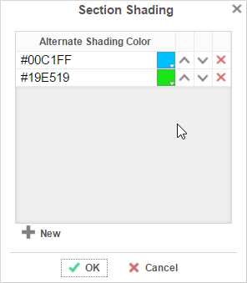
- Press to add a color to the shading.
- Press the color box and select a color in the dropdown; Or enter a hex value.
- Press .

Columns and Rows
Columns and rows of cells can be added, modified, or removed.

Columns
- To select a group of columns, hold the SHIFT key and then click the beginning and ending column.
- Non-contiguous columns can be selected by holding the CTRL key and clicking the desired columns.
- A column can be resized by dragging its right edge horizontally.
- Clicking on a column (or selected group) will display a menu where you can:
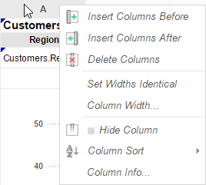

  - Insert a new column.
  - Delete the selected column.
  - Set all selected column widths to be identical.
  - Hide the selected column.
  - Set Column Info to make the label the column and/or make it sortable within the Report Viewer.

Sorting by Columns in the Report Viewer
While viewing reports in the Report Viewer, a user can click the bar at the top of the report to sort by a column. For Express Reports this is handled automatically, but it must be enabled for Standard and Crosstab Reports.

To make a column sortable:
- Click on the column and select 'Column Info…'
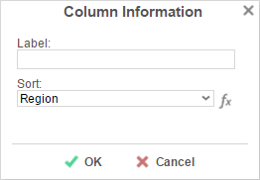
- Provide the column with a Label that will appear in the Interactive Report Viewer Dock.
- From the Sort dropdown select the Data Field to be used for sorting, or provide a formula by pressing the formula button ().

Column Sorts are applied AFTER any sorts defined in the Sorts Menu.
- Click on the column again to set a default sort direction.
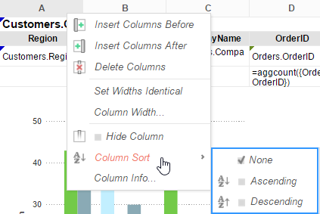

Rows
- To select a group of rows, hold the SHIFT key, then click the top and bottom rows of the area you wish to select.
- Non-contiguous rows can be selected by holding the CTRL key and clicking the desired rows.
- A row can be resized by dragging its bottom edge vertically.
- Clicking on a row (or selected group) will display a menu where you can:
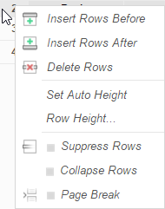
  - Insert a new row.
  - Delete the selected row.
  - Set the selected row's height to be automatically controlled.
  - Suppress the selected row from appearing on the report.
  - Insert a page break (See Using Page Breaks)

Cells
Cells are the containers for all the information in a report. Cells may contain text, images, charts, or links to other reports.
- To enter text, double-click the cell, and a text field will appear.
- To select cells, either click the cells or use the arrow keys to toggle from one to the next.
- Groups of cells can be selected by holding the SHIFT key and clicking on another cell. All the cells in between the two will be selected.
- Non-contiguous cells can be selected by holding the CTRL key and clicking the desired cells.
- A cell can be copied by holding the CTRL key, then dragging and dropping it into a new cell.
- Adjacent cells can be merged and unmerged using the Merge/Split Cell buttons in the Toolbar:
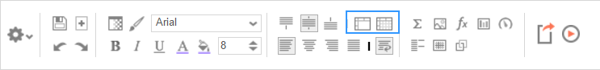

Using Page Breaks
For a Page Break to occur at the beginning of each element of a Data Field, place a page break on the top row of the Group Header Section for that Data Field. See Sections for more detail on Group Headers Sections.
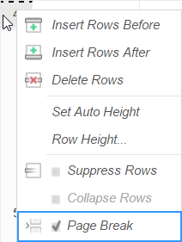

Collapsible Rows
Group Sections can be set to display collapsed by default in the Report Viewer. This causes the contents of the section to be suppressed and individually expandable for each change in the Header. Collapsible rows are only supported in the Report Viewer. Export formats will ignore Collapsible Rows.

Left-click on an arrow next to a Collapsible Row to expand or collapse the group:
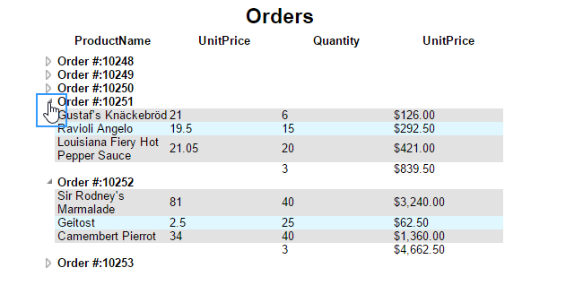
Right-click on an arrow next to a Collapsible Row to see additional display options:
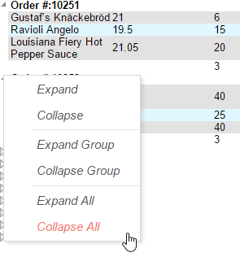
Expand will expand the selected top-level group. (This is the same as left-clicking an arrow.)
Collapse will collapse the selected top-level group. The state of the sub-groups is preserved.
Expand Group will expand the selected top-level group and all sub-groups within that group.
Collapse Group will collapse the selected top-level group and all sub-groups within that group.
Expand All will expand every group and sub-group on the page.
Collapse All will collapse every group and sub-group on the page.

Creating a Collapsible Row
To create a Collapsible Row, first open the desired report in the Report Designer. Click on the desired row number in a Group Header Section, and select Collapse Rows in the dropdown menu:
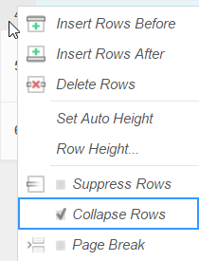

A Collapsible Row is indicated by an arrow at the bottom right of the row number cell.

Properties of a Collapsible Row
Collapsible Rows have the following properties when a report is viewed:
- Collapsible Rows display as collapsed whenever a report is run or altered using the Interactive Report Viewer.
Collapsed or expanded state cannot be saved to User Report preferences.
- Page Breaks below a Collapsible Row are ignored.
- Expanding a Collapsible Row will not alter the Report pagination.

See Sections for more detail on Group Headers Sections.
See Interacting with the Report Viewer for more information the Interactive Report Viewer.

Data Menu
The data menu holds the data that you can put into a report.

Adding Data Fields to a Report
To add a Data Field to a report, select the appropriate Data Category at the top of the menu. Drag and drop the Data Field from the menu to a cell in the Design Grid.
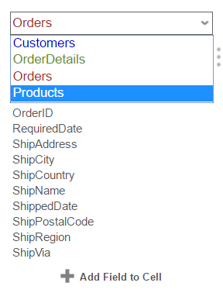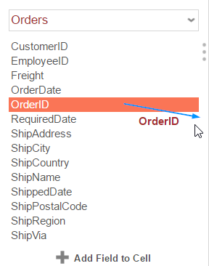
Alternatively, a Data Field can be put into a cell by typing Data Category Name (dot) Data Field Name. (E.g. Orders.OrderID).
To access other Data Categories, see the section on Data Categories.

Toolbar
The toolbar contains the buttons and menus used to modify the report. Modifications can include aesthetic formatting, inserting formulas and images, linking reports, and much more.
The toolbar begins with a drop-down menu. This menu controls changes, such as renaming or filtering, that affect the entire report.
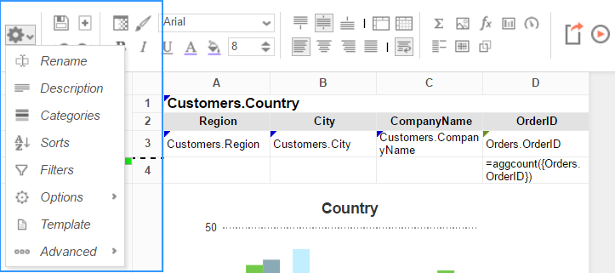

Saving Reports
The report can be saved by pressing the save button (). The report will also save automatically any time it is run or exported.

Undo/Redo
Actions can be undone by pressing the undo button () or using the keyboard shortcut Ctrl+Z. Undone actions can be redone by pressing the redo button () or using the keyboard shortcut Ctrl+Y.

Font & Alignment Options
The text of each cell can be formatted using drop-down menus and buttons in the toolbar. A cell or multiple cells must be selected for these tools to be used.

Font
- To change the font, use the font drop-down menu (). The font names appear in the style that they represent.
- The buttons B, I, and U, make the font bold, italicized, and underlined, respectively.
- Use the menu to set the font size.

Color
- To change the text color, press the Foreground Color button () and select a color or enter a hex value into the Foreground box. Press the clear button () to revert to the default color.
- To change the background color, press the Background Color button () and select a color or enter a hex value into the Background box. Press the clear button () to revert to the default color.

Alignment
- Text can be aligned to the top, center, or bottom of a cell using the vertical alignment buttons.
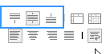
Text can be centered, justified, or aligned to the left or right of a cell using the horizontal alignment buttons.
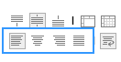
- The wrap text button () will begin a new line if the text is longer than the width of the cell.

Formatting Cells
Press the format cells button () to open the Format Cells window. The window has three tabs: Number, Border, and Conditional.
Cell formatting can be copied using the Format Paintbrush. Select the format you want to copy, press the format paintbrush button (), then click the cell you want to apply the formatting to.

Number
The Number Tab allows you to set the format of numbers and dates.
- General:
  - General format automatically applies formatting to cell values.
- Number:
  - Using the arrows, you can specify how many decimals to display. You can also set the symbol to separate decimals from whole numbers.
  - Check 'Use 1000 Separator' to separate every 3 digits. You can set which symbol is used to separate digits.
  - Check 'Use Currency Symbols' to have the currency sign appear in front of the number.
  - Check 'Append Percent Sign' to have the symbol '%' appear after the number.
  - Check 'Blank When Zero' to leave the cell(s) blank if the value is zero.
  - Check 'Show Negative Symbol' to have a negative sign display in front of negative numbers.
  - Check 'Show Parenthesis' to put ( ) around negative numbers.
  - Use the Color picker to make negative numbers a specific color.
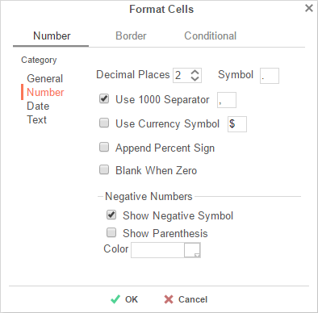
- Date:
  - From the menu, select a time/date format. (E.g. MM-yy will display a date as 'Jun-97').
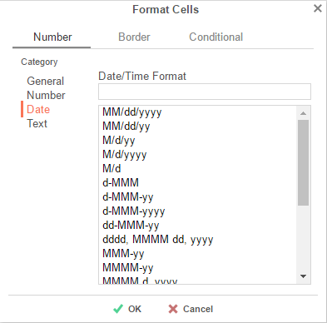
- Text format: Formatting does not apply to cell values.

Border
The Border tab allows you to alter the width and color of the cell edges.

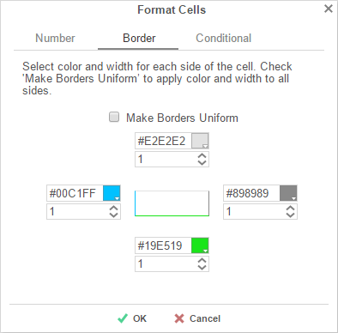
- Uncheck 'Make Borders Uniform' to modify specific edges.
- To widen the borders, either key in a value or use the arrows in the width box.
- To change the color, either select a color from the drop-down or enter a Hex value.

Conditional Formatting/Suppression

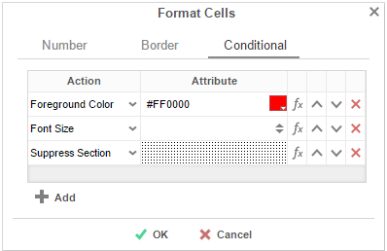
The Conditional tab allows you to set or modify the format of a cell based on a formula you create.

- Press the button to create a new conditional format. Each format must have an Action and a Formula that evaluates to True or False. Some Actions require an Attribute such as a color or a number.
- Select an Action from the dropdown. This action will occur if the formula evaluates to True. Actions include:
  - Foreground Color –Sets the foreground color of the cell.
Attribute: Color
  - Background Color – Sets the background color of the cell.
Attribute: Color
  - Font Size – Sets the size of the text.
Attribute: Number
  - Bold – Bolds the text of the cell.
No Attribute
  - Italic – Italicizes the text of the cell.
No Attribute
  - Underline – Underlines the text of the cell.
No Attribute
  - Horizontal Alignment – Aligns the text of the cell horizontally.
Attributes: Left, Center, Right, or Justify
  - Vertical Alignment – Aligns the text of the cell vertically.
Attributes: Top, Bottom, or Middle
  - Suppress Row – Suppresses the row the cell is in.
No Attribute
  - Suppress Section – Suppresses the entire section that contains the cell.
No Attribute
  - Page Break – Starts a new page.
No Attribute
- Press the Formula Editor Button () to set the condition for the formula.
The formula must evaluate to True or False. For conditional formatting, the Formula Editor will have an add button. This button adds the function CellValue() to the formula. This function returns the value of the cell that conditional format is being applied to.

The formula is still calculated with respect to the section of the cell. For example, for a cell in a report footer, the formula {Order.Profit} > 1000 will return True if the last Order of the detail section profited more than 1,000. To make the condition see if the total profit was greater than 1,000 use the formula 'Sum({Order.Profit})>1000'.
- Use the up () and down () arrows to change the priority of the formats. If two formats share a common action and are both True, then the lower condition will be applied.
- To remove a format, press the delete button ().

AutoSum
To quickly get a total on a Data Field, place the field in a Report or Group Footer and press the AutoSum button (). Alternatively, a sum can be created with the aggSum formula. See Formulas for more information.
Do not use AutoSum on a cell with an aggregate formula such as aggSum.
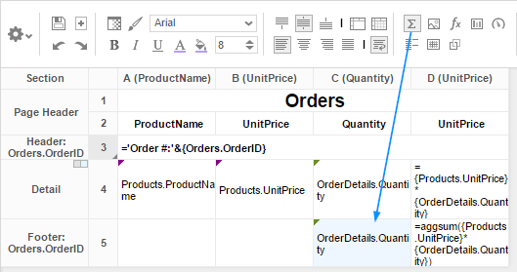

Images
Insert an image from your computer to a cell using the Insert Image button (). This opens the Insert Image window. Select the image you would like to insert, and press .

Formulas
Complex calculations can be done using Formulas. A formula can be added to a cell manually or by using the Formula Editor. To open the Formula Editor, press the Formula Editor Button ().

Suppress Duplicates
You can suppress duplicate values of a Data Object from being displayed. Select the cell and press the Suppress Duplicate button (). E.g. Compare the following reports:
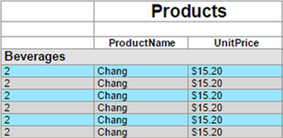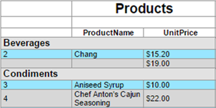

Chart Wizard
To insert a chart into a cell, select a Group Footer or Report Footer cell and press the ' Chart Wizard' button. The Chart Wizard dialog will open. Use the tabs on top or the navigation buttons on the bottom to navigate the wizard.
Select a chart type, then press 'Next' to continue.
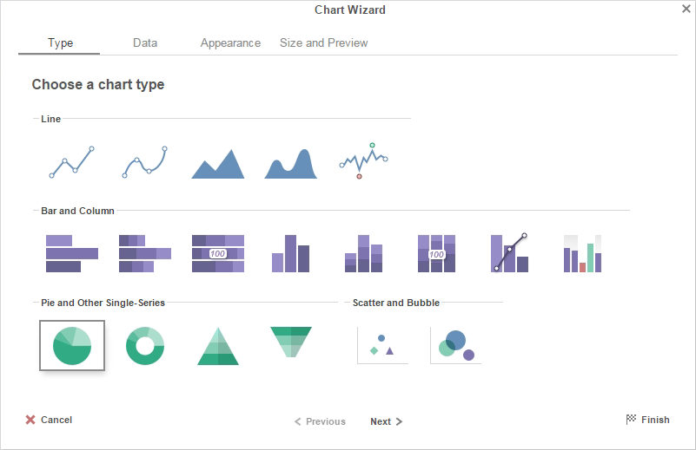
The Chart Wizard contains four tabs:
Type | • | Data | • | Appearance | • | Size and Preview

Type
The Type Tab lays out all the available types of charts you can create. The following chart types are supported:
Click on a chart for more information
Line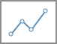 | Spline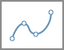 | Area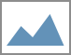 | Spline Area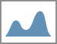 | Spark Line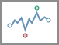
Bar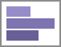 | Stack Bar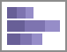 | Stack Bar 100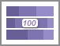 | Column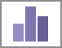 | Stack Column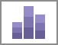 | Stack Col. 100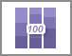 | Pareto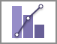 | Spark Column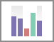
Pie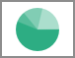 | Doughnut | Pyramid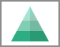 | Funnel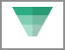
Scatter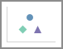 | Bubble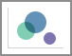

Line, Spline, and Area

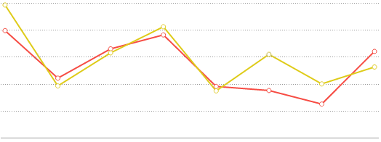
Line charts display a series of data points on a grid, connected by straight lines. They are often used to display a trend in data over intervals of time. Lines are not necessarily representative of any data between connected points. Line charts can be single-series (one line), or multi-series (multiple lines). On a multi-series chart, lines are differentiated by color.
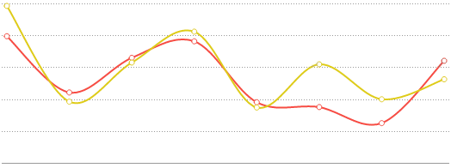
Spline charts are a stylistic variation of a Line chart. Data points are connected by an interpolated curve. They are often used to display a trend in data over time, with estimated data between points. Spline charts are created in the same manner as Line charts.

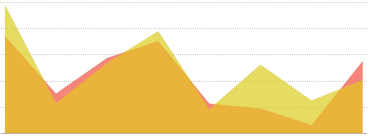
Area charts are a variation of a Line chart. The area below each line is colored to represent cumulative data. They are often used to compare cumulated totals over time. On a multi-series chart, each series is given a distinct color, and the colors blend where series areas overlap. Area charts are created in the same manner as Line charts.

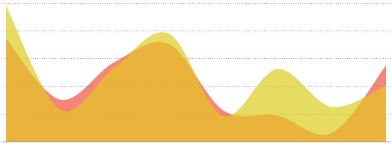
Spline area charts are a stylistic variation of an Area chart. Data points are connected by an interpolated curve, and the area below each curve is colored to represent cumulative data. They are often used to compare cumulated totals over time, with estimated data between points. On a multi-series chart, each series is given a distinct color, and the colors blend where series areas overlap. Spline area charts are created in the same manner as Line charts.

Bar and Column

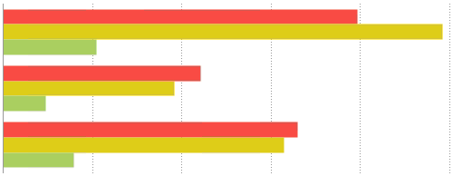
Bar charts use rectangular bars that extend horizontally to show comparisons between categories. Each data value is represented by a bar, the length of which represents its quantity. Bar charts can be single-series (one bar per category) or multi-series (multiple bars per category, each series differentiated by color).

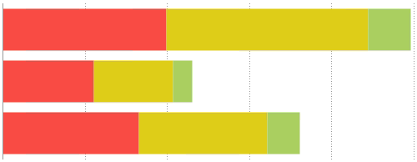
Stack bar charts are a variation of a multi-series Bar chart. Each bar is a category of data values stacked additively. The length of the bar represents the total quantity of the category, and each segment represents the data value in proportion to the total. Each series is differentiated by color. Stack bar charts can be created in the same manner as multi-series Bar charts.
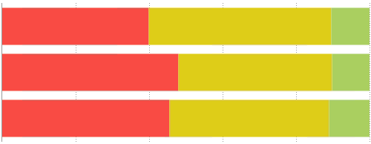
Stack bar 100% charts are a variation of a multi-series Bar chart. Each bar is a category of data values stacked additively. The length of the bar is fixed to 100%, and each segment represents the data value as a percentage of the total. Each series is differentiated by color. Stack bar 100% charts can be created in the same manner as multi-series Bar charts.

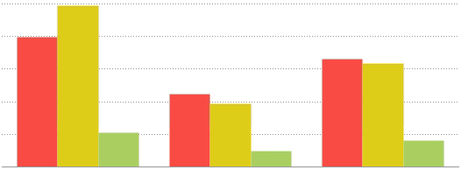
Column charts are a stylistic variation of a Bar chart. They use rectangular columns which extend vertically to show comparisons between categories. Each data value is represented by a column, the height of which represents its quantity. Column charts can be single-series (one column per category), or multi-series (multiple columns per category, each series differentiated by color). Column charts are created in the same manner as Bar charts.

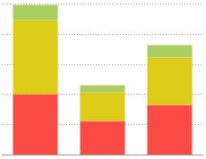
Stack column charts are a variation of a multi-series Column chart. Each column is a category of data values stacked additively. The length of the column represents the total quantity of the category, and each segment represents the data value in proportion to the total. Each series is differentiated by color. Stack column charts can be created in the same manner as multi-series Bar charts.

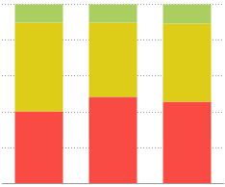
Stack column 100% charts are a variation of a multi-series Column chart. Each column is a category of data values stacked additively. The length of the column is fixed to 100%, and each segment represents the data value as a percentage of the total. Each series is differentiated by color. Stack column 100% charts can be created in the same manner as multi-series Bar charts.

Pie, Doughnut, Pyramid, and Funnel

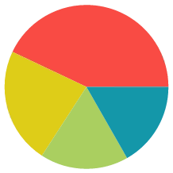

Pie charts are used to show the relationship of individual data fields in a series as portions of the total data in the series. They are shaped like a circle divided into colored "slices," each representing a data value. The area of each slice of the pie is proportional to the quantity it represents.

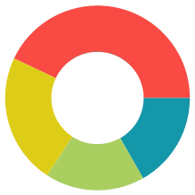

Doughnut charts are a stylistic variation of a Pie chart. They are ring shaped with a circular "hole" in the center like a doughnut. The ring is divided into colored "slices," each representing a data value. The area of each slice is proportional to the quantity it represents. Doughnut charts are created in the same manner as Pie charts.

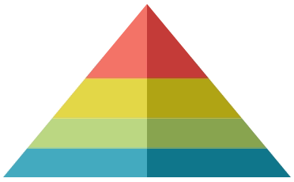
Pyramid charts are a variation of a Pie chart. They are often used when it is necessary to show a hierarchical order of data as well as its quantity.

Each data value is represented by a vertically stacked "slice" of a triangle, the height of each proportional to the quantity it represents. The slices are stacked in sort order. The width of each slice corresponds to its order but has no relation to its quantity. Pyramid charts are created in the same manner as Pie charts.


Funnel charts are a variation of a Pie chart. They are often used to show stages in a process as a falling value or percentage.

Each data value is represented by a vertically stacked "slice" of a triangle, the height of each proportional to the quantity it represents. The slices are stacked in sort order. The width of each slice corresponds to its order but has no relation to its quantity. Funnel charts are created in the same manner as Pie charts.

Scatter

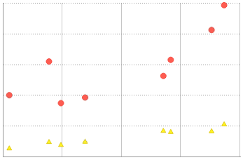

Scatter charts use pairs of data values as coordinates for points on a grid. They are often used to find relationships between two variables in a set of data. Scatter charts can be single-series (one set of points) or multi-series (multiple sets of points). On a multi-series chart, series are differentiated by point color and shape.

Bubble

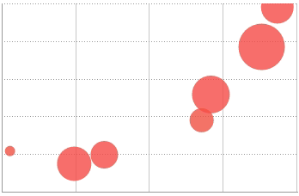
Bubble charts are a variation of a Scatter chart. They use pairs of data values as coordinates for "bubbles" on a grid, and a third data value for the size of the bubble. They are often used to find relationships between three variables in a set of data. Bubble charts can be single-series (one set of bubbles) or multi-series (multiple sets of bubbles). On a multi-series chart, series are differentiated by bubble color.

Pareto

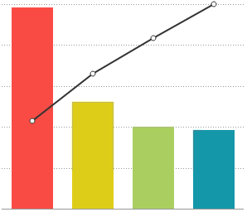

Pareto charts are a type of single-series chart generally used to highlight the most important element amongst a group. Pareto charts combine a Column chart, each column representing a data value sorted in descending order, with a Line chart, each point representing the cumulative percentage of the total.

Spark Line and Column

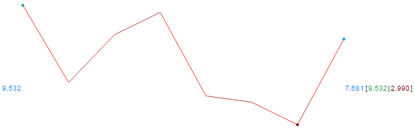
Spark line charts are a variation of a single-series Line chart. They are used to display continuous trends in data, usually with regard to time. Spark line charts have no grid or axes and instead rely on point labels and benchmark lines to provide reference.
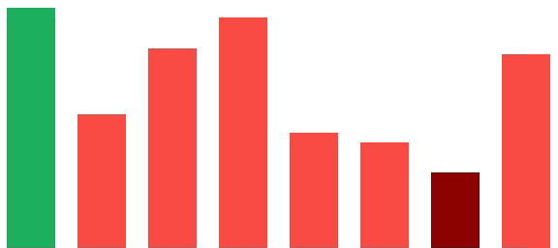
Spark column charts are a variation of a single-series Bar chart. They are used to show comparisons between data values. Spark column charts have no grid or axes, and instead rely on colors and benchmark lines to provide reference.

Data
The Data Tab is used to specify which cells are used as data values for the chart. You can also choose a sort order, as well as upper and lower boundaries for the data and axes. This tab is subdivided into two sections: Data for Chart and Other Options.
Data for Chart
This section contains fields to specify your chart data. You must fill out all the required fields before progressing. This section will contain different options depending on the selected Chart Type and Data Layout.
Use Layout 1 to build a chart one data point at a time. Each data point must contain a numeric Point Value and a Point Label. You can only create single-series charts using this layout.
- Add data points by pressing the button.
- Remove data points by pressing the Delete () button.
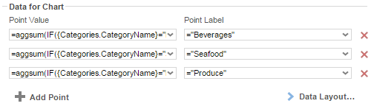
For scatter charts, "Point Value" and "Point Label" correspond to the Y and X-axis values, respectively.
Use Layout 2 when each category has a repeating group with a data point for each series value.
- Add series by pressing the button.
This button is disabled for single series charts.
- Remove series by pressing the Delete () button.
Default options:
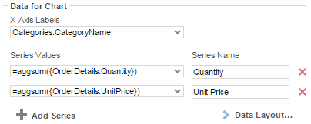
Scatter and Bubble Charts options:
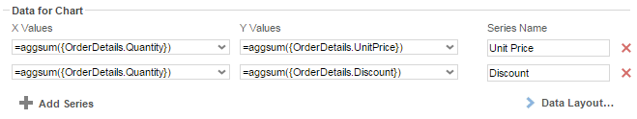
Additional Bubble Chart options:
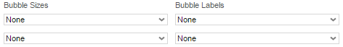
Use Layout 3 when each series is a repeating group which contains (at least) a data value cell and a data label cell.
Default options | Scatter & Bubble Chart options | Additional Bubble Chart options
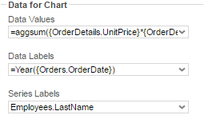 | 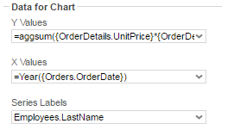 | 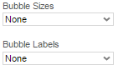

Data Layout
This dialog allows you to specify how your data is organized on the report.

Layout One

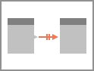
Use Layout 1 when you have a one-to-one relationship between your chart and data and you only wish to chart a single-series of data.
A One-To-One relationship means that for a table of data, there exists a relationship between your chart such that an element from your table can have at most one matching value on the chart. In practice, this means that your chart can only have one series of data. This is the simplest way to lay out your data, but also the most labor intensive. Stack and bubble charts are unsupported.
A common example of a one-to-one relationship is social security numbers. A person has only one social security number, and each social security number belongs to only one person.
Using this layout, you can build charts by plotting out data value/label pairs (or coordinate pairs) using pairs of (non-repeating) cells in the design grid:
([A1], [A2]) => Point (x,y)
([B1], [B2]) => Point (x,y)
Each cell must be written in Formula format, like so:
- Formula: =aggsum({Orders.OrderId})
- String: ="Beverages"
- Number: =34
- Cell reference: =[A4]
Use the Data Tab to select the pairs of cells for each point on your chart.

Layout Two
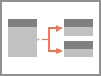
Use Layout 2 when you have a one-to-many relationship between your chart and data and have one or more cells representing each series of data. Single-series and multi-series charts can be created using Layout 2.
A One-To-Many relationship means that for a table of data, there exists a relationship between your chart such that an element from your table can have more than one matching value on the chart. Each such value is referred to as a series.
A common example of a one-to-many relationship is email addresses. A person may have more than one email address, but each email address belongs to only one person.
Using this layout, each series is represented by one or more group ("category") cells:
Series [A1]:
(Category 1, [A1]) => Point (x,y)
(Category 2, [A1]) => Point (x,y)
Series [B1]:
(Category 1, [B1]) => Point (x,y)
(Category 2, [B1]) => Point (x,y)
Use the Data Tab to select the cells for each series on your chart.
A category label cell is required for most chart types.

Layout Three
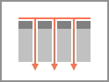
Use Layout 3 when you have a one-to-many relationship between your chart and data and have one cell for data values, one cell for labels, and optionally a cell with a series name for each value and label. Single-series and multi-series charts can be created using Layout 3.
Depending on the arrangement of your data, you can use this layout to build multi-series charts using only a single cell for each the data value, data label, and (optionally) series label:
This example uses a repeating group (Order Year), and a sort on an element (Employee Name) in the repeating group (see Sorts) to create a "category" group within a series group.
Series [B1].1:
(Category [A1].1, [C1].1) => Point (x,y)
(Category [A1].2, [C1].2) => Point (x,y)
Series [B1].2:
(Category [A1].1, [C1].1) => Point (x,y)
(Category [A1].2, [C1].2) => Point (x,y)
Use the Data Tab to select the data value, label, and series cells on your chart.
Charts created in an older software version exclusively support Layout 3.

Other Options
This section contains options for sorting data and setting data and axis bounds.
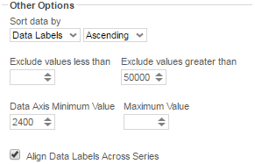
- Use the 'Sort data by' dropdown to specify the order of the chart data (categories and series).
  - Report Order – The chart will follow the order of the information on the report.
  - Data Labels – The chart will be sorted by the data labels (either alphabetically or numerically).
  - Data Values – The chart will be sorted by the data values.
  - You can sort data in Ascending (A- Z, 0-9) or Descending (Z-A, 9-0) order.
- To ignore values that are too large or too small, enter a value into 'Exclude values less/greater than' boxes.
- To manually set the axis values, enter a value into the 'Data Axis Minimum/Maximum Value' boxes.
- Check 'Align Data Labels Across Series' if you have multi-series data with common data labels among the series.

Appearance

The Appearance Tab contains options for customizing how the chart will look. This tab is subdivided into four sections: Colors, Labels, Other Features, and Advanced Features.
Colors
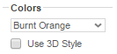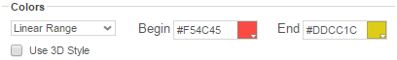
- Use the drop-down to select a color palette to apply to the report.
  - Specify a custom range of Colors by selecting the 'Linear Range' option. Click on the colored squares to open up a color picker, or type in custom hex values.
- Check the 'Use 3D Style' box to give your chart a three-dimensional look.

Labels
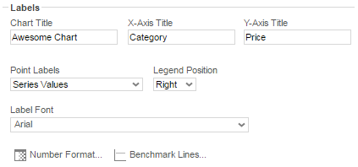
This section allows you to add labels to various elements of the chart.
Not every attribute is applicable to every chart type.
- Chart Title: Enter the text you want to appear in at the top of the chart.
- X-Axis Title: Enter the text you want to appear on the X-Axis (horizontal axis).
- Y-Axis Title: Enter the text you want to appear on the Y-Axis (vertical axis).
- Point Labels: Use this dropdown to select value labels for the points on the chart.
- Legend Position: Use this dropdown to specify where to display the legend.
- Label Font: Use this dropdown to specify the label font.
- Number Format: Specify how data and axis labels should be formatted.
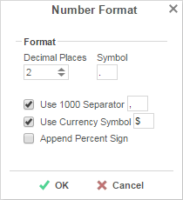
- Benchmark Lines: Add horizontal benchmark lines at specific sections of the chart.
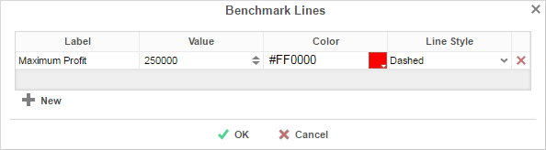
To add a benchmark line press thebutton.
  - Label: Enter the text you want to appear as the label of the benchmark.
  - Value: Specify the numeric value you would like to define as the benchmark. The benchmark line will display horizontally at this value.
  - Color: Use the color picker or type in a custom hex value to specify the color of the line.
  - Line Style: Specify either a Solid or Dashed line.
  - To remove a benchmark, press the Delete () button.

Other Features
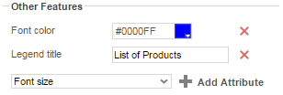
This section contains a list of common miscellaneous features that may be customized. The following features are supported:
Font color
Font size
Background opacity
Background color
Title alignment
Title font size
Title on top
Legend title
Title font size
Show border
Show tooltip
Subtitle
Subtitle font size

- To add a custom attribute, select one from the drop-down and press the button. Then use the picker or type a custom property into the text field.
- To remove a custom attribute, press the Delete () button.

Advanced Features
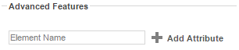
This section allows an experienced user to add Fusion Charts customizations.
This section is recommended for advanced users only. For a full list of advanced features, see Fusion Chart Attributes (web link). Not all features may be supported.
- To add an advanced attribute, type in the name of the attribute, and press the button. Then type a custom property into the text field.
- To remove an advanced attribute, press the Delete () button.

Size and Preview
The Size and Preview Tab allows you to change the size of the chart and see how it will appear on the report.
The chart preview uses placeholder data.
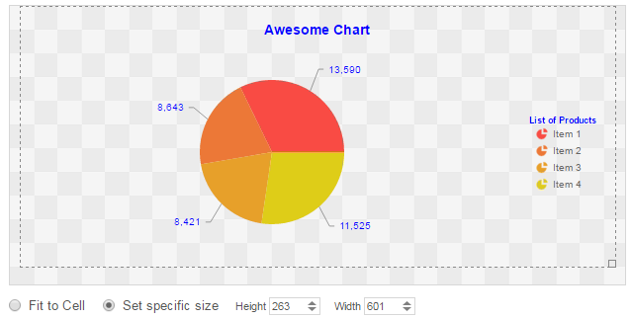
- You can change the size of the chart in one of three ways:
  - Click and drag the outer boundary of the chart.
  - Check the box for 'Set specific size' and type a custom Height and Width (in px) into the selection fields.
  - Check the box for 'Fit to Cell' and resize the chart cell on the Design Grid.

Maps
A Map can be displayed in a report to give a visual representation of geographic data. To insert a Map, select a cell and press the Insert Map button (). The Map Wizard will appear. The Map Wizard has three tabs: Type, Locations, and Data.
Maps should only be placed into a Group Header, Group Footer, Report Header or Report Footer section.

Type
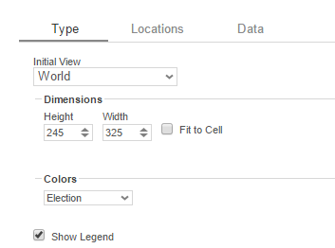
In the Type tab select the initial view, size, colors, and where to display the legend.
- Use the Initial View drop-down to select the location that initially displays on the Map. You may either select the world, a continent, or a country.
- There are three ways to set the size of the Map.
  - Enter the Height and Width in the dimension boxes.
  - Resize the chart by dragging the lower right corner in the preview.
  - Check the box 'Fit to Cell'.
- In the Colors drop-down, either select a color theme or specify a linear range of colors.
- Check 'Show Legend' to display the legend.

Locations

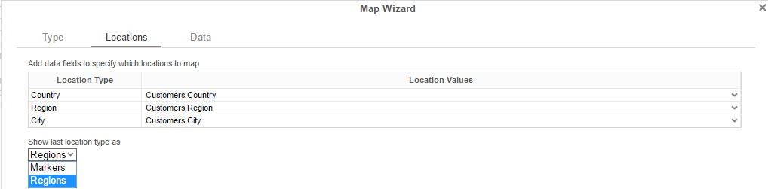

In the Locations Tab, specify which geographic locations should display on the Map.
- Use the Location Values drop-downs to select the cells that contain the geographic information for the Map. To utilize Region information, such as states/provinces, Country information must be provided. Similarly, City information requires Region and Country information.
- The 'Show last Location type as' drop-down specifies how to display the lowest level of information. You can either select circular markers (see image in Data Tab) or shaded geographic regions (see image below).

Data
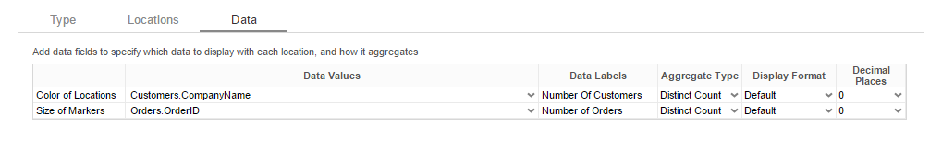
In the Data Tab, specify which data determines the color of each country/region/city and the size of each marker.
For each Data Value:
- Use the Data Values drop-down to specify which cells on the report should be used to determine the color and the size of each marker. Setting a cell for the size of marker is optional.
- Enter a label in the Data Labels column. Labels will appear in the hover effects of Dynamic Maps.
- Use the Aggregation drop-down to select a method to perform on the data:
Summary Functions | - Sum: Totals the all of the data in the Data Field.  - Count: Returns the number of rows in the Data Field.  - Average: Takes the mean of the data in the Data Field.  - Minimum: Displays the lowest value in the Data Field.  - Maximum: Displays the highest value in the Data Field.

- Use the Display Format drop-down to specify how to display the data:
  - Default: Displays the values without any formatting.
  - Currency: Prepends the currency symbol on the values.
  - Percent: Multiplies the Data Value by 100 and appends a percent symbol (%) to the values.
  - Scientific Notation: Displays the values in scientific notation.
    - E.g. If Decimal Places are set to 2 then 123.45 would appear as 1.23 E2.
- Decimal Places: The number of decimal places to display.

Example
The subsequent steps show how to create a Map using the following data:
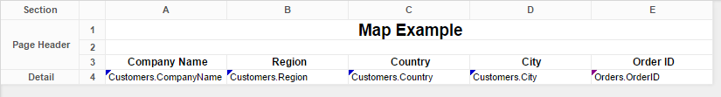
The Map will be colored based on the number of customers in each location and the markers will be sized based on how many orders have been placed in each location.

- Add a Report Footer section to the report, select all the cells in the Report Footer and press the merge cell button ().
- Select the merged cell and press the Insert Map icon ().
- In the Type tab:
  - Set the initial view, size and color.
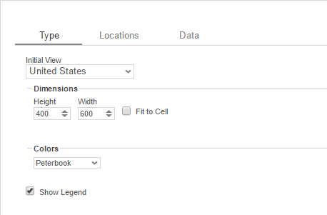
- In the Locations tab, set the field Customers.Country for Country information, Customers.State for Region, and Customers.City for City information. Set the 'Show last location type as' drop-down to Markers.
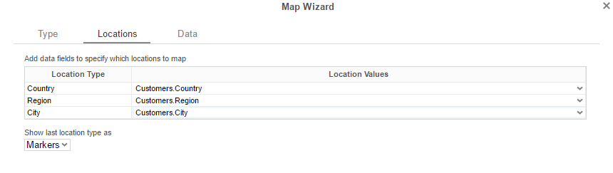
- In the Data tab:
  - Set the field Customers.CompanyName for Color of Locations. Provide a label such as 'Num. of Customers' and set the Aggregate Type to Distinct Count.
  - Set the field Orders.OrderId for the Size of Markers. Provide a label such as 'Num. of Orders' and set the Aggregate Type to Count.

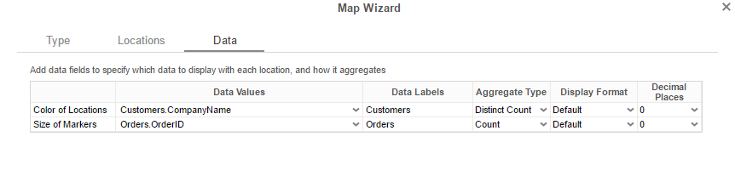
- Press Finish and run the report.

Report Designer:

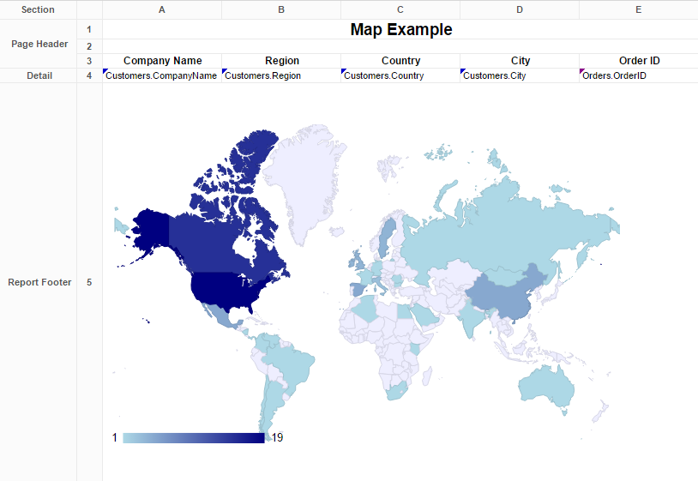

Report Viewer:
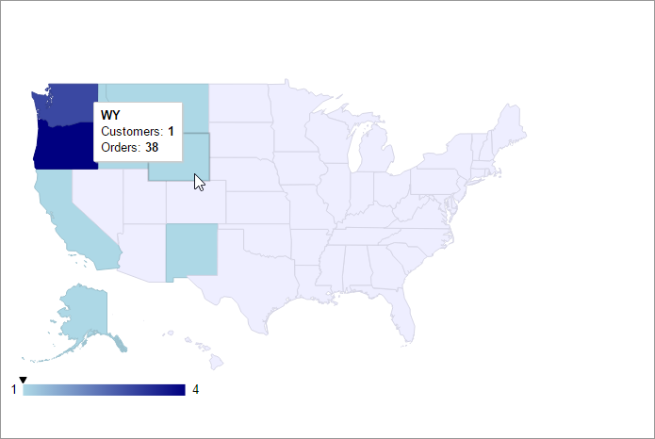

Linked Reports
The ability to create drill downs can be added by linking reports. Linked reports are only available in the Report Viewer or Dashboard Viewer.
The Linked Report menu contains three tabs: Report, Fields, and Formula.
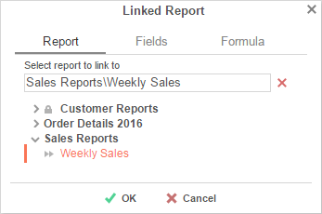

Report
The Report tab allows you to select which report to link to.
- To link a report, select a cell and press the Linked Reports button (). The Linked Report menu will appear. Select the report you want to link and press .
- A cell with a linked report will be indicated by this icon ().
- To unlink a report, select the cell with the linked report and open the Linked Report window. Press the 'Delete' button () and press .
When a link is set on a cell, by default, the unique key of the information being displayed is used to automatically filter the linked report. In the example below, the linked report is filtered for information where Employee Last Name equals 'Buchanan'. Note that report and dashboard filters also affect the data within drilldowns.
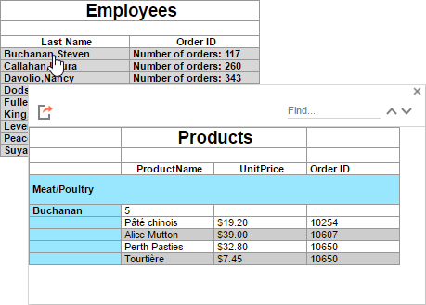

Fields
By default, the application will attempt to map the field contents of the linked cell to the same field in the linked report. (E.g. {Categories.CategoryID} <> {Categories.CategoryID}).
Using the Fields tab, you can specify which fields to link in order to map different fields with similar content. (E.g. {Categories.CategoryID } <> {Products.CategoryID}).
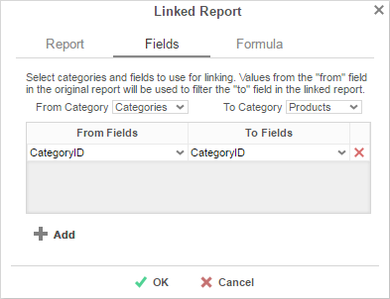
To add a custom link:
- Select the category to link from the parent report in the From Category dropdown.
- Select the category to link to within the linked report in the To Category dropdown.
- Press the button and select the From and To Fields for each new link.
To remove a custom link, press the 'Delete' () button.

Formula
The Formula tab allows you to specify a custom formula in order to further filter the data passed from the linked report. The formula must return True or False. The formula is evaluated for each row in the parent report, and if the condition is not met, the data is excluded from the linked report. See Formulas for more information.
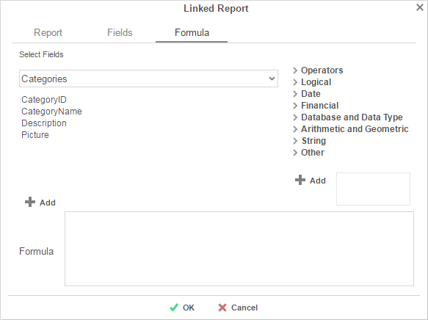
- Add a Data Field by dragging and dropping it into the 'Formula' box or double-clicking it. Or enter it manually using the following format: {DataCategory.DataField}.
Formulas only support one data field. If multiple data fields are used, all but the first will be ignored.
- Add a Parameter by entering it manually using the following format: @ParameterName@.
- Add a function by dragging and dropping it into the 'Formula' box or double-clicking it. Or enter it manually.

Chart Drilldowns
Chart drilldowns can also be created by using the Linked Reports menu. Chart drilldowns are only available in the Report Viewer or Dashboard Viewer.
- To create a drilldown, select a cell that contains a chart and press the Linked Reports button ( ). The Linked Report window will appear displaying the available reports. Select the report you want to link and press .
- To remove a drilldown, select the chart and open the Linked Report window. Press the 'Delete' button ().
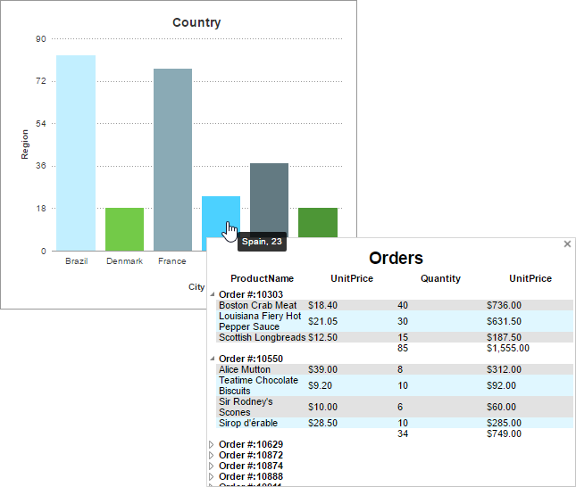

Gauges
A Gauge can be displayed in a report to give a visual representation of the scale of a value. To insert a Gauge, select a cell and press the Insert Gauge button (). The Gauge Wizard will appear. The Gauge Wizard has two tabs: Appearance and Data.
Gauges can be placed in any section of the report.

Appearance
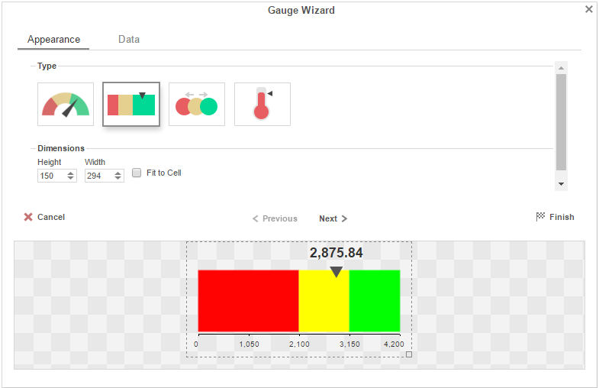
In the Appearance tab select the Type and Dimension of the Gauge.
- Type – Select the icon representing the type of gauge. Available types include: Angular, Linear, Bulb and Thermometer.
- There are three ways to set the size of the Gauge.
  - Enter the Height and Width in the dimension boxes.
  - Resize the gauge by dragging the lower right corner in the preview.
  - Check the box 'Fit to Cell''.

Data
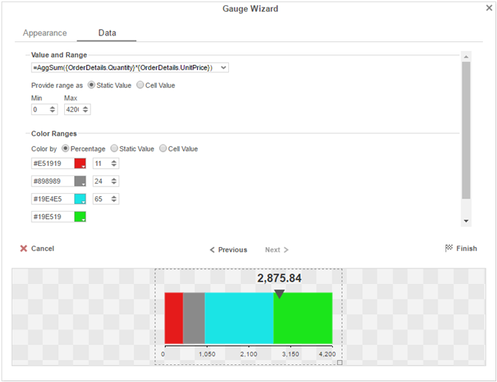
In the Data tab select the Data Values and Color Ranges for the Gauge.
- Use the 'Value and Range' drop-down to select the cell that contains the numeric value for the Gauge.
- Use the 'Provide range as' buttons to specify if the Min and Max values for the Gauge should be static numbers or come from cells on the report.
- In the Color Ranges, use the 'Color By' buttons to specify if color ranges should be percentages of the Max value, static numbers, or come from cells on the report.
Percent Color Ranges must be in ascending numeric order.
- Use the and buttons to create additional colors.
Thermometer Gauges can only have one color.
- To change a color, either use the drop-down () or enter a Hex value.

CrossTabs
CrossTabs allow the report to expand both horizontally and vertically based on data values and display summary information where each column and row meets. CrossTabs can be entered into a Standard Report from the toolbar using the CrossTab Button (). A CrossTab consists of three parts: Row Headers, Column Headers, and Tabulation Data. Additional settings for CrossTabs can be found in the CrossTab Options Menu.
The cells below and to the right of a cell containing a CrossTab must be empty.
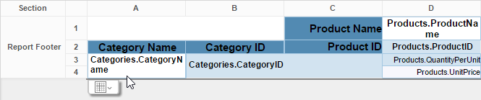

Row Headers
Row Headers expand a CrossTab vertically. A CrossTab has a row for each unique value of a Row Header.
E.g. If you were using sales data, you may have the Row Headers Category.CategoryName and Products.ProductName to provide rows for each product grouped by category.
- To add a Row Header, either drag and drop the Data Field into the 'Row Header Source' panel or select the Data Field and press the 'Add Row Header' button ().
- Press the Formula Editor Button () to insert a formula into the Row Header.
- Press the Edit Header button () to open the Header Options Menu.
In the Header Options Menu you can:
  - Set a Label for the Row Header. This label will appear at the top of the CrossTab.
  - Select a Sorting Method and Direction:
    - None – Does not sort the Row Header.
    - Header Value (Text) – Sorts the Row Header by its values as though they are text.
    - Header Value (Number) – Sorts the Row Header by its values as though they are numbers.
    - Tabular Totals – Sorts the Row Header by the totals of the Tabulation Data.
If there is more than one Row Header the Header Options Menu for the top most Row Header will have Options for subtotals of Tabulation Data.
  - Select where to display subtotals by using the Placement dropdown:
    - None – Does not display subtotals.
    - Top – Displays subtotals above the Tabulation Data for each Row Header value.
    - Bottom – Displays subtotals below the Tabulation Data for each Row Header value.
  - Set a Label for the subtotals.
- Use the up () and down () arrows to rearrange the order of the Row Headers.
- To remove a Row Header, press the delete button ().

Column Headers
Column Headers expand a CrossTab horizontally. A CrossTab has a column for each unique value of a Column Header.

E.g. If you were using sales data, you may have the Column Headers 'Year({Order.OrderDate})' and 'Month({Orders.OrderDate})' to provide columns for each month grouped by year.

- To add a Column Header, either drag and drop the Data Field into the 'Column Header Source' panel or select the Data Field and press the 'Add Column Header' button ().
- Press the Formula Editor Button () to insert a formula into the Column Header.
- Press the Edit Header button () to open the Header Options Menu.
In the Header Options Menu, you can:
  - Set a Label for the Column Header to appear at the top of the CrossTab.
  - Select a Sorting Method and Direction.
    - None – Does not sort the Column Header.
    - Header Value (Text) – Sorts the Column Header by its values as though they were text.
    - Header Value (Number) – Sorts the Column Header by its values as though they were numbers.
    - Tabular Totals – Sorts the Column Header by the totals of the Tabulation Data.
If there is more than one Column Header the Header Options Menu for the topmost Column, Header will have Options for subtotals of Tabulation Data.
  - Select where to display subtotals by using the Placement dropdown.
    - None – Does not display subtotals.
    - Left – Displays subtotals to the left of the Tabulation Data for each Column Header value.
    - Right – Displays subtotals to the right of the Tabulation Data for each Column Header value.
  - Set a Label for the subtotals.
- Use the up () and down () arrows to rearrange the order of the Column Headers.
- To remove a Column Header, press the delete button ().

Tabulation Data
Tabulation Data provides information when data exists for the Column Header and Row Header values. For example, if you have a Row Header on products and a Column Header on the month, then Tabulation Data of Orders.OrderID may use the Count function to display how many orders contained each product each month.
- To add a Tabulation Data field, either drag and drop the Data Field into the 'Tabulation Data' panel or select the Data Field and press the 'Add Tabulation Data' button ().
- Press the Formula Editor Button () to insert a formula into the Tabulation Data.
- Press the Edit Tabulation button () to open the Tabulation Options menu.
In the Tabulation Options Menu, you can:
  - Set a Label for the Tabulation Row to appear at the beginning of each row.
  - Use the Method dropdown to select the summary function to be applied to the Tabulation Data.
Summary Functions | - Sum: Totals the all of the data in the Tabulation Data.  - Count: Returns the number of rows in the Tabulation Data.  - Average: Takes the mean of the data in the Tabulation Data.  - Minimum: Displays the lowest value in the Tabulation Data.  - Maximum: Displays the highest value in the Tabulation Data.  - None: Displays the value in the Tabulation Data without doing any calculations.
  - Use the Value dropdown to select how the Tabulation Data should be displayed.

    - Aggregate: Display the result of the selected Method.
    - Percent of Row: Display the result of the selected method as a percentage of the row total.
    - Percent of Column: Display the result of the selected method as a percentage of the column total.
- Use the up () and down () arrows to move the Tabulation Data order.
- To remove a Tabulation Data field, press the delete button ().

CrossTab Themes
The Theme dropdown can be used to quickly style the CrossTab using one of the pre-defined themes. Further styling can be done to the cells of the CrossTab in the Report Designer.

CrossTab Options
Settings that affect the entire CrossTab are controlled in the CrossTab menu.
Use the menu to adjust the following settings:
General
- Use the Row Headers Placement dropdown to determine how the Row Headers are displayed.
  - Columns – Display the Row Headers in columns from left to right in their order in the Row Header Source panel.
  - Hierarchical – Display Row Headers in a hierarchical structure using indentation to display their order.
- Check 'Repeat CrossTab Header every new page' to repeat Row Header labels and Column Headers on each new page.
Grand Total Row
- To get a total for each column, select 'Top' or 'Bottom' from the Placement dropdown and provide a label in the Label text box.
Grand Total Column
- To get a total for each row, select 'Top' or 'Bottom' from the Placement dropdown and provide a label in the Label text box.

Renaming Reports
To change the name of a report, select 'Rename' in the Toolbar drop-down menu. Enter a new name and select the folder in which you want to save the report. Press .
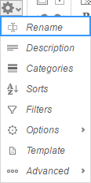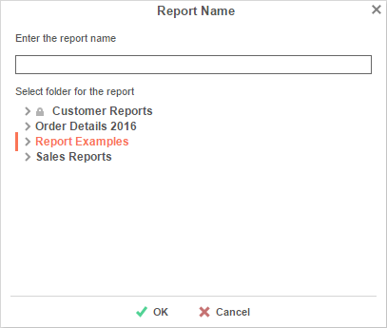

Changing Description
The report description appears at the bottom of the Main Menu. Report descriptions are optional but can be searched. To change a report description, select 'Description' in the Toolbar drop-down menu. Write a description and press .
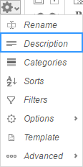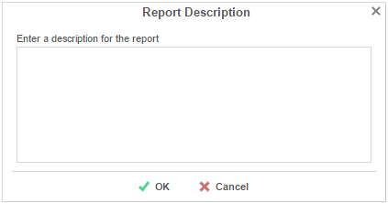

Changing Data Categories
Before you change a Data Category, it is important to understand two terms: Data Category and Data Field.
Data Category – A Data Category is an object that has a group of attributes. E.g. Orders is a category; each order has an ID, a date, a customer etc.
Data Field – A Data Field is a single attribute within a Data Category. E.g. Orders.OrderID is numeric value that identifies a specific order.
To modify the Data Categories, select 'Categories' in the Toolbar drop-down menu.
- To add a Data Category, either drag and drop it to the selection pane, or select the Category and press the button, or double-click the Category.
- To search for a specific Data Category, type its name into the search box.
- To see what Data Fields are in a Category, press the information button ().
- Check the 'Suppress Duplicates' box to prevent duplicate information from appearing on the report.
- To remove a selected Category, press the delete button ().
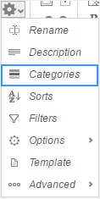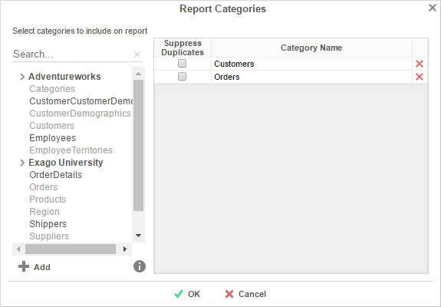

Changing Sorts
To modify the sort criteria of a report, select 'Sorts' in the Toolbar drop-down menu.
- To sort by a Data Field, either drag and drop it to the selection pane, or select the Data Field and press the button, or double-click the Data Field.
- To sort by a Formula, press the button. To edit an existing formula, press the Formula Editor () button. See Sorting by Formula for more information.
- You can order each sort in Ascending (A-Z, 0-9) or Descending (Z-A, 9-0) order.
- Use the up () and down () arrows to indicate the sort priority.
- To remove a sort, press the delete button ().
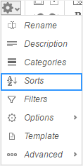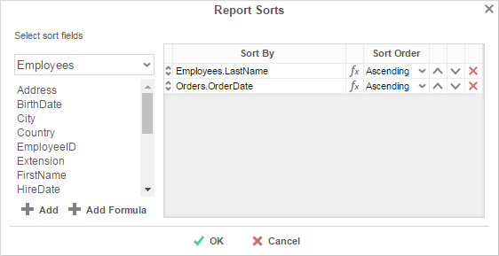

Sorting by Formula
To sort and group by information that may not be contained within an individual data field, you can use Formulas. See Formulas for additional help.
Pressing the button or the Formula Editor () button opens the Formula Editor window:
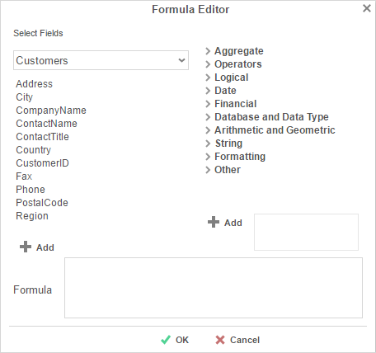
- Add a Data Field by dragging and dropping it into the 'Formula' box or double-clicking it. Or enter it manually using the following format: {DataCategory.DataField}.
- Add a Parameter by entering it manually using the following format: @ParameterName@.
- Add a function by dragging and dropping it into the 'Formula' box or double-clicking it. Or enter it manually.
For example, say I had a data field containing a full date and time, and I wanted to analyze my sales by each month of the year over a multi-year period.
I could use the formula Month({Orders.OrderDate}) to return only the Month component of each date. Then I could sort my sales by Month.

Changing Filters
To modify the filter criteria of a report, select 'Filters' in the Toolbar drop-down menu. There are three types of filters: Standard, Interactive, and Group. Standard filters are based on values you specify. Interactive filters can be applied after running a report to the Report Viewer. Group filters are based on the minimum or maximum value in the Data Field.

Standard Filters
There is no limit to the number of filters that you can define. Filters can be numeric (up to eight decimals) or alphanumeric.
- To filter by a Data Field, either drag and drop it to the selection pane, or select the Data Field and press the button, or double-click the Data Field.
- Use the up () and down () arrows to indicate the filter priority.
- To remove a filter, press the delete button ().
- Set the operator (Equal To, Less Than, One Of, etc.) by selecting from the Operator drop-down.
- To set the value on which to filter, either enter it manually or select from the drop-down. If the Data Field is a date you may use the calendar or function buttons to select a value.
- To allow the filter to be modified at the time the report is executed, check 'Prompt for Value.'
- Select 'AND With Next Filter' to require that the selected filter and the one below it both evaluate to true. Choose 'OR With Next Filter' to require that either be true.
- Check 'Group With Next Filter' to specify the precedence of the filters. Filters can be nested indefinitely by using the following keyboard shortcuts while a filter is selected:
  - Ctrl + [ adds an open-parenthesis before the selected filter.
  - Ctrl + ] adds a close-parenthesis after the selected filter.
  - Ctrl + Shift + [ removes an open-parenthesis from before the selected filter.
  - Ctrl + Shift + ] removes a close-parenthesis from after the selected filter.
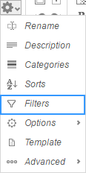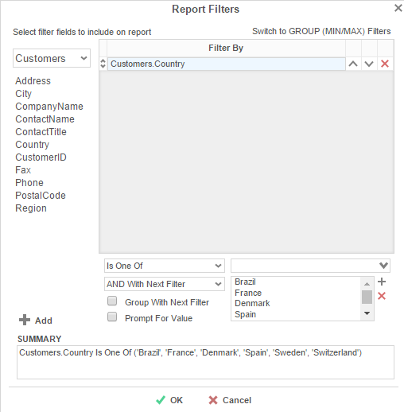

Interactive Filters
Interactive Filters can be created in the Report Viewer Options Menu. These filters can be enabled, disabled, or modified after running a report to the report viewer. For more information, see Interactive Report Viewer Options.
Group (Min/Max) Filters
Group Min/Max filters will cause the report output to display detail containing either the highest or lowest values in a field for either one group, multiple groups, or an entire data set. This is useful if you are only interested in viewing the highest or lowest values — such as the most recent hire date or highest revenue figure — in a given set. Group Min/Max filters are mutually exclusive with standard filters, and there is no limit to the number of group filters you may define.
To modify group filters, click 'Switch to Group (MIN/MAX) filters' . There is no limit to the number of group filters you may define.
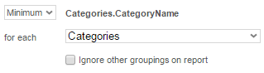
- To filter by a Data Field, either drag and drop it to the selection pane, or select the Data Field and press the button, or double-click the Data Field.
- Specify Minimum or Maximum from the operator drop-down.
- Specify whether to apply the filter to each Category or Sort field. To apply the filter to only the selected group, check the 'Ignore other groupings on report' box.
Selecting 'Entire Data Set' causes the Min/Max filter to apply across the entire report and ignore any other groupings.
- Use the up () and down () arrows to indicate the filter priority.
- To remove a filter, press the delete button ().

General Options
Hover over 'Options' in the Toolbar drop-down and then select the 'General' menu to open the Report Options Window. This window allows you to control various settings including default export type and page orientation.
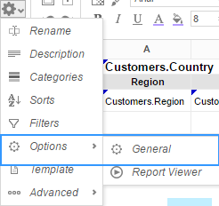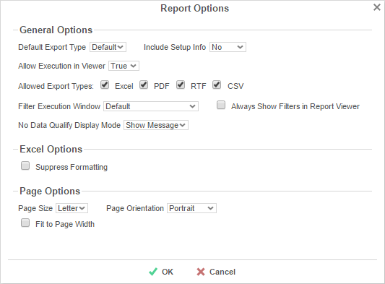
General Options
- Use the Default Export Type drop-down to specify the default format for the report.
- From the 'Include Setup' menu, select Top or Bottom to display the data categories, sorts, and filters at either the beginning or end of the report.
- Output types may be disabled by unchecking the boxes for 'Allowed Export Types'.
- Use the 'Filter Execution Window' drop-down to select which type of Filter menu displays when executing a report that has prompt-for-value filters.
  - Default – Display the default type of filter execution window.
  - Standard – Display the standard filter execution window.
  - Simple with Operator – Display a simplified filter execution window that only allows the operator and value to be changed.
  - Simple without Operator – Display a simplified filter window that only allows the filter value to be changed.
- Check 'Always Show Filter Execution' to show the filter menu and allow changes to be made each time the report is executed.
- Use the 'No Data Qualify Display Mode' to select what to display if no data qualifies for the report.
  - Show Message – Display the standard no data qualified message.
  - Show Report – Display the Page Header, Page Footer, Report Header, and Report Footer sections of the report. Any cells containing Data Fields will not be displayed.
Excel Options
- Check 'Suppress Formatting' to prevent the report formatting from exporting to Excel.
Page Options
- Specify the size for the report in the 'Page Size' menu. Default is Letter.
- Set the orientation for the report in the 'Orientation' menu. Default is Portrait.
- Check 'Fit to Page Width' to scale all columns to fit the width of the page.

Report Viewer Options

Hover over 'Options' in the Toolbar drop-down and then select 'Report Viewer' menu to open the Report Viewer Options Menu. This window allows you to control what interactive capabilities a user has when viewing reports.
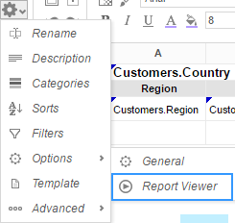

General
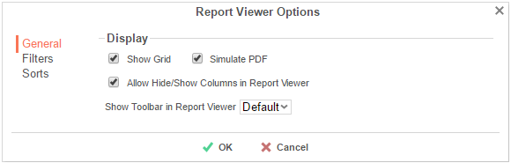

- Uncheck 'Show Grid' to disable grid lines.
- Uncheck 'Simulate PDF' to have the report appear as though it is not on a page.
- Uncheck 'Allow Hide/Show Columns on Execution' to disable the Hide Columns tools.

Filters

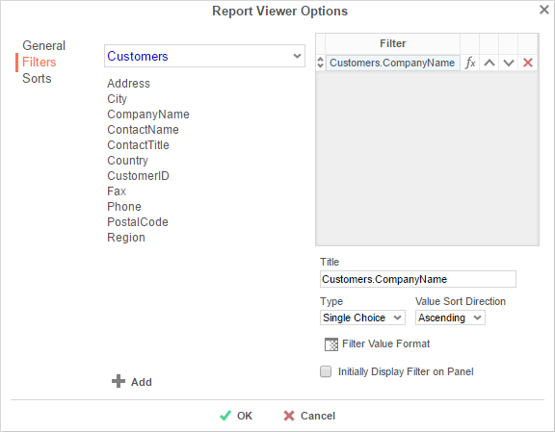
Interactive Filters are filters created on either Data Fields or Formulas and then enabled after running a report to the report viewer.
- To filter by a Data Field, either drag and drop it to the selection pane, or select the Data Field and press the button, or double-click the Data Field.
- To filter by a formula, first add a Data Field, then use the formula button () to open the Formula Editor.
- In the Title box provide a name for the interactive filter.
- Use the Type dropdown to specify what kind of interactive filter to display:
  - Single Choice: A dropdown with the possible values of the filter:

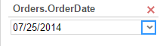

  - Multiple Choice: All possible values for the filter presented with check boxes to select one or more values:

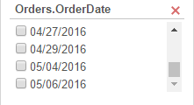

  - Single Slider: Select the filter value by sliding a point along a scale:

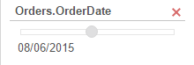

  - Range Slider: A scale that displays values between two points:
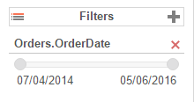
- Press the Format button () to open the format menu and specify how the filter values should be displayed.
- If filtering on an Aggregate formula such as AggSum, use the 'Calculate Value Ever' dropdown to select on which sorted field or category the aggregate should be applied.
- Use the 'Value Sort Direction' to specify if the filter values should display in ascending or descending order.
- Check the 'Initially Display Filter on Panel' box to have the filter enabled automatically when the report is run to the viewer.

Sorts
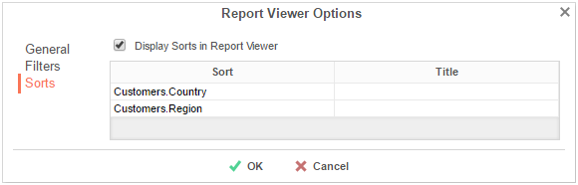
Interactive sorts can be used to change the direction of a report's Sorts while viewing the report in the Report Viewer
- Uncheck 'Display sorts on Execution' to hide interactive sorts in the Report Viewer.
- In the Title column, provide a name for each interactive sort.

Advanced Options
Select 'Advanced' in the Toolbar drop-down menu to open the Advanced Options window. This window allows you to specify additional information about how the Data Categories relate to each other.
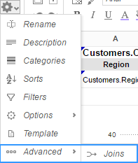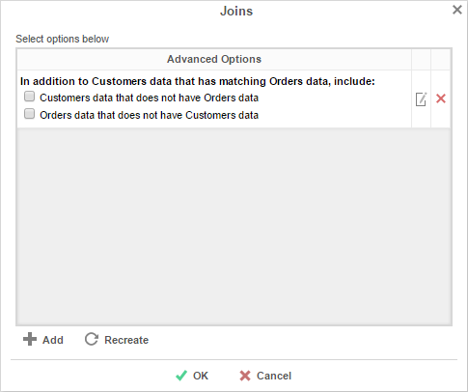
Before using these options, it is important to understand the definition of a Join.
Join – A join defines how two Data Categories are related. Each join has a 'From' Category and a 'To' Category. The From and To objects must have one (or more) Data Fields that contain the same information.
E.g. A join exists between two Data Categories: Orders and Customers. The join goes 'From' Customers 'To' Orders. In this example, when a customer makes an order, that customer's ID is saved with the order. Thus, the Orders Category has the Data Field CustomerID. This Data Field matches the Data Field CustomerID in the Customers Category. This join assures that each customer is paired with the orders that they have made.
- To add a new join, press the button.
- To edit a join, press the edit button ().
- Restore the default joins by pressing the Recreate button ().
- To remove a join, press the delete button ().

When you press the Add or Edit buttons, the Report Join menu will appear. In this menu, you can create or modify a Join for the report:
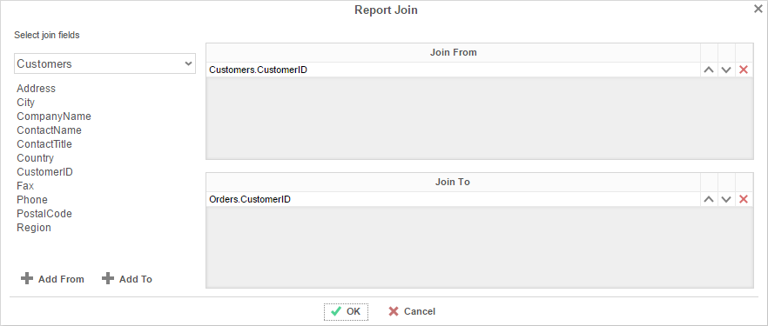
- To set the From Category, drag and drop the Data Field into the 'Join From' panel or select the Data Field and press the button.
- To set the To Category, drag and drop the Data Field into the 'Join To' panel or select the Data Field and press the button.
- Use the up () and down () Arrows to reorder the Data Fields. The position of each Field in 'Join From' should match the position of its corresponding Field in 'Join To'.

Document Template
Reports can also be used to fill in PDF, RTF, or Excel templates, such as internal or government documents. Select 'Templates' in the drop-down menu to open the 'Document Template' window.
- Before using the Templates window, put your data into the cells of your report.
- From the top drop-down, select the template you want to use.
- In the 'Report Field' column, specify which cell of the report corresponds to each 'Template Field'.

Once the fields are complete, exporting the report in the same format as the template will produce a filled-in template.

The example below shows the fields being set in the Document Template window and the output when the report is exported as a PDF.
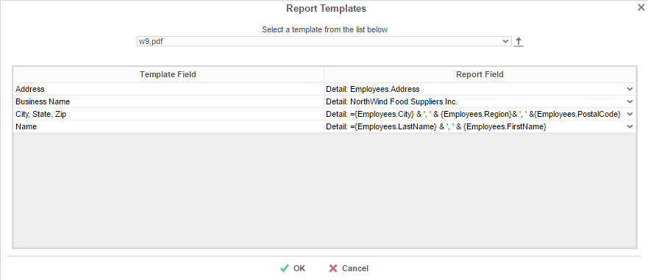
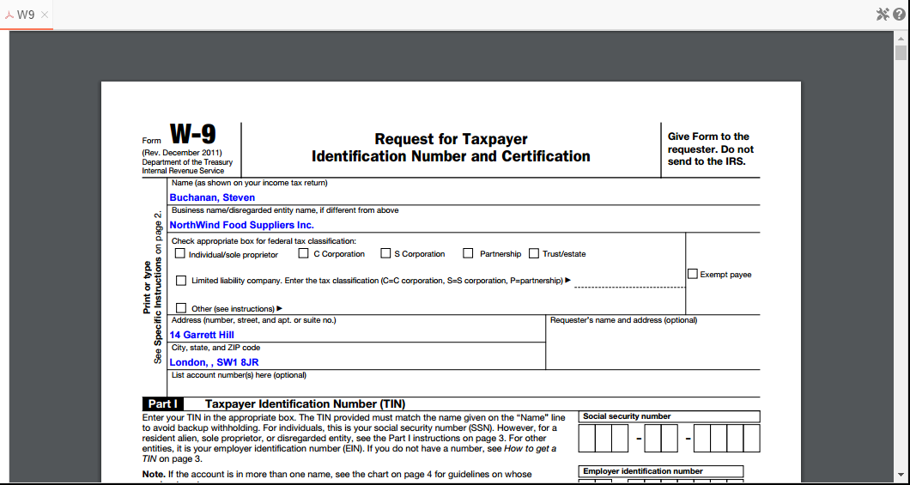

Duplicating Reports
Duplicating reports can save time. This feature creates a new report that is identical to an existing one. Instead of creating the new report from scratch, you can duplicate an existing report, rename it, and make your changes.
- On the Main Menu, select the report you want to duplicate.
- Press the Duplicate button. The Rename Report Window will open.
- Type the name of the new report into the Report Name field.
- Select the folder where the report will be saved.
- Press .

Deleting Reports

Deleting a report removes the report and all of its components.
To delete an existing report:
- On the Main Menu, select the report you want to delete.
- Press the Delete button (). A dialog box will ask if you are sure you want to proceed.
- Press to delete the report.
IMPORTANT. Once the report is deleted, there is no way to recover it.

Scheduling Reports
Reports may be sent to recipients via email using custom scheduled intervals. A scheduled report can be executed and emailed immediately or scheduled to be emailed on a recurring basis. The Scheduler Menu lets you schedule and email reports or edit existing schedules.
To open the Scheduler Menu:
- In the Main Menu, select the report you want to schedule/email.
- Press the Scheduler Menu button (). The Schedule Menu will appear.

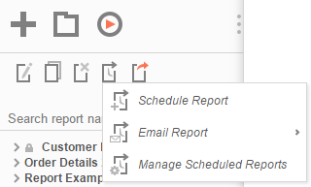

  - To Schedule a report, press new schedule button (). The Schedule Report Wizard will open in a new tab.
  - To email a report, press email button (). The Email Report Menu will appear.
  - To edit existing schedules, press the edit schedule button (). The Schedule Manager will open in a new tab.

If you do not see a Schedule Report button in the Main Menu, then you do not have Report Scheduler permissions and should contact your administrator.

Schedule Report Wizard
The Schedule Report Wizard has five sub tabs. The Recurrence and Recipients tabs are required, and the other tabs are optional.
- Recurrence: Specify the name and format of the report and when the report should be sent out.
- Parameters: (optional) Set values for any parameters used by the report.
- Filters: (optional) Add filters to the report.
- Batch: (optional) Set a list of recipients each of whom will receive a unique filtered version of the report.
- Recipients: Specify the recipient addresses, subject, and body text of the email.

Recurrence Tab
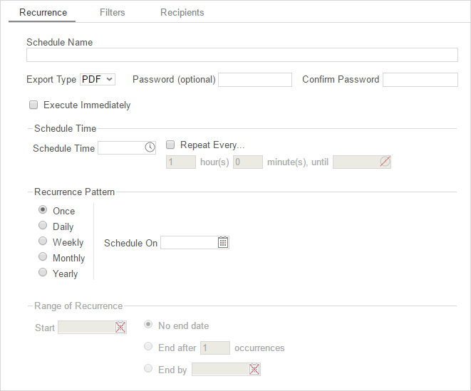
In the Recurrence Tab, give the schedule a name and format. Set the frequency at which you want the report to be executed and sent out. This recurrence can be a one-time, daily, weekly, monthly, or yearly delivery. A date range can also be set to give the report delivery a defined start and end date.
- Give the Schedule a Name and select an export type from the drop-down.
- For PDF reports, a password may be set. The password may require a minimum number of upper/lowercase letters or numbers. To find out the required password strength, hover the mouse over the Password box.
- To execute and send the report immediately, check 'Execute Immediately'.
- Schedule Time
  - Set the time of day the report should be executed by entering a time in the Schedule Time box.
  - Check 'Repeat every' and then specify a time interval to have the schedule be sent on a recurring basis on the day(s) specified in as the Recurrence Pattern.
- Recurrence Patterns
  - Once – Specify to execute the report on a specific day or immediately.
  - Daily – Send the report every weekday or every set number of days.
  - Weekly – Send the report on specific days of the week.
  - Monthly – Set the day of the month to send the report.
  - Yearly – Set the day of the year to send the report.
- Range of Recurrence
  - Use the Range of Recurrence section to set a start date and an end date for the report schedule.

Parameters Tab
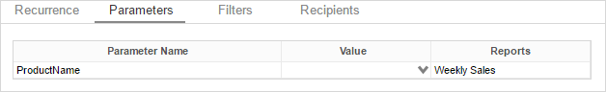
In the Parameters Tab, enter a value for each of the parameters listed.
The Parameters Tab will only be visible if the report is utilizing parameters. See Parameters for more information.

Filters Tab
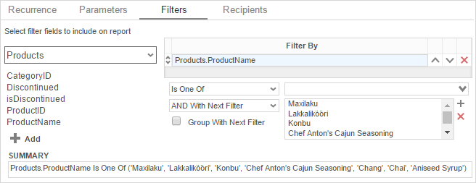
In the Filters Tab create statements to filter the data at runtime. There is no limit to the number of filters that you can define. Filters can be numeric (up to eight decimals) or alphanumeric.
- To filter by a Data Field, either drag and drop it to the selection pane, or select the Data Field and press the button, or double-click the Data Field.
- Use the up () and down () arrows to indicate the filter priority.
- To remove a filter, press the delete button ().
- Set the operator (Equal To, Less Than, One Of, etc.) by selecting from the Operator drop-down.
- To set the value on which to filter, either enter it manually or select from the drop-down. If the Data Field is a date, you may use the calendar or function buttons to select a value.
- To allow the filter to be modified at the time the report is executed, check 'Prompt for Value.'
- Select 'AND With Next Filter' to require that the selected filter and the one below it both evaluate to true. Choose 'OR With Next Filter' to require that either be true.
- Check 'Group With Next Filter' to specify the precedence of the filters. Filters can be nested indefinitely by using the following keyboard shortcuts while a filter is selected:
  - Ctrl + [ adds an open-parenthesis before the selected filter.
  - Ctrl + ] adds a close-parenthesis after the selected filter.
  - Ctrl + Shift + [ removes an open-parenthesis from before the selected filter.
  - Ctrl + Shift + ] removes a close-parenthesis from after the selected filter.

Batch Tab
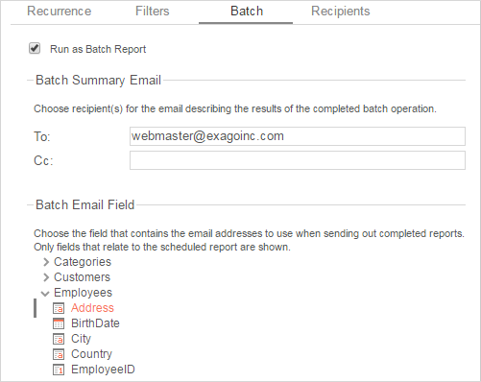
Check the 'Run as Batch Report' box to enable batch execution for the report.
If you don't see this option, your administrator may have disabled it.
Reports can be executed and emailed en masse to a list of addresses, each one filtered by a unique key. For example, a report containing data on a number of employees may be executed such that each employee receives an email containing a version of the report filtered on their own ID.
In order to use batch reporting, a table or other data structure must exist which contains a list of email addresses each associated with a key used to filter the report. Each row may contain optional columns that can be used as parameters in the email message body (using the form '@batch_columnName@').
Key | Email Address | OptionalCol1 | OptionalCol2
The email address table must have a join path defined to a table in the report. It does not need to be added to the report.
- Enter an (optional) Batch Summary Email to send an email which will summarize the result of the batch report execution.
- In the Batch Email Field select the field in the email address table which contains the addresses to use when sending the completed reports.

Recipients Tab
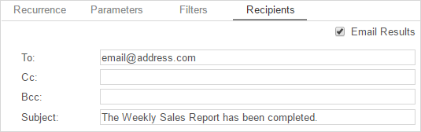
In the Recipients Tab, determine how the schedule will be delivered and list the email address(es) to which the report should be sent. Separate email addresses with a semi-colon (;).
- Check 'Email Results' to have the report sent via email. Uncheck this option to have it saved to a repository.
- An 'Attach Report Output to Email' checkbox will be available when using batch reporting. Uncheck this option to prevent the reports from being attached to the recipient emails.
- In the To field, set the email address(es) to which the report will be delivered.
- In the Cc field, set any address(es) to be carbon copied.
- In the Bcc field, set any address(es) to be blind carbon copied.
When using batch reporting, the To, Cc, and Bcc fields are disabled.
- Set the subject of the email in the Subject field.
- In the Body field, enter the text of the email to be sent with the report. To reference the report name use '@reportName@'. To reference any batch parameters, use '@batch_columnName@', where columnName is one of the columns in the email address table.
@reportName@ is a built-in parameter. See Parameters for more information.

Email Report
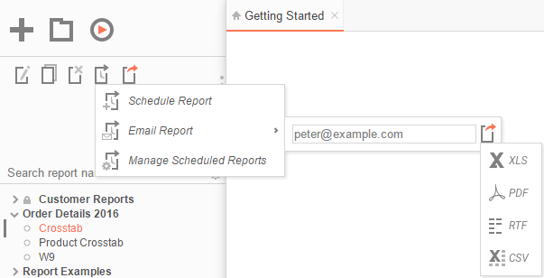
In the Scheduler Menu, use the email icon () to email a report. An input field and export options will appear.
- In the input field, enter the email address.
- Click the drop-down arrow to change the format of the report.
- Select an export type to export and email the report.
Reports can only be emailed as downloadable file types (Excel, PDF, RTF, CSV).

Manage Scheduled Reports
Scheduled Reports can be monitored, edited, and removed using the Manage Scheduled Reports tab.
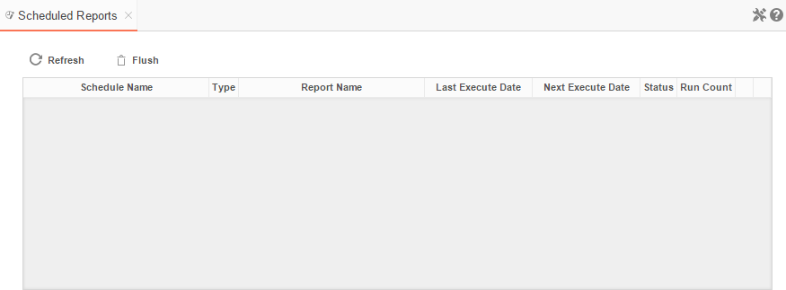To open the tab, press the scheduler icon () in the Main Menu then press (). The Manage Scheduled Reports tab will appear.
- Click at the top of a column to sort the scheduled reports by that column.
- To update the status and list new schedules press the Refresh button.
- To removed completed schedules press the Flush button.
- Press the Edit icon () to open the Schedule Report Wizard and modify the report.
- To delete a schedule press the delete icon ().

Executing Reports
Reports can be run or exported from the Main Menu or the Report Designer.
In the Main Menu select the report you want to run or export. With the report highlighted press the Run Report button . To change the output format, press the Export Type drop-down and select from the available export formats (Excel, PDF, RTF, or CSV).
Right-clicking on the Export Type button will export the report to a PDF.
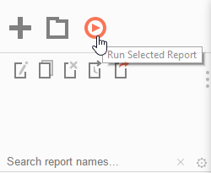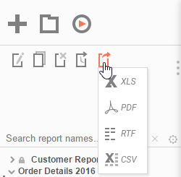
In the Design Tab, press the Run Report button . To change the output format, press the Export Type drop-down and select from the available export formats (Excel, PDF, RTF, or CSV). See Report Options to change the default format for the report:
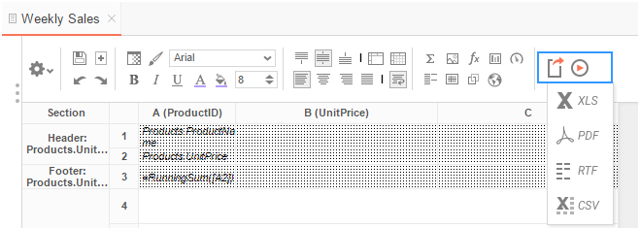

Interacting with Reports
After running a report in the Report Viewer, you can make further modifications to the report's style, formatting, and content. These changes can be exported to other formats, saved to the original report, or saved as a separate copy of the report depending on the settings.
For these interactions to be available, they must be enabled in the Report Viewer Options Menu in the Report Designer.

Changing Styling
While viewing a report in the Report Viewer, right click a cell to open the style menu. Using this menu, you can change font, size, foreground and background color, bold, italic, underline, and alignment options.
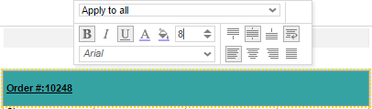

Resizing Columns
The columns of a report can be resized by dragging the light grey bar at the top of the page to the desired size.
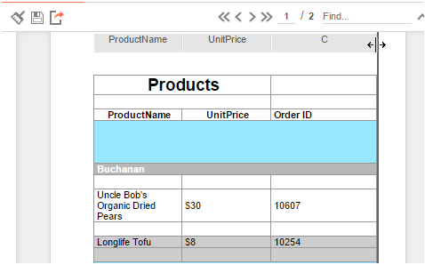

Applying Interactive Filters
Any available interactive filters can be enabled by pressing the add button () in the Filters section of the Interactive Report Viewer dock, which is located next to the report.
Interactive filters must be defined in the Interactive Report Viewer Options Menu. Additional filters can be created directly on the report by right-clicking within the Report Viewer. See Conditional Filters for more details.
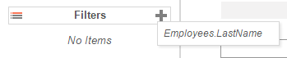
After enabling a filter use the checkbox, dropdown, or slider to select what values should appear on the report. After selecting a value, the report will refresh with the filter applied.
Press the () next to an active filter to remove it. The report will refresh to deactivate the filter.

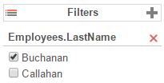

Conditional Filters
You can set filters on specific values in addition to the pre-defined interactive filters by interacting with the report in the Report Viewer.
To create a conditional filter, right-click on a cell of the report, choose an operator from the 'Apply To' dropdown then press the filter button ():
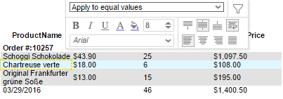
The conditional filter will appear in the dock below the interactive filters and sorts:
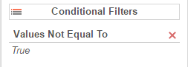

Changing Sorts
In the dock next to the report you can change the direction of any sorts on the report by pressing the ascending () and descending () buttons:

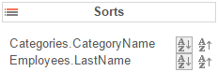

Additionally, you can sort by individual columns of the report by clicking on the light grey bar at the top of the page:

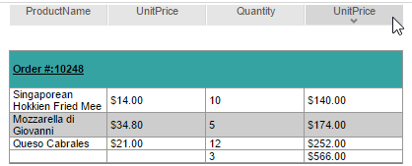

Hiding Columns
In the dock next to the report, you can show/hide the columns of the report by checking/unchecking the column names:

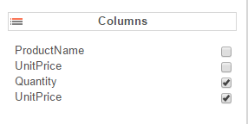

Saving & Clearing Changes
Changes to styling, column sizes, sorts, and filters can be saved in a number of ways.
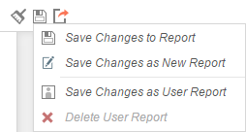
In the toolbar above the report:
- Using the Clear dropdown (), you can remove any changes made to the report.
- Use the Save button () to save interactive changes onto the report.
- Use the Save as New Report button () to make a copy of the report with the changes.
- Use the 'Save Changes as User Report' option under the 'Save Options' dropdown to save your changes as a User Report. The changes will be applied each time you run the report but will not be seen when the same report is run by another user.
- Use the 'Delete User Report' option under the 'Save Options' dropdown to remove any changes that were saved as User Report.

Exporting to Other Formats
From the Report Viewer, you can export a report, including any interactive changes, to other formats such as Excel, PDF, RTF, or CSV. To do so, use the export button in the toolbar above the report and selected the export format.
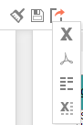

Creating and Editing Dashboards

Dashboards provide a canvas that can display reports, data visualizations, images, text and web pages.
To create a new dashboard, press the New Dashboard icon in the Main Menu. The Dashboard Designer will appear in a new tab.
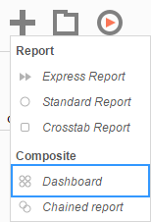

Dashboard Designer
The Dashboard Designer can be used to add reports, text, images, and web pages to a dashboard.
The Dashboard Designer has four components: the Design Canvas, Tool Box, Data Fields, and the Toolbar.
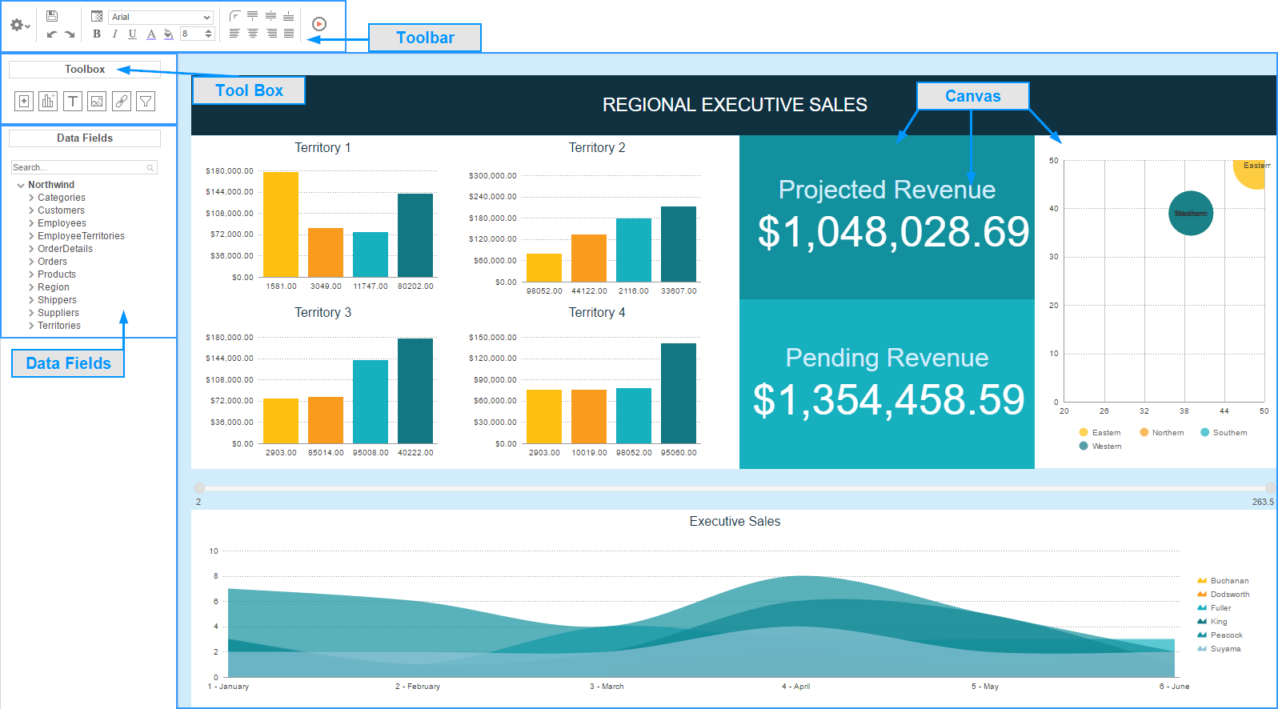
Dashboard Canvas
In the Dashboard Designer, you can:
- Move and resize Dashboard Items
- Style Dashboard Items with alignment, borders, colors, etc.
- Edit Dashboard Items such as Reports, Data Visualizations, and Text
Toolbox
By dragging Dashboard Items from the Toolbox onto the canvas, you can add the following:
- Reports
- Data Visualizations
- Text
- Images
- Web Pages
- Interactive Filters
Data Fields
After dragging a Data Visualization from the Toolbox on to the Canvas, you can add Data Fields by dragging them over the Data Visualization.
Toolbar
Using the toolbar, you are able to:
- Rename the Dashboard and modify its description
- Set the Dashboard to automatically run when entering this tool
- Change the background color of the canvas
- Format the font, font size, alignment, color, and borders of text
- Save the dashboard
- Run the dashboard to the Dashboard Viewer

Dashboard Items
By dragging Dashboard Items onto the canvas, you can add the following items to the dashboard:
- Reports
- Dashboard Visualizations
- Text
- Images
- Web Pages
- Interactive Filters

Adding Reports
To add an existing report to the dashboard, drag and drop the Report Button () over the Dashboard Canvas. The Report Properties menu will appear. The Report Properties menu has four tabs: Report, Filters, Parameters, and Options.
Report
In the Reports Tab, select the report you want to display on the dashboard.
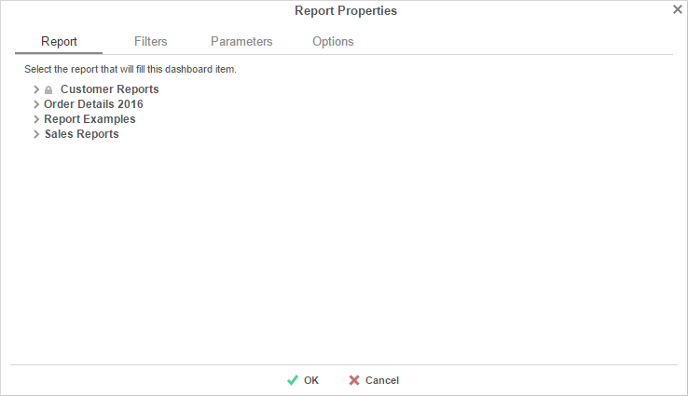

Filters
If the selected report has any Prompt for Value Filters, those filters will appear in the Filters tab. In this tab, you can specify how to prompt for these filter values.
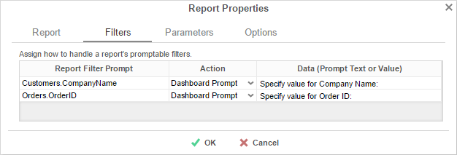
For each Filter:
- Use the Action dropdown to select how the filter should prompt.
  - Dashboard Prompt – When the dashboard runs, you will be prompted for a value that is used by all of the reports on the dashboard that filter using this Data Field.
  - Report Prompt – When the dashboard runs, you will be prompted for a value to filter this specific report.
  - Assign Value – Assign the filter a specific value. This filter will not prompt when the dashboard runs.
- In the 'Data (Prompt Text or Value)' column, enter a value if the Action is Assign Value; if the Action is Dashboard or Report Prompt, enter text to use for the prompt.
Parameters
If the selected report has any Prompting Parameters, those parameters will appear in the Parameters Tab. In this tab, you can specify how to prompt for these parameter values.
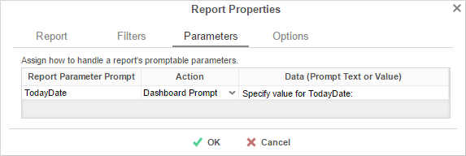
For each Parameter:
- Use the Action dropdown to select how the parameter should prompt.
  - Dashboard Prompt – When the dashboard runs, you will be prompted for a value that is to be used by all of the reports on the dashboard with that parameter.
  - Report Prompt – When the dashboard runs, you will be prompted for a value that is used by this specific report.
  - Assign Value – Assign the parameter a run value and do not prompt when the dashboard runs.
- In the 'Data (Prompt Text or Value)' column, enter a value if the Action is Assign Value; if the Action is Dashboard or Report Prompt, enter text to use for the prompt.

Options
In the Options Tab, specify settings for how the report displays on the dashboard.
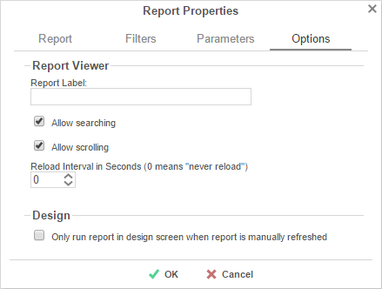
Report Viewer
- In the Report Label box, provide a title for the report. This title will be displayed in on the canvas when editing the dashboard.
- Check 'Allow scrolling' to allow scrolling on the dashboard if the report is larger than the designated size on the canvas.
- Set the number of seconds at which to re-run the report. Set to 0 to only run the report when the dashboard is first run.
Design
- Check 'Only run report in design screen when report is manually refreshed' to prevent the report from being run accidentally while editing the dashboard.

Adding Data Visualizations
To create a new Visualization on the dashboard, drag and drop the Data Visualization icon () onto the Dashboard Canvas. A Data Visualization item will appear.

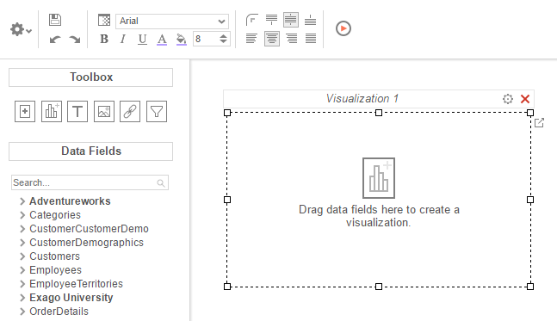

With the Data Visualization item, you can:
- Drag Data Fields onto the item to create a chart or a tabular report.
- Use the Options Menu () to filter, name, or modify other settings of the Visualization.
- Modify how the Data Fields are grouped and summarized by opening the Data Model Menu ().
- Save the Data Visualization as a new Standard Report ().
Subsequent changes in the Standard Report Designer will not be reflected on the Data Visualization. To have those changes appear on the dashboard, add the new report to the dashboard.
- Convert from a chart to tabular report (or vice versa) by selecting 'Convert to Chart' in the right-click menu.
A Data Visualization must have at least two Data fields, one of which must be numeric, in order to display a chart.

Adding Text
To add text to the dashboard, drag and drop the Text icon () over the Dashboard Canvas. A text box will appear. Type the desired text in this box. Use the Toolbar to format the text.

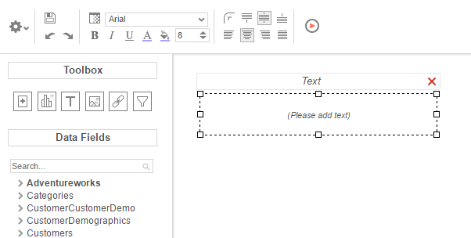

Adding Images
To add an image to the dashboard, drag and drop the Image icon () over the Dashboard Canvas. An image box will appear. Press the insert image button () and select the image to upload.

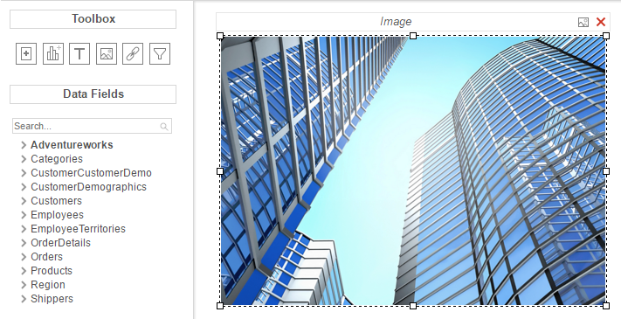

Adding Web Pages
To add a web page to the dashboard, drag the URL Button () over the Dashboard Canvas. A URL menu will appear. Enter the desired URL and press .

Some web pages do not permit being embedded within another web page.

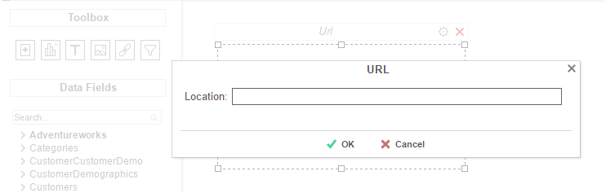

Adding Interactive Filters
To add an interactive filter to the dashboard, drag and drop the Filter icon () over the Dashboard Canvas. The Filter Properties menu will appear. The Filter Properties menu has two tabs: Dashboard Items and Filter.

Dashboard Items
In the Dashboard Items Tab, select which reports and data visualizations the filter should apply to by checking the box in the Controlled column.
All of the reports and visualizations being controlled by the filter must share at least one common Data Category. Interactive filters will apply to the drilldowns on selected reports.
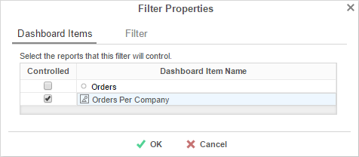
Filter
In the Filter Tab, specify what data should be used and how the interactive filter should appear on the dashboard.
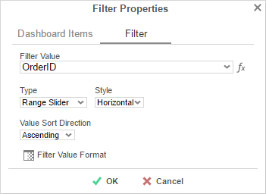
- Use the Filter Value dropdown to select the data field that should be filtered.
The filter can be applied to a calculation instead of a data field by using the formula button ().
- Use the Type dropdown to specify what kind of interactive filter to display:
  - Single Choice: A dropdown with the possible values of the filter.
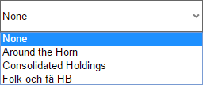

  - Multiple Choice: All possible values for the filter presented with check boxes to select a one or more values.
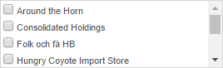

  - Single Slider: Select the filter value by sliding a point along a scale.
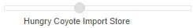

  - Range Slider: A scale that displays values between two points.
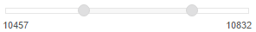
- In the Style dropdown, specify if the filter should be Vertically or Horizontally oriented.
- In the Value Sort Direction dropdown, specify if the filter values should appear from least to greatest (Ascending) or vice versa (Descending).
- Press the Format button () to open the format menu and specify how the filter values should be displayed.

Toolbar

The toolbar contains the buttons and menus used to modify the dashboard.

Saving Dashboards
The dashboard can be saved by pressing the save button ().

Undo/Redo
Actions can be undone by pressing the undo button () or using the keyboard shortcut Ctrl+Z. Undone actions can be redone by pressing the redo button () or using the keyboard shortcut Ctrl+Y.

Borders
To create borders around a dashboard item, select it and press the Format icon ().
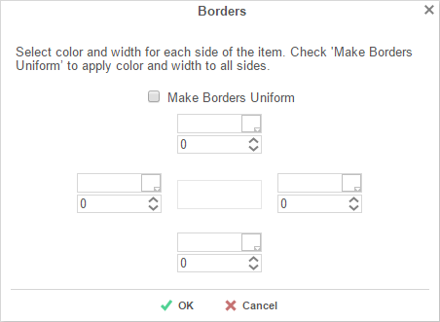
- Uncheck 'Make Borders Uniform' to modify specific edges.
- To widen the borders, either key in a value or use the arrows in the width box.
- To change the color, either select a color from the drop-down or enter a hex value.
Borders can be rounded by pressing the 'Rounded Edges' button () in the toolbar.

Formatting Dashboard Text
Text items can be formatted using buttons in the toolbar. A text item must be selected for these changes to be applied.
Font
- To change the font, use the font drop-down (). The font names appear in the style that they represent.
- The B, I, and U icons make the font bold, italicized, and underlined, respectively.
- Text size can be controlled using the up and down arrows on font size menu ().
Color
- To change the text color, press the Foreground Color button ( ), and then select a color or enter a hex value into the Foreground box. Press the clear button () to revert to the default color.
- To change the background color, press the Background Color button () and then select a color or enter a hex value into the Background box. Press the clear button () to revert to the default color.
Alignment
- Text can be aligned to the top, center, or bottom of a cell using the vertical alignment buttons.
- Text can be centered, justified, or aligned to the left or right of a cell using the horizontal alignment buttons.

Renaming Dashboards
To change the name of a dashboard, select 'Rename' in the Toolbar drop-down menu. Modify the name and select the folder where the Dashboard will be saved. Press .

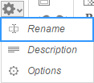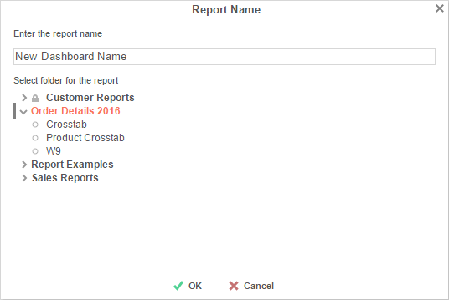

Changing Description
The dashboard description appears at the bottom of the Main Menu. Though dashboard descriptions are optional, they are utilized when searching reports. To modify a dashboard description, select 'Description' in the Toolbar drop-down menu. Fill in the description and press .

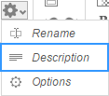

Dashboard Options
Select 'Options' in the Toolbar drop-down menu to open the Dashboard Options Window.

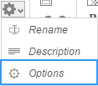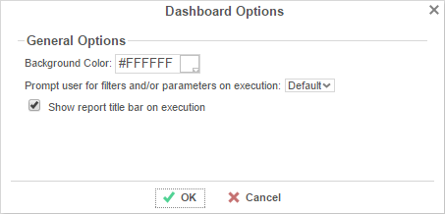

- To change the background color of the dashboard canvas, select a color or enter a hex value.
- Check 'Show report title bar on execution' to allow reports on an executed dashboard to be selected and modified.

Running Dashboards
Dashboards can be run from the Main Menu or the Toolbar. To run a dashboard from the Main Menu, first select the dashboard you want to run and press the 'Run Selected Report' button.

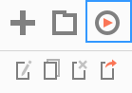

When editing a dashboard, press the 'Run Dashboard' button to run the dashboard.
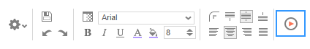

Chained Reports

Chained Reports comprise multiple existing reports, which run in a specific order and compile into a single document. They are a simplified method for managing reports en masse.
Chained Reports can only be exported as downloadable file types (Excel, PDF, RTF, or CSV) Viewer-only features are not supported in chained reports.

Chained Reports do not support Excel templates. Additionally, all RTF reports in a chained report must have a common template.

The Scheduler does not support Chained Reports.

Chained Report Wizard
The Chained Report Wizard is an interactive tool which allows you to create and edit Chained Reports.
To navigate the wizard, either select the desired tab, or use the and buttons.
To save a Chained Report, press the save button.
The Chained Report Wizard has three sub tabs. The Name and Reports tabs must be completed.

Name Tab
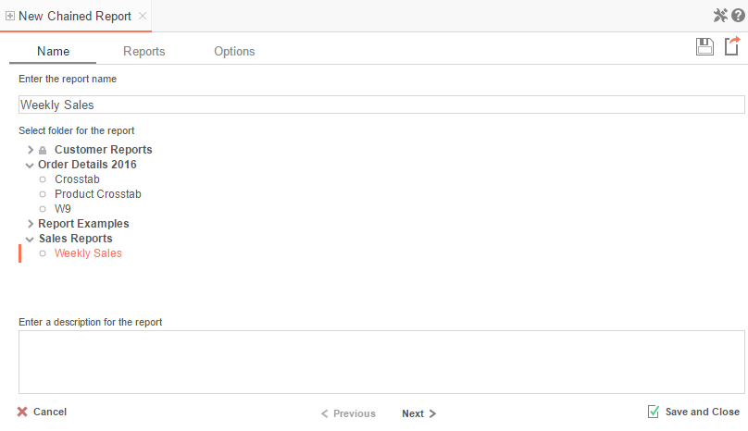
In the Name tab, enter a report name and select the Folder to save the report.
The report name can be up to 255 characters long. Avoid special characters such as ? : / \ * “ < >.
A report's description appears at the bottom of the Main Menu when it is selected. You may also search by a report's description text.
You cannot create a report inside a folder that is read-only ().

Reports Tab
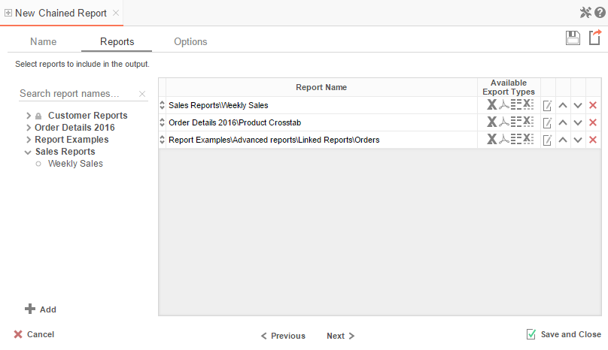

In the Reports Tab, select the reports you wish to include in the Chained Report.

You can only include Standard Reports, Express Reports, and CrossTab reports in a Chained Report.
- To add a report, either drag and drop it to the selection pane, or select the report and press the button, or double-click the report.
- To search for a report, enter the terms into the search bar ().
- A report may be able to export only in certain formats. Available formats for each report are listed under Available Export Types. A Chained Report which contains a format restriction on one of its reports cannot export to that format.
- If a report has 'Prompt for Value' filters or parameters, use the 'Edit Report Options' button () to access the Report Properties menu, where you can specify how to prompt for these filter values:
  - Common Prompt – When the Chained Report executes, you will be prompted for a value that is used by all of the reports on the Chained Report that have filter prompts on this Data Field.
  - Report Prompt – When the Chained Report executes, you will be prompted for a value to filter this specific report.
  - Assign Value – Assign the filter a specific value. This filter will not prompt when the Chained Report executes.
- Use the up () and down () arrows to indicate the order of the reports.
- To remove a report, press the delete button ().

Options Tab
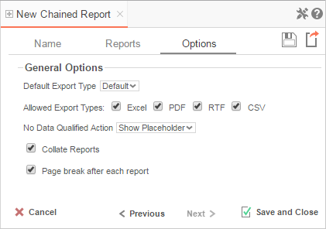
The Options Tab allows you to control various report options for the chained report.
General Options
- Use the 'Default Export Type' menu to specify the default format for the report.
- Output types may be disabled by unchecking the boxes for 'Allowed Export Types'.
- Use the 'No Data Qualified Action' menu to select what to display if no data qualifies for a report.
  - Skip Report – Display the next qualified report.
  - Show Placeholder – Show a placeholder message in place of the report.
- Check the box for 'Collate Reports' to enable report collation. Reports must have a common sort field in order to collate. The values of each sort are used to filter each report and re-execute them in turn.
With collation Disabled (default) the reports output in the following manner:
Report 1, Page 1
Report 1, Page 2
Report 2, Page 1
Report 2, Page 2

With collation Enabled the reports output in the following manner:
Report 1, Sort group 1
Report 2, Sort group 1
Report 1, Sort group 2
Report 2, Sort group 2

- Check the box for 'Page break after each report' to cause new reports to start on a new page.

Formulas

Formulas allow you to do calculations, parse strings, insert images, and much more. Formulas are the composition of functions, parameters, Data Fields, and references to other cells.

Functions
Functions must begin with an '=' sign. You can use more than one function in each cell. Additionally, there are logical functions that allow for if/then/else conditional statements. Functions include date, financial, information, logical, mathematical, statistical, text, and data.
Function names are not case sensitive (aggSum is the same as AggSum).
For a complete list of functions, including description, remarks and examples, refer to Full Description of Functions.

Parameters
To call a parameter, enter its name between '@' signs. Parameters can be used in functions or alone in a cell following an '=' sign.
Parameters are case sensitive (pageNumber is not the same as pagenumber). Parameter names can not contain the '@' symbol.
For a list of parameters and their descriptions, see Full Description of Parameters. Your administrator has the ability to create additional parameters.

Data Fields
To use a Data Field as part of a function, enter the name between curly brackets (E.g.{Orders.OrdersID}).

Referencing a Cell
To reference another cell's value, enter the column name with a capital letter and the row number between square brackets (E.g. [A2]). A cell reference can be used in functions or alone in a cell following an '=' sign.
Cell references will update if rows or columns are added or deleted; however, dragging a cell will not update cell references. This may cause errors in your formulas.

Using Formulas
Formulas can either be entered in the Formula Editor or manually keyed into cells.

Formula Editor
  - Navigate to the Report Designer.
  - Click in the cell in which you want the formula to appear.
  - Press the Formula Editor Button ().
  - Create the desired formula by selecting the desired functions and pressing or by dragging and dropping the function into the Summary box.
When embedding functions, begin with the outermost function and add them moving inward. (E.g. To get =TRUNCATE(SQRT(162)), first add Truncate then the Square Root function.)
  - Press .

Manual Formulas
To manually add formulas:
- Navigate to the Report Designer.
- Double click in the desired cell.
- Enter the formula.
- Save the report.

Full Description of Parameters

pageNumber:
Description | Returns the number of the current page.
Remark | For RTF output, pageNumber cannot be used with other formulas.
Example | =@pageNumber@ will display the current page number for all output types.  ='pg. ' & @pageNumber@ will display 'pg.' followed by the page number for default and PDF outputs.  NOTE. Does not work with chained reports.
reportName:
Description | Returns the name of the report.
reportFullName:
Description | Returns the file path of the report.
Example | For a report named Transcripts in a Folder named Student Documents, @reportFullName@ would return Student Documents/Transcripts.

Quick List of Functions
Aggregate:
AggAvg
AggCount
AggDistinctCount
AggMax
AggMin
AggSum

Financial:
DB
DDB
Fv
Intrate
Ipmt
Nper
Npv
Pmt
Ppmt
Pv
Rate
Sln
Syd

Date:
Date
DateAdd
DateDiff
DateValue
Day
Days360
GlobalDateFormat
GlobalDateTimeFormat
Hour
Minute
Month
Now
Second
Time
TimeFormat1
TimeValue
Today
Year
Arithmetic & Geometric:
Absolute
Acos
Acosh
Asin
Asinh
Atan
Atan2
Atanh
Ceiling
Cos
Cosh
Even
Exp
Fixed
Floor
Int
Ln
Log
Log10
Mod
Odd
Pi
Power
Product
Quotient
Rand
Sin
Sinh
Sqrt
Tan
Tanh
Truncate

Formatting:
Bold
Italic
Underline
String:
Concatenate
Left
Len
Lower
Mid
NewLine
Replace
Right
Trim
Upper
Value
Operators:
&
+
-
*
/
Logical:
And
False
If
Not
Or
Switch
True
Database & Data Type:
IsEven
IsLogical
IsNonText
IsNumber
IsOdd
IsText
Null
Type
Other:
CellValue
FilterValue
Hyperlink
LoadImage
StripHTMLTag
ExcelFormula

Full Description of Functions
This section provides detailed information on the available functions.
Types of Functions:
- Aggregate Functions
- Logical Functions
- Date Functions
- Financial Functions
- Database and Data Type Functions
- Arithmetic and Geometric Functions
- String Functions
- Formatting Functions
- Other Functions

Aggregate Functions
Aggregate functions can be executed on non-numeric fields.
AggAvg:
Description | Returns the average of the values in the field.
Remark | Only accepts Data Fields as input.
Example | E.g. aggAvg({OrderDetail.Quantity}) - returns the average quantity of sales orders.
AggCount:
Description | Returns the number of unique entities in the Data Category.
Remark | The aggCount function uses the Data Category, not the Data Field. For example, the function “aggCount( {Officer.Salary} )” counts the number of Officers. You could replace “Officer.Salary” with any other field in the Officer Data Category and the function would still count the number of officers.  Only accepts Data Fields as input.
Example | E.g. aggCount( {Orders.ProductPrice}) - returns the number of sales orders.
AggDistinctCount:
Description | Returns the number of unique values in the Data Field.
Remark | Unlike aggCount, aggDistinctCount returns the number of unique values of the Data Field.  Only accepts Data Fields as input.
Example | E.g. aggDistinctCount({OrderDetail.Quantity}) - returns the number distinct quantities in an order.
AggMax:
Description | Returns the maximum value in the field.
Remark | Only accepts Data Fields as input.
Example | E.g. aggMax({OrderDetail.Discount}) - returns the largest discount.
AggMin:
Description | Returns the minimum value in the field.
Remark | Only accepts Data Fields as input.
Example | E.g. aggMin({OrderDetail.Discount}) - returns the smallest discount.
AggSum:
Description | Returns the sum of the values in the field.
Remark | Only accepts Data Fields as input.
Example | E.g. aggSum({OrderDetail.Quantity}) - returns the total quantity of units ordered.

Logical Functions
Logical functions can be used to handle conditional information.
And:
Description | Returns TRUE if all its arguments are TRUE; returns FALSE if any argument is FALSE.
Remark | The arguments must evaluate to TRUE or FALSE.  The And function can take more than two arguments as input.
Example | E.g. AND(2+2=4, 4+0=4, 2+3=6) – returns FALSE.
False:
Description | Returns the logical value FALSE.
Remark | You can also type the word FALSE directly onto the worksheet or into a formula; it is interpreted as the logical value FALSE.
If:
Description | Takes three arguments as input. Returns the second argument if the first evaluates to TRUE. Otherwise returns the third argument.
Remark | The first input must evaluate to TRUE or FALSE.
Example | E.g. if({OrderDetail.Price}= 0,'FREE',{OrderDetail.Price}) - returns FREE if the price is 0, otherwise it returns the price.
Not:
Description | Reverses the value of its argument.
Remark | Argument should evaluate to TRUE or FALSE.
Example | E.g. Not(FALSE) - returns TRUE.
Or:
Description | Returns TRUE if any argument is TRUE.
Remark | The arguments must evaluate to logical values such as TRUE or FALSE.  The 'Or' function can take more than two arguments as input.
Example | E.g. OR(2+2=4, 4+0=8, 2+3=6) - returns TRUE.
Switch:
Description | This functions should be used instead of placing if() function inside of if() functions.  Takes any even number of inputs arguments.
Remark | The 1st argument will be the test value to compare to.  The 2nd argument will be returned if none of the comparisons return true.  The 3rd, 5th, 7th… arguments will be compared to the 1st argument. When the first match occurs the following argument will be returned.  For example if argument 3 matches argument 1 then the 4th argument will be returned.
Example | E.g. Switch({Categories.CategoryName},”NOT FOUND”, “Beverages”, “Drink up!”, “Condiments”, “Enhance”, “Confections”, “Sweet Tooth”) – returns a string based on the Category Name.
True:
Description | Returns the logical value TRUE.
Remark | You can also type the word TRUE directly onto the worksheet or into a formula; it is interpreted as the logical value TRUE.

Date Functions
Date functions can be used to do calculations and formatting on Date values.
Date:
Description | Creates a date value from three numeric values.
Remark | This function should be used to represent a date to other functions instead of representing a date as text.
Example | E.g. Date(2012,7,4) – returns the date July 4th, 2012.
DateAdd:
Description | Returns the sum of a date and a quantity of time.
Remark | DateAdd takes three input arguments.  A string representing the interval you want to add. The interval can be. "yyyy" (year), "y" (days), "d" (days), "w" (weeks), "m" (months), "h" (hours), "n" (minutes), "s" (seconds), "ww" (weeks of year), or "q" (quarters).  A real number representing how much time you want to add to the date.  A DateValue.
Example | E.g. DateAdd('h',1,Now()) – returns the date and time 1 hour from now.
DateDiff:
Description | Returns the amount of time between two dates.
Remark | DateDiff takes three input arguments.  A string representing the interval you want to add. The interval can be. "yyyy" (year), "y" (days), "d" (days), "w" (weeks), "m" (months), "h" (hours), "n" (minutes), "s" (seconds), "ww" (weeks of year), or "q" (quarters).  The first date value.  The second date value.
Example | E.g. DateDiff(“yyyy”, date(1787,9,17), now())- returns the number of years since the signing of the United States' Constitution
DateValue:
Description | Converts a date represented as text (e.g. '30-jan-2008') to a date value.
Remark | Any time information in the Date_text is ignored. The ticks returned always represent a time-of-day of Midnight (in the server's local time).  If the year portion of Date_text is omitted, DATEVALUE uses the current year on the server.  Use this function when comparing two dates.
Example | E.g. DateValue(30-jun-2011) – returns the date object 6/30/2011.  E.g. DateValue({Orders.OrderDate}) > DateValue(Today()) – compares the order date to today.
Day:
Description | Returns the day portion of a date as a whole number.
Remark | Values returned by the YEAR, MONTH and DAY functions will be Gregorian Calendar values regardless of the display format for the supplied date value.
Example | E.g. Day({Appointment.Date}) - returns the day of the appointment.

Day360:
Description | Returns the number of days between two dates based on a 360-day year.
Remark | Often used in accounting applications.  Date360 takes three input arguments.  The first date value.  The second date value.  Optional: True/False indicating to use European or American method of computation. If not included the American method is used.
Example | E.g. Day360({Appointment.Date},today())- returns the number of days between today and the appointment date.

GlobalDateFormat:
Description | Returns a DATE value whose format is based on the session format.
Remark | Only accepts data objects as input.
Example | E.g. GlobalDateFormat({Appointment.Date})- returns the date of the appointment based on the session format.

GlobalDateTimeFormat:
Description | Returns a DATETIME value whose format is based on the session format.
Remark | Only accepts data objects as input.
Example | E.g. GlobalDateTimeFormat({Appointment.Date})- returns the date and time of the appointment based on the session format.
Hour:
Description | Returns the hour of a time value ranging from 0 (12:00 AM) to 23 (11:00 PM).
Remark | Times may be entered as text strings within quotation marks or a date time value.
Example | E.g. Hour("2:50:05PM") – returns 14.
Minute:
Description | Returns the Minute of a time value ranging from 0 to 59.
Remark | Times may be entered as text strings within quotation marks or a date time value.
Example | E.g. Minute("2:50:05PM") – returns 50.
Month:
Description | Returns the month portion of a date as a whole number, ranging from 1 (January) to 12 (December).
Remark | Values returned by the YEAR, MONTH and DAY functions will be Gregorian Calendar values regardless of the display format for the supplied date value.
Example | E.g. Month({Appointment.Date})- returns the month of the appointment.
Now:
Description | Returns today's date and time (in local server time).
Remark | If embedding in other functions use Now('false').
Example | E.g. Now() - returns the current date and time.  Now('false') returns the current date and time formatted MM/dd/yyyy hh:mm:ss.
Second:
Description | Returns the seconds of a time value ranging from 0 to 59.
Remark | When a time omits seconds, 0 (zero) is assumed.  Times may be entered as text strings within quotation marks or a date time value.
Example | E.g. Second("2:50:05PM") – returns 5.
Time:
Description | Returns the number of ticks in a period of hours, minutes and seconds.
Remark | This function should be used to represent a time to other functions instead of representing a time as text.  Time takes three input arguments.  Hours  Minutes  Seconds
Example | E.g. Time(14,50,5) – returns 534050000000.
TimeFormat1:
Description | Returns the time component of a DATETIME input as a time object.
Remark | This function should be used to represent a time to other functions instead of representing a time as text.  The return value of this function should be formatted as Text. Cells formatted as General or Date may contain an erroneous placeholder date.
Example | E.g. Timeformat1({Appointment.Date}) – returns the time component of the appointment date in the format 'hh:mm tt'.
TimeValue:
Description | Convert a time represented in text (i.e., “HH-mm-ss”) into time values that can be passed to other functions.
Remark | Acceptable formats include "5:55 PM" and "17:55". A time separator is mandatory ("17:00" is acceptable, "1700" is not).  If AM/PM is not present AM is assumed. When specifying AM or PM, do not use periods ("A.M." or "P.M." will return an error).  The return value of this function should be formatted as Text. Cells formatted as General or Date may contain an erroneous placeholder date.
Example | E.g. TimeValue(Time(14,50,5)) – returns the time object 14:50:05.
Today:
Description | Returns today's date with no time component.
Remark | If embedding in other functions use Today('false').  See the Now() function to get today's date with its time component.
Example | E.g. Today()- returns the current date.  Today('false') returns the current date formatted as MM/dd/yyyy.
Year:
Description | Returns the year portion of a date as a whole number, ranging from 1 to 9999.
Example | E.g. Year(today()) – returns 2011.

Financial Functions
DB:
Description | Returns the depreciation of an asset for a specified period using the fixed-declining balance method. Cost is the initial cost of the asset. Salvage is the value at the end of the depreciation (sometimes called the salvage value of the asset). Life is the number of periods over which the asset is being depreciated (sometimes called the useful life of the asset). Period is the period for which you want to calculate the depreciation. Period must use the same units as life. Month is the number of months in the first year. If month is omitted, it is assumed to be 12.
Remark | The fixed-declining balance method computes depreciation at a fixed rate. DB uses the following formulas to calculate depreciation for a period: (cost - total depreciation from prior periods) * rate where: rate = 1 - ((salvage / cost) ^ (1 / life)), rounded to three decimal places. Depreciation for the first and last periods is a special case. For the first period, DB uses this formula: cost * rate * month / 12. For the last period, DB uses this formula: ((cost - total depreciation from prior periods) * rate * (12 - month)) / 12.
Example | Data Assumptions: Initial cost=1,000,000 (A2); Salvage value=100,000 (A3); Lifetime in years=6 (A4).  E.g. DB([A2],[A3],[A4],1,7) - Depreciation in first year, with only 7 months calculated (186,083.33).  E.g. DB([A2],[A3],[A4],2,7) - Depreciation in second year (259,639.42).  E.g. DB([A2],[A3],[A4],3,7) - Depreciation in third year (176,814.44).  E.g. DB([A2],[A3],[A4],4,7) - Depreciation in fourth year (120,410.64).  E.g. DB([A2],[A3],[A4],5,7) - Depreciation in fifth year (81,999.64).  E.g. DB([A2],[A3],[A4],6,7) - Depreciation in sixth year (55,841.76).  E.g. DB([A2],[A3],[A4],7,7) - Depreciation in seventh year, with only 5 months  calculated (15,845.10).
DDB:
Description | Returns the depreciation of an asset for a specified period using the double-declining balance method or some other method you specify. Cost is the initial cost of the asset. Salvage is the value at the end of the depreciation (sometimes called the salvage value of the asset). Life is the number of periods over which the asset is being depreciated (sometimes called the useful life of the asset). Period is the period for which you want to calculate the depreciation. Period must use the same units as life. Factor is the rate at which the balance declines. If factor is omitted, it is assumed to be 2 (the double-declining balance method).  All five arguments must be positive numbers.
Remark | The double-declining balance method computes depreciation at an accelerated rate. Depreciation is highest in the first period and decreases in successive periods. DDB uses the following formula to calculate depreciation for a period: ((cost-salvage) - total depreciation from prior periods) * (factor/life). Change factor if you do not want to use the double-declining balance method. Use the VDB function if you want to switch to the straight-line depreciation method when depreciation is greater than the declining balance calculation.
Example | Data Assumptions: Initial cost=2400 (A2); Salvage value=300 (A3); Lifetime in years=10 (A4).  E.g. DDB([A2],[A3],[A4]*365,1) - First day's depreciation.  E.g. DDB([A2],[A3],[A4]*12,1,2) - First month's depreciation (40.00).  E.g. DDB([A2],[A3],[A4],1,2) - First year's depreciation (480.00).  E.g. DDB([A2],[A3],[A4],10) - Tenth year's depreciation.  The results are rounded to two decimal places.
FV:
Description | Returns the future value of an investment based on periodic, constant payments and a constant interest rate.
Remark | For a more complete description of the arguments in FV and for more information on annuity functions, see PV (Above). Rate is the interest rate per period. Nper is the total number of payment periods in an annuity. Pmt is the payment made each period; it cannot change over the life of the annuity. Typically, pmt contains principal and interest but no other fees or taxes. If pmt is omitted, you must include the pv argument. Pv is the present value, or the lump-sum amount that a series of future payments is worth right now. If pv is omitted, it is assumed to be 0 (zero), and you must include the pmt argument. Type is the number 0 or 1 and indicates when payments are due. If type is omitted, then it is assumed to be 0. Make sure that you are consistent about the units you use for specifying rate and nper. If you make monthly payments on a four-year loan at 12 percent annual interest, use 12%/12 for rate and 4*12 for nper. If you make annual payments on the same loan, use 12% for rate and 4 for nper. For all the arguments, cash you pay out, such as deposits to savings, is represented by negative numbers; cash you receive, such as dividend checks, is represented by positive numbers.
Example | Data Assumptions: Annual interest rate=6% (A2); Number of payments=10 (A3); Amount of the payment=-200 (A4); Present value=-500 (A5); Payment is due at the beginning of the period=1 (A6)...(see above).  E.g. FV([A2]/12, [A3], [A4], [A5], [A6]) – returns future value of an investment with these terms (2,581.40).
Intrate:
Description | Returns the interest rate for a fully invested security.  Dates should be entered by using the DATE function, or as results of other formulas or functions.  For example, use DATE(2008,5,23) for the 23rd day of May, 2008. Problems can occur if dates are entered as text. Settlement is the security's settlement date. The security settlement date is the date after the issue date when the security is traded to the buyer. Maturity is the security's maturity date. The maturity date is the date when the security expires. Investment is the amount invested in the security. Redemption is the amount to be received at maturity. Basis is the type of day count basis to use.
Remark | The settlement date is the date a buyer purchases a coupon, such as a bond. The maturity date is the date when a coupon expires. For example, suppose a 30-year bond is issued on January 1, 2008, and is purchased by a buyer six months later. The issue date would be January 1, 2008, the settlement date would be July 1, 2008, and the maturity date would be January 1, 2038, which is 30 years after the January 1, 2008, issue date. Settlement, maturity, and basis are truncated to integers. If settlement or maturity is not a valid date, INTRATE returns the #VALUE! error value. If investment = 0 or if redemption = 0, INTRATE returns the #NUM! error value. If basis < 0 or if basis > 4, INTRATE returns the #NUM! error value. If settlement = maturity, INTRATE returns the #NUM! error value.
Example | Data Assumptions...Settlement date=February 15, 2008 (A2); Maturity date=May 15, 2008 (A3); Investment=1,000,000 (A4); Redemption value=1,014,420 (A5); Actual/360 basis (see above)=2 (A6).  E.g. INTRATE([A2],[A3],[A4],[A5],[A6]) - returns discount rate, for the terms of the bond above (0.05768 or 5.77%).
Ipmt:
Description | Returns the interest payment for a given period for an investment based on periodic, constant payments and a constant interest rate. For a more complete description of the arguments in IPMT and for more information about annuity functions, see PV. Rate is the interest rate per period. Per is the period for which you want to find the interest and must be in the range 1 to nper. Nper is the total number of payment periods in an annuity. Pv is the present value, or the lump-sum amount that a series of future payments is worth right now. Fv is the future value, or a cash balance you want to attain after the last payment is made. If fv is omitted, it is assumed to be 0 (the future value of a loan, for example, is 0). Type is the number 0 or 1 and indicates when payments are due. If type is omitted, it is assumed to be 0.
Remark | Make sure that you are consistent about the units you use for specifying rate and nper. If you make monthly payments on a four-year loan at 12 percent annual interest, use 12%/12 for rate and 4*12 for nper. If you make annual payments on the same loan, use 12% for rate and 4 for nper. For all the arguments, cash you pay out, such as deposits to savings, is represented by negative numbers; cash you receive, such as dividend checks, is represented by positive numbers.
Example | Data Assumptions: Annual interest=10% (A2); Period for which you want to find the interest=1 (A3); Years of loan=3 (A5); Present value of loan=8000 (A6).  E.g. IPMT([A2]/12, [A3]*3, [A4], [A5]) - Interest due in the first month for a loan with the terms above (-22.41).  The interest rate is divided by 12 to get a monthly rate. The years the money is paid out is multiplied by 12 to get the number of payments.
Nper:
Description | Returns the number of periods for an investment based on periodic, constant payments and a constant interest rate. For a more complete description of the arguments in NPER and for more information about annuity functions, see PV (above). Rate is the interest rate per period. Pmt is the payment made each period; it cannot change over the life of the annuity. Typically, pmt contains principal and interest but no other fees or taxes. Pv is the present value, or the lump-sum amount that a series of future payments is worth right now. Fv is the future value, or a cash balance you want to attain after the last payment is made. If fv is omitted, it is assumed to be 0 (the future value of a loan, for example, is 0). Type is the number 0 or 1 and indicates when payments are due.
Remark | Set Type equal to 0 (or omitted) if payments are due at the end of the period; Set type equal to 1 if payments are due at the beginning of the period.
Example | Data Assumptions: Annual interest rate=12% (A2); Payment made each period=-100 (A3); Present Value=-1000 (A4); Future Value=10000 (A5); Payment is due at the beginning of the period=1 (A6).  E.g. NPER([A2]/12, [A3], [A4], [A5], 1) - Periods for the investment with the above terms (60).  E.g. NPER([A2]/12, [A3], [A4], [A5]) - Periods for the investment with the above terms, except payments are made at the beginning of the period (60).  E.g. NPER([A2]/12, [A3], [A4]) - Periods for the investment with the above terms, except with a future value of 0 (-9.578).
Npv:
Description | Calculates the net present value of an investment by using a discount rate and a series of future payments (negative values) and income (positive values). Rate is the rate of discount over the length of one period. Value1, value2, ...are 1 to 29 arguments representing the payments and income. Value1, value2, ...must be equally spaced in time and occur at the end of each period. NPV uses the order of value1, value2, ...to interpret the order of cash flows. Be sure to enter your payment and income values in the correct sequence. Arguments that are numbers, empty cells, logical values, or text representations of numbers are counted; arguments that are error values or text that cannot be translated into numbers are ignored. If an argument is an array or reference, then only numbers in that array or reference are counted. Empty cells, logical values, text, or error values in the array or reference are ignored.
Remark | The NPV investment begins one period before the date of the value1 cash flow and ends with the last cash flow in the list. The NPV calculation is based on future cash flows. If your first cash flow occurs at the beginning of the first period, the first value must be added to the NPV result, not included in the values arguments. For more information, see the example below. NPV is similar to the PV function (present value). The primary difference between PV and NPV is that PV allows cash flows to begin either at the end or at the beginning of the period. Unlike the variable NPV cash flow values, PV cash flows must be constant throughout the investment. For information about annuities and financial functions, see PV. NPV is also related to the IRR function (internal rate of return). IRR is the rate for which NPV equals zero: NPV(IRR(...), ...) = 0.
Example | Data Assumptions: Annual discount rate=10% (A2); Initial cost of investment one year from today=-10,000 (A3); Return from first year=3,000 (A5); Return from second year=4,200 (A6).  E.g. NPV([A2], [A3], [A4], [A5], [A6]) - Net present value of this investment (1,188.44) ...In the preceding example, you include the initial $10,000 cost as one of the values, because the payment occurs at the end of the first period.
Pmt:
Description | Calculates the payment for a loan based on constant payments and a constant interest rate. For a more complete description of the arguments in PMT, see the PV function. Rate is the interest rate for the loan. Nper is the total number of payments for the loan. Pv is the present value, or the total amount that a series of future payments is worth now; also known as the principal. Fv is the future value, or a cash balance you want to attain after the last payment is made. If fv is omitted, it is assumed to be 0 (zero), that is, the future value of a loan is 0. Type is the number 0 (zero) or 1 and indicates when payments are due.
Remark | The payment returned by PMT includes principal and interest but no taxes, reserve payments, or fees sometimes associated with loans. Make sure that you are consistent about the units you use for specifying rate and nper. If you make monthly payments on a four-year loan at an annual interest rate of 12 percent, use 12%/12 for rate and 4*12 for nper. If you make annual payments on the same loan, use 12 percent for rate and 4 for nper.
Example | Data Assumptions: Annual interest rate=8% (A2); Number of months of payments=10 (A3); Amount of loan=10000 (A4).  E.g. PMT([A2]/12, [A3], [A4]) - Monthly payment for a loan with the above terms (-1,037.03).  E.g. PMT([A2]/12, [A3], [A4], 0, 1) - Monthly payment for a loan with the above terms, except payments are due at the beginning of the period (-1,030.16).
Ppmt:
Description | Returns the payment on the principal for a given period for an investment based on periodic, constant payments and a constant interest rate. For a more complete description of the arguments in PPMT, see PV (above). Rate is the interest rate per period. Per specifies the period and must be in the range 1 to nper. Nper is the total number of payment periods in an annuity. Pv is the present value—the total amount that a series of future payments is worth now. Fv is the future value, or a cash balance you want to attain after the last payment is made. If fv is omitted, it is assumed to be 0 (zero), that is, the future value of a loan is 0. Type is the number 0 or 1 and indicates when payments are due.
Remark | Make sure that you are consistent about the units you use for specifying rate and nper. If you make monthly payments on a four-year loan at 12 percent annual interest, use 12%/12 for rate and 4*12 for nper. If you make annual payments on the same loan, use 12% for rate and 4 for nper.
Example | Data Assumptions: Annual interest rate=10% (A2); Number of years in the loan=2 (A3); Amount of loan=2000 (A4).  E.g. PPMT([A2]/12, 1, [A3]*12, [A4]) - Payment on principle for the first month of loan (-75.62).  The interest rate is divided by 12 to get a monthly rate. The number of years the money is paid out is multiplied by 12 to get the number of payments.
Pv:
Description | Returns the present value of an investment. The present value is the total amount that a series of future payments is worth now. For example, when you borrow money, the loan amount is the present value to the lender. Rate is the interest rate per period. For example, if you obtain a car loan at a 10% annual interest rate and make monthly payments, your interest rate per month is 10%/12, or 0.83%. You would enter 10%/12, or 0.83%, or 0.0083, into the formula as the rate. Nper is the total number of payment periods in an annuity. For example, if you get a four-year car loan and make monthly payments, your loan has 4*12 (or 48) periods. You would enter 48 into the formula for nper. Pmt is the payment made each period and cannot change over the life of the annuity. Typically, pmt includes principal and interest, but no other fees or taxes. For example, the monthly payments on a $10,000, four-year car loan at 12 percent are $263.33. You would enter -263.33 into the formula as the pmt. If pmt is omitted, you must include the fv argument. Fv is the future value, or a cash balance you want to attain after the last payment is made. If fv is omitted, then it is assumed to be 0 (the future value of a loan, for example, is 0). For example, if you want to save $50,000 to pay for a special project in 18 years, then $50,000 is the future value. You could then make a conservative guess at an interest rate and determine how much you must save each month. If fv is omitted, then you must include the pmt argument. Type is the number 0 or 1 and indicates when payments are due.
Remark | Make sure that you are consistent about the units you use for specifying rate and nper. If you make monthly payments on a four-year loan at 12 percent annual interest, use 12%/12 for rate and 4*12 for nper. If you make annual payments on the same loan, use 12% for rate and 4 for nper. In annuity functions, cash you pay out, such as a deposit to savings, is represented by a negative number; cash you receive, such as a dividend check, is represented by a positive number. For example, a $1,000 deposit to the bank would be represented by the argument -1000 if you are the depositor and by the argument 1000 if you are the bank.
Example | Data Assumptions: Money paid out of an insurance annuity at the end of every month=500 (A2); 8% is the interest rate earned on the money paid out (A3); 20 is the number of years the money will be paid out (A4).  E.g. Pv([A3]/12, 12*[A4], [A2], , 0) - Present value of an annuity with the stated terms (-59,777.15). The result is negative because it represents money that you would pay in an outgoing cash flow. If you are asked to pay ($60,000) for the annuity, you would determine this would not be a good investment because the present value of the annuity (59,777.15) is less than what you are asked to pay.  The interest rate is divided by 12 to get a monthly rate. The years the money is paid out is multiplied by 12 to get the number of payments.
Rate:
Description | Returns the interest rate per period of an annuity. RATE is calculated by iteration and can have zero or more solutions. If the successive results of RATE do not converge to within 0.0000001 after 20 iterations, RATE returns the #NUM! error value. For a complete description of the arguments nper, pmt, pv, fv, and type, see PV. Nper is the total number of payment periods in an annuity. Pmt is the payment made each period and cannot change over the life of the annuity. Typically, pmt includes principal and interest but no other fees or taxes. If pmt is omitted, you must include the fv argument. Pv is the present value—the total amount that a series of future payments is worth now. Fv is the future value, or a cash balance you want to attain after the last payment is made. If fv is omitted, it is assumed to be 0 (the future value of a loan, for example, is 0). Type is the number 0 or 1 and indicates when payments are due.
Remark | Guess is your guess for what the rate will be. If you omit guess, it is assumed to be 10 percent. If RATE does not converge, try different values for guess. RATE usually converges if guess is between 0 and 1. Make sure that you are consistent about the units you use for specifying guess and nper. If you make monthly payments on a four-year loan at 12 percent annual interest, use 12%/12 for guess and 4*12 for nper. If you make annual payments on the same loan, use 12% for guess and 4 for nper.
Example | Data Assumptions: Years of the loan=4 (A2); Monthly payment=-200 (A3); Amount of the loan=8000 (A4).  E.g. Rate([A2]*12, [A3], [A4]) - Monthly rate of the loan with the stated terms (1%).  The number of years of the loan is multiplied by 12 to get the number of months.
Sln:
Description | Returns the straight-line depreciation of an asset for one period.
Remark | Cost is the initial cost of the asset. Salvage is the value at the end of the depreciation (sometimes called the salvage value of the asset). Life is the number of periods over which the asset is depreciated (sometimes called the useful life of the asset).
Example | Data Assumptions: Cost=30,000 (A2); Salvage value=7,500 (A3); Years of useful life=10 (A4).  E.g. Sln([A2], [A3], [A4]) - The depreciation allowance for each year (2,250).
Syd:
Description | Returns the sum-of-years' digits depreciation of an asset for a specified period.
Remark | Cost is the initial cost of the asset. Salvage is the value at the end of the depreciation (sometimes called the salvage value of the asset). Life is the number of periods over which the asset is depreciated (sometimes called the useful life of the asset). Per is the period and must use the same units as life.
Example | Data Assumptions: initial cost=30,000 (A2); Salvage value=7,500 (A3); Lifespan in years=10 (A4).  E.g. Syd([A2], [A3], [A4], 1) - Yearly depreciation allowance for the first year (4,090.91).  E.g. Syd([A2], [A3], [A4], 10) - Yearly depreciation allowance for the tenth year (409.09).

Database & Data Type Functions
DataRowCount:
Description | Returns the number of rows retrieved from the data source when executing the report.
Example | Suppose report is run to retrieve basic information on 10 employees  E.g. DataRowCount() should return 10.
IsEven:
Description | Checks if a value is an even number.
Example | E.g. IsEven([A1]) – returns TRUE if the cell [A1] contains an even number, FALSE otherwise.
IsLogical:
Description | Checks if a value is TRUE or FALSE.
Example | E.g. IsLogical([A1]) – returns TRUE if the cell [A1] contains TRUE/FALSE, FALSE otherwise.
IsNonText:
Description | Checks if a value is not text.
Remark | Non Text values include dates, numbers, images and blank cells.
Example | E.g. IsNonText([A1]) – returns TRUE if the cell [A1] contains non text, FALSE otherwise.
IsNoDataQualified:
Description | Returns True if no data qualified for the report execution. Otherwise it returns false.
Example | Suppose report is run to retrieve basic information on 10 employees  E.g. IsNoDataQualified() returns false.
IsNumber:
Description | Checks if a value is a number.
Remark | Does not convert text to numbers. Ex IsNumber(“19”) returns FALSE.
Example | E.g. IsNumber([A1]) – returns TRUE if the cell [A1] contains a number, FALSE otherwise.
IsOdd:
Description | Checks if a value is odd.
Example | E.g. IsOdd([A1]) – returns TRUE if the cell [A1] contains an odd number, FALSE otherwise.
IsText:
Description | Checks if a value is text.
Example | E.g. IsText([A1]) – returns TRUE if the cell [A1] contains text, FALSE otherwise.
Null:
Description | Returns a null value (Nothing in VB).
Type:
Description | Returns the type of value.
Remark | Returns 1 if the value is a number, 2 if it is text.
Example | E.g. Type(“John Smit”) – returns 2.

Arithmetic & Geometric Functions
Abs:
Description | Returns the absolute value of a number.
Example | E.g. Abs(-23.1) – returns 23.1.
Acos:
Description | Returns the arccosine, or inverse cosine, of a number.
Remark | The input must be from -1 to 1.  The returned angle is given in radians in the range 0 (zero) to pi. If you want to convert the result from radians to degrees, then multiply it by 180/PI() or use the DEGREES function.
Example | E.g. Acos(-.231) – returns 1.80390168255052.
Acosh:
Description | Returns the inverse hyperbolic cosine of the given number.
Remark | The input must be a real number greater than or equal to 1.
Example | E.g. Acosh(10) – returns 2.993223.
Asin:
Description | Returns the arcsine of the given number in radians, in the range -Pi/2 to Pi/2.
Remark | The input is the sine of the angle you want and must be in the range from -1 to 1.
Example | E.g. Asin(-0.5) – returns 0.5236.
Asinh:
Description | Returns the inverse hyperbolic sine of a number.
Remark | The input can be any real number.  asinh(sinh(n)) returns n.
Example | E.g. Asinh(-2.5) – returns -1.64723.
Atan:
Description | Returns the arctangent, inverse tangent of a number.
Remark | The input can be any real number.  Atan returns an angle given in radians in the range -Pi/2 to Pi/2.
Example | E.g. Atan(1) – returns 0.785398 (pi/4).
Atan2:
Description | Returns the angle from the x-axis to a line containing the origin (0, 0) and a point with coordinates (x,y).
Remark | The input requires two values, the x and y coordinates.  If both x,y are 0, then Atan2 will return the error #Div/0!  A negative result represents a clockwise angle.
Example | E.g. Atan2(1, 1) – returns 0.785398 (pi/4).
Atanh:
Description | Returns the inverse hyperbolic tangent of a number.
Remark | The input must be from -1 to 1.  Atanh(tanh(n)) returns n.
Example | E.g. Atanh(.76159416) – returns 1 (approximately).
Ceiling:
Description | Returns the number rounded up, away from zero, to the nearest multiple of significance.
Remark | The input requires two values, the number to be rounded and the multiple of significance.  Regardless of the sign of number, a value is rounded up when adjusted away from zero.  If the argument is non-numeric, then Ceiling returns the error #VALUE!
Example | E.g. Ceiling(4.42,.05) – returns 4.45.
Cos:
Description | Returns the cosine, of an angle in radians.
Remark | The returned angle is given in radians in the range 0 (zero) to pi. If you want to convert the result from radians to degrees, then multiply it by 180/PI() or use the DEGREES function.
Example | E.g. Cos(1.047) – returns 0.500171.
Cosh:
Description | Returns the hyperbolic cosine of a number.
Example | E.g. Cos(4) – returns 27.30823.
Even:
Description | Returns a number rounded up to the nearest even integer.
Remark | Regardless of the sign of number, a value is rounded away from zero.  If the number is non-numeric, then EVEN returns the error #VALUE!
Example | E.g. Even(1.5) – returns 2.
Exp:
Description | Returns e raised to the power of the input.
Remark | Exp is the inverse of Ln, the natural logarithm.
Example | E.g. Exp(1) – returns 2.718282 (the approximate value of e).
Fixed:
Description | Returns the first argument rounded to the number of decimal places specified in the second argument.
Remark | Takes three input values:  1. The number you want to round.  2. The number of digits to the right of the decimal to include.  3. (Optional) TRUE/FALSE whether to omit commas. The default is FALSE (includes commas as normal).
Example | E.g. Fixed(1234.5678, 2) – returns 1,234.56.
Floor:
Description | Rounds the number down, toward zero, to the nearest multiple of significance.
Remark | The input requires two values, the number to be rounded, and the multiple of significance.  Regardless of the sign of number, a value is down toward zero.  If the argument is non-numeric, then Floor returns the error #VALUE!
Example | E.g. Floor(2.6, .5) – returns 2.5.
Int:
Description | Rounds a number down to the nearest integer.
Remark | The input must be a real number.
Example | E.g. Int(2.6) – returns 2.
Ln:
Description | Returns the natural logarithm of a number.
Remark | LN is the inverse of the EXP function.
Example | E.g. Ln(86) – returns 4.454347.
Log:
Description | Returns the logarithm of a number to the base you specify.
Remark | The first input is the number and the second is the base (if omitted base 10 used).
Example | E.g. Log(100) – returns 2.
Log10:
Description | Returns the base 10 logarithm of a number.
Example | E.g. Log10(86) – returns 1.934498451.
Mod:
Description | Returns the remainder after first argument is divided by the second argument.
Remark | The second argument must not be 0.
Example | E.g. Mod(27,5) – returns 2.
Odd:
Description | Returns a number rounded up to the nearest odd integer.
Remark | The input must be a real number. Odd always rounds away from zero.
Example | E.g. Mod(1.5) – returns 3.
Pi:
Description | Returns the number 3.14159265358979, the mathematical constant pi, accurate to 15 digits.
Example | E.g. Pi() – returns 3.14159265358979.
Power:
Description | Returns the result of the first argument raised to the second argument.
Remark | The operator ^ may be used instead of this function.
Example | E.g. Power(5,2) – returns 25.
Product:
Description | Returns the product of the arguments.
Remark | The * symbol may be used in place of product.  Arguments must be numbers, cell references or text representations of numbers.
Example | E.g. Product(5,2) – returns 10. Also 5 * 2 - returns 10.
Quotient:
Description | Returns the integer portion of a division.
Remark | The / symbol may be used in place of product.  This function discards the remainder of the division.
Example | E.g. Quotient(5,2) – returns 2. Also 5/2 – returns 2.
Rand:
Description | Returns an evenly-distributed random number between 0 and 1 (inclusive).
Remark | To generate a random real number between a and b, use: RAND()*(b-a)+a.
Example | E.g. Rand() – returns a random number between 0 and 1.
Round:
Description | Returns a rounded number.
Remark | Takes one or two input:  The number to round.  2. The number of decimal places desired.
Example | E.g. Round(5.236, 2) – returns 5.24
RunningSum:
Description | Returns a running total of the input field.
Remark | Takes one or two input:  The Data Field you want to sum.  2. OPTIONAL: A Data Field or Category. The running sum will reset to 0 whenever there is a new value for this Data Field or Category.  RunningSum should not be used with the AutoSum feature.
Example | E.g.  1. RunningSum({Employees.Salary}) – returns running total of all the employee's salary.  2. RunningSum({Employees.Salary}, {Employees.Region}) – returns a running total of employee's salary for each region.  3. RunningSum({Employees.Salary}, {Company}) – returns a running total of employee's salary for each Company.
Sin:
Description | Returns the sine of the given angle.
Remark | The returned angle is given in radians in the range 0 (zero) to pi. If you want to convert the result from radians to degrees, then multiply it by 180/PI() or use the DEGREES function.
Example | E.g. Sin(1.047) – returns .0865926611287823.
Sinh:
Description | Returns the hyperbolic sine of a number.
Example | E.g. Sinh(4) – returns 27.1899171971278.
Sqrt:
Description | Returns the positive square root of the argument.
Remark | If the input is negative Sqrt returns the error #NUM!.
Example | E.g. Sqrt(25) – returns 5.
Tan:
Description | Returns the tangent of the given angle.
Remark | The returned angle is given in radians in the range 0 (zero) to pi. If you want to convert the result from radians to degrees, then multiply it by 180/PI() or use the DEGREES function.
Example | E.g. Tan(.785) – returns .99920.
Tanh:
Description | Returns the hyperbolic tangent of a number.
Example | E.g. Tanh(-2) – returns .96403.
Truncate:
Description | Truncates a number to an integer by removing the fractional part of the number.
Remark | INT and TRUNC are different only when using negative numbers: TRUNC (-4.3) returns -4, but INT (-4.3) returns -5 because -5 is the lower number.
Example | E.g. Truncate(9.9) – returns 9.

String Functions
Concatenate:
Description | Joins several text strings into one text string.
Remark | The "&" operator can be used instead of CONCATENATE to join text items.
Example | E.g. Concatenate(“This “, “is “, “one string!” ) – returns This is one string!
Left:
Description | Returns the first character(s) of a text string.
Remark | The first argument is the string you want to display. The second argument is number of characters you want.
Example | E.g. Left(“example”, 2 ) – returns E.g.
Len:
Description | Returns the number of characters in a text string.
Example | E.g. Len(“example” ) – returns 7.
Lower:
Description | Converts all uppercase letters in a text string to lowercase.
Example | E.g. Lower(“EXAMPLE” ) – returns example.
Mid:
Description | Returns a specific number of characters from a text string starting where you specify.
Remark | Mid takes three input arguments:  1. The text string.  2. The place you want to start.  3. The number of characters you want to display.
Example | E.g. Mid(“example” , 2, 3) – returns xam.
NewLine:
Description | Begins a new line of text.
Replace:
Description | Replaces part of a text string.
Remark | Replace takes four input arguments:  1. The text string to partially replaced.  2. The place you want to start replacing.  3. The number of characters to replace.  3. The string you want to substitute.
Example | E.g. Replace("example", 2, 3, "*") – returns e*ple.
Right:
Description | Returns the last characters in a text string.
Remark | The first argument is the string you want to display. The second argument is number of characters you want.
Example | E.g. Right("example", 2) – returns le.
Trim:
Description | Removes all spaces from text except for single spaces between words.
Example | E.g. Trim("This sentence has weird spacing.", 2) – returns This sentence has weird spacing.
Upper:
Description | Converts text to uppercase.
Example | E.g. Upper("example") – returns EXAMPLE.
Value:
Description | Converts a text string that represents a number to a number.
Example | E.g. Value("$1,000") – returns 1000.

Formatting Functions
Bold:
Description | Applies the bold formatting to the input.
Remark | Can be used to bold part but not all of the text in a cell.  An entire cell can be made bold using the bold button in the toolbar or ctrl + B.
Example | E.g. ='The second half of '& bold('this sentence is bold.') – returns 'The second half of this sentence is bold.'
Italic:
Description | Applies the italic formatting to the input.
Remark | Can be used to italic part but not all of the text in a cell.  An entire cell can be italicized using the italic button in the toolbar or ctrl + I.
Example | E.g. = 'The second half of '&italic ('this sentence is italic.') – returns 'The second half of this sentence is bold.'
Underline:
Description | Applies the underline formatting to the input.
Remark | Can be used to underline part but not all of the text in a cell.  An entire cell can be underlined using the underline button in the toolbar or ctrl + U.
Example | E.g. = 'The second half of '&underline ('this sentence is underlined.') – returns 'The second half of this sentence is underlined.'

Other Functions
CellValue:
Description | Returns the value of the current cell.
Remark | This function is only used in Conditional Formatting.
Example | Suppose a cell of a report displays the price of products.  E.g. CellValue()>150 returns True if the price of the product is greater than 150.
FilterValue:
Description | Returns the current value of a filter.
Remark | Takes three arguments.  1. The index of the filter.  2. The sub-index used for filters that contain multiple values (i.e. between or one of).  3. (Optional) a true/false indicator if the value should be formatted following the user's culture settings. This is used for numbers and dates.  If there are no filters the function will return an Index out of Range message.  Indexes begin with 1.
Example | Suppose the filter summary is “Order Detail.UnitPrice > '3.6' and Products.ProductName is one of ('Boston Crab Meat', 'Tofu')”.  E.g. FilterValue(2,2) returns Tofu.
Hyperlink:
Description | Creates a hyperlink to an external website.
Remark | Takes two arguments.  1. The URL of the website.  2. (Optional) the text to display in the cell.  If display text is omitted, the URL will display.  If PDF exports open in a tab within this application, then clicking the hyperlink may direct a user to leave the application.
Example | E.g. Hyperlink('www.fakeWebSite.com', 'click here') returns a hyperlink that displays the text 'click here' . Clicking this text will open http://www.fakeWebSite.com.
LoadImage:
Description | Loads a server side image based on the input path into the cell.
Remark | Can be used to load an image dynamically in place of the insert image feature. The path to the image must be in quotation marks. The entire path of the image is not required if your administrator has set a 'LoadImage' Prefix. Can also be used to load images stored in a database by using a data field as the function's argument (without quotes).
Example | E.g. LoadImage("C:/StarryNight.jpg")  E.g. LoadImage({Categories.Picture})
StripHtmlTags:
Description | Removes any HTML tags from the input string.
Remark | The input must be a string in between quotation marks.
Example | E.g. StripHtmlTags("<h1>This is heading 1</h1>") returns This is heading 1.
ExcelFormula:
Description | Passes an Excel formula to an Excel report..
Remark | The input must be a string in between quotation marks.
Example | E.g. ExcelFormula("SUM(A1:A100)") will pass the formula SUM(A1:A100) to Excel, which will evaluate the formula when the spreadsheet is opened.

Other

User Preferences
If given permission by your administrator, the User Preferences button will appear in the top right corner. Press the User Preferences button () to open the User Preferences menu.
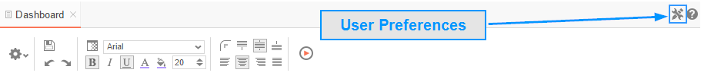

Startup Reports
In the User Preferences menu, set your preferences such as which reports should run at startup and/or what User Reports should be applied.
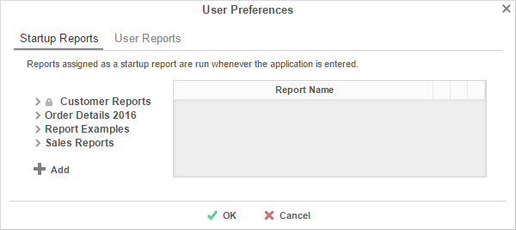
- To filter a report, either drag and drop it to the selection pane, or select the report and press the button, or double-click the report.
- To disable a user report, press the delete button ().

Context Sensitive Help
Context sensitive help is available at any point in the application. Press the help button (), and documentation will appear in a new tab. The guide will automatically open to the section that reflects the feature you are using.
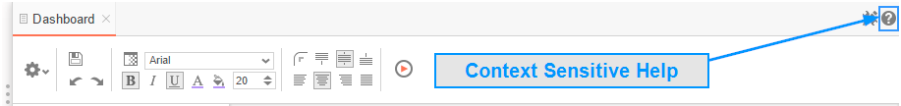

Exago, Inc.
Two Enterprise Drive
Shelton, CT 06484 USA
203.225.0876
http://www.exagoinc.com

