

**User Guide**

**Version 2016.1**

© 2016 Exago Inc. All rights reserved.

Exago Reporting is a registered trademark of Exago, Inc. Windows is a registered trademark of Microsoft Corporation in the United States and other countries. All other company and product names mentioned may be trademarks of the respective companies with which they are associated.

Exago Inc. makes a sincere effort to ensure the accuracy of the material. The content of this manual is furnished for informational use only, is subject to change without notice, and should not be construed as a commitment by Exago Inc. Exago Inc. assumes no responsibility or liability for any errors or inaccuracies that may appear in this document.

Except as permitted by licensing agreement, no part of this publication may be reproduced, stored in a retrieval system, or transmitted, in any form or by any means, without the prior written permission of Exago Inc.

Exago Inc. strives to provide our customers with high-quality printed and online documentation. If you have any comments or suggestions on how we can improve our documentation for your use, please contact us at: [webmaster@exagoinc.com](mailto:webmaster@exagoinc.com).

|  |  |
| --- | --- |
| Exago, Inc. Two Enterprise Drive Shelton, CT 06484 USA | |
| Phone | 203.225.0876 |
| Fax | 203.926.9505 |
| Email | [exagoinc.com](http://www.exagoinc.com/) |
| Support & Development | |
| Phone | 845.481.5221 |
| Fax | 845.255.0209 |
| Email | support@exagoinc.com |
| Web | [exagosupport.com](http://www.exagosupport.com/) |
| Blog | [exagoinc.com/blog.html](http://www.exagoinc.com/blog.html) |

# Table of Contents

[Table of Contents 3](#_Toc450573966)

[About 6](#_Toc450573967)

[Supported Browsers 6](#_Toc450573968)

[Navigation 6](#_Toc450573969)

[Main Menu 7](#_Toc450573970)

[Tabs 7](#_Toc450573971)

[Creating New Reports 8](#_Toc450573972)

[Types of Reports 8](#_Toc450573973)

[Express Report Wizard 10](#_Toc450573974)

[Name Tab 10](#_Toc450573975)

[Categories Tab 11](#_Toc450573976)

[Sorts Tab 12](#_Toc450573977)

[Filters Tab 13](#_Toc450573978)

[Layout Tab 14](#_Toc450573979)

[Options Tab 19](#_Toc450573980)

[New Standard Report Wizard 22](#_Toc450573981)

[Name Tab 22](#_Toc450573982)

[Categories Tab 23](#_Toc450573983)

[Sorts Tab 24](#_Toc450573984)

[Filters Tab 25](#_Toc450573985)

[Layout Tab 26](#_Toc450573986)

[New CrossTab Wizard 30](#_Toc450573987)

[Name Tab 30](#_Toc450573988)

[Categories Tab 31](#_Toc450573989)

[Filters Tab 32](#_Toc450573990)

[Layout Tab 33](#_Toc450573991)

[Searching Reports 39](#_Toc450573992)

[Folder Management 40](#_Toc450573993)

[Editing Reports 41](#_Toc450573994)

[Report Designer 42](#_Toc450573995)

[Design Grid 42](#_Toc450573996)

[Data Menu 42](#_Toc450573997)

[Toolbar 43](#_Toc450573998)

[Design Grid 44](#_Toc450573999)

[Sections 44](#_Toc450574000)

[Columns and Rows 46](#_Toc450574001)

[Cells 49](#_Toc450574002)

[Using Page Breaks 49](#_Toc450574003)

[Collapsible Rows 49](#_Toc450574004)

[Data Menu 52](#_Toc450574005)

[Adding Data Fields to a Report 52](#_Toc450574006)

[Toolbar 53](#_Toc450574007)

[Saving Reports 53](#_Toc450574008)

[Undo/Redo 53](#_Toc450574009)

[Font & Alignment Options 53](#_Toc450574010)

[Formatting Cells 54](#_Toc450574011)

[AutoSum 58](#_Toc450574012)

[Images 58](#_Toc450574013)

[Formulas 58](#_Toc450574014)

[Suppress Duplicates 58](#_Toc450574015)

[Chart Wizard 59](#_Toc450574016)

[Maps 76](#_Toc450574017)

[Linked Reports 81](#_Toc450574018)

[Gauges 82](#_Toc450574019)

[CrossTabs 85](#_Toc450574020)

[Renaming Reports 90](#_Toc450574021)

[Changing Description 90](#_Toc450574022)

[Changing Data Categories 90](#_Toc450574023)

[Changing Sorts 91](#_Toc450574024)

[Changing Filters 92](#_Toc450574025)

[General Options 94](#_Toc450574026)

[Report Viewer Options 95](#_Toc450574027)

[Advanced Options 98](#_Toc450574028)

[Document Template 99](#_Toc450574029)

[Duplicating Reports 101](#_Toc450574030)

[Deleting Reports 102](#_Toc450574031)

[Scheduling Reports 103](#_Toc450574032)

[Schedule Report Wizard 103](#_Toc450574033)

[Recurrence Tab 104](#_Toc450574034)

[Parameters Tab 105](#_Toc450574035)

[Filters Tab 105](#_Toc450574036)

[Recipients Tab 106](#_Toc450574037)

[Email Report 107](#_Toc450574038)

[Manage Scheduled Reports 108](#_Toc450574039)

[Executing Reports 109](#_Toc450574040)

[Interacting with Reports 109](#_Toc450574041)

[Changing Styling 110](#_Toc450574042)

[Resizing Columns 110](#_Toc450574043)

[Applying Interactive Filters 110](#_Toc450574044)

[Conditional Filters 111](#_Toc450574045)

[Changing Sorts 111](#_Toc450574046)

[Hiding Columns 112](#_Toc450574047)

[Saving & Clearing Changes 112](#_Toc450574048)

[Exporting to Other Formats 113](#_Toc450574049)

[Creating and Editing Dashboards 114](#_Toc450574050)

[Dashboard Designer 114](#_Toc450574051)

[Dashboard Items 116](#_Toc450574052)

[Toolbar 125](#_Toc450574053)

[Chained Reports 130](#_Toc450574054)

[Chained Report Wizard 130](#_Toc450574055)

[Name Tab 130](#_Toc450574056)

[Reports Tab 131](#_Toc450574057)

[Options Tab 132](#_Toc450574058)

[Formulas 133](#_Toc450574059)

[Functions 133](#_Toc450574060)

[Parameters 133](#_Toc450574061)

[Data Fields 133](#_Toc450574062)

[Referencing a Cell 133](#_Toc450574063)

[Using Formulas 134](#_Toc450574064)

[Formula Editor 134](#_Toc450574065)

[Manual Formulas 134](#_Toc450574066)

[Full Description of Parameters 136](#_Toc450574067)

[Quick List of Functions 137](#_Toc450574068)

[Full Description of Functions 138](#_Toc450574069)

[Aggregate Functions 139](#_Toc450574070)

[Logical Functions 141](#_Toc450574071)

[Date Functions 143](#_Toc450574072)

[Financial Functions 147](#_Toc450574073)

[Database & Data Type Functions 154](#_Toc450574074)

[Arithmetic & Geometric Functions 156](#_Toc450574075)

[String Functions 163](#_Toc450574076)

[Formatting Functions 165](#_Toc450574077)

[Other Functions 166](#_Toc450574078)

[Other 168](#_Toc450574079)

[User Preferences 168](#_Toc450574080)

[Startup Reports 168](#_Toc450574081)

[Context Sensitive Help 169](#_Toc450574082)

# About

This application is a powerful yet easy-to-use reporting tool. It runs in your web browser and does not require any downloads.

## Supported Browsers

Supported browsers include:

* Firefox 3+
* Internet Explorer 9+ / Edge
* Google Chrome
* Safari

## Navigation

This application consists of two sections. On the left is the [Main Menu](#_Main_Menu) and on the right are [Tabs](#_Tabs). The Main Menu displays the available reports, folders, and buttons. Tabs can contain the New Report Wizard, report outputs, design windows, or help pages.

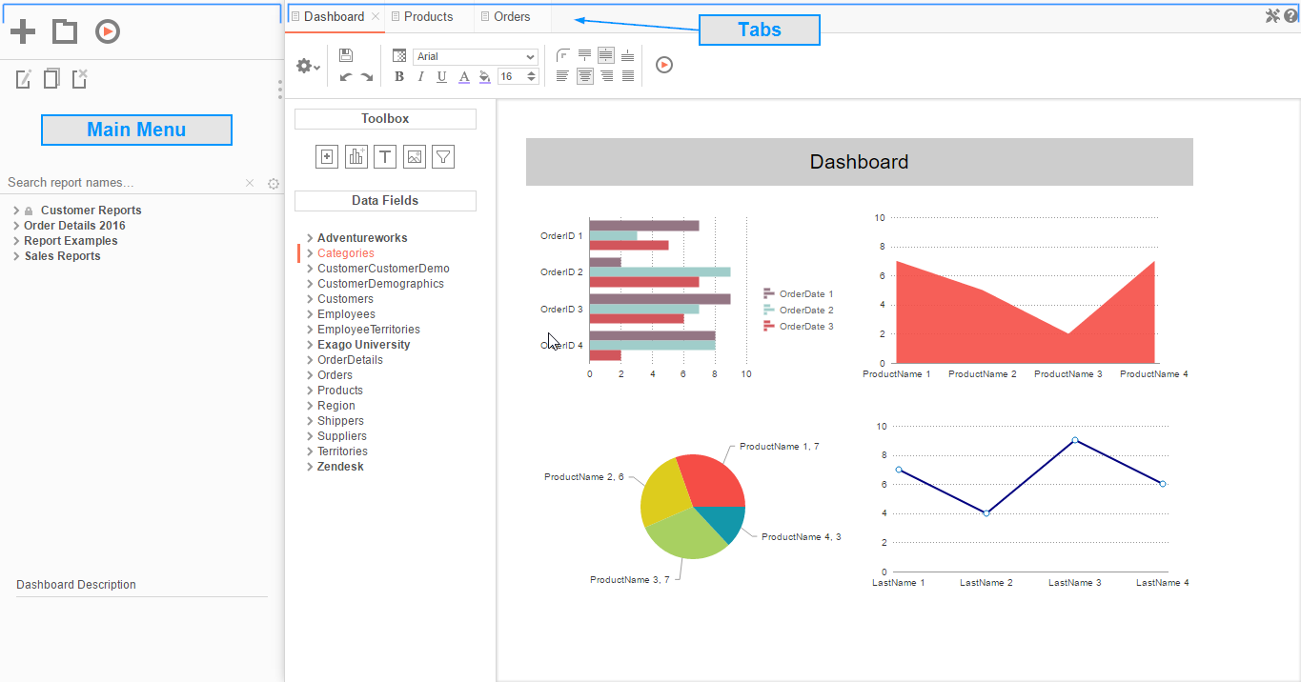

### Main Menu

Through the Main Menu you can:

* Create new reports
* Search for reports
* Read report descriptions
* Run reports
* Export reports to other types (Excel, PDF, RTF and CSV)
* Duplicate reports to save time setting up reports that are similar
* Edit reports
* Delete reports
* Schedule reports to be emailed or archived
* Manage folders and report storage

Click the splitter icon  to hide the Main Menu. This is located in the top left corner of the application’s interface between the Main Menu and the Tabs.

### Tabs

The right section is made up of tabs containing the New Report Wizard, reports outputs, design windows, or help pages. Tabs can be closed by clicking the () to the right of the tab name.

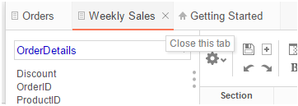

Tabs can be rearranged by clicking and dragging them left or right.



# Creating New Reports

To create a new report, click the New Report Button. This will launch the [New Report Wizard](#_New_Report_Wizard) in a new tab.

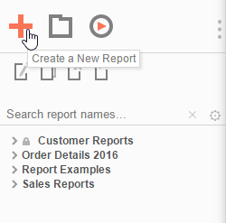

## Types of Reports

This application has five types of reports.

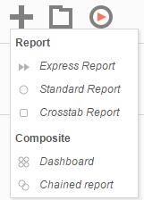

* ** Express Reports** – This simplified report designer enables you to quickly build reports with basic layouts and calculations. For more information, see [Express Reports](#_Express_Report_Wizard_1).
* ** Standard Reports** – This type of report uses an intuitive grid to lay out data and labels. Standard reports can provide more complex sections in which to group data and make specialized calculations. For more information, see [Report Designer](#_Report_Designer).
* ** CrossTab Reports** – CrossTab reports utilize the Standard Report Designer to create reports that may expand both horizontally and vertically based on data. For more information, see [CrossTabs](#_New_CrossTab_Wizard).
* ** Dashboards** – This is a canvas for combining and laying out reports, data visualizations, images, text and web pages. For more information, see [Dashboards](#_Creating_and_Editing_1).
*  **Chained Reports** – This type of report compiles multiple reports into a single document. For more information, see [Chained Reports](#_Creating_Chained_Reports).

## Express Report Wizard

The Express Report Wizard is an interactive tool which allows you to quickly create and edit Express Reports.

To navigate the wizard, either click the desired tab or use the buttons at the bottom.

To save an Express Report, click the save  button.

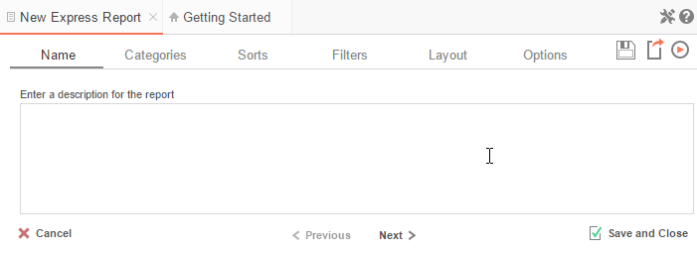

The Express Report Wizard has six sub tabs. The **Name**, **Categories** and **Layout** tabs must be completed while the other tabs are optional.

### Name Tab

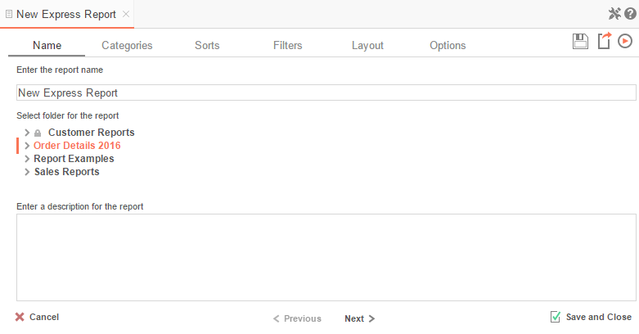

In the Name tab, enter a report name and click on the Folder where the report will be saved.

The report name can be up to 255 characters long. Avoid special characters such as ? : / \ \* “ < >.

A report’s description appears at the bottom of the Main Menu when it is selected. The description text may also be used to search for a report.

NOTE.You cannot create a report inside a folder that is read-only ().

### Categories Tab

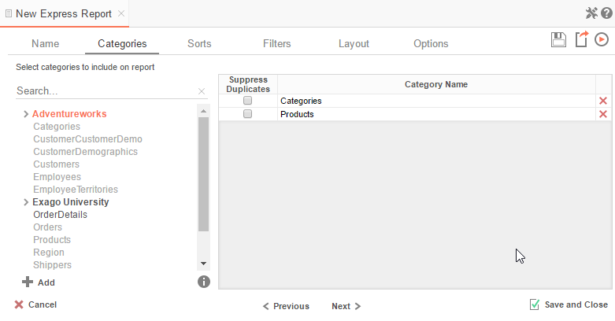

In the Categories Tab, select the Data Categories that you would like to have access to on the report. It is important to understand two terms: **Data Category** and **Data Field**.

**Data Category** – A Data Category is a data object that has several attributes. E.g. Orders is a category; each order has an ID, a date, a customer, etc.

**Data Field –** A Data Field is a single attribute within a category. E.g. **Orders.OrderID** is numeric value that identifies a specific order.

* To add a Data Category, either drag and drop it to the ‘*Category Name*’ Column, use the button or double-click the category.
* To search for a specific Data Category or folder, type its name into the Search box.
* To see what Data Fields are in a Data Category, click the information button ().
* Check the ‘*Suppress Duplicates*’ box to suppress any repeated records from that category.
* To remove a Data Category, click the delete button ().

### Sorts Tab

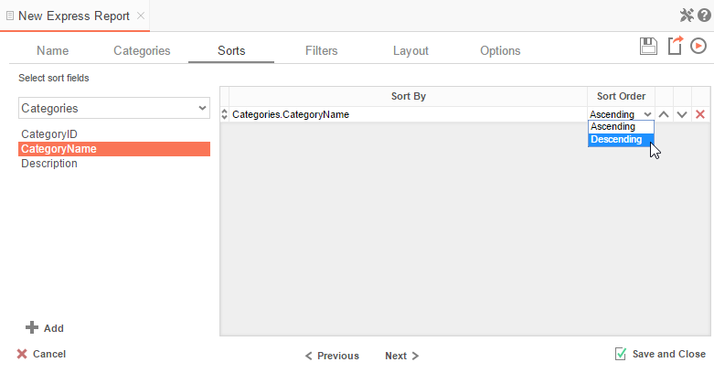

In the Sorts Tab, specify which Data Fields will be used to determine the order of data on the report.

* To sort by a Data Field, either drag and drop it to the ‘*Sort By’* Column, use the  button, or double-click the field.
* You can sort each Data Field in **Ascending** (A-Z, 0-9) or **Descending** (Z-A, 9-0) order.
* Use the up () and down () arrows to indicate the sort priority.
* To remove a sort, click the delete button ().

### Filters Tab

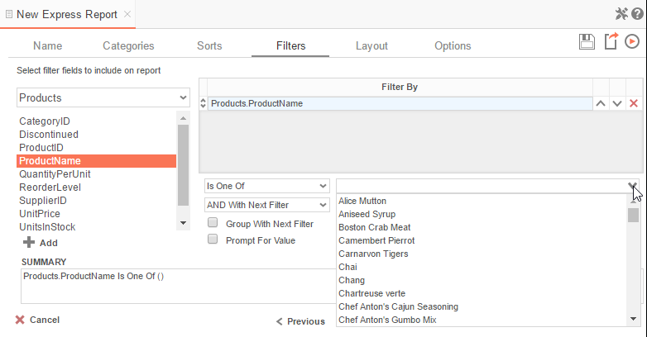

In the Filters Tab, create statements that will be used to filter the data when you execute the report.

There is no limit to the number of filters that can be defined. Filters can be numeric (up to eight decimals) or alphanumeric.

* To filter a Data Field, either drag and drop it to the ‘*Filter By*’ column, use the  button, or double-click the field.
* Use the up () and down () arrows to indicate the filter priority.
* To remove a filter, click the delete button ().
* Set the operator (**Equal To**, **Less Than**, **One Of**, etc.) by selecting it from the operator drop-down.
* Set the filter value by either entering it manually or selecting a value from the drop-down. If the Data Field is a date, the calendar and function buttons can be used to select a value.
* Check ‘*Prompt for Value*’ to allow the filter to be modified at the time the report is executed.
* Select ‘*AND With Next Filter*’ to require that the selected filter and the one below it both evaluate to true. Choose ‘*OR With Next Filter*’ to require that either be true.
* Check ‘*Group With Next Filter*’ to specify the precedence of the filters. Filters can be nested indefinitely by using the following keyboard shortcuts while a filter is selected:
  + **Ctrl + [** adds an open-parenthesis before the selected filter.
  + **Ctrl + ]** adds a close-parenthesis after the selected filter.
  + **Ctrl + Shift + [** removes an open-parenthesis from before the selected filter.
  + **Ctrl + Shift + ]** removes a close-parenthesis from after the selected filter.

### Layout Tab

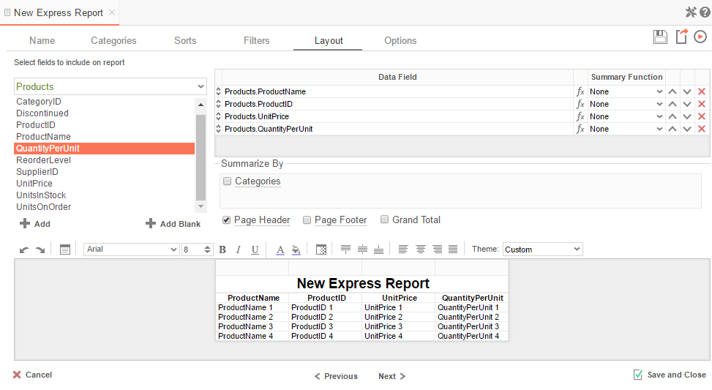

In the Layout Tab, select which Data Fields will appear on the report. For each Data Field chosen, the report will automatically create a column header and the Data Field. Additionally, subtotals, grand totals, and page header/footers can be created.

#### Display Data

* To place a Data Field on the report, either drag and drop it to the ‘*Data Field*’ column, use the  button, or double-click it.
* To add blank columns that can be edited manually, click the  button. You can enter text into a blank column.
* Use the up () and down () arrows to indicate the order the Data Fields should appear on the report. The Data Field at the top will appear as the leftmost column of the report.
* The Summary Function column is used to make subtotals and grand totals. See [Subtotals and Grand Totals](#_Sub-Totals_and_Grand) for more information.
* To remove a Data Field, click the delete button ().

For each Data Field added in the Sorts tab, a checkbox will appear in the ‘*Summarize By*’ box. Using the ‘*Summarize By*’ box you can display subtotals, grand totals, or headers for the values of a Data Field.

#### Subtotals and Grand Totals

* To display subtotals, check the box of the category you want subtotals for. Then, for each Data Field you want totaled, select a Summary Function (see below).
* To display grand totals, check the Grand Total box. Then, for each Data Field you want totaled, select a Summary Function (see below).

Summary Functions:

* + **Sum**: Totals the all of the data in the Data Field.
  + **Count**: Returns the number of rows in the Data Field.
  + **Average**: Takes the mean of the data in the Data Field.
  + **Minimum**: Displays the lowest value in the Data Field.
  + **Maximum**: Displays the highest value in the Data Field.

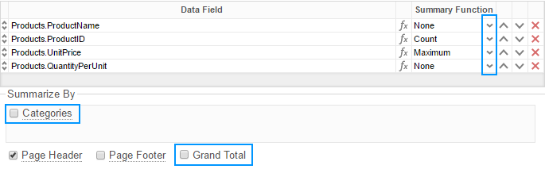

#### Data Headers

To display a header for each value of a Data Field, click on the associated Data Category in the Summarize By box. Click the Data Category name next to the checkbox, and the Header Menu will appear.

* To include a blank row before each unique value of the selected Data Field, check the box ‘*Add space before each unique item*’.
* To include a Header, check the box ‘*Include Header at the beginning*’. In order to select the text that will appear as the header value, use the Header Text dropdown to select a Data Field or use the [Formula Editor](#_Formula_Editor) Button () to create a formula.
* Use the ‘*Summarize by each unique*’ dropdown to specify if the header should repeat based on a specific Data Field or if it should repeat for all of the keys of a Category.
* Check the box ‘*Include Total at the end*’ to have a subtotal created for this Category.

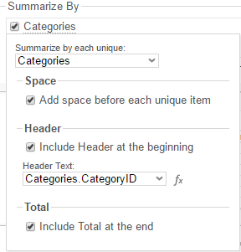

#### Page Header

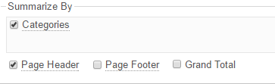

To display information on the top of each page, check the ‘*Page Header*’ box. Click ‘*Page Header*’ and the Page Header Menu will appear:

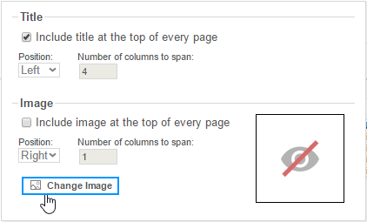

* Check the box ‘*Include Title at the top of every page*’ to display the name of the report on each page. If an image is also included, use the position dropdown to set where the title should appear and the number of columns it should span.
* Use the ‘*Change Image*’ button to upload an image to display at the top of each page. If a title is also included, use the position dropdown to set where the image should appear and the number of columns it should span.

#### Footers

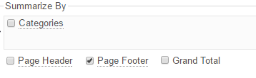

To display information on the bottom of each page, check the ‘*Page Footer*’ box. Click on ‘*Page Footer*’ and the Page Footer Menu will appear:

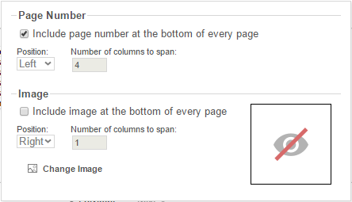

* Check the box ‘*Include page number at the bottom of every page*’ to display the page number on each page. If an image is also included, use the position dropdown to set where the page number should appear and the number of columns it should span.
* Use the ‘*Change Image*’ button to upload an image to display at the bottom of each page. If the page number is also included, use the position dropdown to set where the image should appear and the number of columns it should span.

#### Preview

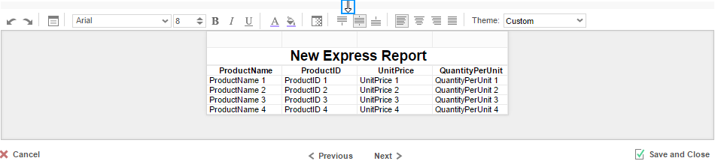

At the bottom of the Layout Tab, a preview will display how the report will appear based on the fields that have been added. You can increase/decrease the size of the preview or hide it altogether by dragging the top of the Express Report Designer box.

#### Styling Express Reports



The toolbar above the preview can be used to style the Express Report. To utilize this toolbar, select the cell(s) in the preview you want to modify, then use one of the following options:

 **Undo/Redo** – can undo or redo the last change made. You can also use **Ctrl+Z** /**Ctrl+Y**, respectively.

** Layout Options** – see [Layout Options](#_Layout_Options) for more information.

**Font** – see [Font](#_Font) for more information.

**color.png Foreground & Background Color** – see [Color](#_Color) for more information.

** Number/Date Format/Border Color** – see [Formatting Cells](#_Number) for more information.

 **Alignment** – see [Alignment](#_Alignment) for more information.

**Theme** – Quickly style the report using one of the pre-defined themes.

#### Layout Options

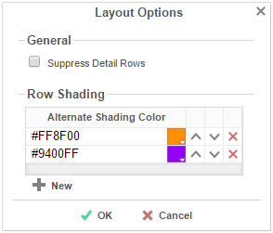

In Layout Options you can hide the detail information and set row shading.

* Check ‘*Suppress Detail Rows*’ to only display Subtotals, Grand Totals, Data Headers & Page Headers/Footers.
* To add row shading click the ‘New’ button and select a color from the color dropdown or enter a hex value.

NOTE. Row Shading is only applied to the detail rows that contain Data Fields.

### Options Tab

The Options Tab allows you to control various report settings.

**General Options**

**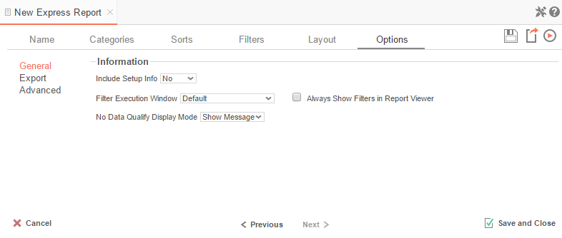**

* From the ‘*Include Setup*’ menu, select **Top** or **Bottom** to display the data categories, sorts, and filters at either the beginning or end of the report.
* Select which type of Filter menu to display when executing a report that has prompt-for-value filters.
  + **Default –** Display the default type of filter execution window.
  + **Standard –** Display the standard filter execution window.
  + **Simple with Operator –** Display a simplified filter execution window that only allows the operator and value to be changed.
  + **Simple without Operator –** Display a simplified filter window that only allows the filter value to be changed.
* Check ‘*Always Show Filters in Report Viewer*’ to show the filter menu and allow changes to be made each time the report is run.

**Export Options**

**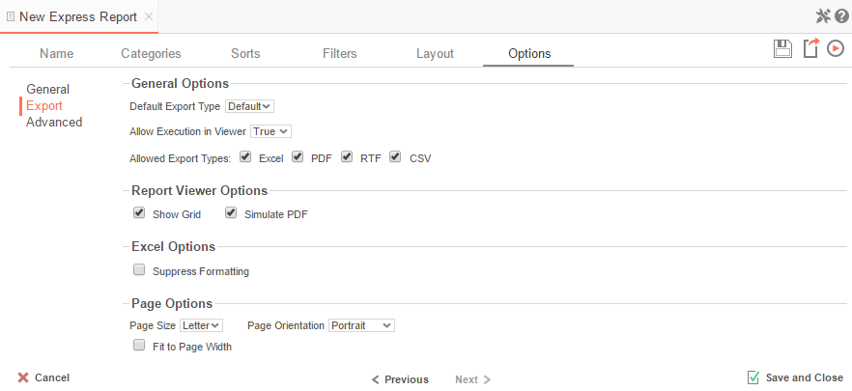**

General Export Options

* Use the Default Export Type drop-down to specify the default format for the report.
* Output types may be disabled by unchecking the respective ‘*Allowed Export Types*’ box.

Report Viewer Options

* Uncheck ‘*Show Grid*’ to disable grid lines.
* Uncheck ‘*Simulate PDF*’ to prevent the report from appearing as though it were on a page.

Excel Options

* Check ‘*Suppress Formatting*’ to prevent the report formatting from exporting to Excel.

Page Options

* Specify the size of the report in the ‘*Page Size*’ drop-down. Default is **Letter**.
* Set the orientation for the report in the ‘*Orientation*’ menu. Default is **Portrait**.
* Check ‘*Fit to Page Width*’ to scale all columns to fit the width of the page.

**Advanced Options**

**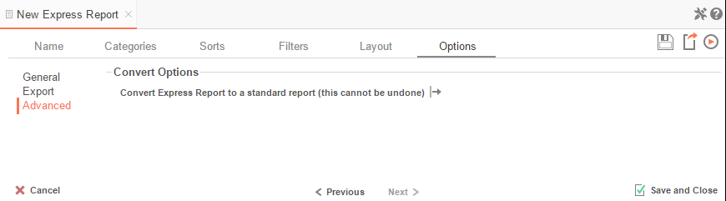**

In the Advanced Options an Express Report can be converted to a Standard Report.

IMPORTANT**.** This CANNOT be undone.

* Click the ‘*Convert simple report to a standard report*’ button to convert an Express Report to a Standard Report.

## New Standard Report Wizard

The New Standard Report Wizard is an interactive tool which will walk through the process of creating a new standard report. All of the selections made in the New Standard Report Wizard can be modified in the Report Designer after the report has been created.

To navigate the wizard, either click the desired tab or use the buttons at the bottom.

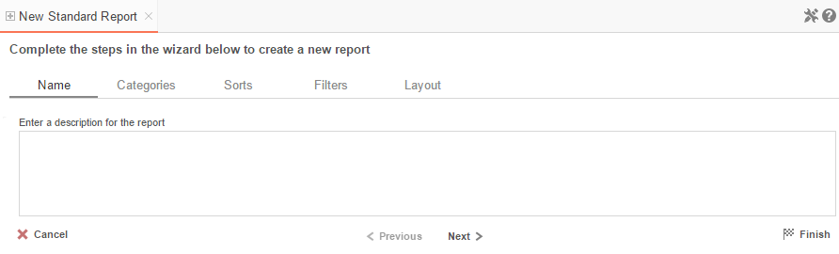

The New Report Wizard has five sub tabs. The **Name** and **Categories** tabs must be completed while the other tabs are optional.

### Name Tab

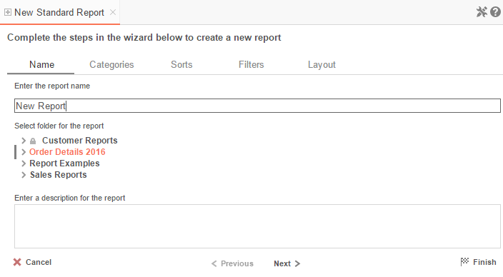

In the Name tab enter a report name and click on the Folder where the report will be saved.

The report name can be up to 255 characters long. Avoid special characters such as ? : / \ \* “ < >.

The report’s description appears at the bottom of the Main Menu when it is selected. The description text may also be used to search for a report.

NOTE.You cannot create a report inside a folder that is read-only ().

### Categories Tab

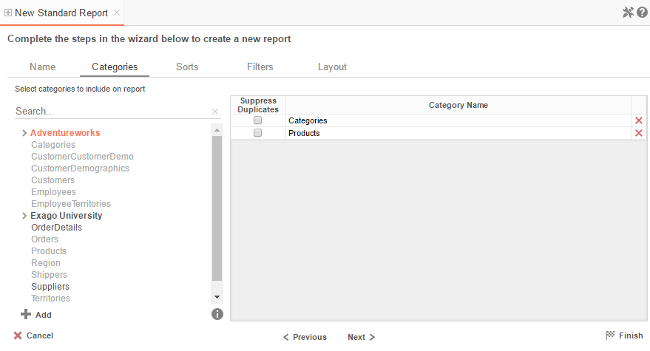

In the Categories Tab, select the Data Categories that you would like to have access to on the report. It is important to understand two terms: **Data Category** and **Data Field**.

**Data Category** – A Data Category is a data object that has several attributes. E.g. Students is a category; each student has an ID, a major, an advisor, etc.

**Data Field –** A Data Field is a single attribute within a category. E.g. Students.ID is the numeric value that identifies a specific student.

* To add a Data Category, either drag and drop it to the ‘*Category Name*’ Column, use the  button, or double-click the category.
* To search for a specific Data Category or folder, type its name into the Search box.
* To see what Data Fields are in a Data Category, click on a Data Category and then click the information button ().
* Check the ‘*Suppress Duplicates*’ box to suppress any repeated records from that category.
* To remove a Data Category, click the delete button ().

### Sorts Tab

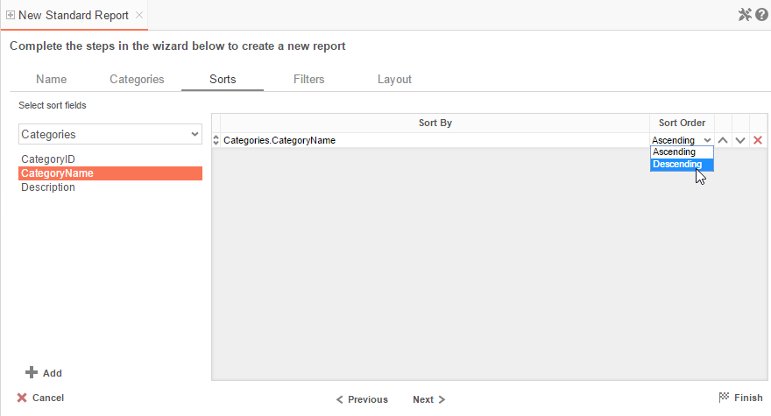

In the Sorts tab, specify which Data Fields will be used to determine the order of data on the report.

* To sort by a Data Field either drag and drop it to the ‘*Sort By’* Column, use the  button or double-click the field.
* You can sort each Data Field in **Ascending** (A-Z, 0-9) or **Descending** (Z-A, 9-0) order.
* Use the up () and down () arrows to indicate the sort priority.
* To remove a sort, click the delete button ().

### Filters Tab

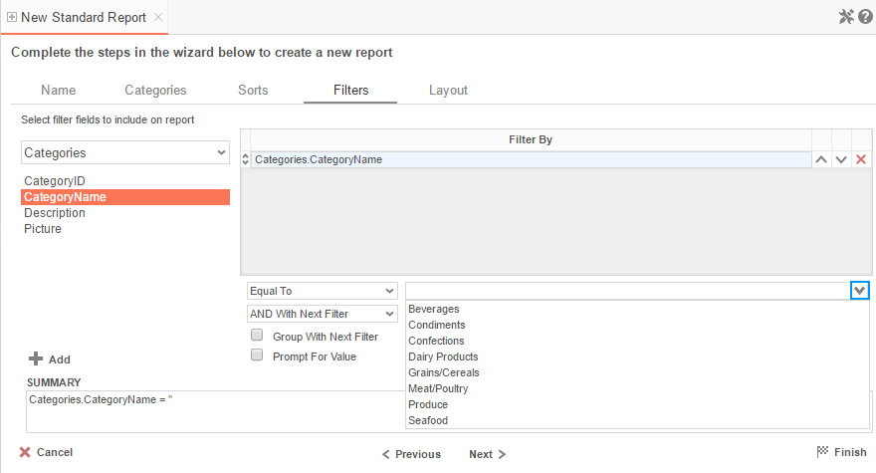

In the Filters Tab, create statements that will be used to filter the data when you run a report.

There is no limit to the number of filters that can be defined. Filters can be numeric (up to eight decimal places) or alphanumeric.

* To filter a Data Field, either drag and drop it to the ‘*Filter By*’ column, use the  button or double-click it.
* Use the up () and down () arrows to indicate the filter priority.
* To remove a filter, click the delete button ().
* Set the operator (**Equal To**, **Less Than**, **One Of**, etc.) by selecting it from the operator drop-down.
* Set the filter value by either entering it manually or selecting a value from the drop-down. If the Data Field is a date, the calendar and function buttons can be used to select a value.
* Select ‘*AND With Next Filter*’ to require that the selected filter and the one below it both evaluate to true. Choose ‘*OR With Next Filter*’ to require that either be true.
* Check ‘*Group With Next Filter*’ to specify the precedence of the filters. Filters can be nested indefinitely by using the following keyboard shortcuts while a filter is selected:
  + **Ctrl + [** adds an open-parenthesis before the selected filter.
  + **Ctrl + ]** adds a close-parenthesis after the selected filter.
  + **Ctrl + Shift + [** removes an open-parenthesis from before the selected filter.
  + **Ctrl + Shift + ]** removes a close-parenthesis from after the selected filter.
* Check ‘*Prompt for Value*’ to allow the filter to be modified at the time the report is executed.

### Layout Tab

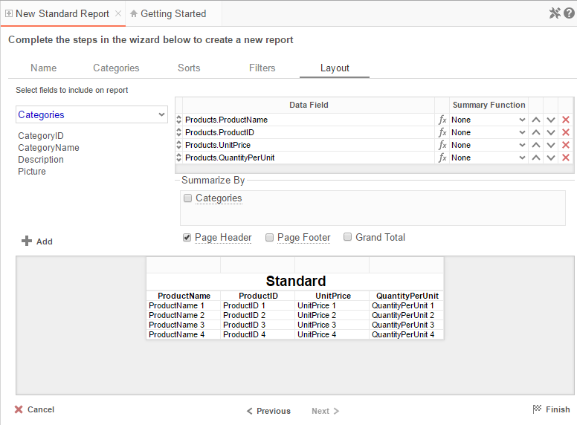

In the Layout Tab, select the Data Fields that will appear on the report. For each Data Field chosen, the report will automatically create a column header and place the Data Field in the detail section. Additionally, subtotals, grand totals, and a page header/footer can be created.

#### Display Data

* To place a Data Field on the report, either drag and drop it to the ‘*Data Field*’’ column, use the  button, or double-click the field.
* Use the up () and down () arrows to indicate the order the Data Fields should appear on the report. The Data Field at the top will appear on the report as the left-most column.
* The Summary Function column is used to make subtotals and grand totals. See [Subtotals and Grand Totals](#_Sub-Totals_and_Grand) for more information.
* To remove a Data Field, click the delete button ().

For each Data Field added in the Sorts tab, a checkbox will appear in the ‘*Summarize By*’ box. Using the ‘*Summarize By*’ box you can display subtotals, grand totals, or headers for the values of a Data Field.



#### Subtotals and Grand Totals

* To display subtotals, check the box of the category you want subtotals for in the *Summarize By* box. Then, for each Data Field you want totaled, select a Summary Function.
* To display grand totals, check the Grand Total box. Then for each Data Field you want totaled, select a Summary Function.

|  |  |
| --- | --- |
| Summary Functions | * **Sum**: Totals the all of the data in the Data Field. * **Count**: Returns the number of rows in the Data Field. * **Average**: Takes the mean of the data in the Data Field. * **Minimum**: Displays the lowest value in the Data Field. * **Maximum**: Displays the highest value in the Data Field. |

#### Data Headers

A checkbox will appear in the *Summarize By* box for each Data Category in the [Sorts tab](#_Sorts_Tab). To display a header for each value of a Data Field, click on the associated Data Category in the *Summarize By* box. Click the Data Category name next to the checkbox, and the Header Menu will appear.

* To include a Header, check the box ‘*Include Header at the beginning*’. In order to select the text that will appear as the header value, use the Header dropdown to select a Data Field or use the [Formula Editor](#_Formula_Editor) Button () to create a formula.
* Use the ‘*Summarize by each unique*’ dropdown to specify if the header should repeat based on a specific field or fields within a Category.
* Check the box ‘*Include Total at the end*’ to have a subtotal created for this Category.

#### Page Header



To display information on the top of each page, check the ‘*Page Header*’ box. Click on ‘*Page Header*’ and the Page Header Menu will appear.



* Check the box ‘*Include Title at the top of every page*’ to display the name of the report on each page. If an image is also included, use the position dropdown to set where the title should appear and the number of columns it should span.
* Use the ‘*Change Image*’ button to upload an image to display at the top of each page. If a title is also included, use the position dropdown to set where the image should appear and the number of columns it should span.

#### Footers



To display information on the bottom of each page, check the ‘*Page Footer*’ box. Click on ‘*Page Footer*’ and the Page Footer Menu will appear.



* Check the box ‘*Include page number at the bottom of every page*’ to display the page number on each page. If an image is also included, use the position dropdown to set where the page number should appear and the number of columns it should span.
* Use the ‘*Change Image*’ button to upload an image to display at the bottom of each page. If the page number is also included, use the position dropdown to set where the image should appear and the number of columns it should span.

#### Preview

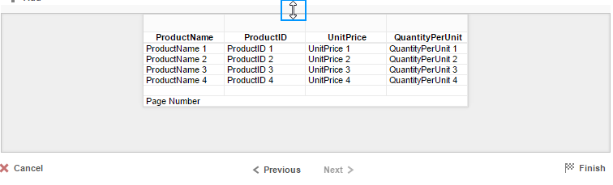

At the bottom of the Layout Tab, a preview will display how the report will appear based on the fields that have been added. You can increase/decrease the size of the preview or hide it altogether by dragging the top of the preview box.

## New CrossTab Wizard

The New Crosstab Wizard is an interactive tool which will walk through the process of creating a new CrossTab report. All of the settings in the New CrossTab Wizard can be modified in the Report Designer after the report has been created.

To navigate the wizard, either click the desired tab or use the buttons at the bottom.

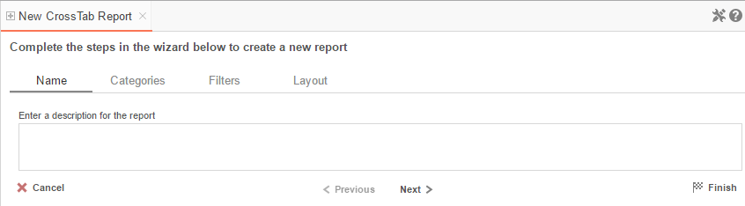

The New Report Wizard has four sub tabs. The Name, Categories, and Layout tabs must be completed while the other tabs are optional.

### Name Tab

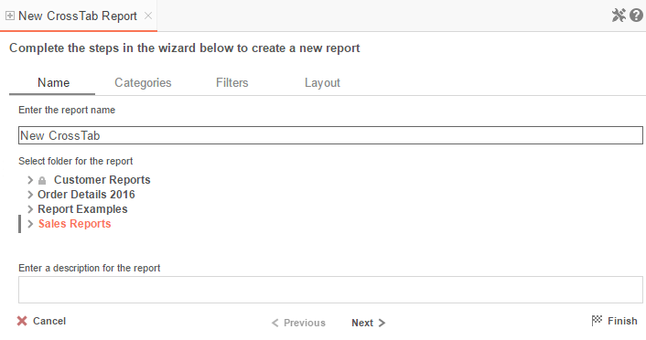

In the Name Tab, enter a report name and click on the Folder where the report will be saved.

The report name can be up to 255 characters long. Avoid special characters such as ? : / \ \* “ < >.

A report’s description appears at the bottom of the Main Menu when it is selected. The description text may also be used to search for a report.

NOTE.You cannot create a report inside a folder that is read-only ().

### Categories Tab

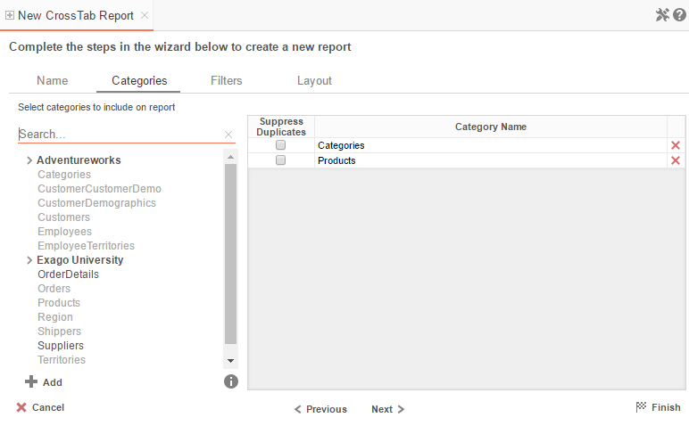

In the Categories Tab, select the Data Categories that you would like to have access to on the report. It is important to understand two terms: **Data Category** and **Data Field**.

**Data Category** – A Data Category is a data object that has several attributes. E.g. Students is a category; each student has an ID, a major, an advisor etc.

**Data Field –** A Data Field is a single attribute within a category. E.g. Students.ID is the numeric value that identifies a specific student.

* To add a Data Category, either drag and drop it to the ‘*Category Name*’ Column, use the  button or double-click the category.
* To search for a specific Data Category or folder, type its name into the Search box.
* To see what Data Fields are in a Data Category, click the information button ().
* Check the ‘*Suppress Duplicates*’ box to suppress any repeated records from that category.
* To remove a Data Category, click the delete button ().

### Filters Tab

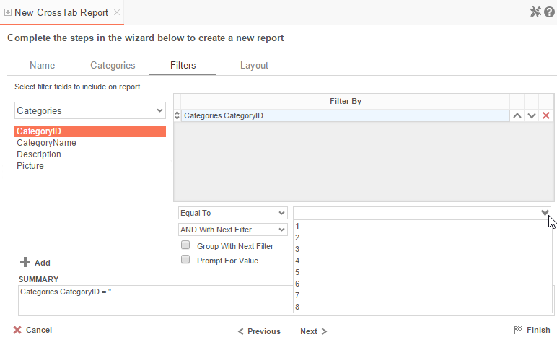

In the Filters Tab, create statements to filter the data at runtime.

There is no limit to the number of filters that can be defined. Filters can be numeric (up to eight decimals) or alphanumeric.

* To filter a Data Field, either drag and drop it to the ‘*Filter By*’ column, use the  button or double-click the field.
* Use the up () and down () arrows to indicate the filter priority.
* To remove a filter, click the delete button ().
* Set the operator (**Equal To**, **Less Than**, **One Of**, etc.) by selecting it from the operator drop-down.
* Set the filter value by either entering it manually or selecting a value from the drop-down. If the Data Field is a date, the calendar and function buttons can be used to select a value.
* Check ‘*Prompt for Value*’ to allow the filter to be modified at the time the report is executed.
* Select ‘*AND With Next Filter*’ to require that the selected filter and the one below it both evaluate to true. Choose ‘*OR With Next Filter*’ to require that either be true.
* Check ‘*Group With Next Filter*’ to specify the precedence of the filters. Filters can be nested indefinitely by using the following keyboard shortcuts while a filter is selected:
  + **Ctrl + [** adds an open-parenthesis before the selected filter.
  + **Ctrl + ]** adds a close-parenthesis after the selected filter.
  + **Ctrl + Shift + [** removes an open-parenthesis from before the selected filter.
  + **Ctrl + Shift + ]** removes a close-parenthesis from after the selected filter.

### Layout Tab

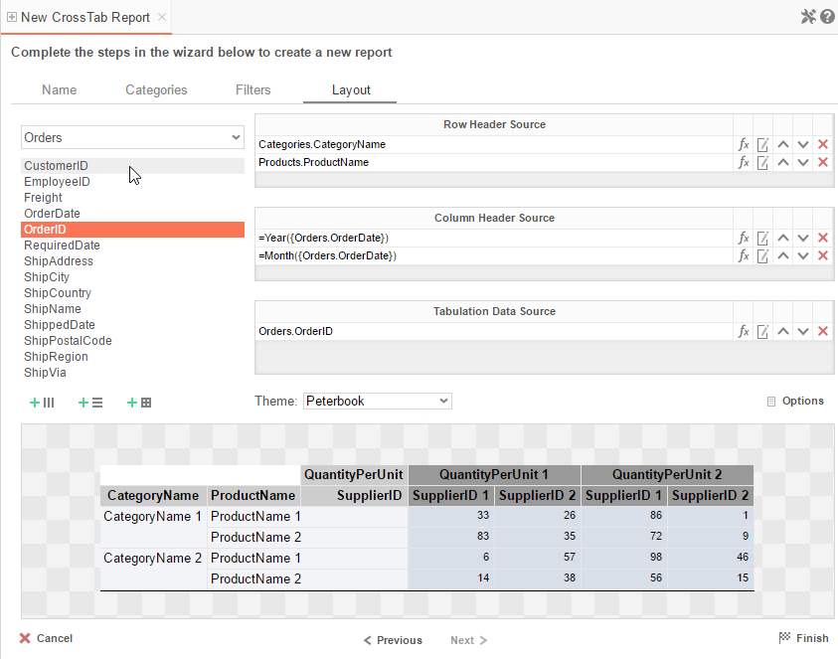

In the Layout Tab, design the CrossTab by moving Data Fields into the Row Header, Column Header, and Tabulation Data panels.

#### Row Headers

Row Headers expand a CrossTab vertically. A CrossTab has a row for each unique value of a Row Header.

E.g. If you were using sales data, you might select Row Headers **Category.CategoryName** and **Products.ProductName** to provide rows for each product grouped by category.

* To add a Row Header, either drag and drop the data field to the ‘*Row Header Source*’ panel or use the  button.
* Click the [Formula Editor](#_Formula_Editor) Button () to insert a formula into the Row Header.
* Click the Edit Header button () to open the header options menu.  
    
  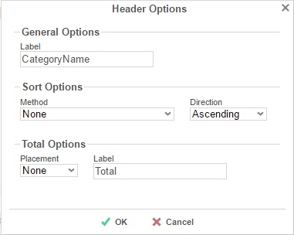

In the Header Options Menu, you can:

* + Set a *Label* for the Row Header. This label will appear at the top of the CrossTab.
  + Select a sorting *Method* and *Direction*:
    - **None** – Does not sort the Row Headers.
    - **Header Value (Text)** – Sorts the Row Header by its values as though they are text.
    - **Header Value (Number)** – Sorts the Row Header by its values as though they are numbers.
    - **Tabular Totals** – Sorts the Row Header by the totals of the Tabulation Data.

NOTE. If there is more than one Row Header, the Header Options Menu for the top-most Row Header will have Options for subtotals of Tabulation Data.

* + Select where to display subtotals by using the *Placement* dropdown:
    - **None** – Does not display subtotals.
    - **Top** – Displays subtotals above the Tabulation Data for each Row Header value.
    - **Bottom** – Displays subtotals below the Tabulation Data for each Row Header value.
  + Set a *Label* for the subtotals.
* Use the up () and down () arrows to rearrange the order of the Row Headers.
* To remove a Row Header, click the delete button ().

#### Column Headers

Column Headers expand a CrossTab horizontally. A CrossTab has a column for each unique value of a Column Header.

E.g. If you were using sales data, you may have the Column Headers ‘Year({Order.OrderDate})’ and ‘Month({Orders.OrderDate})’ to provide columns for each month grouped by year.

* To add a Column Header, either drag and drop a data field to the ‘*Column Header Source*’ panel or use the  button.
* Click the [Formula Editor](#_Formula_Editor) Button () to insert a formula into the Column Header.
* Click the Edit Header button () to open the Header Options menu.  
    
  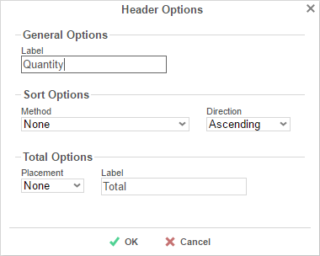  
    
  In the Header Options Menu, you can:
  + Set a *Label* for the Column Header to appear at the top of the CrossTab.
  + Select a Sorting *Method* and *Direction*:
    - **None** – Does not sort the Column Headers.
    - **Header Value (Text)** – Sorts the Column Header by its values as though they were text.
    - **Header Value (Number)** – Sorts the Column Header by its values as though they were numbers.
    - **Tabular Totals** – Sorts the Column Header by the totals of the Tabulation Data.

NOTE. If there is more than one Column Header, the Header Options Menu for the topmost Column Header will have Options for subtotals of Tabulation Data.

* + Select where to display subtotals by using the *Placement* dropdown.
    - **None** – Does not display subtotals.
    - **Left** – Displays subtotals to the left of the Tabulation Data for each Column Header value.
    - **Right** – Displays subtotals to the right of the Tabulation Data for each Column Header value.
  + Set a *Label* for the subtotals.
* Use the up () and down () arrows to rearrange the order of the Column Headers.
* To remove a Column Header, click the delete button ().

#### Tabulation Data

Tabulation Data provides information when data exists for both the Column Header and Row Header values.

E.g. If you have a Row Header on **Products** and a Column Header on the **Month**, then Tabulation Data of **Orders.OrderID** may use the **Count** function to display how many orders contained each product each month.

* To add a Tabulation Data Source, either drag and drop a data field to the ‘*Tabulation Data*’ panel or use the  button.
* Click the [Formula Editor](#_Formula_Editor) Button () to insert a formula into the Tabulation Data.
* Click the Edit Tabulation button () to open the Tabulation Options menu.  
    
  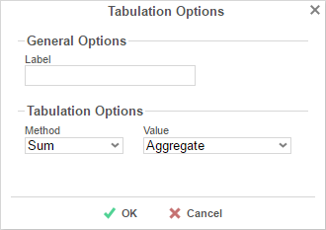  
    
  In the Tabulation Options Menu, you can:
  + Set a *Label* for the Tabulation Row to appear at the beginning of each row.
  + Use the *Method* dropdown to select the summary function to be applied to the Tabulation Data.

|  |  |
| --- | --- |
| Summary Functions | * **Sum**: Totals the all of the data in the Tabulation Data. * **Count**: Returns the number of rows in the Tabulation Data. * **Average**: Takes the mean of the data in the Tabulation Data. * **Minimum**: Displays the lowest value in the Tabulation Data. * **Maximum**: Displays the highest value in the Tabulation Data. * **None**: Displays the value in the Tabulation Data without doing any calculations. |

* + Use the *Value* dropdown to select how the Tabulation Data should be displayed:
    - **Aggregate**: Display the result of the selected Method.
    - **Percent of Row**: Display the result of the selected Method as a percentage of the row total.
    - **Percent of Colum**: Display the result of the selected Method as a percentage of the column total.
* Use the up () and down () arrows to rearrange the order of the Tabulation Data.
* To remove a Tabulation Data Source, click the delete button ().

#### CrossTab Themes

The Theme dropdown can be used to quickly style the CrossTab using a predefined theme. Further styling can be done in the [Report Designer](#_Report_Designer).

#### CrossTab Options

Settings that affect the entire CrossTab are controlled in the CrossTab Options Menu. Open the CrossTab Options Menu by clicking the  button.

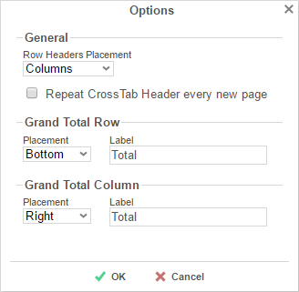

Using this menu, you can adjust the following settings:

**General**

* Use the *Row Headers Placement* dropdown to determine how the Row Headers are displayed.
  + **Columns** – Display the Row Headers in columns from left to right in the order they appear in the Row Header Source panel.
  + **Hierarchical** – Display Row Headers in a hierarchical structure using indentation to display their order.
* Check ‘*Repeat CrossTab Header every new page*’ to repeat Row Header labels and Column Headers on each new page.

**Grand Total Row**

* To get a total for each column, select ‘**Top**’ or ‘**Bottom**’ from the *Placement* dropdown and provide a label in the *Label* text box.

**Grand Total Column**

* To get a total for each row, select ‘**Top**’ or ‘**Bottom**’ from the *Placement* dropdown and provide a label in the *Label* text box.

#### Preview

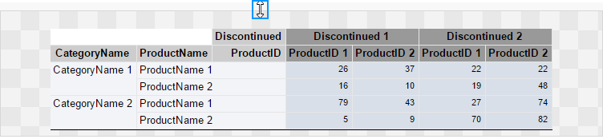

At the bottom of the Layout Tab, a preview will display how the Crosstab will appear based on the fields that have been added. You can increase/decrease the size of the preview or hide it altogether by dragging the top of the preview box.

# Searching Reports

To search for a specific report, enter your search terms in the search box in the Main Menu. All reports that contain one or more of the search terms in their names will appear.

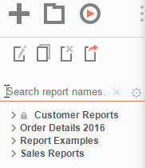

To cancel your search and return to a complete list of reports, click the Clear button ().

To expand your search to include report descriptions, click on the Settings icon () and check the ‘*Include Description (slower)* ’ box.

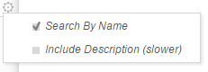

# Folder Management

NOTE. If you do not see a Manage Folders button in the Main Menu, then you do not have folder management privileges and should contact your administrator.

In the Main Menu, click the Manage Folders button. A drop-down menu will appear:

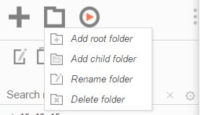

 *Add root folder*: Add a new folder at the base of the directory.

 *Add child folder*: Add a new folder within the selected folder.

 *Rename folder*: Rename the selected folder.

 *Delete folder*: Delete the selected folder. The folder must be empty.

NOTE. A folder marked read-only () cannot be modified.

# Editing Reports

To edit an existing report:

1. On the [Main Menu](#_Main_Menu), select the report you want to edit.
2. Click the Edit button () or double click the report.
   * For Standard and CrossTab reports, the [Report Designer](#_Report_Designer) will open in a new tab.
   * For Express Reports, the [Express Report Wizard](#_Express_Reports_Wizard_1) will open in a new tab.
   * For Chained Reports, the [Chained Report Wizard](#_Chained_Report_Wizard) will open in a new tab.
   * For Dashboards, the [Dashboard Designer](#_Dashboard_Designer) will open in a new tab.

NOTE.You cannot edit reports marked read-only (). You can duplicate a read-only report into an unlocked folder and edit the duplicate.

## Report Designer

The Report Designer can be used to add data, charts, formulas, sorts, filters and many other features to a report.

The Report Designer has three parts: the [Design Grid](#_Design_Grid), the [Data Menu](#_Data_Menu) and the [Toolbar](#_Toolbar).

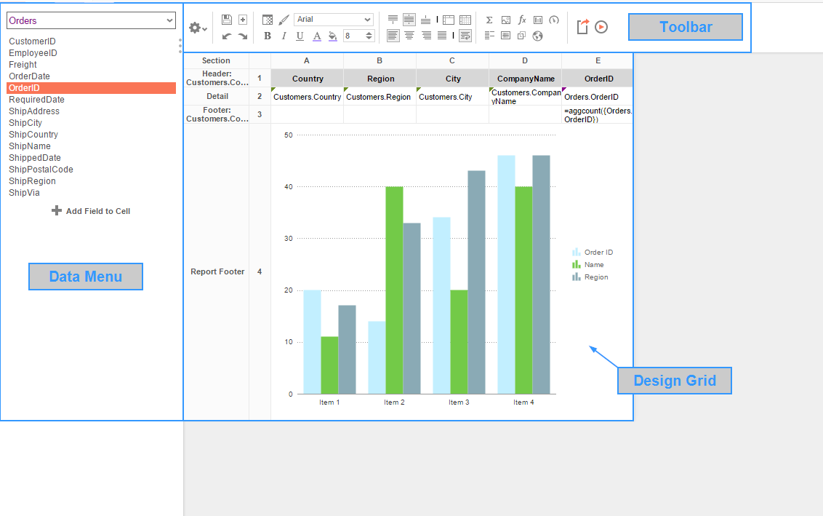

### Design Grid

In the design grid, you can:

* Add and delete rows, columns, and sections.
* Enter Data Fields, text, and formulas.
* Drag and drop data and text into different sections, rows, or columns.

### Data Menu

Using the data menu, you can:

* Drag and drop Data Fields onto cells in the report.

Click the splitter icon (  ) to hide the data menu.

### Toolbar

Using the toolbar, you can:

* Rename the report.
* Add, modify, or remove sorts and filters.
* Format cells’ font, font size, alignment, color, and borders.
* Use the Formula Editor to create complex functions.
* Insert charts, gauges, and images.
* Link reports, allowing users to drilldown for more detail.
* Save the report.
* Run the report in the Report Viewer.
* Export the report to Excel, CVS, RTF, or PDF.
* Add or remove Data Categories from the report.
* Add Action Events.

## Design Grid

In the design grid, you can:

* Add and delete rows, columns, and sections.
* Enter data fields, text, and formulas.
* Drag and drop fields into different sections, rows, or columns.

### Sections

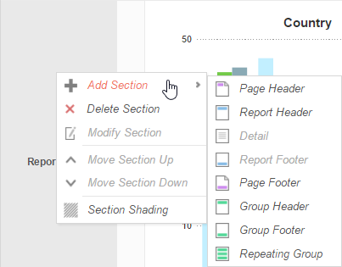

Sections dictate how the data appears in a report. There are five types of sections: page, report, details, group, and repeating group.

**Page Header & Page Footer –** The rows in the Page Header section appear at the top of every page of a report. Typically, the Page Header section is used to designate column headers for a report. The rows in the Page Footer section appear at the bottom of every page of a report. Typically, the Page Footer sections are used to display the page number and/or confidentiality notices for a report.

NOTE. Formulas and calculations should not be made in the Page Footer section.

NOTE. If you are printing a report, remember that Excel output does not have pages. Page Headers will appear only once at the beginning of the report. Reports run via the Report Viewer will display Page Headers similarly unless ‘Simulate PDF’ is checked in the [Options](#_Report_Options) menu.

**Report Header & Report Footer** – The rows in the Report Header appear at the beginning of a report. Typically, these rows display the title of a report. The rows in the Report Footer appear at the end of a report. Typically, the Report Footer displays grand totals and summary information for the report.

**Detail –** The Detail section is the main section of most reports. When a report is executed, the Details Section creates a row for each element in the Data Categories. For example, if the Detail section contains the Data Field **Orders.OrderId**, the report will display each Order Id on a separate row.

**Group Header & Group Footer –** Group Header/Footer sections require a sort on a Data Field. The rows in a Group Header section will appear above the Detail section for each unique value of the sorted Data Field. Typically, Group Header sections are used to display data as labels. For example, a report may contain a Group Header on **Orders.OrderDate** and display **Orders.OrderId** in the Detail section. The output would display each date with orders that occurred on that date below them.

The rows in a Group Footer section will appear below the Detail section for each unique value of the sorted Data Field. Typically, Group Footer sections are used to calculate subtotals. For example, a report may contain a Group Footer on **Orders.OrderDate** which displays the number of orders made on each date.

NOTE.Group Header/Footer sections can also be set to display rows for each value of a formula instead of a Data Field. (E.g. The report may be sorted on the Data Field **Orders.OrderDate,** but the report should show subtotals for each month. A Group Footer on the formula ‘=Month({Orders.OrderDate})’ will display rows containing subtotals for each month.)

**Repeating Groups –** Repeating Groups require a sort on a Data Field. Repeating Groups have their own header, details and footer subsections. Repeating Groups should only be used when the data has multiple one-to-many relationships and each should be rendered completely before the other.

(E.g. Each Professor can teach multiple classes and advise multiple students. For each professor you want to see all the classes they teach and then all the students they advise.)

#### Using Sections

Sections can be added, deleted, modified, moved, and assigned shading.

**Adding Sections**

1. Click anywhere in the Section Column.
2. Hover your mouse over ‘Add Section’, then select the type of section you would like to add.

**Deleting Sections**

1. In the Section Column, click on the section you want to delete.
2. Click ‘Delete Section’.

**Modify Sections (Group Header/Footers and Repeating Groups only)**

1. In the Section Column, click on the section you want to modify.
2. Click ‘Modify Section’. This will bring up a ‘Modify Group Section’ Menu.
3. Select from the drop-down the desired Data Field for the group to use.
4. Click OK.

**Section Shading**

1. In the Section Column, click on the section that you want to Shade.
2. Click ‘Section Shading’. This will bring up the Section Shading menu.  
     
   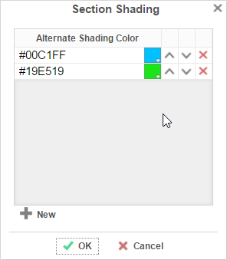
3. Click ‘New’ to add a color to the shading.
4. Click the color box to select a color or enter a hex value.
5. Click ‘OK’.

### Columns and Rows

Columns and rows of cells can be added, modified, or removed.

#### Columns

* To select a group of columns, hold the SHIFT key and then click the beginning and ending column.
* Non-contiguous columns can be selected by holding the CTRL key and clicking the desired columns.
* A column can be resized by dragging its right edge horizontally.
* Clicking on a column (or selected group) will display a menu where you can:  
  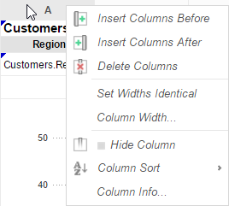
  + Insert a new column.
  + Delete the selected column.
  + Set all selected column widths to be identical.
  + Hide the selected column.
  + Set *Column Info* to make the label the column and/or make it [sortable within the Report Viewer](#_Sorting_by_Columns).

#### Sorting by Columns in the Report Viewer

While viewing reports in the Report Viewer, a user can click the bar at the top of the report to [sort by a column](#_Changing_Sorts_1). For Express Reports this is handled automatically, but it must be enabled for Standard and Crosstab Reports.

To make a column sortable:

* Click on the column and select ‘Column Info…’  
    
  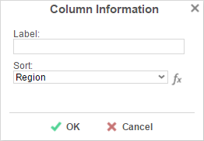
* Provide the column with a *Label* that will appear in the [Interactive Report Viewer Dock](#_Hiding_Columns).
* From the *Sort* dropdown select the Data Field to be used for sorting, or provide a formula by clicking the formula button ().

NOTE. Column Sorts are applied AFTER any sorts defined in the [Sorts Menu](#_Changing_Sorts).

* Click on the column again to set a default sort direction.  
    
  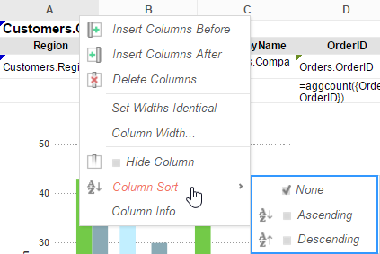

#### Rows

* To select a group of rows, hold the **SHIFT** key, then click the top and bottom rows of the area you wish to select.
* Non-contiguous rows can be selected by holding the **CTRL** key and clicking the desired rows.
* A row can be resized by dragging its bottom edge vertically.
* Clicking on a row (or selected group) will display a menu where you can:  
    
  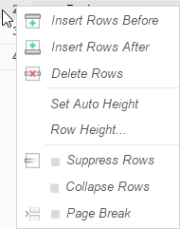  
  + Insert a new row.
  + Delete the selected row.
  + Set the selected row’s height to be automatically controlled.
  + Suppress the selected row from appearing on the report.
  + Insert a page break.

NOTE. See [Using Page Breaks](#_Using_Page_Breaks)

### Cells

Cells are the containers for all the information in a report. Cells may contain text, images, charts, or links to other reports.

* To enter text, double-click the cell, and a text field will appear.
* To select cells, either click the cells or use the arrow keys to toggle from one to the next.
* Groups of cells can be selected by holding the **SHIFT** key and clicking on another cell. All the cells in between the two will be selected.
* Non-contiguous cells can be selected by holding the **CTRL** key and clicking the desired cells.
* A cell can be copied by holding the **CTRL** key, then dragging and dropping it into a new cell.
* Adjacent cells can be merged and unmerged using the Merge/Split Cell buttons in the [Toolbar](#_Toolbar):

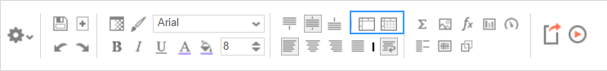

### Using Page Breaks

For a Page Break to occur at the beginning of each element of a Data Field, place a page break on the top row of the Group Header Section for that Data Field. See [Sections](#_Sections) for more detail on Group Headers Sections.

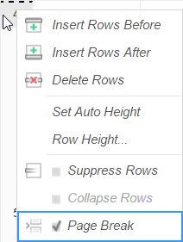

### Collapsible Rows

A Group Section can be set to display collapsed by default in the Report Viewer. This causes the contents of the section to be suppressed and individually expandable for each change in the Header. Collapsible rows are only supported in the Report Viewer. Export formats will ignore Collapsible Rows.

Left-click on an arrow next to a Collapsible Row to expand or collapse the group:

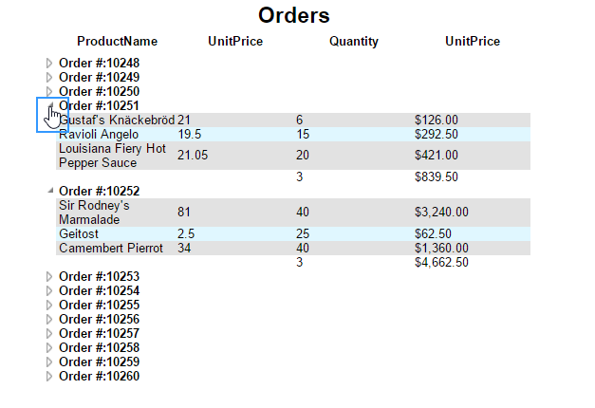

Right-click on an arrow next to a Collapsible Row to see additional display options:

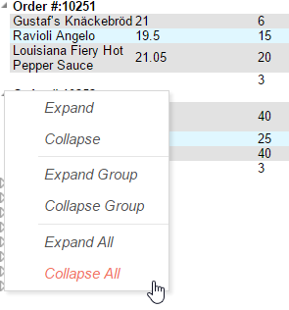

**Expand** will expand the selected top-level group. (This is the same as left-clicking an arrow.)

**Collapse** will collapse the selected top-level group. The state of the sub-groups is preserved.

**Expand Group** will expand the selected top-level group and all sub-groups within that group.

**Collapse Group** will collapse the selected top-level group and all sub-groups within that group.

**Expand All** will expand every group and sub-group on the page.

**Collapse All** will collapse every group and sub-group on the page.

#### Creating a Collapsible Row

To create a Collapsible Row, first open the desired report in the Report Designer. Click on the desired row number in a Group Header Section, and select **Collapse Rows** in the dropdown menu:

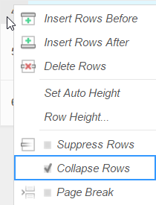

A Collapsible Row is indicated by an arrow at the bottom right of the row number cell.

#### Properties of a Collapsible Row

Collapsible Rows have the following properties when a report is viewed:

* Collapsible Rows display as collapsed whenever a report is run or altered using the Interactive Report Viewer.

NOTE.Collapsed or expanded state cannot be saved to User Report preferences.

* Page Breaks below a Collapsible Row are ignored.
* Expanding a Collapsible Row will not alter the Report pagination.

See [Sections](#_Sections) for more detail on Group Headers Sections.

See [Interacting with the](#_Interacting_with_HTML) Report Viewer for more information the Interactive Report Viewer.

## Data Menu

The data menu holds the data that you can put into a report.

### Adding Data Fields to a Report

To add a Data Field to a report, select the appropriate Data Category at the top of the menu. Drag and drop the Data Field from the menu to a cell in the Design Grid.

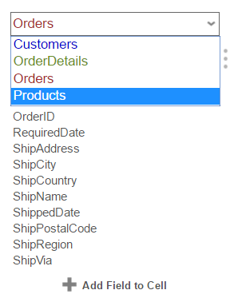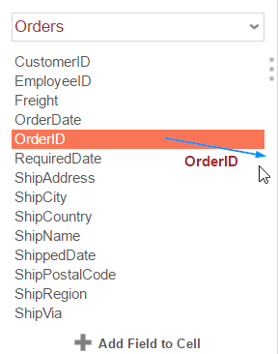

Alternatively, a Data Field can be put into a cell by typing Data Category Name (dot) Data Field Name. (E.g. **Orders.OrderID**).

To access other Data Categories, see [the section on Data Categories](#_Data_Categories).

## Toolbar

The toolbar contains the buttons and menus used to modify the report. Modifications can include aesthetic formatting, inserting formulas and images, linking reports, and much more.

The toolbar begins with a drop-down menu. This menu controls changes, such as renaming or filtering, that affect the entire report.

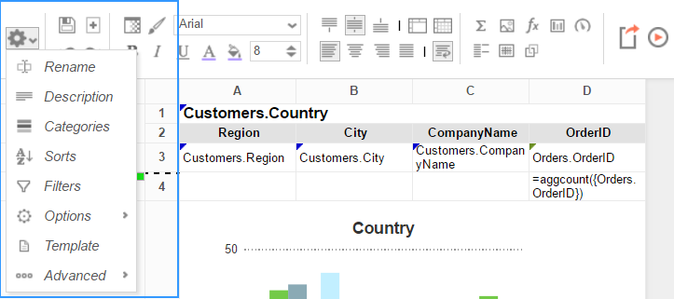

### Saving Reports

The report can be saved by clicking the save button (). The report will also save automatically any time it is run or exported.

### Undo/Redo

Any action on a report can be undone by clicking () or pressing **Ctrl**+**Z**. Undone actions can be redone by clicking () or pressing **Ctrl**+**Y**.

### Font & Alignment Options

The text of each cell can be formatted using drop-down menus and buttons in the toolbar. A cell or multiple cells must be selected for these tools to be used.

#### Font

* To change the font, use the font drop-down menu (font.png). The font names appear in the style that they represent.
* The buttons **B**, *I*, and U, make the font bold, italicized, and underlined, respectively.
* Use the font size.png menu to set the font size.

#### Color

* To change the text color, click the Foreground Color button () and then select a color or enter a hex value into the Foreground box. Click the clear button to revert to the default color ().
* To change the background color, click the Background Color button () and then select a color or enter a hex value into the Background box. Click the clear button to revert to the default color ().

#### Alignment

* Text can be aligned to the top, center, or bottom of a cell using the vertical alignment buttons.

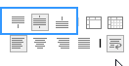

Text can be centered, justified, or aligned to the left or right of a cell using the horizontal alignment buttons.

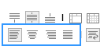

* The wrap text button () will begin a new line if the text is longer than the width of the cell.

### Formatting Cells

Click the format cells button () to open the Format Cells window. The window has three tabs: Number, Border, and Conditional.

NOTE. Cell formatting can be copied using the Format Paintbrush. Select the format you want to copy, click the format paintbrush button (), then click the cell you want to apply the formatting to.

#### Number

The *Number* Tab allows you to set the format of numbers and dates.

* General:
  + General format automatically applies formatting to cell values.
* Number:
  + Using the arrows, you can specify how many decimals to display. You can also set the symbol to separate decimals from whole numbers.
  + Check ‘*Use 1000 Separator*’ to separate every 3 digits. You can set which symbol is used to separate digits.
  + Check ‘*Use Currency Symbols*’ to have the currency sign appear in front of the number.
  + Check ‘*Append Percent Sign*’ to have the symbol ‘%’ appear after the number.
  + Check ‘*Blank When Zero*’ to leave the cell(s) blank if the value is zero.
  + Check ‘*Show Negative Symbol*’ to have a negative sign display in front of negative numbers.
  + Check ‘*Show Parenthesis*’ to put ( ) around negative numbers.
  + Use the *Color* picker to make negative numbers a specific color.

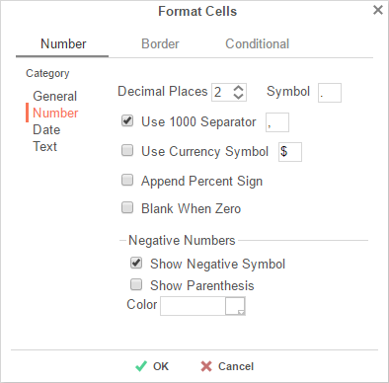

* Date:
  + From the menu, select a time/date format. (E.g. MM-yy will display a date as ‘Jun-97’).

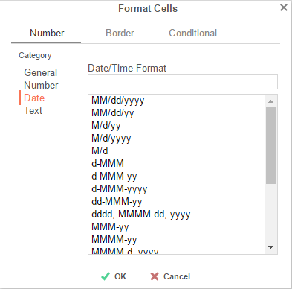

* Text format: Formatting does not apply to cell values.

#### Border

The *Border* tab allows you to alter the width and color of the cell edges.

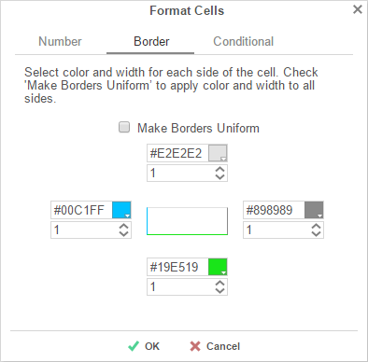

* Uncheck ‘Make Borders Uniform’ to modify specific edges.
* To widen the borders, either key in a value or use the arrows in the width box.
* To change the color, either select a color from the drop-down or enter a Hex value.

#### Conditional Formatting/Suppression

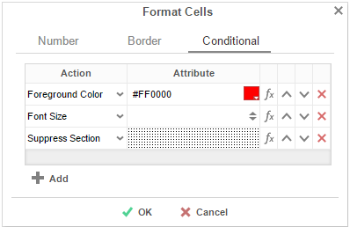

The *Conditional* tab allows you to set or modify the format of a cell based on a formula you create.

* Click the  button to create a new conditional format. Each format must have an Action and a Formula that evaluates to True or False. Some Actions require an Attribute such as a color or a number.
* Select an Action from the dropdown. This action will occur if the formula evaluates to True. Actions include:
  + **Foreground Color** –Sets the foreground color of the cell.

Attribute: Color

* + **Background Color** – Sets the background color of the cell.

Attribute: Color

* + **Font Size** – Sets the size of the text.

Attribute: Number

* + **Bold** – Bolds the text of the cell.

No Attribute

* + **Italic** – Italicizes the text of the cell.

No Attribute

* + **Underline** – Underlines the text of the cell.

No Attribute

* + **Horizontal Alignment** – Aligns the text of the cell horizontally.

Attributes: Left, Center, Right, or Justify

* + **Vertical Alignment** – Aligns the text of the cell vertically.

Attributes: Top, Bottom, or Middle

* + **Suppress Row** – Suppresses the row the cell is in.

No Attribute

* + **Suppress Section** – Suppresses the entire section that contains the cell.

No Attribute

* + **Page Break** – Starts a new page.

No Attribute

* Click the [Formula Editor](#_Formula_Editor) Button () to set the condition for the formula.

NOTE. The formula must evaluate to True or False. For conditional formatting, the Formula Editor will have an add  button. This button adds the function CellValue() to the formula. This function returns the value of the cell that conditional format is being applied to.

NOTE. The formula is still calculated with respect to the section of the cell. For example, for a cell in a report footer, the formula {Order.Profit} > 1000 will return True if the last Order of the detail section profited more than 1,000. To make the condition see if the total profit was greater than 1,000 use the formula ‘Sum({Order.Profit})>1000’.

* Use the up () and down () arrows to change the priority of the formats. If two formats share a common action and are both True, then the lower condition will be applied.
* To remove a format, click the delete button ().

### AutoSum

To quickly get a total on a Data Field, place the field in a Report or Group Footer and click the AutoSum button (). Alternatively, a sum can be created with the *aggSum* formula. See [Formulas](#_Formulas) for more information.

NOTE. Do not use **AutoSum** on a cell with an aggregate formula such as *aggSum*.

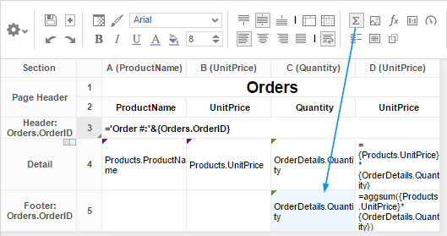

### Images

Insert an image from your computer to a cell using the Insert Image button (). This opens the Insert Image window. Select the image you would like to insert, and click ‘OK’.

### Formulas

Complex calculations can be done using [Formulas](#_Formulas). A formula can be added to a cell manually or by using the [Formula Editor](#_Formula_Editor). To open the Formula Editor, click the Formula Editor Button ().

### Suppress Duplicates

You can suppress duplicate values of a Data Object from being displayed. Select the cell and click the Suppress Duplicate button (). E.g. Compare the following reports:

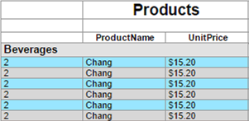 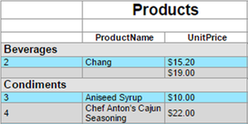

### Chart Wizard

To insert a chart into a cell, select a Group Footer or Report Footer cell and click the 'charts icon.png Chart Wizard' button. The Chart Wizard dialog will open. Use the tabs on top or the navigation buttons on the bottom to navigate the wizard.

Select a chart type, then press 'Next’ to continue.

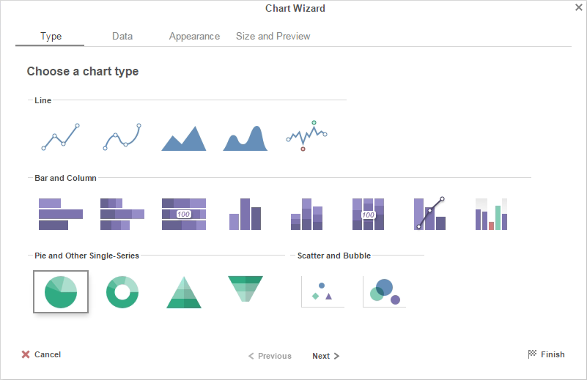

The Chart Wizard contains four tabs:

|  |  |  |  |  |  |  |
| --- | --- | --- | --- | --- | --- | --- |
| [Type](#_Type_1) | • | [Data](#_Data_Format) | • | [Appearance](#_Appearance) | • | [Size and Preview](#_Size_and_Preview) |

#### Type

The Type Tab lays out all the available types of charts you can create. The following chart types are supported:

*Click on a chart for more information*

|  |  |  |  |  |  |  |  |
| --- | --- | --- | --- | --- | --- | --- | --- |
| [Line](#Line)**[line.png](#Line)** | [Spline](#Spline)**[spline.png](#Spline)** | [Area](#Area)**[area.png](#Area)** | [Spline Area](#Spline_area)**[spline area.png](#Spline_area)** | [Spark Line](#Spark_line)**[spark line.png](#Spark_line)** |  |  |  |
| [Bar](#Bar)**[bar.png](#Bar)** | [Stack Bar](#Stack_bar)**[stack bar.png](#Stack_bar)** | [Stack Bar 100](#Stack_bar_100)**[100 stack bar.png](#Stack_bar_100)** | [Column](#Col)**[column.png](#Col)** | [Stack Column](#Stack_col)**[stack column.png](#Stack_col)** | [Stack Col. 100](#Stack_col_100)**[100 stack column.png](#Stack_col_100)** | [Pareto](#_Pareto)**[pareto.png](#_Pareto)** | [Spark Column](#_Spark_Line_and)**[spark column.png](#_Spark_Line_and)** |
| [Pie](#Pie)**[pie.png](#Pie)** | [Doughnut](#Doughnut)**[doughnut.png](#Doughnut)** | [Pyramid](#Pyramid)**[pyramid.png](#Pyramid)** | [Funnel](#Funnel)**[funnel.png](#Funnel)** |  |  |  |  |
| [Scatter](#_Scatter)**[scatter.png](#_Scatter)** | [Bubble](#_Bubble)**[bubble.png](#_Bubble)** |  |  |  |  |  |  |

##### Line, Spline, and Area

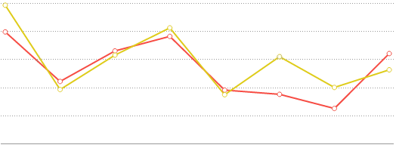

**Line charts** display a series of data points on a grid, connected by straight lines. They are often used to display a trend in data over intervals of time. Lines are not necessarily representative of any data between connected points. Line charts can be **single-series** (one line), or **multi-series** (multiple lines). On a multi-series chart, lines are differentiated by color.

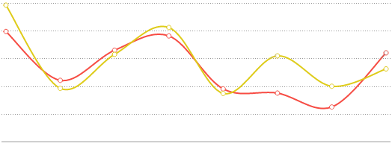

**Spline charts** are a stylistic variation of a [Line chart](#Line). Data points are connected by an interpolated curve. They are often used to display a trend in data over time, with estimated data between points. Spline charts are created in the same manner as [Line charts](#Line).

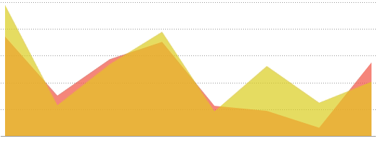

**Area charts** are a variation of a [Line chart](#Line). The area below each line is colored to represent cumulative data. They are often used to compare cumulated totals over time. On a multi-series chart, each series is given a distinct color, and the colors blend where series areas overlap. Area charts are created in the same manner as [Line charts](#Line).

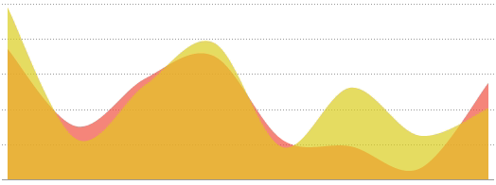

**Spline area charts** are a stylistic variation of an [Area chart](#Area). Data points are connected by an interpolated curve, and the area below each curve is colored to represent cumulative data. They are often used to compare cumulated totals over time, with estimated data between points. On a multi-series chart, each series is given a distinct color, and the colors blend where series areas overlap. Spline area charts are created in the same manner as [Line charts](#Line).

##### Bar and Column

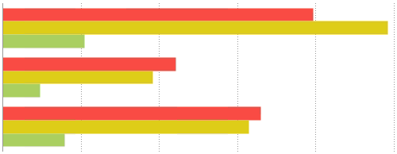

**Bar charts** use rectangular bars that extend horizontally to show comparisons between categories. Each data value is represented by a bar, the length of which represents its quantity. Bar charts can be **single-series** (one bar per category) or **multi-series** (multiple bars per category, each series differentiated by color).

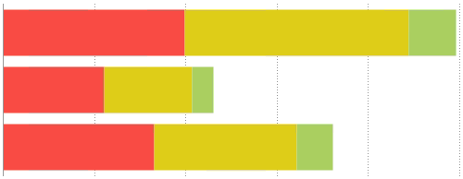

**Stack bar charts** are a variation of a **multi-series** [Bar chart](#Bar). Each bar is a category of data values stacked additively. The length of the bar represents the total quantity of the category, and each segment represents the data value in proportion to the total. Each series is differentiated by color. Stack bar charts can be created in the same manner as multi-series [Bar charts](#Bar).

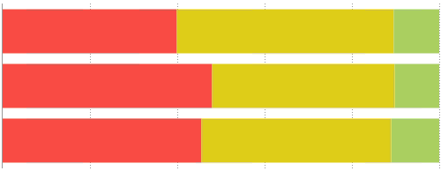

**Stack bar 100% charts** are a variation of a **multi-series** [Bar chart](#Bar). Each bar is a category of data values stacked additively. The length of the bar is fixed to 100%, and each segment represents the data value as a percentage of the total. Each series is differentiated by color. Stack bar 100% charts can be created in the same manner as multi-series [Bar charts](#Bar).

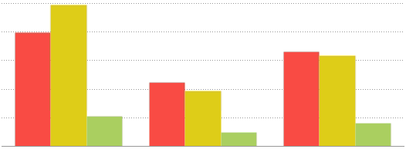

**Column charts** are a stylistic variation of a [Bar chart](#Bar). They use rectangular columns which extend vertically to show comparisons between categories. Each data value is represented by a column, the height of which represents its quantity. Column charts can be **single-series** (one column per category), or **multi-series** (multiple columns per category, each series differentiated by color). Column charts are created in the same manner as [Bar charts](#Bar).

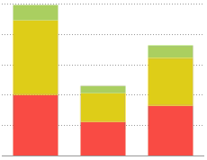

**Stack column charts** are a variation of a **multi-series** [Column chart](#Col). Each column is a category of data values stacked additively. The length of the column represents the total quantity of the category, and each segment represents the data value in proportion to the total. Each series is differentiated by color. Stack column charts can be created in the same manner as multi-series [Bar charts](#Bar).

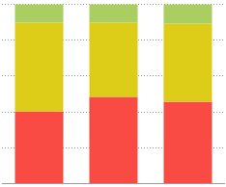

**Stack column 100% charts** are a variation of a **multi-series** [Column chart](#Col). Each column is a category of data values stacked additively. The length of the column is fixed to 100%, and each segment represents the data value as a percentage of the total. Each series is differentiated by color. Stack column 100% charts can be created in the same manner as multi-series [Bar charts](#Bar).

##### Pie, Doughnut, Pyramid, and Funnel

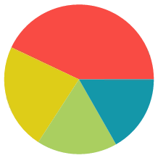

**Pie charts** are used to show the relationship of individual data fields in a series as portions of the total data in the series. They are shaped like a circle divided into colored "slices," each representing a data value. The area of each slice of the pie is proportional to the quantity it represents.

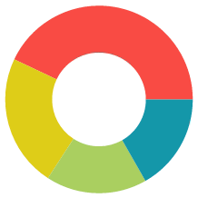

**Doughnut charts** are a stylistic variation of a [Pie chart](#Pie). They are ring shaped with a circular "hole" in the center like a doughnut. The ring is divided into colored "slices," each representing a data value. The area of each slice is proportional to the quantity it represents. Doughnut charts are created in the same manner as [Pie charts](#Pie).

**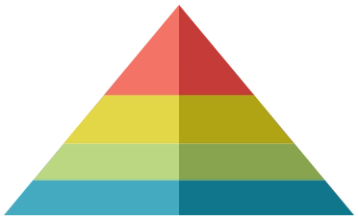Pyramid charts** are a variation of a [Pie chart](#Pie). They are often used when it is necessary to show a hierarchical order of data as well as its quantity.

Each data value is represented by a vertically stacked "slice" of a triangle, the height of each proportional to the quantity it represents. The slices are stacked in sort order. The width of each slice corresponds to its order but has no relation to its quantity. Pyramid charts are created in the same manner as [Pie charts](#Pie).

**Funnel charts** are a variation of a [Pie chart](#Pie). They are often used to show stages in a process as a falling value or percentage.

Each data value is represented by a vertically stacked "slice" of a triangle, the height of each proportional to the quantity it represents. The slices are stacked in sort order. The width of each slice corresponds to its order but has no relation to its quantity. Funnel charts are created in the same manner as [Pie charts](#Pie).

##### Scatter

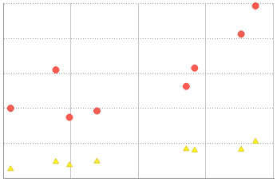

**Scatter charts** use pairs of data values as coordinates for points on a grid. They are often used to find relationships between two variables in a set of data. Scatter charts can be **single-series** (one set of points) or **multi-series** (multiple sets of points). On a multi-series chart, series are differentiated by point color and shape.

##### Bubble

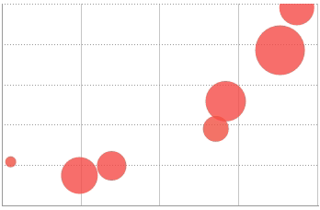

**Bubble charts** are a variation of a [Scatter chart](#_Scatter). They use pairs of data values as coordinates for "bubbles" on a grid, and a third data value for the size of the bubble. They are often used to find relationships between three variables in a set of data. Bubble charts can be **single-series** (one set of bubbles) or **multi-series** (multiple sets of bubbles). On a multi-series chart, series are differentiated by bubble color.

##### Pareto

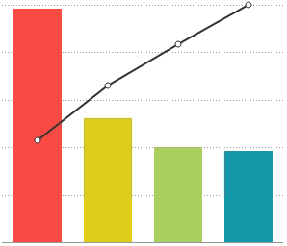

**Pareto charts** are a type of **single-series** chart generally used to highlight the most important element amongst a group. Pareto charts combine a [Column chart](#Col), each column representing a data value sorted in descending order, with a [Line chart](#Line), each point representing the cumulative percentage of the total.

##### Spark Line and Column

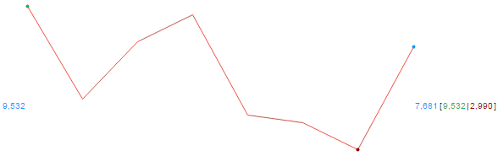

**Spark line charts** are a variation of a **single-series** [Line chart](#Line). They are used to display continuous trends in data, usually with regard to time. Spark line charts have no grid or axes and instead rely on point labels and benchmark lines to provide reference.

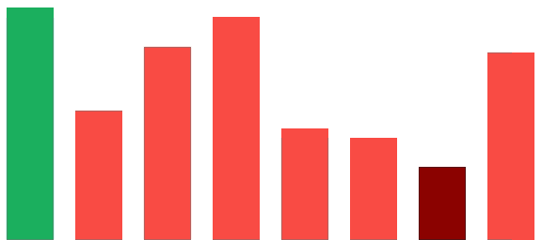

**Spark column charts** are a variation of a **single-series** [Bar chart](#Bar). They are used to show comparisons between data values. Spark column charts have no grid or axes, and instead rely on colors and benchmark lines to provide reference.

#### Data

The Data Tab is used to specify which cells are used as data values for the chart. You can also choose a sort order, as well as upper and lower boundaries for the data and axes. This tab is subdivided into two sections: [Data for Chart](#data_for_chart) and [Other Options](#other_options).

**Data for Chart**

This section contains fields to specify your chart data. You must fill out all the required fields before progressing. This section will contain different options depending on the selected [Chart Type](#_Type_1)and [Data Layout](#_Data_Layout).

Use [Layout 1](#_Layout_One)to build a chart one data point at a time. Each data point must contain a numeric Point Value and a Point Label. You can only create single-series charts using this layout.

* Add data points by clicking the http://i.imgur.com/0VDnbFV.pngbutton.
* Remove data points by clicking the Delete () button.

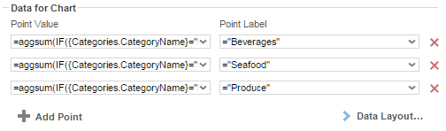

NOTE. For scatter charts, "Point Value" and "Point Label" correspond to the Y and X-axis values, respectively.

Use [Layout 2](#_Layout_Two) when each category has a repeating group with a data point for each series value.

* Add series by clicking the http://i.imgur.com/DZELV7K.pngbutton.  
  NOTE. This button is disabled for single series charts.
* Remove series by clicking the Delete () button.

Default options:

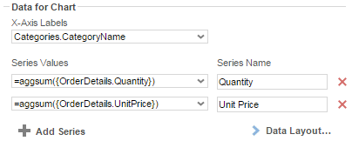

Scatter and Bubble Charts options:

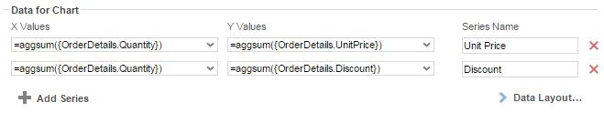

Additional Bubble Chart options:

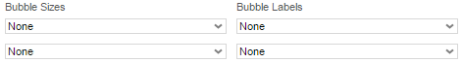

Use [Layout 3](#_Layout_Three) when each series is a repeating group which contains (at least) a data value cell and a data label cell.

|  |  |  |
| --- | --- | --- |
| Default options | Scatter & Bubble Chart options | Additional Bubble Chart options |
| **data_tab_layout_3.png** | scat options.png | bub options.png |

#### Data Layout

This dialog allows you to specify how your data is organized on the report.

##### Layout One

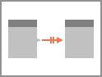

Use Layout 1 when you have a **one-to-one** relationship between your chart and data and you only wish to chart a **single-series** of data.

A **One-To-One** relationship means that for a table of data, there exists a relationship between your chart such that an element from your table can have **at most** **one** matching value on the chart. In practice, this means that your chart can only have one series of data. This is the simplest way to lay out your data, but also the most labor intensive. Stack and bubble charts are unsupported.

NOTE. A common example of a one-to-one relationship is social security numbers. A person has only one social security number, and each social security number belongs to only one person.

Using this layout, you can build charts by plotting out data value/label pairs (or coordinate pairs) using pairs of (non-repeating) cells in the design grid:



([A1], [A2]) => Point (x,y)

([B1], [B2]) => Point (x,y)

Each cell must be written in [Formula](#_Formulas_1) format, like so:

* Formula: *=aggsum({Orders.OrderId})*
* String: *="Beverages"*
* Number: *=34*
* Cell reference: *=[A4]*

Use the [Data Tab](#_Data) to select the pairs of cells for each point on your chart.

##### Layout Two

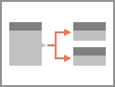

Use Layout 2 when you have a **one-to-many** relationship between your chart and data and have one or more cells representing each series of data. Single-series and multi-series charts can be created using Layout 2.

A **One-To-Many** relationship means that for a table of data, there exists a relationship between your chart such that an element from your table can have **more than one** matching value on the chart. Each such value is referred to as a **series**.

NOTE. A common example of a one-to-many relationship is email addresses. A person may have more than one email address, but each email address belongs to only one person.

Using this layout, each series is represented by one or more **group** ("category") cells:

l2.png

Series [A1]:

(Category 1, [A1]) => Point (x,y)

(Category 2, [A1]) => Point (x,y)

Series [B1]:

(Category 1, [B1]) => Point (x,y)

(Category 2, [B1]) => Point (x,y)

Use the [Data Tab](#_Data) to select the cells for each series on your chart.

NOTE. A category label cell is required for most chart types.

##### Layout Three

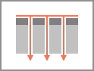

Use Layout 3 when you have a **one-to-many** relationship between your chart and data and have one cell for data values, one cell for labels, and optionally a cell with a series name for each value and label. Single-series and multi-series charts can be created using Layout 3.

Depending on the arrangement of your data, you can use this layout to build multi-series charts using only a single cell for each the data value, data label, and (optionally) series label:

l3.png

This example uses a repeating **group** (Order Year), and a **sort** on an element (Employee Name) in the repeating group (see [Sorts](#_Sorts_Tab)) to create a "category" group within a series group.

Series [B1].1:

(Category [A1].1, [C1].1) => Point (x,y)

(Category [A1].2, [C1].2) => Point (x,y)

Series [B1].2:

(Category [A1].1, [C1].1) => Point (x,y)

(Category [A1].2, [C1].2) => Point (x,y)

Use the [Data Tab](#_Data) to select the data value, label, and series cells on your chart.

NOTE. Charts created in an older software version exclusively support Layout 3.

**Other Options**

This section contains options for sorting data and setting data and axis bounds.

**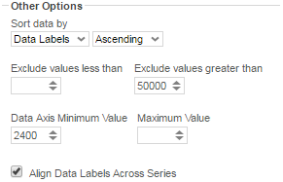**

* Use the ‘*Sort data by*’ dropdown to specify the order of the chart data (categories and series).
  + **Report Order** – The chart will follow the order of the information on the report.
  + **Data Labels** – The chart will be sorted by the data labels (either alphabetically or numerically).
  + **Data Values** – The chart will be sorted by the data values.
  + You can sort data in **Ascending** (A- Z, 0-9) or **Descending** (Z-A, 9-0) order.
* To ignore values that are too large or too small, enter a value into ‘*Exclude values less/greater than*’ boxes.
* To manually set the axis values, enter a value into the ‘*Data Axis Minimum/Maximum Value*’ boxes.
* Check ‘*Align Data Labels Across Series*’ if you have multi-series data with common data labels among the series.

#### Appearance

The Appearance Tab contains options for customizing how the chart will look. This tab is subdivided into four sections: [Colors](#colors), [Labels](#labels), [Other Features](#other_features), and [Advanced Features](#advanced_features).

**Colors**

colors.pngcolors range.png

* Use the drop-down to select a color palette to apply to the report.
  + Specify a custom range of *Colors* by selecting the **'Linear Range'** option. Click on the colored squares to open up a color picker, or type in custom hex values.
* Check the *'Use 3D Style'* box to give your chart a three-dimensional look.

**Labels**

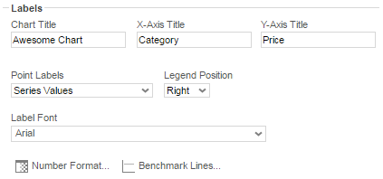

This section allows you to add labels to various elements of the chart.

NOTE.Not every attribute is applicable to every chart type.

* *Chart Title*: Enter the text you want to appear in at the top of the chart.
* *X-Axis Title*: Enter the text you want to appear on the X-Axis (horizontal axis).
* *Y-Axis Title*: Enter the text you want to appear on the Y-Axis (vertical axis).
* *Point Labels*: Use this dropdown to select value labels for the points on the chart.
* *Legend Position*: Use this dropdown to specify where to display the legend.
* *Label Font*: Use this dropdown to specify the label font.
* Number Format: Specify how data and axis labels should be formatted.  
  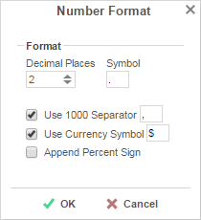
* Benchmark Lines: Add horizontal benchmark lines at specific sections of the chart. **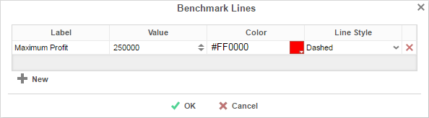**  
    
  To add a benchmark line press thehttp://i.imgur.com/gkYikeM.pngbutton.
  + *Label*: Enter the text you want to appear as the label of the benchmark.
  + *Value*: Specify the numeric value you would like to define as the benchmark. The benchmark line will display horizontally at this value.
  + *Color*: Use the color picker or type in a custom hex value to specify the color of the line.
  + *Line Style*: Specify either a **Solid** or **Dashed** line.
  + To remove a benchmark, click the Delete () button.

**Other Features**

**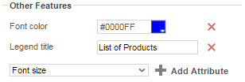**

This section contains a list of common miscellaneous features that may be customized.

* To add a custom attribute, select one from the drop-down and click the cid:image001.png@01D1A09D.5F864640 button. Then use the picker or type a custom property into the text field.
* To remove a custom attribute, click the Delete () button.

**Advanced Features**

**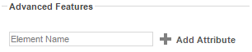**

This section allows an experienced user to add *Fusion Charts* customizations.

NOTE. This section is recommended for advanced users only.

NOTE. For a full list of advanced features, see [Fusion Chart Attributes](http://www.fusioncharts.com/dev/chart-attributes.html) (web link). Not all features may be supported.

* To add an advanced attribute, type in the name of the attribute, and click the cid:image001.png@01D1A09D.5F864640button. Then type a custom property into the text field.
* To remove an advanced attribute, click the Delete () button.

#### Size and Preview

The Size and Preview Tab allows you to change the size of the chart and see how it will appear on the report.

NOTE. The chart preview uses placeholder data.

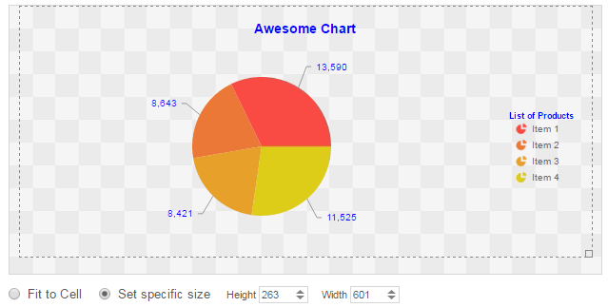

* You can change the size of the chart in one of three ways:
  + Click and drag the outer boundary of the chart.
  + Check the box for 'Set specific size' and type a custom Height and Width (in px) into the selection fields.
  + Check the box for 'Fit to Cell' and resize the chart cell on the Design Grid.

### Maps

A Map can be displayed in a report to give a visual representation of geographic data. To insert a Map, select a cell and click the Insert Map button (). The Map Wizard will appear. The Map Wizard has three tabs: Type, Locations, and Data.

NOTE. Maps should only be placed into a Group Header, Group Footer, Report Header or Report Footer section.

#### Type

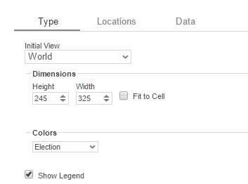

In the Type tab select the initial view, size, colors, and where to display the legend.

* Use the *Initial View* drop-down to select the location that initially displays on the Map. You may either select the world, a continent, or a country.
* There are three ways to set the size of the Map.
  + Enter the *Height* and *Width* in the dimension boxes.
  + Resize the chart by dragging the lower right corner in the preview.
  + Check the box ‘*Fit to Cell*’.
* In the *Colors* drop-down, either select a color theme or specify a linear range of colors.
* Check ‘*Show Legend*’ to display the legend.

#### Locations

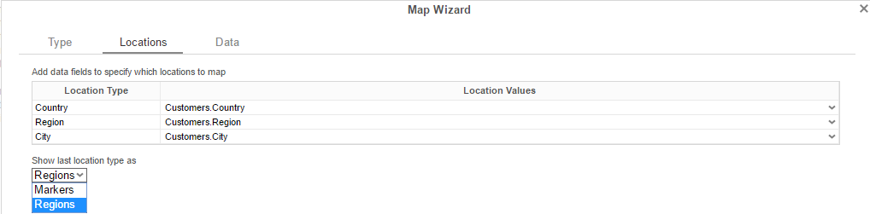

In the Locations Tab, specify which geographic locations should display on the Map.

* Use the *Location Values* drop-downs to select the cells that contain the geographic information for the Map. To utilize Region information, such as states/provinces, Country information must be provided. Similarly, City information requires Region and Country information.
* The ‘*Show last Location type as*’ drop-down specifies how to display the lowest level of information. You can either select circular markers (see image in Data Tab) or shaded geographic regions (see image below).

#### Data

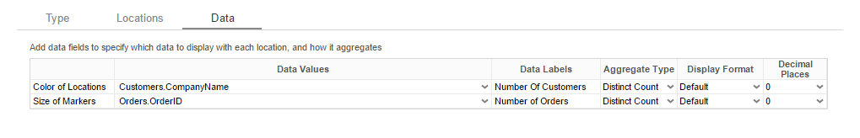

In the Data Tab, specify which data determines the color of each country/region/city and the size of each marker.

For each Data Value:

* Use the *Data Values* drop-down to specify which cells on the report should be used to determine the color and the size of each marker. Setting a cell for the size of marker is optional.
* Enter a label in the *Data Labels* column. Labels will appear in the hover effects of Dynamic Maps.
* Use the *Aggregation* drop-down to select a method to perform on the data:

|  |  |
| --- | --- |
| Summary Functions | * **Sum**: Totals the all of the data in the Data Field. * **Count**: Returns the number of rows in the Data Field. * **Average**: Takes the mean of the data in the Data Field. * **Minimum**: Displays the lowest value in the Data Field. * **Maximum**: Displays the highest value in the Data Field. |

* Use the *Display Format* drop-down to specify how to display the data:  
  + **Default**: Displays the values without any formatting.
  + **Currency**: Prepends the currency symbol on the values.
  + **Percent**: Multiplies the Data Value by 100 and appends a percent symbol (%) to the values.
  + **Scientific Notation**: Displays the values in scientific notation.
    - E.g. If Decimal Places are set to 2 then 123.45 would appear as 1.23 E2.
* *Decimal Places*: The number of decimal places to display.

#### Example

The subsequent steps show how to create a Map using the following data:

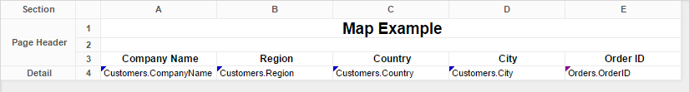

The Map will be colored based on the number of customers in each location and the markers will be sized based on how many orders have been placed in each location.

* Add a Report Footer section to the report, select all the cells in the Report Footer and click the merge cell button ().
* Select the merged cell and click the Insert Map icon ().
* In the Type tab:
  + Set the initial view, size and color.

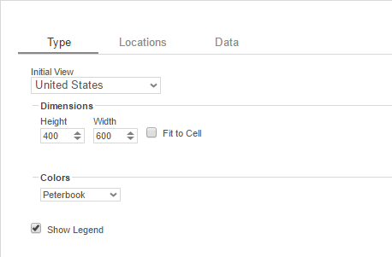

* In the Locations tab, set the field **Customers.Country** for Country information, **Customers.State** for Region, and **Customers.City** for City information. Set the ‘Show last location type as’ drop-down to Markers.

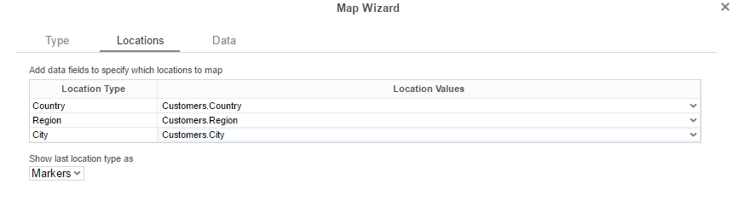

* In the Data tab:
  + Set the field **Customers.CompanyName** for Color of Locations. Provide a label such as ‘Num. of Customers’ and set the Aggregate Type to Distinct Count.
  + Set the field **Orders.OrderId** for the Size of Markers. Provide a label such as ‘Num. of Orders’ and set the Aggregate Type to Count.

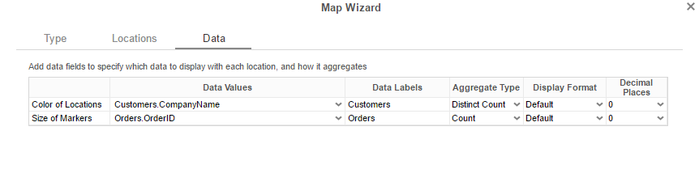

* Click Finish and run the report.

**Report Designer:**

**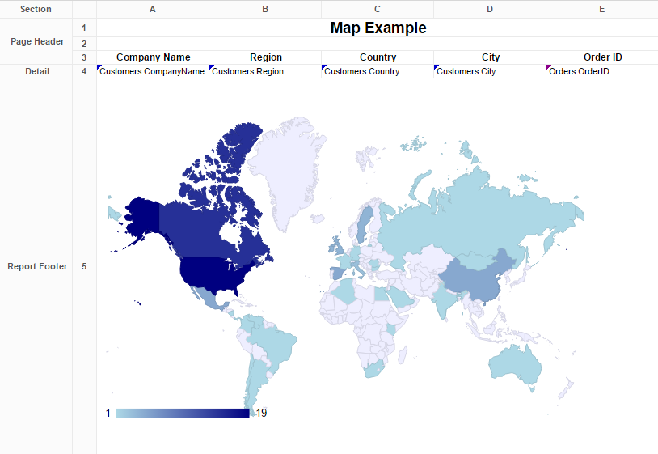**

**Report Viewer:**

**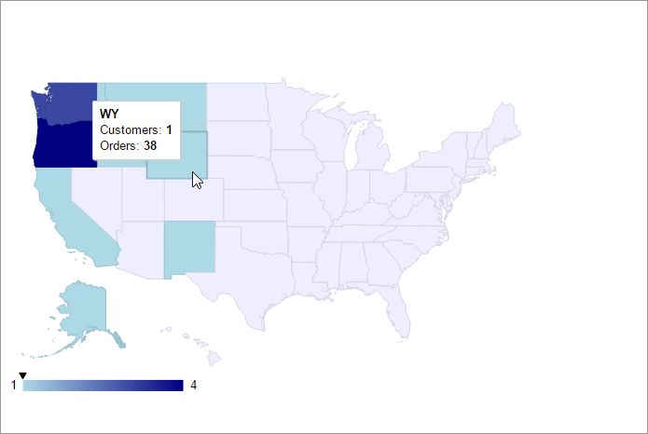**

### Linked Reports

The ability to create drill downs can be added by linking reports. Linked reports are only available in the Report Viewer or Dashboard Viewer.

* To link a report, select a cell and click the Linked Reports button (). The Linked Report window will appear displaying the available reports. Select the report you want to link and press ‘OK.’
* A cell with a linked report will be indicated by this icon ().
* To unlink a report, select the cell with the linked report and open the Linked Report window. Click the ‘Remove Link’ button ().

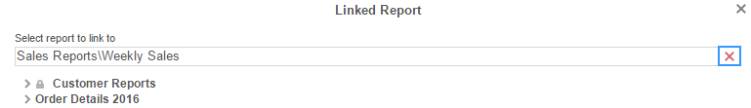

When a link is set on a cell, the unique key of the information being displayed is used to automatically filter the linked report. In the example below, the linked report is filtered for information where Employee Last Name equals ‘Buchanan’.

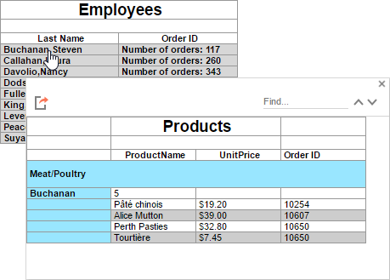

#### Chart Drilldowns

Chart drilldowns can also be created by using the Linked Reports menu. Chart drilldowns are only available in the Report Viewer or Dashboard Viewer.

* To create a drilldown, select a cell that contains a chart and click the Linked Reports button ( ). The Linked Report window will appear displaying the available reports. Select the report you want to link and press ‘OK.’
* To remove a drilldown, select the chart and open the Linked Report window. Click the ‘Remove Link’ button ().

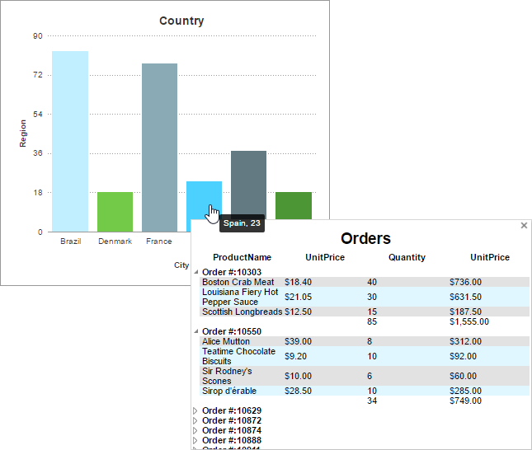

### Gauges

A Gauge can be displayed in a report to give a visual representation of the scale of a value. To insert a Gauge, select a cell and click the Insert Gauge button (). The Gauge Wizard will appear. The Gauge Wizard has two tabs: Appearance and Data.

NOTE. Gauges can be placed in any section of the report.

#### Appearance

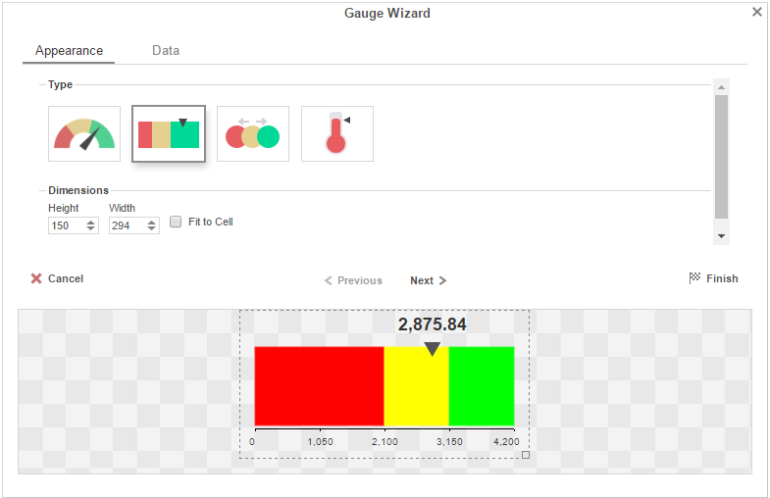

In the Appearance tab select the Type and Dimension of the Gauge.

* **Type** – Select the icon representing the type of gauge. Available types include: Angular, Linear, Bulb and Thermometer.
* There are three ways to set the size of the Gauge.
  + Enter the *Height* and *Width* in the dimension boxes.
  + Resize the gauge by dragging the lower right corner in the preview.
  + Check the box ‘*Fit to Cell*’’.

#### Data

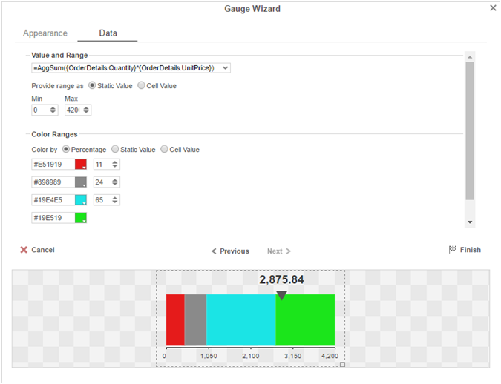

In the Data tab select the Data Values and Color Ranges for the Gauge.

* Use the Data Values drop-down to select the cell that contains the numeric value for the Gauge.
* Use the ‘Provide range as’ buttons to specify if the Min and Max values for the Gauge should be static numbers or come from cells on the report.
* In the Color Ranges, use the ‘Color By’ buttons to specify if color ranges should be percentages of the Max value, static numbers, or come from cells on the report.

NOTE. Percent Color Ranges must be in ascending numeric order.

* Use the  and remove.png buttons to create additional colors.

NOTE. Thermometer Gauges can only have one color.

* To change a color, either use the drop-down () or enter a Hex value.

### CrossTabs

CrossTabs allow the report to expand both horizontally and vertically based on data values and display summary information where each column and row meets. CrossTabs can be entered into a Standard Report from the toolbar using the CrossTab Button (). A CrossTab consists of three parts: [Row Headers](#_Row_Headers), [Column Headers](#_Column_Headers), and [Tabulation Data](#_Tabulation_Data). Additional settings for CrossTabs can be found in the [CrossTab Options Menu](#_CrossTab_Options).

NOTE. The cells below and to the right of a cell containing a CrossTab must be empty.

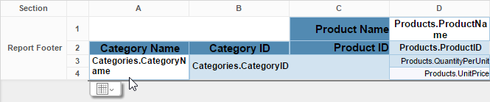

#### Row Headers

Row Headers expand a CrossTab vertically. A CrossTab has a row for each unique value of a Row Header.

E.g. If you were using sales data, you may have the Row Headers **Category.CategoryName** and **Products.ProductName** to provide rows for each product grouped by category.

* To add a Row Header, either drag and drop it to the ‘*Row Header Source*’ panel or use the ‘*Add Row Header*’ button ().
* Click the [Formula Editor](#_Formula_Editor) Button () to insert a formula into the Row Header.
* Click the Edit Header button () to open the Header Options Menu.  
     
    
  In the Header Options Menu you can:  
  + Set a *Label* for the Row Header. This label will appear at the top of the CrossTab.
  + Select a Sorting *Method* and *Direction*:  
    - **None** – Does not sort the Row Header.
    - **Header Value (Text)** – Sorts the Row Header by its values as though they are text.
    - **Header Value (Number)** – Sorts the Row Header by its values as though they are numbers.
    - **Tabular Totals** – Sorts the Row Header by the totals of the Tabulation Data.

NOTE. If there is more than one Row Header the Header Options Menu for the top most Row Header will have Options for subtotals of Tabulation Data.

* + Select where to display subtotals by using the *Placement* dropdown:  
    - **None** – Does not display subtotals.
    - **Top** – Displays subtotals above the Tabulation Data for each Row Header value.
    - **Bottom** – Displays subtotals below the Tabulation Data for each Row Header value.
  + Set a *Label* for the subtotals.
* Use the up () and down () arrows to rearrange the order of the Row Headers.
* To remove a Row Header, click the delete button ().

#### Column Headers

Column Headers expand a CrossTab horizontally. A CrossTab has a column for each unique value of a Column Header.

E.g. If you were using sales data, you may have the Column Headers ‘Year({Order.OrderDate})’ and ‘Month({Orders.OrderDate})’ to provide columns for each month grouped by year.

* To add a Column Header, either drag and drop it to the ‘*Column Header Source*’ panel or use the ‘*Add Column Header*’ button ().
* Click the [Formula Editor](#_Formula_Editor) Button () to insert a formula into the Column Header.
* Click the Edit Header button () to open the Header Options Menu.  
    
    
    
  In the Header Options Menu, you can:  
  + Set a *Label* for the Column Header to appear at the top of the CrossTab.
  + Select a Sorting *Method* and *Direction*.  
    - **None** – Does not sort the Column Header.
    - **Header Value (Text)** – Sorts the Column Header by its values as though they were text.
    - **Header Value (Number)** – Sorts the Column Header by its values as though they were numbers.
    - **Tabular Totals** – Sorts the Column Header by the totals of the Tabulation Data.

NOTE. If there is more than one Column Header the Header Options Menu for the topmost Column, Header will have Options for subtotals of Tabulation Data.

* + Select where to display subtotals by using the *Placement* dropdown.  
    - **None** – Does not display subtotals.
    - **Left** – Displays subtotals to the left of the Tabulation Data for each Column Header value.
    - **Right** – Displays subtotals to the right of the Tabulation Data for each Column Header value.
  + Set a *Label* for the subtotals.
* Use the up () and down () arrows to rearrange the order of the Column Headers.
* To remove a Column Header, click the delete button ().

#### Tabulation Data

Tabulation Data provides information when data exists for the Column Header and Row Header values. For example, if you have a Row Header on products and a Column Header on the month, then Tabulation Data of **Orders.OrderID** may use the Count function to display how many orders contained each product each month.

* To add a Tabulation Data field, either drag and drop it to the ‘*Tabulation Data*’ panel or use the ‘*Add Tabulation Data*’ button ().
* Click the [Formula Editor](#_Formula_Editor) Button () to insert a formula into the Tabulation Data.
* Click the Edit Tabulation button () to open the Tabulation Options menu.  
    
    
    
  In the Tabulation Options Menu, you can:  
  + Set a Label for the Tabulation Row to appear at the beginning of each row.
  + Use the Method dropdown to select the summary function to be applied to the Tabulation Data.

|  |  |
| --- | --- |
| Summary Functions | * **Sum**: Totals the all of the data in the Tabulation Data. * **Count**: Returns the number of rows in the Tabulation Data. * **Average**: Takes the mean of the data in the Tabulation Data. * **Minimum**: Displays the lowest value in the Tabulation Data. * **Maximum**: Displays the highest value in the Tabulation Data. * **None**: Displays the value in the Tabulation Data without doing any calculations. |

* + Use the Value dropdown to select how the Tabulation Data should be displayed.
    - **Aggregate**: Display the result of the selected Method.
    - **Percent of Row**: Display the result of the selected method as a percentage of the row total.
    - **Percent of Column**: Display the result of the selected method as a percentage of the column total.
* Use the up () and down () arrows to move the Tabulation Data order.
* To remove a Tabulation Data field, click the delete button ().

#### CrossTab Themes

The Theme dropdown can be used to quickly style the CrossTab using one of the pre-defined themes. Further styling can be done to the cells of the CrossTab in the [Report Designer](#_Report_Designer).

#### CrossTab Options

Settings that affect the entire CrossTab are controlled in the CrossTab Options Menu. Open the CrossTab Options Menu by clicking the Options button ().



Use the menu to adjust the following settings:

**General**

* Use the *Row Headers Placement* dropdown to determine how the Row Headers are displayed.
  + **Columns** – Display the Row Headers in columns from left to right in their order in the Row Header Source panel.
  + **Hierarchical** – Display Row Headers in a hierarchical structure using indentation to display their order.
* Check ‘*Repeat CrossTab Header every new page*’ to repeat Row Header labels and Column Headers on each new page.

**Grand Total Row**

* To get a total for each column, select ‘**Top**’ or ‘**Bottom**’ from the *Placement* dropdown and provide a label in the *Label* text box.

**Grand Total Column**

* To get a total for each row, select ‘**Top**’ or ‘**Bottom**’ from the *Placement* dropdown and provide a label in the *Label* text box.

### Renaming Reports

To change the name of a report, click ‘*Rename*’ in the Toolbar drop-down menu. Enter a new name and select the folder in which you want to save the report. Click ‘OK’.

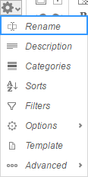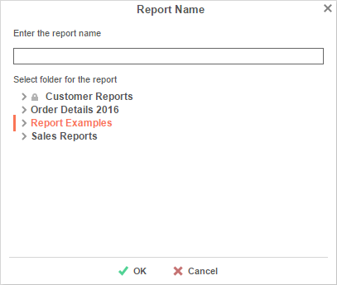

### Changing Description

The report description appears at the bottom of the [Main Menu](#_Main_Menu). Report descriptions are optional but can be searched. To change a report description, click ‘*Description*’ in the Toolbar drop-down menu. Write a description and click ‘OK.’

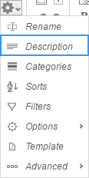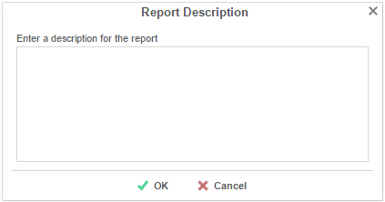

### Changing Data Categories

Before you change a Data Category, it is important to understand two terms: **Data Category** and **Data Field**.

**Data Category** – A Data Category is an object that has a group of attributes. E.g. Orders is a category; each order has an ID, a date, a customer etc.

**Data Field –** A Data Field is a single attribute within a Data Category. E.g. Orders.OrderID is numeric value that identifies a specific order.

To modify the Data Categories, click ‘*Categories*’ in the Toolbar drop-down menu.

* To add a Data Category to a report, either drag and drop it to the ‘*Category Name*’ panel, use the button, or double-click it.
* To search for a specific Data Category, type its name into the search box.
* To see what Data Fields are in a Category, click the information button ().
* Check the ‘*Suppress Duplicates*’ box to prevent duplicate information from appearing on the report.
* To remove a selected Category, click the delete button ().

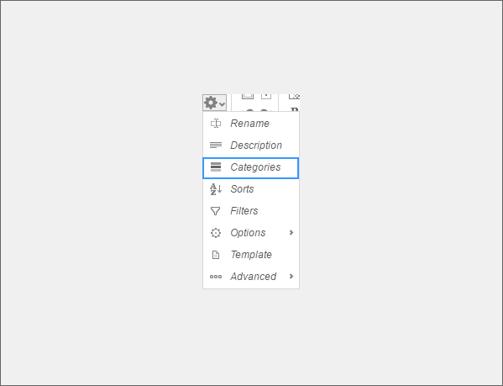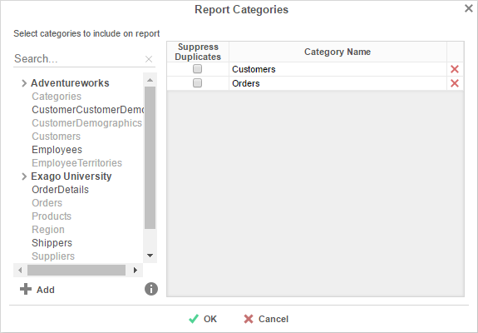

### Changing Sorts

To modify the sort criteria of a report, click ‘*Sorts*’ in the Toolbar drop-down menu.

* To sort by a Data Field, either drag and drop it to the ‘*Sort by*’ panel, use the  button, or double-click it.
* You can sort each field in **Ascending** (A- Z, 0-9) or **Descending** (Z-A, 9-0) order.
* Use the up () and down () arrows to indicate the sort priority.
* To remove a sort, click the delete button ().

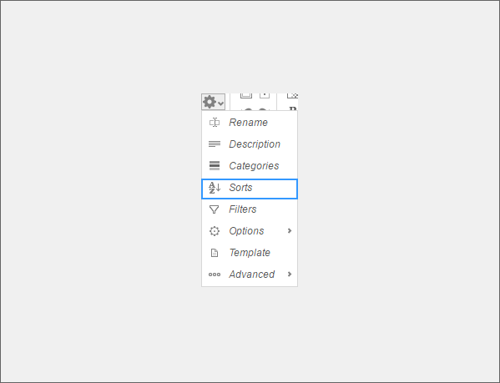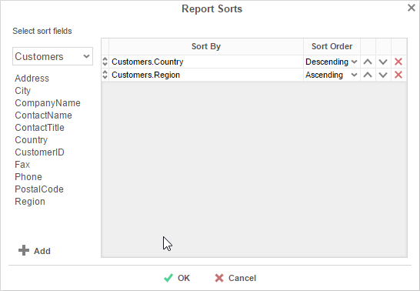

### Changing Filters

To modify the filter criteria of a report, click ‘Filters’ in the Toolbar drop-down menu. There are three types of filters: [Standard](#_Standard_Filters_1), [Interactive](#_Interactive_Filters), and [Group](#_Group_(Min/Max)_Filters_1). Standard filters are based on values you specify. Interactive filters can be applied after running a report to the Report Viewer. Group filters are based on the minimum or maximum value in the Data Field.

#### Standard Filters

There is no limit to the number of filters that you can define. Filters can be numeric (up to eight decimals) or alphanumeric.

* To filter a Data Field, either drag and drop it to the ‘*Filter By*’ panel, use the  button, or double-click it.
* Use the up () and down () arrows to indicate the filter priority.
* To remove a filter, click the delete button ().
* Set the operator (**Equal To**, **Less Than**, **One Of**, etc.) by selecting from the *Operator* drop-down.
* To set the value on which to filter, either enter it manually or select from the drop-down. If the Data Field is a date you may use the calendar or function buttons to select a value.
* To allow the filter to be modified at the time the report is executed, check ‘*Prompt for Value*.’
* Select ‘*AND With Next Filter*’ to require that the selected filter and the one below it both evaluate to true. Choose ‘*OR With Next Filter*’ to require that either be true.
* Check ‘*Group With Next Filter*’ to specify the precedence of the filters. Filters can be nested indefinitely by using the following keyboard shortcuts while a filter is selected:
  + **Ctrl + [** adds an open-parenthesis before the selected filter.
  + **Ctrl + ]** adds a close-parenthesis after the selected filter.
  + **Ctrl + Shift + [** removes an open-parenthesis from before the selected filter.
  + **Ctrl + Shift + ]** removes a close-parenthesis from after the selected filter.

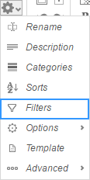**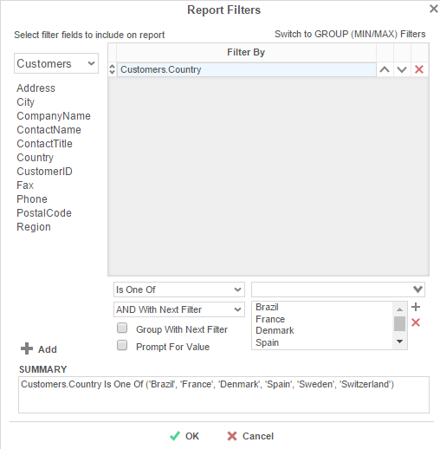**

#### Interactive Filters

Interactive Filters can be created in the Report Viewer Options Menu. These filters can be enabled, disabled, or modified after running a report to the report viewer. For more information, see [Interactive Report Viewer Options](#_Interactive_HTML_Options).

#### Group (Min/Max) Filters

Group filters are based on the minimum or maximum value in the Data Field. To modify group filters, click ‘*Switch to Group (MIN/MAX) filters*’. There is no limit to the number of group filters you may define.

* To filter a Data Field’s minimum or maximum value either drag and drop it to the ‘*Filter By*’ panel, use thebutton, or double-click it.
* Specify **Minimum** or **Maximum** from the *Operator* drop-down.
* Use the up () and down () arrows to indicate the filter priority.
* To remove a filter, click the delete button ().

### General Options

Hover over ‘*Options*’ in the Toolbar drop-down and then click on ‘*General*’ menu to open the Report Options Window. This window allows you to control various settings including default export type and page orientation.

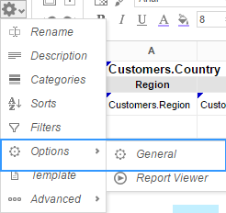 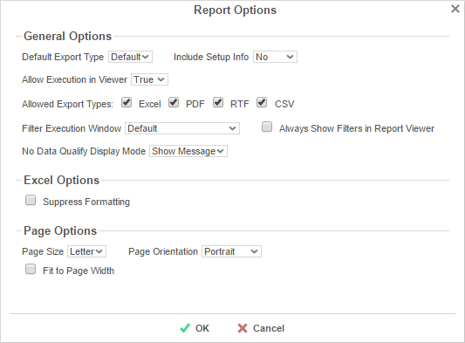

**General Options**

* Use the Default Export Type drop-down to specify the default format for the report.
* From the ‘*Include Setup*’ menu, select **Top** or **Bottom** to display the data categories, sorts, and filters at either the beginning or end of the report.
* Output types may be disabled by unchecking the boxes for ‘*Allowed Export Types*’.
* Use the ‘*Filter Execution Window*’ drop-down to select which type of Filter menu displays when executing a report that has prompt-for-value filters.
  + **Default –** Display the default type of filter execution window.
  + **Standard –** Display the standard filter execution window.
  + **Simple with Operator –** Display a simplified filter execution window that only allows the operator and value to be changed.
  + **Simple without Operator –** Display a simplified filter window that only allows the filter value to be changed.
* Check ‘*Always Show Filter Execution*’ to show the filter menu and allow changes to be made each time the report is executed.
* Use the ‘*No Data Qualify Display Mode*’ to select what to display if no data qualifies for the report.
  + **Show Message** – Display the standard no data qualified message.
  + **Show Report** – Display the Page Header, Page Footer, Report Header, and Report Footer sections of the report. Any cells containing Data Fields will not be displayed.

**Excel Options**

* Check ‘*Suppress Formatting*’ to prevent the report formatting from exporting to Excel.

**Page Options**

* Specify the size for the report in the ‘*Page Size*’ menu. Default is **Letter**.
* Set the orientation for the report in the ‘*Orientation*’ menu. Default is **Portrait**.
* Check ‘*Fit to Page Width*’ to scale all columns to fit the width of the page.

### Report Viewer Options

Hover over ‘*Options*’ in the Toolbar drop-down and then click on ‘*Report Viewer*’ menu to open the Report Viewer Options Menu. This window allows you to control what interactive capabilities a user has when viewing reports.

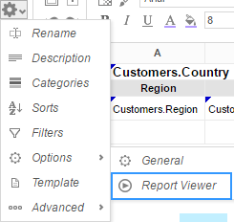

#### General

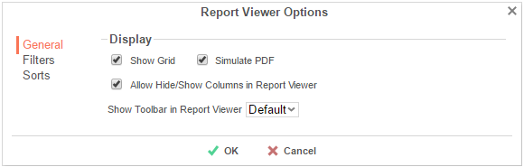

* Uncheck ‘*Show Grid*’ to disable grid lines.
* Uncheck ‘*Simulate PDF*’ to have the report appear as though it is not on a page.
* Uncheck ‘*Allow Hide/Show Columns on Execution*’ to disable the [Hide Columns](#_Hiding_Columns) tools.

#### Filters

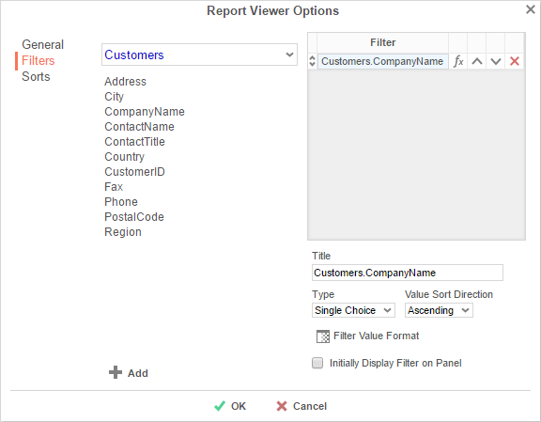

Interactive Filters are filters created on either Data Fields or Formulas and then enabled after running a report to the report viewer.

* To filter a Data Field, either drag and drop it to the ‘Filter’ panel, use the  button, or double-click it. To filter by a formula, first add a Data Field, then use the formula button () to open the [Formula Editor](#_Formula_Editor).
* In the Title box provide a name for the interactive filter.
* Use the Type dropdown to specify what kind of interactive filter to display:
  + **Single Choice**: A dropdown with the possible values of the filter:



* + **Multiple Choice**: All possible values for the filter presented with check boxes to select one or more values:

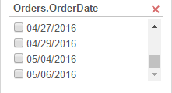

* + **Single Slider**: Select the filter value by sliding a point along a scale:

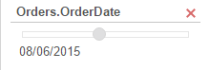

* + **Range Slider**: A scale that displays values between two points:

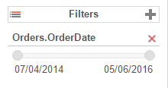

* Click the Format button () to open the format menu and specify how the filter values should be displayed.
* If filtering on an [Aggregate](#_Agregate_Functions) formula such as *AggSum*, use the ‘*Calculate Value Ever*’ dropdown to select on which sorted field or category the aggregate should be applied.
* Use the ‘*Value Sort Direction*’ to specify if the filter values should display in ascending or descending order.
* Check the ‘Initially Display Filter on Panel’ box to have the filter enabled automatically when the report is run to the viewer.

#### Sorts

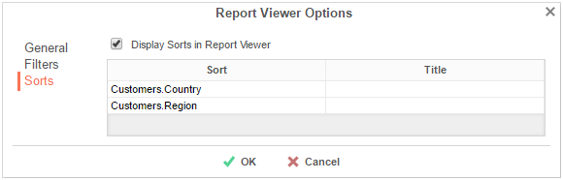

Interactive sorts can be used to change the direction of a report’s [Sorts](#_Changing_Sorts) while viewing the report in the Report Viewer

* Uncheck ‘*Display sorts on Execution*’ to hide interactive sorts in the Report Viewer.
* In the *Title* column, provide a name for each interactive sort.

### Advanced Options

Click ‘*Advanced*’ in the Toolbar drop-down menu to open the Advanced Options window. This window allows you to specify additional information about how the Data Categories relate to each other.

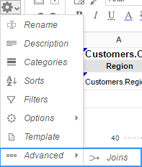 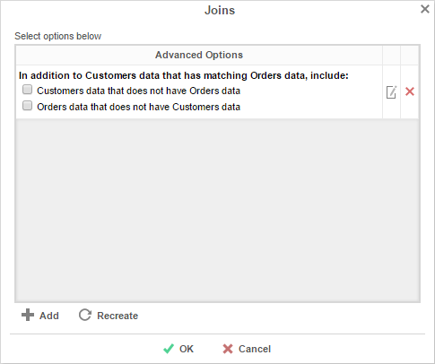

Before using these options, it is important to understand the definition of a **Join**.

**Join** – A join defines how two Data Categories are related. Each join has a ‘From’ Category and a ‘To’ Category. The From and To objects must have one (or more) Data Fields that contain the same information.

E.g. A join exists between two Data Categories: *Orders* and *Customers*. The join goes ‘From’ Customers ‘To’ Orders. In this example, when a customer makes an order, that customer’s ID is saved with the order. Thus, the Orders Category has the Data Field CustomerID. This Data Field matches the Data Field CustomerID in the Customers Category. This join assures that each customer is paired with the orders that they have made.

* To add a new join, click the  button.
* To edit a join, click the edit button ().
* Restore the default joins by clicking the Recreate button (recreate.png).
* To remove a join, click the delete button ().

When you click the Add or Edit buttons, the Report Join menu will appear. In this menu, you can create or modify a Join for the report:

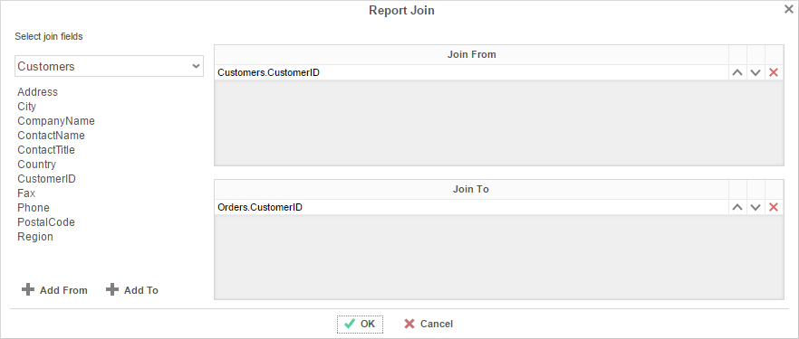

* To set the From Category, select a Data Field from the Category and drag it into the ‘*Join From*’ panel or use the add from.png button.
* To set the To Category, select a Data Field from the Category and drag it into the ‘*Join To*’ panel or use the add to.png button.
* Use the up () and down () Arrows to reorder the Data Fields. The position of each Field in ‘*Join From*’ should match the position of its corresponding Field in ‘*Join To*’.

### Document Template

Reports can also be used to fill in PDF, RTF, or Excel templates, such as internal or government documents. Click ‘Templates’ in the drop-down menu to open the ‘Document Template’ window.

* Before using the Templates window, put your data into the cells of your report.
* From the top drop-down, select the template you want to use.
* In the ‘Report Field’ column, specify which cell of the report corresponds to each ‘Template Field’.

Once the fields are complete, [exporting the report](#_Executing_Reports) in the same format as the template will produce a filled-in template.

The example below shows the fields being set in the Document Template window and the output when the report is exported as a PDF.

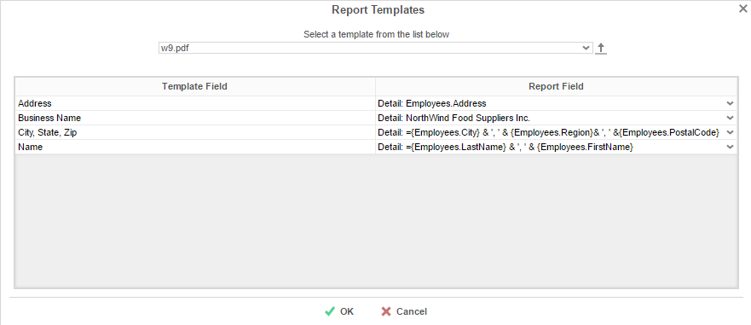

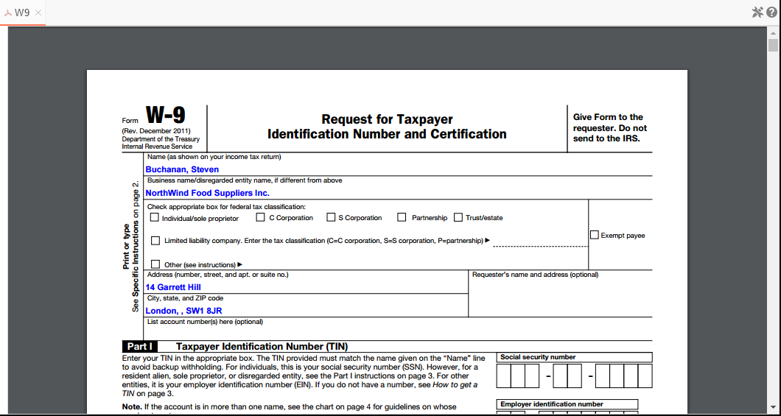

# Duplicating Reports

Duplicating reports can save time. This feature creates a new report that is identical to an existing one. Instead of creating the new report from scratch, you can duplicate an existing report, rename it, and make your changes.

1. On the [Main Menu](#_Main_Menu), select the report you want to duplicate.
2. Click the Duplicate button. The Rename Report Window will open.
3. Type the name of the new report into the Report Name field.
4. Select the folder where the report will be saved.
5. Click ‘OK’.

# Deleting Reports

Deleting a report removes the report and all of its components.

To delete an existing report:

1. On the [Main Menu](#_Main_Menu), select the report you want to delete.
2. Click the Delete button (). A dialog box will ask if you are sure you want to proceed.
3. Click OK in the dialog box. The report is deleted.

IMPORTANT.Once the report is deleted, there is **no way** to recover it.

# Scheduling Reports

Reports may be sent to recipients via email using custom scheduled intervals. A scheduled report can be executed and emailed immediately or scheduled to be emailed on a recurring basis. The Scheduler Menu lets you schedule and email reports or edit existing schedules.

To open the Scheduler Menu:

1. In the [Main Menu](#_Main_Menu), select the report you want to schedule/email.
2. Click the Scheduler Menu button (). The Schedule Menu will appear.

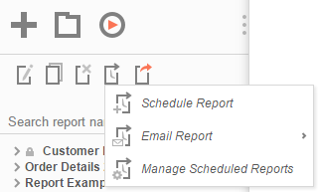

* 1. To Schedule a report, click new schedule button (). The  [Schedule Report Wizard](#_Report_Schedule_Wizard) will open in a new tab.
  2. To email a report, click email button (). The [Email Report Menu](#_Email_Report) will appear.
  3. To edit existing schedules, click the edit schedule button (). The [Schedule Manager](#_Manage_Scheduled_Reports) will open in a new tab.

NOTE. If you do not see a Schedule Report button in the Main Menu, then you do not have Report Scheduler permissions and should contact your administrator.

## Schedule Report Wizard

The Schedule Report Wizard has four sub tabs. The Recurrence and Recipients tabs are required, and the other tabs are optional.

1. **Recurrence**: Specify the name and format of the report and when the report should be sent out.
2. **Parameters**: (optional) Set values for any parameters used by the report.
3. **Filters**: (optional) Add filters to the report.
4. **Recipients**: Specify the recipient addresses, subject, and body text of the email.

### Recurrence Tab

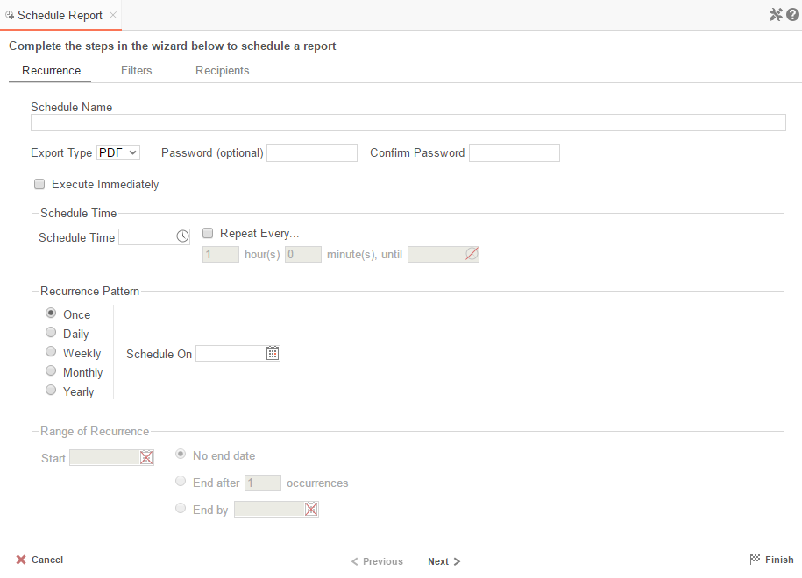

In the Recurrence Tab, give the schedule a name and format. Set the frequency at which you want the report to be executed and sent out. This recurrence can be a one-time, daily, weekly, monthly, or yearly delivery. A date range can also be set to give the report delivery a defined start and end date.

* Give the Schedule a Name and select an export type from the drop-down.
* For PDF reports, a password may be set. The password may require a minimum number of upper/lowercase letters or numbers. To find out the required password strength, hover the mouse over the Password box.
* To execute and send the report immediately, check ‘*Execute Immediately*’.
* Schedule Time
  + Set the time of day the report should be executed by entering a time in the *Schedule Time* box.
  + Check ‘*Repeat every*’ and then specify a time interval to have the schedule be sent on a recurring basis on the day(s) specified in as the Recurrence Pattern.
* Recurrence Patterns
  + **Once** – Specify to execute the report on a specific day or immediately.
  + **Daily** – Send the report every weekday or every set number of days.
  + **Weekly** – Send the report on specific days of the week.
  + **Monthly** – Set the day of the month to send the report.
  + **Yearly** – Set the day of the year to send the report.
* Range of Recurrence
  + Use the Range of Recurrence section to set a start date and an end date for the report schedule.

### Parameters Tab

In the Parameters Tab, enter a value for each of the parameters listed.

NOTE.The Parameters Tab will only be visible if the report is utilizing parameters. See [Parameters](#_Parameters) for more information.

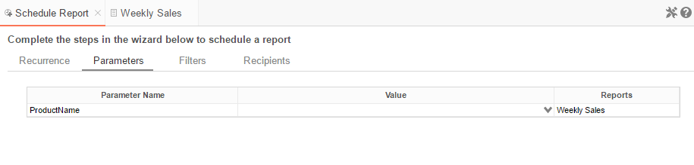

### Filters Tab

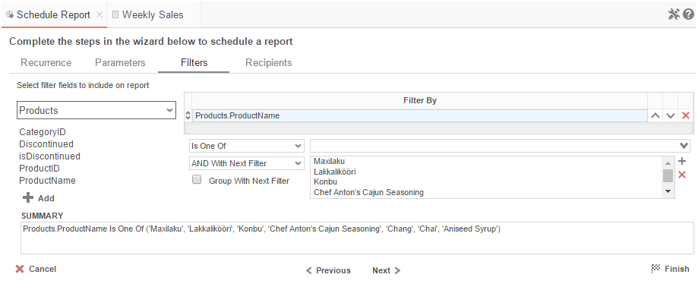

In the Filters Tab create statements to filter the data at runtime. There are two types of filters: [Standard](#_Standard_Filters_2) and [Group](#_Group_(Min/Max)_Filters_1). Standard filters are based on values you specify. Group filters are based on the minimum or maximum value in the Data Field.

**Standard Filters**

There is no limit to the number of filters that you can define. Filters can be numeric (up to eight decimals) or alphanumeric.

* To filter a Data Field, either drag and drop it to the ‘*Filter By*’ panel, use the button, or double-click it.
* Use the up () and down () arrows to indicate the filter priority.
* To remove a filter, click the delete button ().
* Set the operator (**Equal To**, **Less Than**, **One Of**, etc.) by selecting from the *Operator* drop-down.
* To set the value on which to filter, either enter it manually or select from the drop-down. If the Data Field is a date, you may use the calendar or function buttons to select a value.
* To allow the filter to be modified at the time the report is executed, check ‘*Prompt for Value*.’
* Select ‘*AND With Next Filter*’ to require that the selected filter and the one below it both evaluate to true. Choose ‘*OR With Next Filter*’ to require that either be true.
* Check ‘*Group With Next Filter*’ to specify the precedence of the filters. Filters can be nested indefinitely by using the following keyboard shortcuts while a filter is selected:
  + **Ctrl + [** adds an open-parenthesis before the selected filter.
  + **Ctrl + ]** adds a close-parenthesis after the selected filter.
  + **Ctrl + Shift + [** removes an open-parenthesis from before the selected filter.
  + **Ctrl + Shift + ]** removes a close-parenthesis from after the selected filter.

**Group (Min/Max) Filters**

Group filters are based on the minimum or maximum value in the Data Field. To modify group filters, click ‘*Switch to Group (MIN/MAX) filters*’. There is no limit to the number of group filters you may define.

* To filter a Data Field’s minimum or maximum value, either drag and drop it to the ‘Filter By’ panel, use the button or double-click it.
* Specify Minimum or Maximum from the operator drop-down.
* Use the up () and down () arrows to indicate the filter priority.
* To remove a filter, click the delete button ().

### Recipients Tab

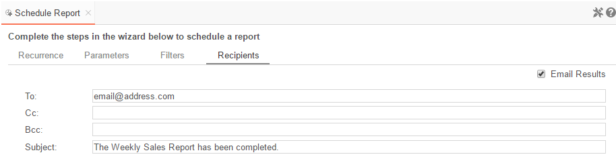

In the Recipients Tab, determine how the schedule will be delivered and list the email address(es) to which the report should be sent. Separate email addresses with a semi-colon (;).

* Check ‘*Email Results*’ to have the report sent via email. Uncheck this option to have it saved to a repository.
* In the To field, set the email address(es) to which the report will be delivered.
* In the Cc field, set any address(es) to be carbon copied.
* In the Bcc field, set any address(es) to be blind carbon copied.
* Set the subject of the email in the Subject field.
* In the Body field, enter the text of the email to be sent with the report. To reference the report, name use ‘@reportName@’.

NOTE. In this application, @reportName@ is a built-in parameter. For more information on this behavior, see [Parameters](#_Parameters).

## Email Report

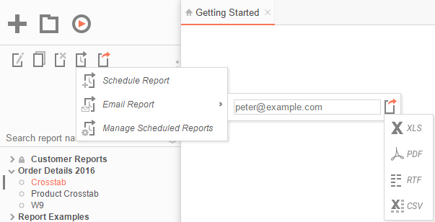

In the [Scheduler Menu](#_Scheduling_Reports), use the email icon () to email a report. An input field and export options will appear.

* In the input field, enter the email address.
* Click the drop-down arrow to change the format of the report.
* Select an export type and click the matching button to execute and email the report.

NOTE. Reports may only be emailed as downloadable file types (Excel, PDF, RTF, CSV).

## Manage Scheduled Reports

Scheduled Reports can be monitored, edited, and removed using the Manage Scheduled Reports tab.

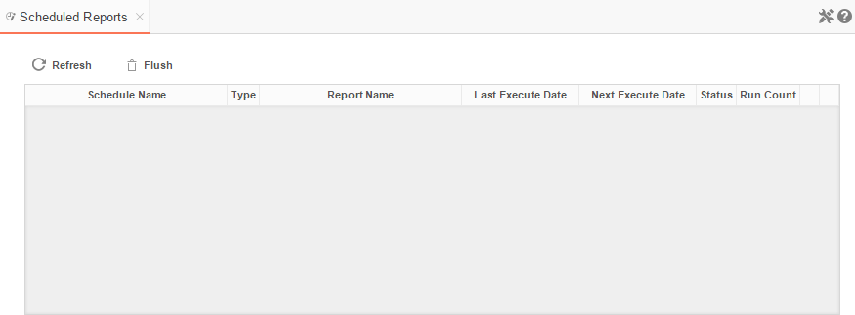To open the tab, click the scheduler icon () in the [Main Menu](#_Main_Menu) then click (). The Manage Scheduled Reports tab will appear.

* Click at the top of a column to sort the scheduled reports by that column.
* To update the status and list new schedules click the Refresh button.
* To removed completed schedules click the Flush button.
* Click the Edit icon () to open the [Schedule Report Wizard](#_Schedule_Report_Wizard) and modify the report.
* To delete a schedule click the delete icon ().

# Executing Reports

Reports can be run or exported from the [Main Menu](#_Main_Menu) or the [Report Designer](#_Report_Designer).

In the Main Menu select the report you want to run or export. With the report highlighted click the Run Report button . To change the output format, click the Export Type drop-down  and select from the available export formats (Excel, PDF, RTF, or CSV).

NOTE. Right-clicking on the Export Type button will export the report to a PDF.

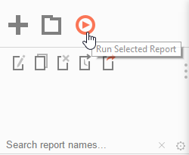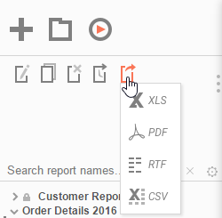

In the Design Tab, click the Run Report button. To change the output format, click the drop-down and select from the available export formats (Excel, PDF, RTF, or CSV). See [Report Options](#_Report_Options) to change the default format for the report:

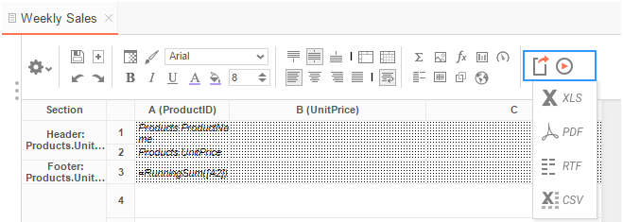

## Interacting with Reports

After running a report in the Report Viewer, you can make further modifications to the report’s style, formatting, and content. These changes can be exported to other formats, saved to the original report, or saved as a separate copy of the report depending on the settings.

For these interactions to be available, they must be enabled in the [Report Viewer Options Menu](#_Interactive_HTML_Options_1) in the Report Designer.

### Changing Styling

While viewing a report in the Report Viewer, right click a cell to open the style menu. Using this menu, you can change font, size, foreground and background color, bold, italic, underline, and alignment options.

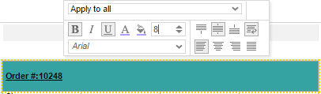

### Resizing Columns

The columns of a report can be resized by dragging the light grey bar at the top of the page to the desired size.

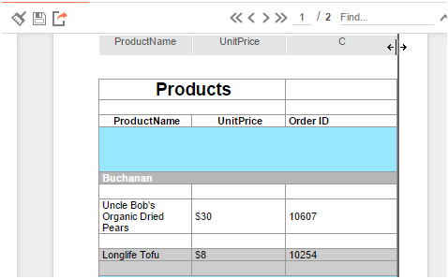

### Applying Interactive Filters

Any available interactive filters can be enabled by clicking the add button () in the Filters section of the Interactive Report Viewer dock, which is located next to the report.

NOTE. Interactive filters must be defined in the [Interactive Report Viewer Options Menu](#_Interactive_HTML_Options_1). Additional filters can be created directly on the report by right-clicking within the Report Viewer. See [Conditional Filters](#_Conditional_Filters) for more details.

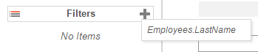

After enabling a filter use the checkbox, dropdown, or slider to select what values should appear on the report. After selecting a value, the report will refresh with the filter applied.

Click the () next to an active filter to remove it. The report will refresh to deactivate the filter.

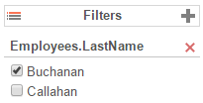

### Conditional Filters

You can set filters on specific values in addition to the pre-defined [interactive filters](#_Applying_Interactive_Filters) by interacting with the report in the Report Viewer.

To create a conditional filter, right-click on a cell of the report, choose an operator from the ‘Apply To’ dropdown then click the filter button ():

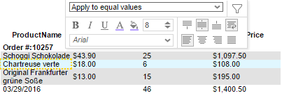

The conditional filter will appear in the dock below the interactive filters and sorts:

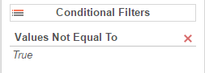

### Changing Sorts

In the dock next to the report you can change the direction of any sorts on the report by clicking the ascending () and descending () buttons:

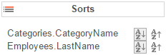

Additionally, you can sort by individual columns of the report by clicking on the light grey bar at the top of the page:

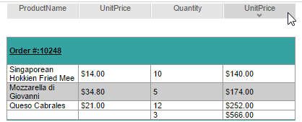

### Hiding Columns

In the dock next to the report, you can show/hide the columns of the report by checking/unchecking the column names:

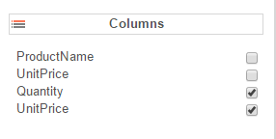

### Saving & Clearing Changes

Changes to styling, column sizes, sorts, and filters can be saved in a number of ways.

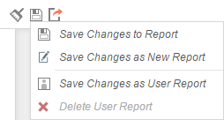

In the toolbar above the report:

* Using the *Clear* dropdown (), you can remove any changes made to the report.
* Use the *Save* button () to save interactive changes onto the report.
* Use the *Save as New Report* button () to make a copy of the report with the changes.
* Use the ‘*Save Changes as User Report*’ option under the ‘*Save Options*’ dropdown to save your changes as a User Report. The changes will be applied each time you run the report but will not be seen when the same report is run by another user.
* Use the ‘*Delete User Report*’ option under the ‘*Save Options*’ dropdown to remove any changes that were saved as User Report.

### Exporting to Other Formats

From the Report Viewer, you can export a report, including any interactive changes, to other formats such as Excel, PDF, RTF, or CSV. To do so, use the export button in the toolbar above the report and selected the export format.

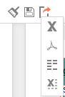

# Creating and Editing Dashboards

Dashboards provide a canvas that can display reports, data visualizations, images, text and web pages.

To create a new dashboard, click the New Dashboard icon in the [Main Menu](#_Main_Menu). The [Dashboard Designer](#_Dashboard_Designer) will appear in a new tab.

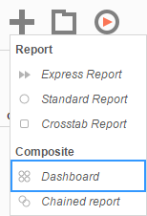

## Dashboard Designer

The Dashboard Designer can be used to add reports, text, images, and web pages to a dashboard.

The Dashboard Designer has four components: the Design Canvas, Tool Box, Data Fields, and the Toolbar.

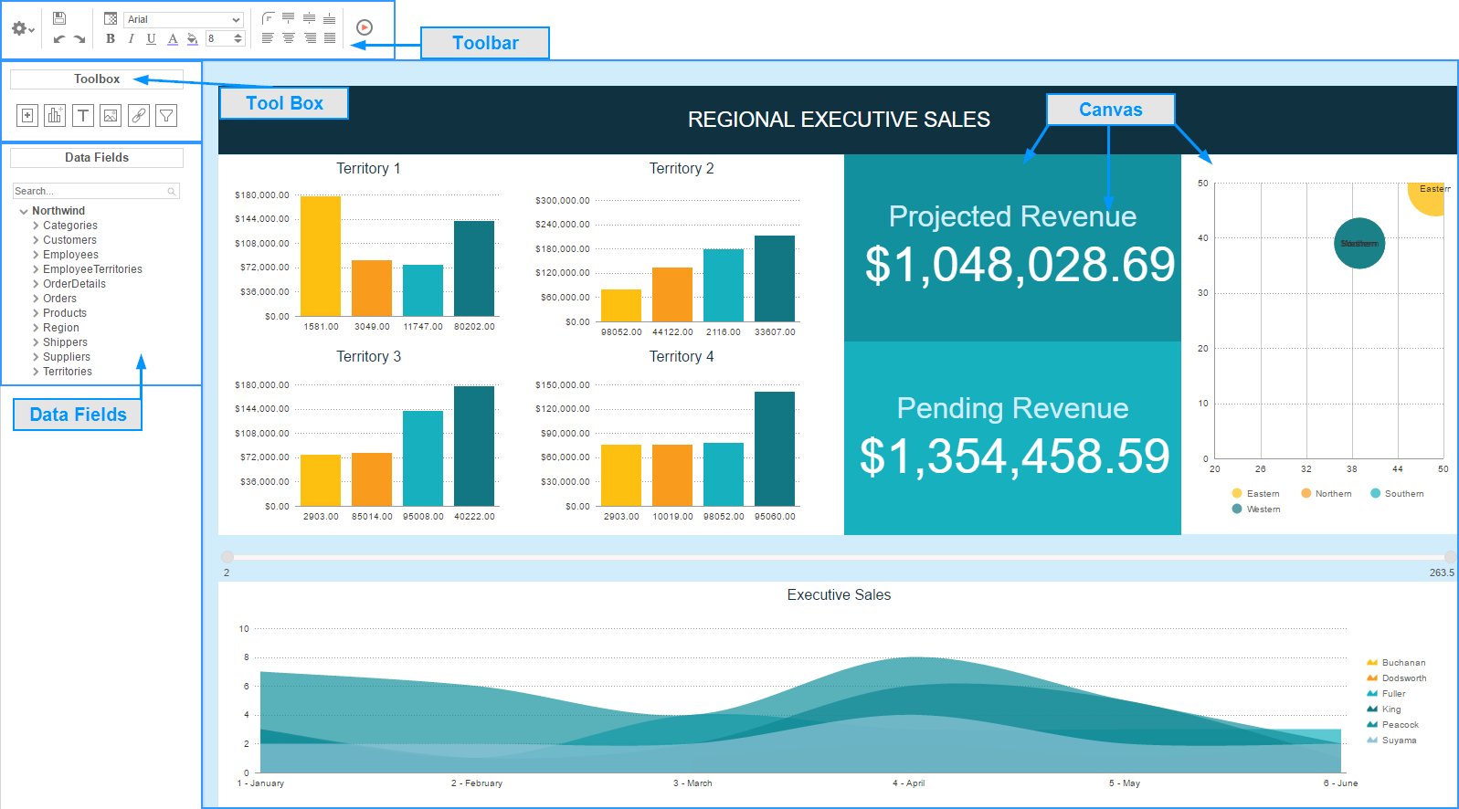

**Dashboard Canvas**

In the Dashboard Designer, you can:

* Move and resize Dashboard Items
* Style Dashboard Items with alignment, borders, colors, etc.
* Edit Dashboard Items such as Reports, Data Visualizations, and Text

**Toolbox**

By dragging Dashboard Items from the Toolbox onto the canvas, you can add the following:

* Reports
* Data Visualizations
* Text
* Images
* Web Pages
* Interactive Filters

**Data Fields**

After dragging a Data Visualization from the Toolbox on to the Canvas, you can add Data Fields by dragging them over the Data Visualization.

**Toolbar**

Using the toolbar, you are able to:

* Rename the Dashboard and modify its description
* Set the Dashboard to automatically run when entering this tool
* Change the background color of the canvas
* Format the font, font size, alignment, color, and borders of text
* Save the dashboard
* Run the dashboard to the Dashboard Viewer

### Dashboard Items

By dragging Dashboard Items onto the canvas, you can add the following items to the dashboard:

* Reports
* Dashboard Visualizations
* Text
* Images
* Web Pages
* Interactive Filters

#### Adding Reports

To add an existing report to the dashboard, drag and drop the Report Button () over the Dashboard Canvas. The Report Properties menu will appear. The Report Properties menu has four tabs: Report, Filters, Parameters, and Options.

**Report**

In the Reports Tab, select the report you want to display on the dashboard.

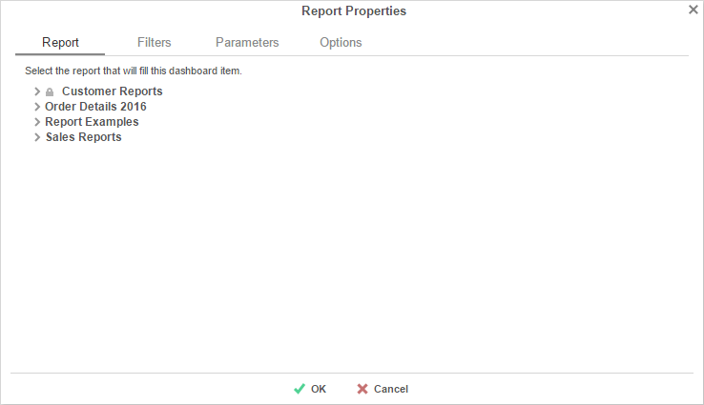

**Filters**

If the selected report has any *Prompt for Value* Filters, those filters will appear in the Filters tab. In this tab, you can specify how to prompt for these filter values.

For each Filter:

* Use the Action dropdown to select how the filter should prompt.
  + **Dashboard Prompt** – When the dashboard runs, you will be prompted for a value that is used by all of the reports on the dashboard that filter using this Data Field.
  + **Report Prompt** – When the dashboard runs, you will be prompted for a value to filter this specific report.
  + **Assign Value** – Assign the filter a specific value. This filter will not prompt when the dashboard runs.
* In the ‘Data (Prompt Text or Value)’ column, enter a value if the Action is Assign Value; if the Action is Dashboard or Report Prompt, enter text to use for the prompt.

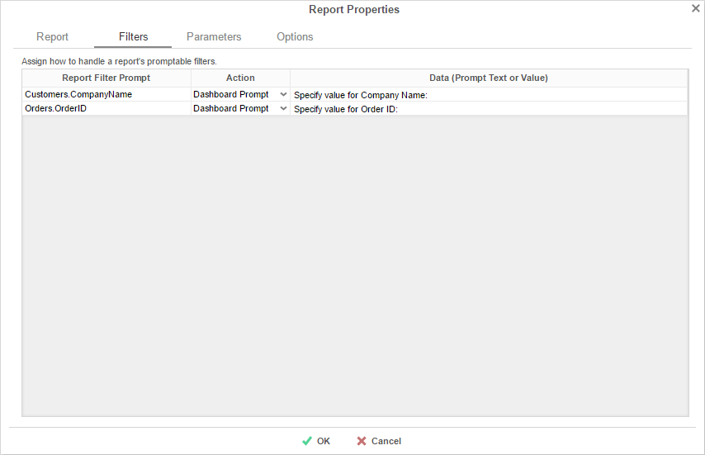

**Parameters**

If the selected report has any Prompting Parameters, those parameters will appear in the Parameters Tab. In this tab, you can specify how to prompt for these parameter values.

For each Parameter:

* Use the Action dropdown to select how the parameter should prompt.
  + **Dashboard Prompt** – When the dashboard runs, you will be prompted for a value that is to be used by all of the reports on the dashboard with that parameter.
  + **Report Prompt** – When the dashboard runs, you will be prompted for a value that is used by this specific report.
  + **Assign Value** – Assign the parameter a run value and do not prompt when the dashboard runs.
* In the ‘Data (Prompt Text or Value)’ column, enter a value if the Action is Assign Value; if the Action is Dashboard or Report Prompt, enter text to use for the prompt.

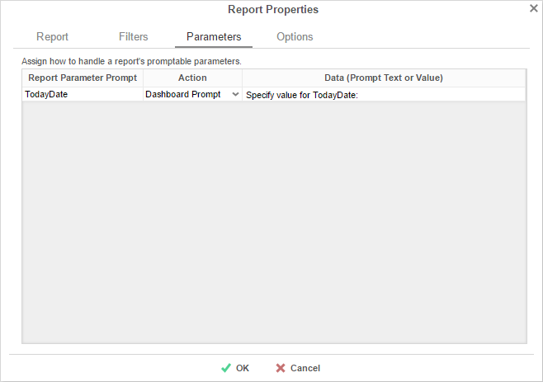

**Options**

In the Options Tab, specify settings for how the report displays on the dashboard.

**Report Viewer**

* In the Title Text box, provide a title for the report. This title will be displayed in on the canvas when editing the dashboard.
* Check ‘Allow scrolling’ to allow scrolling on the dashboard if the report is larger than the designated size on the canvas.
* Set the number of seconds at which to re-run the report. Set to 0 to only run the report when the dashboard is first run.

**Design**

* Check the ‘Only run report in design screen when report is manually refreshed’ to prevent the report from being run accidentally while editing the dashboard.

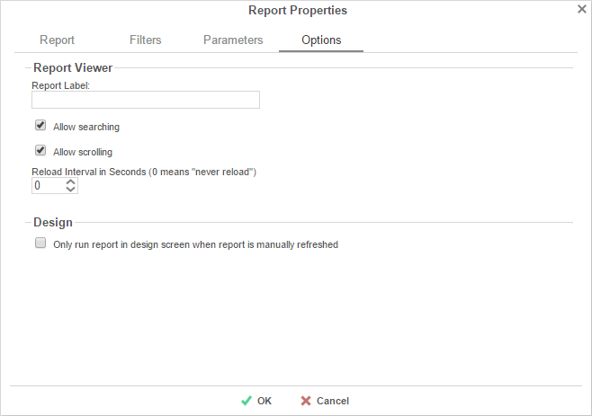

#### Adding Data Visualizations

To create a new Visualization on the dashboard, drag and drop the Data Visualization icon () onto the Dashboard Canvas. A Data Visualization item will appear.

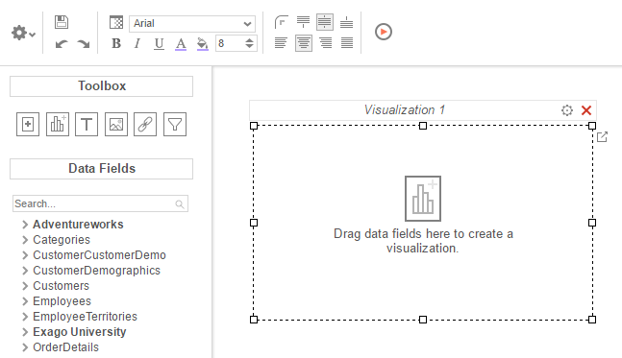

With the Data Visualization item, you can:

* Drag Data Fields onto the item to create a chart or a tabular report.
* Use the Options Menu () to filter, name, or modify other settings of the Visualization.
* Modify how the Data Fields are grouped and summarized by opening the Data Model Menu ().
* Save the Data Visualization as a new [Standard Report](#_Types_of_Reports) ().

NOTE. Subsequent changes in the Standard Report Designer will not be reflected on the Data Visualization. To have those changes appear on the dashboard, [add the new report](#_Adding_Reports) to the dashboard.

* Convert from a chart to tabular report (or vice versa) by selecting ‘Convert to Chart’ in the right-click menu.

NOTE. A Data Visualization must have at least two Data fields, one of which must be numeric, in order to display a chart.

#### Adding Text

To add text to the dashboard, drag and drop the Text icon () over the Dashboard Canvas. A text box will appear. Type the desired text in this box. Use the [Toolbar](#_Formatting_Dashboard_Items) to format the text.

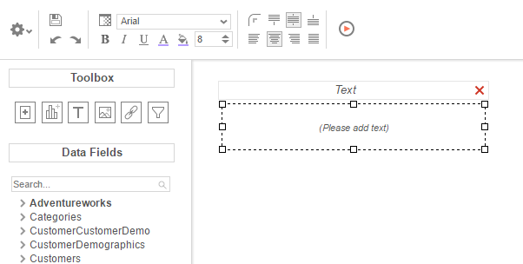

#### Adding Images

To add an image to the dashboard, drag and drop the Image icon () over the Dashboard Canvas. An image box will appear. Click the insert image button () and select the image to upload.

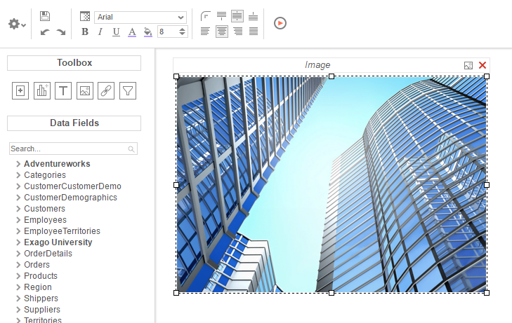

#### Adding Web Pages

To add a web page to the dashboard, drag the URL Button () over the Dashboard Canvas. A URL menu will appear. Enter the desired URL and press  OK.

NOTE. Some web pages do not permit being embedded within another web page.

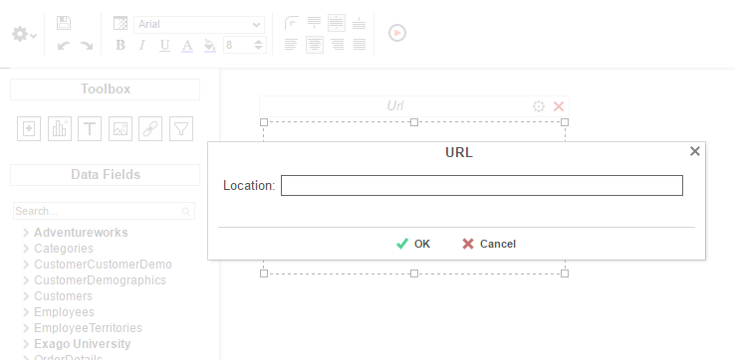

#### Adding Interactive Filters

To add an interactive filter to the dashboard, drag and drop the Filter icon () over the Dashboard Canvas. The Filter Properties menu will appear. The Filter Properties menu has two tabs: Dashboard Items and Filter.

**Dashboard Items**

In the Dashboard Items Tab, select which reports and data visualizations the filter should apply to by checking the box in the Controlled column.

NOTE. All of the reports and visualizations being controlled by the filter must share at least one common Data Category.

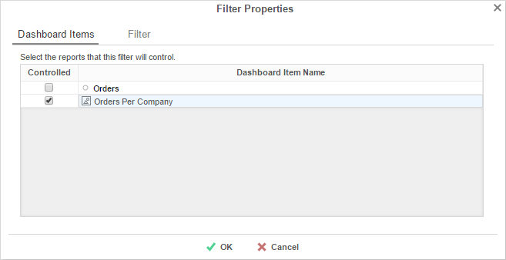

**Filter**

In the Filter Tab, specify what data should be used and how the interactive filter should appear on the dashboard.

* Use the Filter value dropdown to select the data field that should be filtered.

NOTE. The filter can be applied to a calculation instead of a data field by using the formula button ().

* Use the Type dropdown to specify what kind of interactive filter to display:
  + Single Choice: A dropdown with the possible values of the filter.

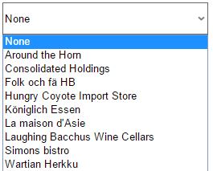

* + Multiple Choice: All possible values for the filter presented with check boxes to select a one or more values.

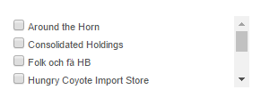

* + Single Slider: Select the filter value by sliding a point along a scale.

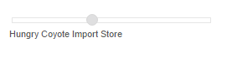

* + Range Slider: A scale that displays values between two points.



* In the style dropdown, specify if the filter should be vertically or horizontally oriented.
* In the Value Sort Direction, specify if the filter values should appear from least to greatest (ascending) or vice versa (descending).
* Click the Format button () to open the format menu and specify how the filter values should be displayed.

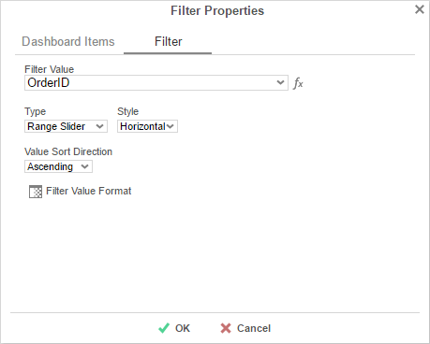

### Toolbar

The toolbar contains the buttons and menus used to modify the dashboard.

#### Saving Dashboards

The dashboard can be saved by clicking the save button ().

#### Undo/Redo

Any action on a dashboard can be undone by clicking () or pressing **CTRL** + **Z**. Undone actions can be redone by clicking () or pressing **CTRL** + **Y**.

#### Borders

To create borders around a dashboard item, select it and click the Format icon ().

* Uncheck ‘Make Borders Uniform’ to modify specific edges.
* To widen the borders, either key in a value or use the arrows in the width box.
* To change the color, either select a color from the drop-down or enter a hex value.

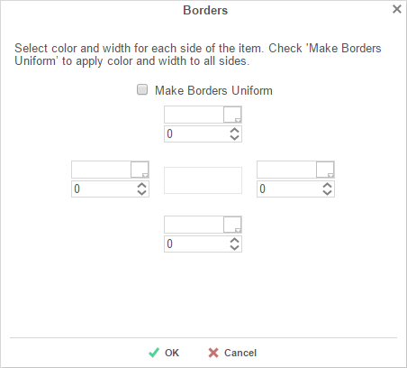

Borders can be rounded by clicking the ‘Rounded Edges’ button () in the toolbar.

#### Formatting Dashboard Text

Text items can be formatted using buttons in the toolbar. A text item must be selected for these changes to be applied.

**Font**

* To change the font, use the font drop-down (). The font names appear in the style that they represent.
* The **B**, *I*, and U icons make the font bold, italicized, and underlined, respectively.
* Text size can be controlled using the up and down arrows on font size menu ().

**Color**

* To change the text color, click the Foreground Color button ( ), and then select a color or enter a hex value into the Foreground box. Click the clear button to revert to the default color ().
* To change the background color, click the Background Color button () and then select a color or enter a hex value into the Background box. Click the clear button to revert to the default color ().

**Alignment**

* Text can be aligned to the top, center, or bottom of a cell using the vertical alignment buttons.



* Text can be centered, justified, or aligned to the left or right of a cell using the horizontal alignment buttons.



#### Renaming Dashboards

To change the name of a dashboard, click ‘Rename’ in the Toolbar drop-down menu. Modify the name and select the folder where the Dashboard will be saved. Click ‘OK’.

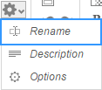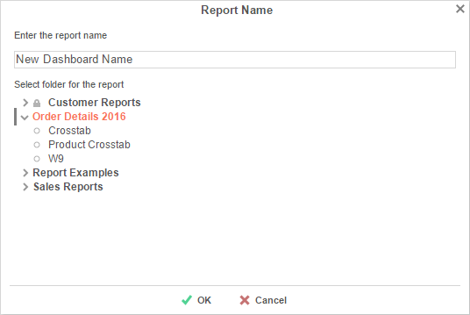

#### Changing Description

The dashboard description appears at the bottom of the [Main Menu](#_Main_Menu). Though dashboard descriptions are optional, they are utilized when searching reports. To modify a dashboard description, click ‘Description’ in the Toolbar drop-down menu. Fill in the description and click ‘OK.’

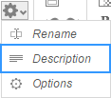

#### Dashboard Options

Click ‘Options’ in the Toolbar drop-down menu to open the Dashboard Options Window.

**General Options**

* To change the background color of the dashboard canvas, select a color or enter a hex value.
* Check ‘Show report title bar on execution’ to allow reports on an executed dashboard to be selected and modified.

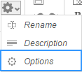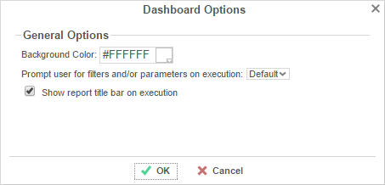

#### Executing Dashboards

Dashboards can be run from the [Main Menu](#_Main_Menu) or the [Toolbar](#_Toolbar_1). To run a dashboard from the Main Menu, first select the dashboard you want to run and click the ‘Run Selected Report’ button. When editing a dashboard, simply click ‘Run Dashboard’ to view the dashboard.

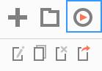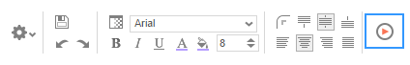

# Chained Reports

Chained Reports comprise multiple existing reports, which run in a specific order and compile into a single document. They are a simplified method for managing reports en masse.

NOTE.Chained Reports can only be exported as downloadable file types (Excel, PDF, RTF, or CSV) Viewer-only features are not supported in chained reports.

NOTE.Chained Reports do not support Excel templates. Additionally, all reports in a chained report must have a common RTF template.

NOTE.The Scheduler does not support Chained Reports.

## Chained Report Wizard

The Chained Report Wizard is an interactive tool which allows you to create and edit Chained Reports.

To navigate the wizard, either click the desired tab or use the buttons at the bottom.

To save a Chained Report, click the save button.

The Chained Report Wizard has three sub tabs. The Name and Reports tabs must be completed.

### Name Tab

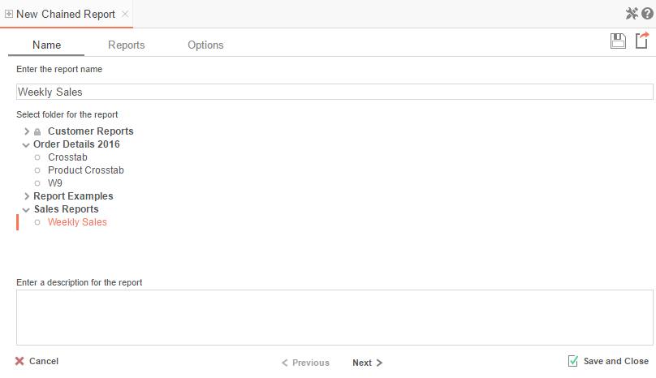

In the Name Tab, enter a report name and click on the Folder where the report will be saved.

The report name can be up to 255 characters long. Avoid special characters such as ? : / \ \* “ < >.

The report’s description appears at the bottom of the Main Menu when it is selected. The description text is also used when searching for a report.

NOTE.You cannot create a report inside a folder that is read-only ().

### Reports Tab

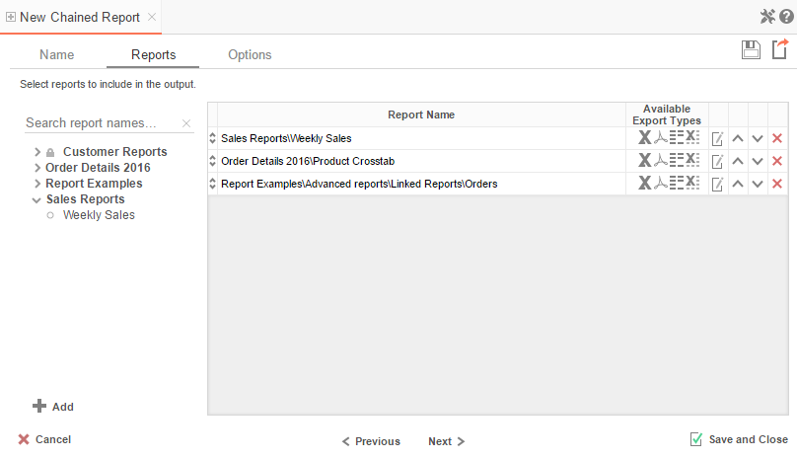

In the Reports Tab, select the reports you wish to include in the Chained Report.

NOTE.You can only include Standard Reports, Express Reports, and CrossTab reports in a Chained Report.

* To add a report, either drag and drop it to the ‘Report Name’ Column, use the  button, or double-click it.
* To search for a specific report, enter the terms that you want to search for in the search box.
* A report may be able to export only in certain formats. Available formats for each report are listed under Available Export Types. A Chained Report which contains a format restriction on one of its reports cannot export to that format.
* If a report has ‘*Prompt for Value*’ filters or parameters, click the ‘Edit Report Options’ button () to access the **Report Properties** menu, where you can specify how to prompt for these filter values:
  + **Common Prompt** – When the Chained Report executes, you will be prompted for a value that is used by all of the reports on the Chained Report that have filter prompts on this Data Field.
  + **Report Prompt** – When the Chained Report executes, you will be prompted for a value to filter this specific report.
  + **Assign Value** – Assign the filter a specific value. This filter will not prompt when the Chained Report executes.
* Use the up () and down () arrows to indicate the order of the reports.
* To remove a report, click the delete button ().

### Options Tab

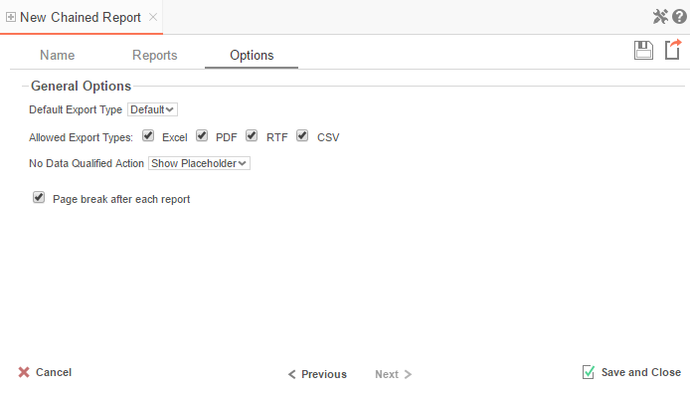

The Options Tab allows you to control various report options for the chained report.

**General Export Options**

* Use the ‘*Default Export Type*’ menu to specify the default format for the report.
* Output types may be disabled by unchecking the boxes for ‘*Allowed Export Types*’.
* Use the ‘*No Data Qualified Action*’ menu to select what to display if no data qualifies for a report.
  + **Skip Report –** Display the next qualified report.
  + **Show Placeholder** – Show a placeholder message in place of the report.

# Formulas

Formulas allow you to do calculations, parse strings, insert images, and much more. Formulas are the composition of functions, parameters, Data Fields, and references to other cells.

## Functions

Functions must begin with an ‘=’ sign. You can use more than one function in each cell. Additionally, there are logical functions that allow for if/then/else conditional statements. Functions include date, financial, information, logical, mathematical, statistical, text, and data.

NOTE.Function names **are not** case sensitive (aggSum is the same as AggSum).

For a complete list of functions, including description, remarks and examples, refer to [Full Description of Functions](#__RefHeading__11297_1934010483).

## Parameters

To call a parameter, enter its name between ‘@’ signs. Parameters can be used in functions or alone in a cell following an ‘=’ sign.

NOTE. Parameters **are** case sensitive (pageNumber is **not** the same as pagenumber). Parameter names should not contain the ‘@’ symbol.

For a list of parameters and their descriptions, see [Full Description of Parameters](#_Quick_List_of). Your administrator has the ability to create additional parameters.

## Data Fields

To use a Data Field as part of a function, enter the name between curly brackets (E.g.**{Orders.OrdersID}**).

## Referencing a Cell

To reference another cell’s value, enter the column name with a capital letter and the row number between square brackets (E.g. **[A2]**). A cell reference can be used in functions or alone in a cell following an ‘=’ sign.

NOTE.Cell references will update if rows or columns are added or deleted; however, dragging a cell will **not** update cell references. This may cause errors in your formulas.

## Using Formulas

Formulas can either be entered in the Formula Editor or manually keyed into cells.

### Formula Editor

* 1. Navigate to the [Report Designer](#chapter_03_editing_reports_repor_915).
  2. Click in the cell in which you want the formula to appear.
  3. Click the Formula Editor Button ().

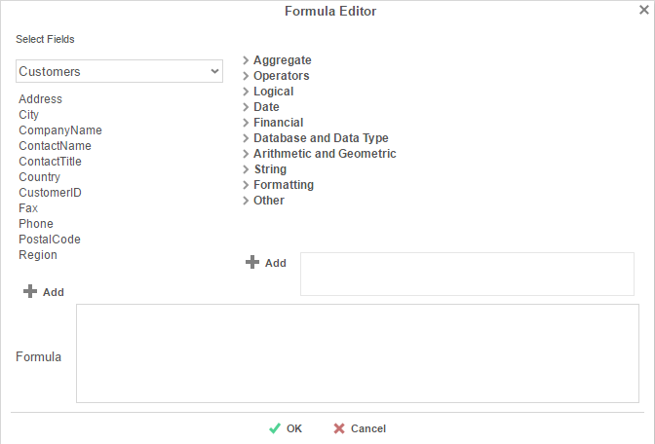

* 1. Create the desired formula by selecting the desired functions and clicking or drag-and

-dropping the function into the Summary box.

NOTE. When embedding functions, begin with the outermost function and add them moving inward. (E.g. To get =TRUNCATE(SQRT(162)), first add Truncate then the square root function.)

* 1. Click OK.

### Manual Formulas

To manually add formulas:

1. Navigate to the [Report Designer](#chapter_03_editing_reports_repor_915).
2. Double click in the desired cell.
3. Enter the formula.
4. Save the report.

## Full Description of Parameters

**pageNumber**:

|  |  |
| --- | --- |
| **Description** | Returns the number of the current page. |
| **Remark** | For RTF output, pageNumber cannot be used with other formulas. |
| **Example** | =@pageNumber@ will display the current page number for all output types.  =‘Pg. ‘ & @pageNumber@ will display ‘pg.’ followed by the page number for default and PDF outputs. |

**reportName**:

|  |  |
| --- | --- |
| **Description** | Returns the name of the report. |

**reportFullName**:

|  |  |
| --- | --- |
| **Description** | Returns the file path of the report. |
| **Example** | For a report named Transcripts in a Folder named Student Documents, @reportFullName@ would return Student Documents/Transcripts. |

## Quick List of Functions

[Aggregate](#_Agregate_Functions):

AggAvg

AggCount

AggDistinctCount

AggMax

AggMin

AggSum

[Financial](#__RefHeading__11301_1934010483)**:**

DB  
DDB  
Fv  
Intrate  
Ipmt  
Nper  
Npv  
Pmt  
Ppmt  
Pv  
Rate  
Sln  
Syd

[Date](#__RefHeading__11299_1934010483)**:**

Date  
DateAdd  
DateDiff  
DateValue  
Day  
Days360  
GlobalDateFormat  
GlobalDateTimeFormat  
Hour  
Minute  
Month  
Now  
Second  
Time  
TimeFormat1  
TimeValue  
Today  
Year

[Arithmetic & Geometric](#__RefHeading__11305_1934010483)**:**

Absolute  
Acos  
Acosh  
Asin  
Asinh  
Atan  
Atan2  
Atanh  
Ceiling  
Cos  
Cosh  
Even  
Exp  
Fixed  
Floor  
Int  
Ln  
Log  
Log10  
Mod  
Odd  
Pi  
Power  
Product  
Quotient  
Rand  
Sin  
Sinh  
Sqrt  
Tan  
Tanh  
Truncate

[Formatting](#_Formatting_Functions)**:**

Bold

Italic

Underline

[String](#__RefHeading__11311_1934010483)**:**

Concatenate  
Left  
Len  
Lower  
Mid  
NewLine  
Replace  
Right  
Trim  
Upper  
Value

**Operators**:

&  
+

-

\*

/

[Logical](#_Logical_Functions_1)**:**

And  
False  
If  
Not  
Or  
Switch  
True

[Database & Data Type](#__RefHeading__11303_1934010483)**:**

DBNull  
IsBlank  
IsError  
IsEven  
IsLogical  
IsNonText  
IsNull  
IsNumber  
IsOdd  
IsText  
Null  
Type

[Other](#_Other_Functions)**:**

FilterValue  
LoadImage  
StripHTMLTag

## Full Description of Functions

This section provides detailed information on the available functions.

**Types of Functions:**

* **Aggregate Functions**
* **Logical Functions**
* **Date Functions**
* **Financial Functions**
* **Database and Data Type Functions**
* **Arithmetic and Geometric Functions**
* **String Functions**
* **Formatting Functions**
* **Other Functions**

### Aggregate Functions

Aggregate functions can be executed on non-numeric fields.

**AggAvg**:

|  |  |
| --- | --- |
| **Description** | Returns the average of the values in the field. |
| **Remark** | Only accepts Data Fields as input. |
| **Example** | E.g. **aggAvg({OrderDetail.Quantity})** - returns the average quantity of sales orders. |

**AggCount**:

|  |  |
| --- | --- |
| **Description** | Returns the number of unique entities in the Data Category. |
| **Remark** | The aggCount function uses the Data Category, not the Data Field. For example, the function “aggCount( {Officer.Salary} )” counts the number of Officers. You could replace “Officer.Salary” with any other field in the Officer Data Category and the function would still count the number of officers.  Only accepts Data Fields as input. |
| **Example** | E.g.**aggCount( {Orders.ProductPrice})** - returns the number of sales orders. |

**AggDistinctCount**:

|  |  |
| --- | --- |
| **Description** | Returns the number of unique values in the Data Field. |
| **Remark** | Unlike aggCount, aggDistinctCount returns the number of unique values of the Data Field.  Only accepts Data Fields as input. |
| **Example** | E.g.**aggDistinctCount({OrderDetail.Quantity})** - returns the number distinct quantities in an order. |

**AggMax**:

|  |  |
| --- | --- |
| **Description** | Returns the maximum value in the field. |
| **Remark** | Only accepts Data Fields as input. |
| **Example** | E.g. **aggMax({OrderDetail.Discount})** - returns the largest discount. |

**AggMin**:

|  |  |
| --- | --- |
| **Description** | Returns the minimum value in the field. |
| **Remark** | Only accepts Data Fields as input. |
| **Example** | E.g. **aggMin({OrderDetail.Discount})** - returns the smallest discount. |

**AggSum:**

|  |  |
| --- | --- |
| **Description** | Returns the sum of the values in the field. |
| **Remark** | Only accepts Data Fields as input. |
| **Example** | E.g. **aggSum({OrderDetail.Quantity}) -**returns the total quantity of units ordered. |

### Logical Functions

Logical functions can be used to handle conditional information.

**And**:

|  |  |
| --- | --- |
| **Description** | Returns **TRUE** if all its arguments are **TRUE**; returns **FALSE** if any argument is **FALSE**. |
| **Remark** | The arguments must evaluate to **TRUE** or **FALSE**.  NOTE. The And function can take more than two arguments as input. |
| **Example** | E.g. **AND(2+2=4, 4+0=4, 2+3=6)** – returns **FALSE**. |

**False**:

|  |  |
| --- | --- |
| **Description** | Returns the logical value **FALSE**. |
| **Remark** | You can also type the word **FALSE** directly onto the worksheet or into a formula; it is interpreted as the logical value **FALSE**. |
| **Example** |  |

**If**:

|  |  |
| --- | --- |
| **Description** | Takes three arguments as input. Returns the second argument if the first evaluates to **TRUE**. Otherwise returns the third argument. |
| **Remark** | The first input must evaluate to **TRUE** or **FALSE**. |
| **Example** | E.g. **if({OrderDetail.Price}= 0,’FREE’,{OrderDetail.Price}) -** returns FREE if the price is 0, otherwise it returns the price. |

**Not**:

|  |  |
| --- | --- |
| **Description** | Reverses the value of its argument. |
| **Remark** | Argument should evaluate to **TRUE** or **FALSE**. |
| **Example** | E.g. **Not(FALSE)** - returns **TRUE**. |

**Or**:

|  |  |
| --- | --- |
| **Description** | Returns **TRUE** if any argument is **TRUE.** |
| **Remark** | The arguments must evaluate to logical values such as **TRUE** or **FALSE.**  NOTE. The ‘Or’ function can take more than two arguments as input. |
| **Example** | E.g. **OR(2+2=4, 4+0=8, 2+3=6)** - returns **TRUE.** |

**Switch**:

|  |  |
| --- | --- |
| **Description** | This functions should be used instead of placing if() function inside of if() functions.  Takes any even number of inputs arguments. |
| **Remark** | The 1st argument will be the test value to compare to.  The 2nd argument will be returned if none of the comparisons return true.  The 3rd, 5th, 7th… arguments will be compared to the 1st argument. When the first match occurs the following argument will be returned.  For example if argument 3 matches argument 1 then the 4th argument will be returned. |
| **Example** | E.g. **Switch({Categories.CategoryName},”NOT FOUND”, “Beverages”, “Drink up!”, “Condiments”, “Enhance”, “Confections”, “Sweet Tooth”)** – returns a string based on the Category Name. |

**True**:

|  |  |
| --- | --- |
| **Description** | Returns the logical value **TRUE**. |
| **Remark** | You can also type the word **TRUE** directly onto the worksheet or into a formula; it is interpreted as the logical value **TRUE**. |
| **Example** |  |

### Date Functions

Date functions can be used to do calculations and formatting on Date values.

**Date**:

|  |  |
| --- | --- |
| **Description** | Creates a date value from three numeric values. |
| **Remark** | This function should be used to represent a date to other functions instead of representing a date as text. |
| **Example** | E.g. **Date(2012,7,4)** – returns the date July 4th, 2012. |

**DateAdd**:

|  |  |
| --- | --- |
| **Description** | Returns the sum of a date and a quantity of time. |
| **Remark** | DateAdd takes three input arguments.  A string representing the interval you want to add. The interval can be. "yyyy" (year), "y" (days), "d" (days), "w" (weeks), "m" (months), "h" (hours), "n" (minutes), "s" (seconds), "ww" (weeks of year), or "q" (quarters).  A real number representing how much time you want to add to the date.  A DateValue. |
| **Example** | E.g. **DateAdd(‘h’,1,Now())** – returns the date and time 1 hour from now. |

**DateDiff**:

|  |  |
| --- | --- |
| **Description** | Returns the amount of time between two dates. |
| **Remark** | DateDiff takes three input arguments.  A string representing the interval you want to add. The interval can be. "yyyy" (year), "y" (days), "d" (days), "w" (weeks), "m" (months), "h" (hours), "n" (minutes), "s" (seconds), "ww" (weeks of year), or "q" (quarters).  The first date value.  The second date value. |
| **Example** | E.g. **DateDiff(“yyyy”, date(1787,9,17), now())-** returns the number of years since the signing of the United States’ Constitution |

**DateValue**:

|  |  |
| --- | --- |
| **Description** | Converts a date represented as text (e.g. '30-jan-2008') to a date value. |
| **Remark** | Any time information in the Date\_text is ignored. The ticks returned always represent a time-of-day of Midnight (in the server's local time).  If the year portion of Date\_text is omitted, DATEVALUE uses the current year on the server.  Use this function when comparing two dates. |
| **Example** | E.g. **DateValue(30-jun-2011)** – returns the date object 6/30/2011.  E.g. **DateValue({Orders.OrderDate}) > DateValue(Today())** – compares the order date to today. |

**Day**:

|  |  |
| --- | --- |
| **Description** | Returns the day portion of a date as a whole number. |
| **Remark** | Values returned by the YEAR, MONTH and DAY functions will be **Gregorian** Calendar values regardless of the display format for the supplied date value. |
| **Example** | E.g. **Day({Appointment.Date})**- returns the day of the appointment. |

**Day360**:

|  |  |
| --- | --- |
| **Description** | Returns the number of days between two dates based on a 360-day year. |
| **Remark** | Often used in accounting applications.  Date360 takes three input arguments.  The first date value.  The second date value.  Optional: True/False indicating to use European or American method of computation. If not included the American method is used. |
| **Example** | E.g. **Day360({Appointment.Date},today())-** returns the number of days between today and the appointment date. |

**GlobalDateFormat**:

|  |  |
| --- | --- |
| **Description** | Returns a **DATE** value whose format is based on the session format. |
| **Remark** | Only accepts data objects as input. |
| **Example** | E.g. **GlobalDateFormat({Appointment.Date})**- returns the date of the appointment based on the session format. |

**GlobalDateTimeFormat**:

|  |  |
| --- | --- |
| **Description** | Returns a **DATETIME** value whose format is based on the session format. |
| **Remark** | Only accepts data objects as input. |
| **Example** | E.g. **GlobalDateTimeFormat({Appointment.Date})-** returns the date and time of the appointment based on the session format. |

**Hour**:

|  |  |
| --- | --- |
| **Description** | Returns the hour of a time value ranging from 0 (12:00 AM) to 23 (11:00 PM). |
| **Remark** | Times may be entered as text strings within quotation marks or a date time value. |
| **Example** | E.g. **Hour("2:50:05PM")** – returns 14. |

**Minute:**

|  |  |
| --- | --- |
| **Description** | Returns the Minute of a time value ranging from 0 to 59. |
| **Remark** | Times may be entered as text strings within quotation marks or a date time value. |
| **Example** | E.g. **Minute("2:50:05PM")** – returns 50. |

**Month:**

|  |  |
| --- | --- |
| **Description** | Returns the month portion of a date as a whole number, ranging from 1 (January) to 12 (December). |
| **Remark** | Values returned by the YEAR, MONTH and DAY functions will be **Gregorian** Calendar values regardless of the display format for the supplied date value. |
| **Example** | E.g. **Month({Appointment.Date})-** returns the month of the appointment. |

**Now:**

|  |  |
| --- | --- |
| **Description** | Returns today’s date and time (in local server time). |
| **Remark** | If embedding in other functions use Now(‘false’). |
| **Example** | E.g. **Now()** - returns the current date and time.  **Now(‘false’)** returns the current date and time formatted MM/dd/yyyy hh:mm:ss. |

**Second:**

|  |  |
| --- | --- |
| **Description** | Returns the seconds of a time value ranging from 0 to 59. |
| **Remark** | When a time omits seconds, 0 (zero) is assumed.  Times may be entered as text strings within quotation marks or a date time value. |
| **Example** | E.g. **Second("2:50:05PM")** – returns 5. |

**Time:**

|  |  |
| --- | --- |
| **Description** | Returns the number of ticks in a period of hours, minutes and seconds. |
| **Remark** | This function should be used to represent a time to other functions instead of representing a time as text.  Time takes three input arguments.  Hours  Minutes  Seconds |
| **Example** | E.g. **Time(14,50,5)** – returns 534050000000. |

**TimeFormat1:**

|  |  |
| --- | --- |
| **Description** | Returns the time component of a **DATETIME** input formatted as 'hh:mm tt'. |
| **Remark** | This function should be used to represent a time to other functions instead of representing a time as text. |
| **Example** | E.g. **Timeformat1({Appointment.Date})** – returns the appointment date in the format as ‘hh:mm tt’. |

**TimeValue:**

|  |  |
| --- | --- |
| **Description** | Convert a time represented in text (*i.e.,* “HH-mm-ss”) into time values that can be passed to other functions. |
| **Remark** | Acceptable formats include "5:55 PM" and "17:55". A time separator is mandatory ("17:00" is acceptable, "1700" is not).  If AM/PM is not present AM is assumed. When specifying AM or PM, do not use periods ("A.M." or "P.M." will return an error). |
| **Example** | E.g.TimeValue(Time(14,50,5))-returns the time object 14:50:05. |

**Today:**

|  |  |
| --- | --- |
| **Description** | Returns today’s date with no time component. |
| **Remark** | If embedding in other functions use Today(‘false’).  See the Now() function to get today's date with its time component. |
| **Example** | E.g.**Today()-** returns the current date.  **Today(‘false’)** returns the current date formatted as MM/dd/yyyy. |

**Year:**

|  |  |
| --- | --- |
| **Description** | Returns the year portion of a date as a whole number, ranging from 1 to 9999. |
| **Example** | E.g. **Year(today()) –** returns 2011. |

### Financial Functions

**DB:**

|  |  |
| --- | --- |
| **Description** | Returns the depreciation of an asset for a specified period using the **fixed-declining balance** method. Cost is the initial cost of the asset. Salvage is the value at the end of the depreciation (sometimes called the salvage value of the asset). Life is the number of periods over which the asset is being depreciated (sometimes called the useful life of the asset). Period is the period for which you want to calculate the depreciation. Period must use the same units as life. Month is the number of months in the first year. If month is omitted, it is assumed to be 12. |
| **Remark** | The **fixed-declining balance** method computes depreciation at a fixed rate. DB uses the following formulas to calculate depreciation for a period: (cost - total depreciation from prior periods) \* rate where: rate = 1 - ((salvage / cost) ^ (1 / life)), rounded to three decimal places. Depreciation for the first and last periods is a special case. For the first period, DB uses this formula: cost \* rate \* month / 12. For the last period, DB uses this formula: ((cost - total depreciation from prior periods) \* rate \* (12 - month)) / 12. |
| **Example** | **Data Assumptions**: Initial cost=1,000,000 (A2); Salvage value=100,000 (A3); Lifetime in years=6 (A4).  E.g. **DB([A2],[A3],[A4],1,7)** - Depreciation in first year, with only 7 months calculated (186,083.33).  E.g. **DB([A2],[A3],[A4],2,7)** - Depreciation in second year (259,639.42).  E.g. **DB([A2],[A3],[A4],3,7) *-*** Depreciation in third year (176,814.44). E.g. **DB([A2],[A3],[A4],4,7)** - Depreciation in fourth year (120,410.64).  E.g. **DB([A2],[A3],[A4],5,7)** - Depreciation in fifth year (81,999.64).  E.g. **DB([A2],[A3],[A4],6,7)** - Depreciation in sixth year (55,841.76).  E.g. **DB([A2],[A3],[A4],7,7)** - Depreciation in seventh year, with only 5 months  calculated (15,845.10). |

**DDB:**

|  |  |
| --- | --- |
| **Description** | Returns the depreciation of an asset for a specified period using the **double-declining balance** method or some other method you specify. Cost is the initial cost of the asset. Salvage is the value at the end of the depreciation (sometimes called the **salvage value** of the asset). Life is the number of periods over which the asset is being depreciated (sometimes called the **useful life** of the asset). Period is the period for which you want to calculate the depreciation. Period must use the same units as life. Factor is the rate at which the balance declines. If factor is omitted, it is assumed to be 2 (the **double-declining balance** method).  NOTE. All **five** arguments must be positive numbers. |
| **Remark** | The **double-declining balance** method computes depreciation at an accelerated rate. Depreciation is highest in the first period and decreases in successive periods. DDB uses the following formula to calculate depreciation for a period: ((cost-salvage) - total depreciation from prior periods) \* (factor/life). Change factor if you do not want to use the **double-declining balance** method. Use the VDB function if you want to switch to the **straight-line depreciation** method when depreciation is greater than the **declining balance** calculation. |
| **Example** | **Data Assumptions:** Initial cost=2400 (A2); Salvage value=300 (A3); Lifetime in years=10 (A4).  E.g. **DDB([A2],[A3],[A4]\*365,1)** - First day's depreciation.  E.g. **DDB([A2],[A3],[A4]\*12,1,2)** - First month's depreciation (40.00).  E.g. **DDB([A2],[A3],[A4],1,2)** - First year's depreciation (480.00).  E.g. **DDB([A2],[A3],[A4],10)**- Tenth year's depreciation.  NOTE. The results are rounded to two decimal places. |

**FV:**

|  |  |
| --- | --- |
| **Description** | Returns the future value of an investment based on periodic, constant payments and a constant interest rate. |
| **Remark** | For a more complete description of the arguments in FV and for more information on annuity functions, see PV (Above). Rate is the interest rate per period. Nper is the total number of payment periods in an annuity. Pmt is the payment made each period; it cannot change over the life of the annuity. Typically, pmt contains principal and interest but no other fees or taxes. If pmt is omitted, you must include the pv argument. Pv is the present value, or the lump-sum amount that a series of future payments is worth right now. If pv is omitted, it is assumed to be 0 (zero), and you must include the pmt argument. Type is the number 0 or 1 and indicates when payments are due. If type is omitted, then it is assumed to be 0. Make sure that you are consistent about the units you use for specifying rate and nper. If you make monthly payments on a four-year loan at 12 percent annual interest, use 12%/12 for rate and 4\*12 for nper. If you make annual payments on the same loan, use 12% for rate and 4 for nper. For all the arguments, cash you pay out, such as deposits to savings, is represented by negative numbers; cash you receive, such as dividend checks, is represented by positive numbers. |
| **Example** | **Data Assumptions:** Annual interest rate=6% (A2); Number of payments=10 (A3); Amount of the payment=-200 (A4); Present value=-500 (A5); Payment is due at the beginning of the period=1 (A6)...(see above).  E.g.***FV([A2]/12, [A3], [A4], [A5], [A6])*** – returns future value of an investment with these terms (2,581.40). |

**Intrate:**

|  |  |
| --- | --- |
| **Description** | Returns the interest rate for a fully invested security.  NOTE. Dates should be entered by using the DATE function, or as results of other formulas or functions.  For example, use **DATE(2008,5,23)** for the 23rd day of May, 2008. Problems can occur if dates are entered as text. Settlement is the security's settlement date. The security settlement date is the date after the issue date when the security is traded to the buyer. Maturity is the security's maturity date. The maturity date is the date when the security expires. Investment is the amount invested in the security. Redemption is the amount to be received at maturity. Basis is the type of day count basis to use. |
| **Remark** | The settlement date is the date a buyer purchases a coupon, such as a bond. The maturity date is the date when a coupon expires. For example, suppose a 30-year bond is issued on January 1, 2008, and is purchased by a buyer six months later. The issue date would be January 1, 2008, the settlement date would be July 1, 2008, and the maturity date would be January 1, 2038, which is 30 years after the January 1, 2008, issue date. Settlement, maturity, and basis are truncated to integers. If settlement or maturity is not a valid date, INTRATE returns the #VALUE! error value. If investment = 0 or if redemption = 0, INTRATE returns the #NUM! error value. If basis < 0 or if basis > 4, INTRATE returns the #NUM! error value. If **settlement = maturity**, INTRATE returns the #NUM! error value. |
| **Example** | Data Assumptions...Settlement date=February 15, 2008 (A2); Maturity date=May 15, 2008 (A3); Investment=1,000,000 (A4); Redemption value=1,014,420 (A5); Actual/360 basis (see above)=2 (A6).  E.g. **INTRATE([A2],[A3],[A4],[A5],[A6])** - returns discount rate, for the terms of the bond above (0.05768 or 5.77%). |

**Ipmt:**

|  |  |
| --- | --- |
| **Description** | Returns the interest payment for a given period for an investment based on periodic, constant payments and a constant interest rate. For a more complete description of the arguments in IPMT and for more information about annuity functions, see PV. Rate is the interest rate per period. Per is the period for which you want to find the interest and must be in the range 1 to nper. Nper is the total number of payment periods in an annuity. Pv is the present value, or the lump-sum amount that a series of future payments is worth right now. Fv is the future value, or a cash balance you want to attain after the last payment is made. If fv is omitted, it is assumed to be 0 (the future value of a loan, for example, is 0). Type is the number 0 or 1 and indicates when payments are due. If type is omitted, it is assumed to be 0. |
| **Remark** | Make sure that you are consistent about the units you use for specifying rate and nper. If you make monthly payments on a four-year loan at 12 percent annual interest, use 12%/12 for rate and 4\*12 for nper. If you make annual payments on the same loan, use 12% for rate and 4 for nper. For all the arguments, cash you pay out, such as deposits to savings, is represented by negative numbers; cash you receive, such as dividend checks, is represented by positive numbers. |
| **Example** | Data Assumptions: Annual interest=10% (A2); Period for which you want to find the interest=1 (A3); Years of loan=3 (A5); Present value of loan=8000 (A6).  E.g. **IPMT([A2]/12, [A3]\*3, [A4], [A5])** - Interest due in the first month for a loan with the terms above (-22.41).  NOTE. The interest rate is divided by 12 to get a monthly rate. The years the money is paid out is multiplied by 12 to get the number of payments. |

**Nper:**

|  |  |
| --- | --- |
| **Description** | Returns the number of periods for an investment based on periodic, constant payments and a constant interest rate. For a more complete description of the arguments in NPER and for more information about annuity functions, see PV (above). Rate is the interest rate per period. Pmt is the payment made each period; it cannot change over the life of the annuity. Typically, pmt contains principal and interest but no other fees or taxes. Pv is the present value, or the lump-sum amount that a series of future payments is worth right now. Fv is the future value, or a cash balance you want to attain after the last payment is made. If fv is omitted, it is assumed to be 0 (the future value of a loan, for example, is 0). Type is the number 0 or 1 and indicates when payments are due. |
| **Remark** | Set Type equal to 0 (or omitted) if payments are due at the end of the period; Set type equal to 1 if payments are due at the beginning of the period. |
| **Example** | Data Assumptions: Annual interest rate=12% (A2); Payment made each period=-100 (A3); Present Value=-1000 (A4); Future Value=10000 (A5); Payment is due at the beginning of the period=1 (A6).  E.g. **NPER([A2]/12, [A3], [A4], [A5], 1)** - Periods for the investment with the above terms (60).  E.g. **NPER([A2]/12, [A3], [A4], [A5])** - Periods for the investment with the above terms, except payments are made at the beginning of the period (60).  E.g. **NPER([A2]/12, [A3], [A4])** - Periods for the investment with the above terms, except with a future value of 0 (-9.578). |

**Npv:**

|  |  |
| --- | --- |
| **Description** | Calculates the net present value of an investment by using a discount rate and a series of future payments (negative values) and income (positive values). Rate is the rate of discount over the length of one period. Value1, value2, ...are 1 to 29 arguments representing the payments and income. Value1, value2, ...must be equally spaced in time and occur at the end of each period. NPV uses the order of value1, value2, ...to interpret the order of cash flows. Be sure to enter your payment and income values in the correct sequence. Arguments that are numbers, empty cells, logical values, or text representations of numbers are counted; arguments that are error values or text that cannot be translated into numbers are ignored. If an argument is an array or reference, then only numbers in that array or reference are counted. Empty cells, logical values, text, or error values in the array or reference are ignored. |
| **Remark** | The NPV investment begins one period before the date of the value1 cash flow and ends with the last cash flow in the list. The NPV calculation is based on future cash flows. If your first cash flow occurs at the beginning of the first period, the first value must be added to the NPV result, not included in the values arguments. For more information, see the example below. NPV is similar to the PV function (present value). The primary difference between PV and NPV is that PV allows cash flows to begin either at the end or at the beginning of the period. Unlike the variable NPV cash flow values, PV cash flows must be constant throughout the investment. For information about annuities and financial functions, see PV. NPV is also related to the IRR function (internal rate of return). IRR is the rate for which **NPV equals zero: NPV(IRR(...), ...) = 0.** |
| **Example** | Data Assumptions: Annual discount rate=10% (A2); Initial cost of investment one year from today=-10,000 (A3); Return from first year=3,000 (A5); Return from second year=4,200 (A6).  E.g. **NPV([A2], [A3], [A4], [A5], [A6])** - Net present value of this investment (1,188.44) ...In the preceding example, you include the initial $10,000 cost as one of the values, because the payment occurs at the end of the first period. |

**Pmt:**

|  |  |
| --- | --- |
| **Description** | Calculates the payment for a loan based on constant payments and a constant interest rate. For a more complete description of the arguments in PMT, see the PV function. Rate is the interest rate for the loan. Nper is the total number of payments for the loan. Pv is the present value, or the total amount that a series of future payments is worth now; also known as the principal. Fv is the future value, or a cash balance you want to attain after the last payment is made. If fv is omitted, it is assumed to be 0 (zero), that is, the future value of a loan is 0. Type is the number 0 (zero) or 1 and indicates when payments are due. |
| **Remark** | The payment returned by PMT includes principal and interest but no taxes, reserve payments, or fees sometimes associated with loans. Make sure that you are consistent about the units you use for specifying rate and nper. If you make monthly payments on a four-year loan at an annual interest rate of 12 percent, use 12%/12 for rate and 4\*12 for nper. If you make annual payments on the same loan, use 12 percent for rate and 4 for nper. |
| **Example** | Data Assumptions: Annual interest rate=8% (A2); Number of months of payments=10 (A3); Amount of loan=10000 (A4).  E.g. **PMT([A2]/12, [A3], [A4])** - Monthly payment for a loan with the above terms (-1,037.03). E.g. **PMT([A2]/12, [A3], [A4], 0, 1)** - Monthly payment for a loan with the above terms, except payments are due at the beginning of the period (-1,030.16). |

**Ppmt:**

|  |  |
| --- | --- |
| **Description** | Returns the payment on the principal for a given period for an investment based on periodic, constant payments and a constant interest rate. For a more complete description of the arguments in PPMT, see PV (above). Rate is the interest rate per period. Per specifies the period and must be in the range 1 to nper. Nper is the total number of payment periods in an annuity. Pv is the present value—the total amount that a series of future payments is worth now. Fv is the future value, or a cash balance you want to attain after the last payment is made. If fv is omitted, it is assumed to be 0 (zero), that is, the future value of a loan is 0. Type is the number 0 or 1 and indicates when payments are due. |
| **Remark** | Make sure that you are consistent about the units you use for specifying rate and nper. If you make monthly payments on a four-year loan at 12 percent annual interest, use 12%/12 for rate and 4\*12 for nper. If you make annual payments on the same loan, use 12% for rate and 4 for nper. |
| **Example** | Data Assumptions: Annual interest rate=10% (A2); Number of years in the loan=2 (A3); Amount of loan=2000 (A4). E.g. **PPMT([A2]/12, 1, [A3]\*12, [A4])** - Payment on principle for the first month of loan (-75.62).  NOTE. the interest rate is divided by 12 to get a monthly rate. The number of years the money is paid out is multiplied by 12 to get the number of payments. |

**Pv**:

|  |  |
| --- | --- |
| **Description** | Returns the present value of an investment. The present value is the total amount that a series of future payments is worth now. For example, when you borrow money, the loan amount is the present value to the lender. Rate is the interest rate per period. For example, if you obtain a car loan at a 10% annual interest rate and make monthly payments, your interest rate per month is 10%/12, or 0.83%. You would enter 10%/12, or 0.83%, or 0.0083, into the formula as the rate. Nper is the total number of payment periods in an annuity. For example, if you get a four-year car loan and make monthly payments, your loan has 4\*12 (or 48) periods. You would enter 48 into the formula for nper. Pmt is the payment made each period and cannot change over the life of the annuity. Typically, pmt includes principal and interest, but no other fees or taxes. For example, the monthly payments on a $10,000, four-year car loan at 12 percent are $263.33. You would enter -263.33 into the formula as the pmt. If pmt is omitted, you must include the fv argument. Fv is the future value, or a cash balance you want to attain after the last payment is made. If fv is omitted, then it is assumed to be 0 (the future value of a loan, for example, is 0). For example, if you want to save $50,000 to pay for a special project in 18 years, then $50,000 is the future value. You could then make a conservative guess at an interest rate and determine how much you must save each month. If fv is omitted, then you must include the pmt argument. Type is the number 0 or 1 and indicates when payments are due. |
| **Remark** | Make sure that you are consistent about the units you use for specifying rate and nper. If you make monthly payments on a four-year loan at 12 percent annual interest, use 12%/12 for rate and 4\*12 for nper. If you make annual payments on the same loan, use 12% for rate and 4 for nper. In annuity functions, cash you pay out, such as a deposit to savings, is represented by a negative number; cash you receive, such as a dividend check, is represented by a positive number. For example, a $1,000 deposit to the bank would be represented by the argument -1000 if you are the depositor and by the argument 1000 if you are the bank. |
| **Example** | Data Assumptions: Money paid out of an insurance annuity at the end of every month=500 (A2); 8% is the interest rate earned on the money paid out (A3); 20 is the number of years the money will be paid out (A4). E.g. **Pv([A3]/12, 12\*[A4], [A2], , 0)** - Present value of an annuity with the stated terms (-59,777.15). The result is negative because it represents money that you would pay in an outgoing cash flow. If you are asked to pay ($60,000) for the annuity, you would determine this would not be a good investment because the present value of the annuity (59,777.15) is less than what you are asked to pay.  NOTE. that the interest rate is divided by 12 to get a monthly rate. The years the money is paid out is multiplied by 12 to get the number of payments. |

**Rate:**

|  |  |
| --- | --- |
| **Description** | Returns the interest rate per period of an annuity. RATE is calculated by iteration and can have zero or more solutions. If the successive results of RATE do not converge to within 0.0000001 after 20 iterations, RATE returns the #NUM! error value. For a complete description of the arguments nper, pmt, pv, fv, and type, see PV. Nper is the total number of payment periods in an annuity. Pmt is the payment made each period and cannot change over the life of the annuity. Typically, pmt includes principal and interest but no other fees or taxes. If pmt is omitted, you must include the fv argument. Pv is the present value—the total amount that a series of future payments is worth now. Fv is the future value, or a cash balance you want to attain after the last payment is made. If fv is omitted, it is assumed to be 0 (the future value of a loan, for example, is 0). Type is the number 0 or 1 and indicates when payments are due. |
| **Remark** | Guess is your guess for what the rate will be. If you omit guess, it is assumed to be 10 percent. If RATE does not converge, try different values for guess. RATE usually converges if guess is between 0 and 1. Make sure that you are consistent about the units you use for specifying guess and nper. If you make monthly payments on a four-year loan at 12 percent annual interest, use 12%/12 for guess and 4\*12 for nper. If you make annual payments on the same loan, use 12% for guess and 4 for nper. |
| **Example** | Data Assumptions: Years of the loan=4 (A2); Monthly payment=-200 (A3); Amount of the loan=8000 (A4). E.g. **Rate([A2]\*12, [A3], [A4])** - Monthly rate of the loan with the stated terms (1%).  NOTE. that the number of years of the loan is multiplied by 12 to get the number of months. |

**Sln:**

|  |  |
| --- | --- |
| **Description** | Returns the straight-line depreciation of an asset for one period. |
| **Remark** | Cost is the initial cost of the asset. Salvage is the value at the end of the depreciation (sometimes called the salvage value of the asset). Life is the number of periods over which the asset is depreciated (sometimes called the useful life of the asset). |
| **Example** | Data Assumptions: Cost=30,000 (A2); Salvage value=7,500 (A3); Years of useful life=10 (A4). E.g. **Sln([A2], [A3], [A4])** - The depreciation allowance for each year (2,250). |

**Syd:**

|  |  |
| --- | --- |
| **Description** | Returns the sum-of-years' digits depreciation of an asset for a specified period. |
| **Remark** | Cost is the initial cost of the asset. Salvage is the value at the end of the depreciation (sometimes called the salvage value of the asset). Life is the number of periods over which the asset is depreciated (sometimes called the useful life of the asset). Per is the period and must use the same units as life. |
| **Example** | Data Assumptions: initial cost=30,000 (A2); Salvage value=7,500 (A3); Lifespan in years=10 (A4). E.g. **Syd([A2], [A3], [A4], 1)** - Yearly depreciation allowance for the first year (4,090.91). E.g. **Syd([A2], [A3], [A4], 10)** - Yearly depreciation allowance for the tenth year (409.09). |

### Database & Data Type Functions

**DataRowCount:**

|  |  |
| --- | --- |
| **Description** | Returns the number of rows retrieved from the data source when executing the report. |
| **Example** | Suppose report is run to retrieve basic information on 10 employees  E.g. **DataRowCount()** should return 10. |

**DBNull:**

|  |  |
| --- | --- |
| **Description** | Returns DBNULL. |

**IsBlank:**

|  |  |
| --- | --- |
| **Description** | Checks if a cell is empty. |
| **Example** | E.g. **IsBlank([A1])** – returns TRUE if the cell [A1] is blank, FALSE otherwise. |

**IsError:**

|  |  |
| --- | --- |
| **Description** | Checks if a value is an error value. |
| **Remark** | Error values include (#N/A, #VALUE!, #REF!, #DIV/0!, #NUM!, #NAME?, or #NULL!). |
| **Example** | E.g. **IsError([A1])** – returns TRUE if the cell [A1] contains an error value, FALSE otherwise. |

**IsEven:**

|  |  |
| --- | --- |
| **Description** | Checks if a value is an even number. |
| **Example** | E.g. **IsEven([A1])** – returns TRUE if the cell [A1] contains an even number, FALSE otherwise. |

**IsLogical:**

|  |  |
| --- | --- |
| **Description** | Checks if a value is TRUE or FALSE. |
| **Example** | E.g. **IsLogical([A1])** – returns TRUE if the cell [A1] contains TRUE/FALSE, FALSE otherwise. |

**IsNonText:**

|  |  |
| --- | --- |
| **Description** | Checks if a value is not text. |
| **Remark** | Non Text values include dates, numbers, images and blank cells. |
| **Example** | E.g. **IsNonText([A1])** – returns TRUE if the cell [A1] contains non text, FALSE otherwise. |

**IsNoDataQualified:**

|  |  |
| --- | --- |
| **Description** | Returns True if no data qualified for the report execution. Otherwise it returns false. |
| **Example** | Suppose report is run to retrieve basic information on 10 employees  E.g. **IsNoDataQualified()** returns false. |

**IsNull:**

|  |  |
| --- | --- |
| **Description** | Checks whether a value is null (Nothing in VB). |

**IsNumber:**

|  |  |
| --- | --- |
| **Description** | Checks if a value is a number. |
| **Remark** | Does not convert text to numbers. Ex **IsNumber(“19”)** returns FALSE. |
| **Example** | E.g. **IsNumber([A1])** – returns TRUE if the cell [A1] contains a number, FALSE otherwise. |

**IsOdd:**

|  |  |
| --- | --- |
| **Description** | Checks if a value is odd. |
| **Example** | E.g. **IsOdd([A1])** – returns TRUE if the cell [A1] contains an odd number, FALSE otherwise. |

**IsText:**

|  |  |
| --- | --- |
| **Description** | Checks if a value is text. |
| **Example** | E.g. **IsText([A1])** – returns TRUE if the cell [A1] contains text, FALSE otherwise. |

**Null:**

|  |  |
| --- | --- |
| **Description** | Returns a null value (Nothing in VB). |

**Type:**

|  |  |
| --- | --- |
| **Description** | Returns the type of value. |
| **Remark** | Returns 1 if the value is a number, 2 if it is text. |
| **Example** | E.g. **Type(“John Smit”)** – returns 2. |

### Arithmetic & Geometric Functions

**+, -, \*, /:**

|  |  |
| --- | --- |
| **Description** | Basic mathematical functions. |

**Abs:**

|  |  |
| --- | --- |
| **Description** | Returns the absolute value of a number. |
| **Remark** |  |
| **Example** | E.g. **Abs(-23.1)** – returns 23.1. |

**Acos:**

|  |  |
| --- | --- |
| **Description** | Returns the **arccosine**, or **inverse cosine**, of a number. |
| **Remark** | The input must be from -1 to 1.  The returned angle is given in radians in the range 0 (zero) to pi. If you want to convert the result from **radians** to **degrees**, then **multiply it by 180/PI()** or use the DEGREES function. |
| **Example** | E.g. **Acos(-.231)** – returns 1.80390168255052. |

**Acosh:**

|  |  |
| --- | --- |
| **Description** | Returns the **inverse hyperbolic cosine** of the given number. |
| **Remark** | The input must be a real number greater than or equal to 1. |
| **Example** | E.g. **Acosh(10)** – returns 2.993223. |

**Asin:**

|  |  |
| --- | --- |
| **Description** | Returns the **arcsine** of the given number in radians, in the range -Pi/2 to Pi/2. |
| **Remark** | The input is the sine of the angle you want and must be in the range from -1 to 1. |
| **Example** | E.g. **Asin(-0.5)** – returns 0.5236. |

**Asinh:**

|  |  |
| --- | --- |
| **Description** | Returns the inverse hyperbolic sine of a number. |
| **Remark** | The input can be any real number.  NOTE. ***asinh(sinh(n))*** returns ***n***. |
| **Example** | E.g. **Asinh(-2.5)** – returns -1.64723. |

**Atan:**

|  |  |
| --- | --- |
| **Description** | Returns the arctangent, inverse tangent of a number. |
| **Remark** | The input can be any real number.  Atan returns an angle given in radians in the range -Pi/2 to Pi/2. |
| **Example** | E.g. **Atan(1)** – returns 0.785398 (pi/4). |

**Atan2:**

|  |  |
| --- | --- |
| **Description** | Returns the angle from the x-axis to a line containing the origin (0, 0) and a point with coordinates (x,y). |
| **Remark** | The input requires two values, the x and y coordinates.  NOTE. If both x,y are 0, then Atan2 will return the error **#Div/0!**  A negative result represents a clockwise angle. |
| **Example** | E.g. **Atan2(1, 1)**– returns 0.785398 (pi/4)*.* |

**Atanh:**

|  |  |
| --- | --- |
| **Description** | Returns the inverse hyperbolic tangent of a number**.** |
| **Remark** | The input must be from -1 to 1.  NOTE. ***Atanh(tanh(n))*** returns ***n***. |
| **Example** | E.g. **Atanh(.76159416)** – returns 1 (approximately). |

**Ceiling:**

|  |  |
| --- | --- |
| **Description** | Returns the number rounded up, away from zero, to the nearest multiple of significance. |
| **Remark** | The input requires two values, the number to be rounded and the multiple of significance.  Regardless of the sign of number, a value is rounded up when adjusted away from zero.  NOTE. If the argument is non-numeric, then Ceiling returns the error #VALUE! |
| **Example** | E.g. **Ceiling(4.42,.05)** – returns 4.45. |

**Cos:**

|  |  |
| --- | --- |
| **Description** | Returns the cosine, of an angle in radians. |
| **Remark** | The returned angle is given in radians in the range 0 (zero) to pi. If you want to convert the result from **radians** to **degrees**, then **multiply it by 180/PI()** or use the DEGREES function. |
| **Example** | E.g. **Cos(1.047)** – returns 0.500171. |

**Cosh:**

|  |  |
| --- | --- |
| **Description** | Returns the **hyperbolic cosine** of a number. |
| **Example** | E.g. **Cos(4)** – returns 27.30823. |

**Even:**

|  |  |
| --- | --- |
| **Description** | Returns a number rounded up to the nearest even integer. |
| **Remark** | Regardless of the sign of number, a value is rounded away from zero.  NOTE. If the number is non-numeric, then EVEN returns the error #VALUE! |
| **Example** | E.g. **Even(1.5)**– returns 2. |

**Exp:**

|  |  |
| --- | --- |
| **Description** | Returns *e* raised to the power of the input. |
| **Remark** | Exp is the inverse of Ln, the natural logarithm. |
| **Example** | E.g. **Exp(1)**– returns 2.718282 (the approximate value of *e*). |

**Fixed:**

|  |  |
| --- | --- |
| **Description** | Returns the first argument rounded to the number of decimal places specified in the second argument. |
| **Remark** | Takes three input values:  1. The number you want to round. 2. The number of digits to the right of the decimal to include. 3. (Optional) TRUE/FALSE whether to omit commas. The default is FALSE (includes commas as normal). |
| **Example** | E.g. **Fixed(1234.5678, 2)**– returns 1,234.56. |

**Floor:**

|  |  |
| --- | --- |
| **Description** | Rounds the number down, toward zero, to the nearest multiple of significance. |
| **Remark** | The input requires two values, the number to be rounded, and the multiple of significance.  Regardless of the sign of number, a value is down toward zero.  NOTE. If the argument is non-numeric, then Floor returns the error #VALUE! |
| **Example** | E.g. **Floor(2.6, .5)** – returns 2.5. |

**Int**:

|  |  |
| --- | --- |
| **Description** | Rounds a number down to the nearest integer. |
| **Remark** | The input must be a real number. |
| **Example** | E.g. **Int(2.6)**– returns 2. |

**Ln:**

|  |  |
| --- | --- |
| **Description** | Returns the natural logarithm of a number. |
| **Remark** | LN is the inverse of the EXP function. |
| **Example** | E.g. **Ln(86)** – returns 4.454347. |

**Log:**

|  |  |
| --- | --- |
| **Description** | Returns the logarithm of a number to the base you specify. |
| **Remark** | The first input is the number and the second is the base (if omitted base 10 used). |
| **Example** | E.g. **Log(100)**– returns 2. |

**Log10:**

|  |  |
| --- | --- |
| **Description** | Returns the base 10 logarithm of a number. |
| **Remark** |  |
| **Example** | E.g. **Log10(86)**– returns 1.934498451. |

**Mod:**

|  |  |
| --- | --- |
| **Description** | Returns the remainder after first argument is divided by the second argument. |
| **Remark** | The second argument must not be 0. |
| **Example** | E.g. **Mod(27,5)**– returns 2. |

**Odd:**

|  |  |
| --- | --- |
| **Description** | Returns a number rounded up to the nearest odd integer. |
| **Remark** | The input must be a real number. Odd always rounds away from zero. |
| **Example** | E.g. **Mod(1.5) –** returns 3. |

**Pi:**

|  |  |
| --- | --- |
| **Description** | Returns the number 3.14159265358979, the mathematical constant **pi**, accurate to 15 digits. |
| **Remark** |  |
| **Example** | E.g. **Pi()**– returns 3.14159265358979. |

**Power:**

|  |  |
| --- | --- |
| **Description** | Returns the result of the first argument raised to the second argument. |
| **Remark** | The operator ^ may be used instead of this function. |
| **Example** | E.g. **Power(5,2)**– returns 25. |

**Product:**

|  |  |
| --- | --- |
| **Description** | Returns the product of the arguments. |
| **Remark** | The \* symbol may be used in place of product.  Arguments must be numbers, cell references or text representations of numbers. |
| **Example** | E.g. **Product(5,2) –** returns 10. Also **5 \* 2** - returns 10. |

**Quotient:**

|  |  |
| --- | --- |
| **Description** | Returns the integer portion of a division. |
| **Remark** | The / symbol may be used in place of product.  This function discards the remainder of the division. |
| **Example** | E.g. Quotient(5,2) – returns 2. Also **5/2** – returns 2. |

**Rand:**

|  |  |
| --- | --- |
| **Description** | Returns an evenly-distributed random number between 0 and 1 (inclusive). |
| **Remark** | To generate a random real number between a and b, use: **RAND()\*(b-a)+a.** |
| **Example** | E.g. **Rand()**– returns a random number between 0 and 1. |

**Round:**

|  |  |
| --- | --- |
| **Description** | Returns a rounded number. |
| **Remark** | Takes one or two input:  The number to round. 2. The number of decimal places desired. |
| **Example** | E.g. **Round(5.236, 2)**– returns 5.24 |

**RunningSum:**

|  |  |
| --- | --- |
| **Description** | Returns a running total of the input field. |
| **Remark** | Takes one or two input:  The Data Field you want to sum. 2. OPTIONAL: A Data Field or Category. The running sum will reset to 0 whenever there is a new value for this Data Field or Category.  NOTE. RunningSum should not be used with the AutoSum feature. |
| **Example** | E.g.  1. **RunningSum({Employees.Salary})**– returns running total of all the employee’s salary.  2. **RunningSum({Employees.Salary}, {Employees.Region})** – returns a running total of employee’s salary for each region.  3. **RunningSum({Employees.Salary}, {Company})** – returns a running total of employee’s salary for each Company. |

**Sin:**

|  |  |
| --- | --- |
| **Description** | Returns the **sine** of the given angle. |
| **Remark** | The returned angle is given in radians in the range 0 (zero) to pi. If you want to convert the result from **radians** to **degrees**, then **multiply it by 180/PI()** or use the DEGREES function. |
| **Example** | E.g. **Sin(1.047)** – returns .0865926611287823. |

**Sinh:**

|  |  |
| --- | --- |
| **Description** | Returns the **hyperbolic sine** of a number. |
| **Remark** |  |
| **Example** | E.g. **Sinh(4)**– returns 27.1899171971278. |

**Sqrt:**

|  |  |
| --- | --- |
| **Description** | Returns the positive square root of the argument. |
| **Remark** | If the input is negative **Sqrt** returns the error **#NUM!.** |
| **Example** | E.g. **Sqrt(25)**– returns 5. |

**Tan:**

|  |  |
| --- | --- |
| **Description** | Returns the tangent of the given angle. |
| **Remark** | The returned angle is given in radians in the range 0 (zero) to pi. If you want to convert the result from **radians** to **degrees**, then **multiply it by 180/PI()** or use the DEGREES function. |
| **Example** | E.g. **Tan(.785) –** returns .99920. |

**Tanh:**

|  |  |
| --- | --- |
| **Description** | Returns the**hyperbolic tangent** of a number. |
| **Remark** |  |
| **Example** | E.g. **Tanh(-2)**– returns .96403. |

**Truncate:**

|  |  |
| --- | --- |
| **Description** | Truncates a number to an integer by removing the fractional part of the number. |
| **Remark** | INT and TRUNC are different only when using negative numbers: TRUNC (-4.3) returns -4, but INT (-4.3) returns -5 because -5 is the lower number. |
| **Example** | E.g. **Truncate(9.9)**– returns 9. |

### String Functions

**Concatenate:**

|  |  |
| --- | --- |
| **Description** | Joins several text strings into one text string. |
| **Remark** | The "&" operator can be used instead of CONCATENATE to join text items. |
| **Example** | E.g. **Concatenate(“This “, “is “, “one string!” )**– returns This is one string! |

**Left:**

|  |  |
| --- | --- |
| **Description** | Returns the first character(s) of a text string. |
| **Remark** | The first argument is the string you want to display. The second argument is number of characters you want. |
| **Example** | E.g. **Left(“example”, 2 ) –** returns E.g. |

**Len:**

|  |  |
| --- | --- |
| **Description** | Returns the number of characters in a text string. |
| **Example** | E.g. **Len(“example” )**– returns 7. |

**Lower:**

|  |  |
| --- | --- |
| **Description** | Converts all uppercase letters in a text string to lowercase. |
| **Example** | E.g. **Lower(“EXAMPLE” )**– returns example. |

**Mid:**

|  |  |
| --- | --- |
| **Description** | Returns a specific number of characters from a text string starting where you specify. |
| **Remark** | Mid takes three input arguments:  1. The text string. 2. The place you want to start. 3. The number of characters you want to display. |
| **Example** | E.g. **Mid(“example” , 2, 3) –** returns xam. |

**NewLine:**

|  |  |
| --- | --- |
| **Description** | Begins a new line of text. |

**Replace:**

|  |  |
| --- | --- |
| **Description** | Replaces part of a text string. |
| **Remark** | Replace takes four input arguments:  1. The text string to partially replaced. 2. The place you want to start replacing. 3. The number of characters to replace. 3. The string you want to substitute. |
| **Example** | E.g. **Replace("example", 2, 3, "\*")** – returns e\*ple. |

**Right:**

|  |  |
| --- | --- |
| **Description** | Returns the last characters in a text string. |
| **Remark** | The first argument is the string you want to display. The second argument is number of characters you want. |
| **Example** | E.g. **Right("example", 2)** – returns le. |

**Trim:**

|  |  |
| --- | --- |
| **Description** | Removes all spaces from text except for single spaces between words. |
| **Example** | E.g. **Trim("This sentence has weird spacing.", 2)** – returns This sentence has weird spacing. |

**Upper:**

|  |  |
| --- | --- |
| **Description** | Converts text to uppercase. |
| **Example** | E.g. **Upper("example")** – returns EXAMPLE. |

**Value:**

|  |  |
| --- | --- |
| **Description** | Converts a text string that represents a number to a number. |
| **Example** | E.g. **Value("$1,000")** – returns 1000. |

### Formatting Functions

**Bold:**

|  |  |
| --- | --- |
| **Description** | Applies the bold formatting to the input. |
| **Remark** | Can be used to bold part but not all of the text in a cell.  An entire cell can be made bold using the bold button in the toolbar or ctrl + B. |
| **Example** | E.g. **=‘The second half of ‘& bold(‘this sentence is bold.’)**– returns ‘The second half of **this sentence is bold**.’ |

**Italic:**

|  |  |
| --- | --- |
| **Description** | Applies the italic formatting to the input. |
| **Remark** | Can be used to italic part but not all of the text in a cell.  An entire cell can be italicized using the italic button in the toolbar or ctrl + I. |
| **Example** | E.g. **= ‘The second half of ‘&italic (‘this sentence is italic.’)**– returns ‘The second half of *this sentence is bold.*’ |

**Underline:**

|  |  |
| --- | --- |
| **Description** | Applies the underline formatting to the input. |
| **Remark** | Can be used to underline part but not all of the text in a cell.  An entire cell can be underlined using the underline button in the toolbar or ctrl + U. |
| **Example** | E.g. **= ‘The second half of ‘&underline (‘this sentence is underlined.’)**– returns ‘The second half of this sentence is underlined*.*’ |

### Other Functions

**CellValue:**

|  |  |
| --- | --- |
| **Description** | Returns the value of the current cell. |
| **Remark** | This function is only used in [Conditional Formatting](#_Conditional_Formatting/Suppression). |
| **Example** | Suppose a cell of a report displays the price of products.  E.g. **CellValue()> 150** returns True if the price of the product is greater than 150. |

**FilterValue:**

|  |  |
| --- | --- |
| **Description** | Returns the current value of a filter. |
| **Remark** | Takes three arguments.  1. The index of the filter.  2. The sub-index used for filters that contain multiple values (i.e. between or one of).  3. (Optional) a true/false indicator if the value should be formatted following the user’s culture settings. This is used for numbers and dates.  If there are no filters the function will return an Index out of Range message.  Indexes begin with 1. |
| **Example** | Suppose the filter summary is “Order Detail.UnitPrice > '3.6' and Products.ProductName is one of ('Boston Crab Meat', 'Tofu')”.  E.g. **FilterValue(2,2)** returns Tofu. |

**Hyperlink:**

|  |  |
| --- | --- |
| **Description** | Creates a hyperlink to an external website. |
| **Remark** | Takes two arguments.  1. The URL of the website.  2. (Optional) the text to display in the cell.  If display text is omitted, the URL will display.  NOTE. If PDF exports open in a tab within this application, then clicking the hyperlink may direct a user to leave the application. |
| **Example** | E.g. **Hyperlink(‘www.fakeWebSite.com’, ‘click here’)** returns a hyperlink that displays the text ‘click here’ . Clicking this text will open http://www.fakeWebSite.com. |

**LoadImage:**

|  |  |
| --- | --- |
| **Description** | Loads a server side image based on the input path into the cell. |
| **Remark** | Can be used to load an image dynamically in place of the insert image feature. The path to the image must be in quotation marks. The entire path of the image is not required if your administrator has set a 'LoadImage' Prefix. |
| **Example** | E.g. **LoadImage("c:/StaryNight.JPG")** will return |

**StripHtmlTags:**

|  |  |
| --- | --- |
| **Description** | Removes any HTML tags from the input string. |
| **Remark** | The input must be a string in between quotation marks. |
| **Example** | E.g. **StripHtmlTags("<h1>This is heading 1</h1>")** - returns This is heading 1. |

# Other

## User Preferences

If given permission by your administrator, the User Preferences button will appear in the top right corner. Click the User Preferences button () to open the User Preferences menu.

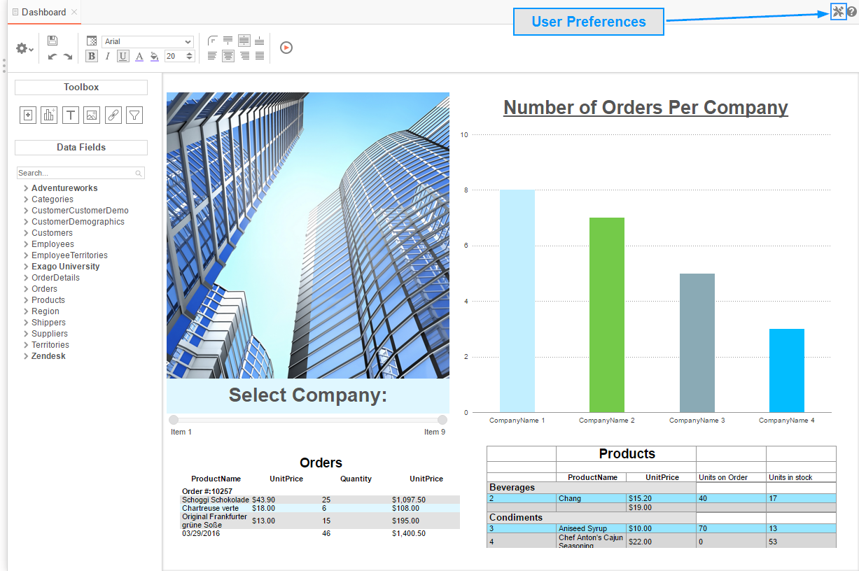

### Startup Reports

In the User Preferences menu, set your preferences such as which reports should run at startup and/or what User Reports should be applied.

* To execute a report on startup, either drag and drop it to the ‘Report Name’ panel, use the button, or double-click it.
* To disable a user report, click the delete button ().

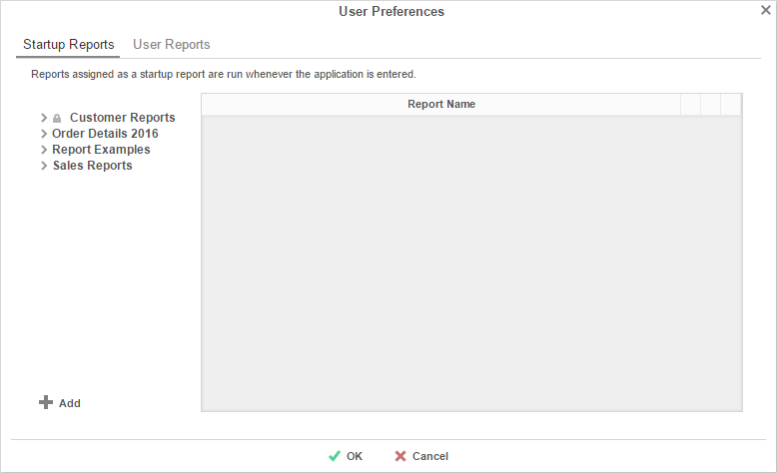

## Context Sensitive Help

Context sensitive help is available at any point in the application. Click the help button (), and documentation will appear in a new tab. The guide will automatically open to the section that reflects the feature you are using.

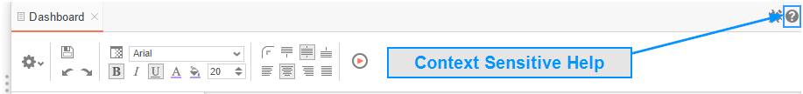



Exago, Inc.  
Two Enterprise Drive  
Shelton, CT 06484 USA  
203.225.0876  
[http://www.exagoinc.com](http://www.exagoinc.com/)